# Answer of 1

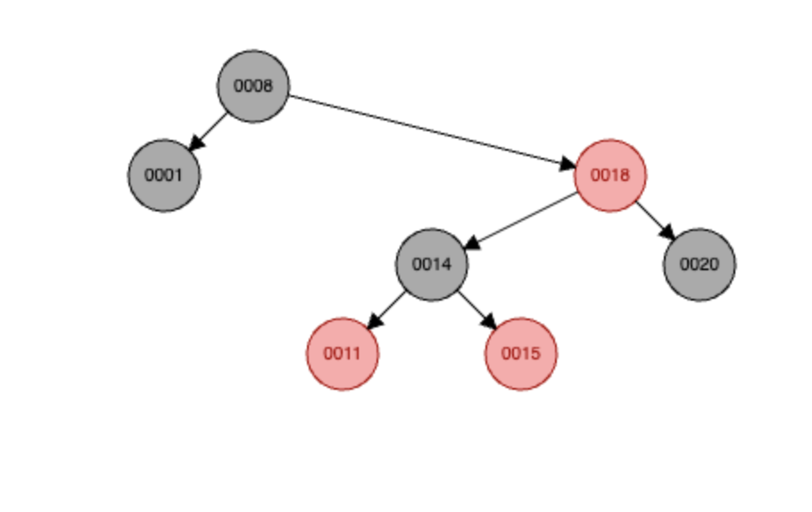

# Answer of 2

1. Insert [1,2,3,4,5,6,7,8]

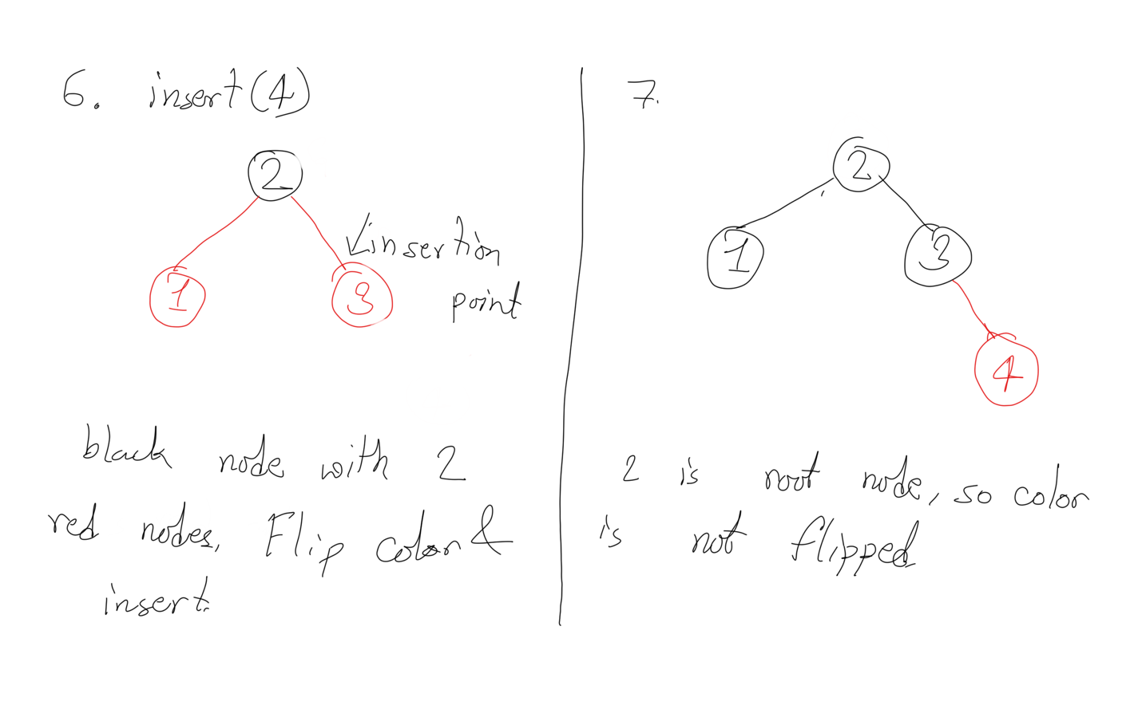

1. [3,2,1 5,4,6]

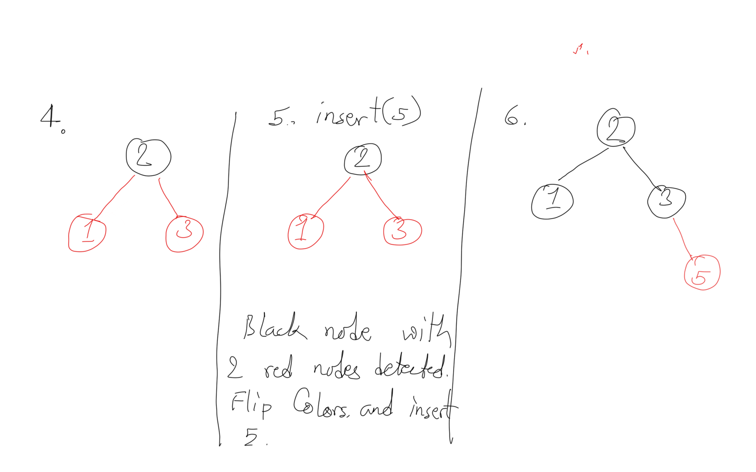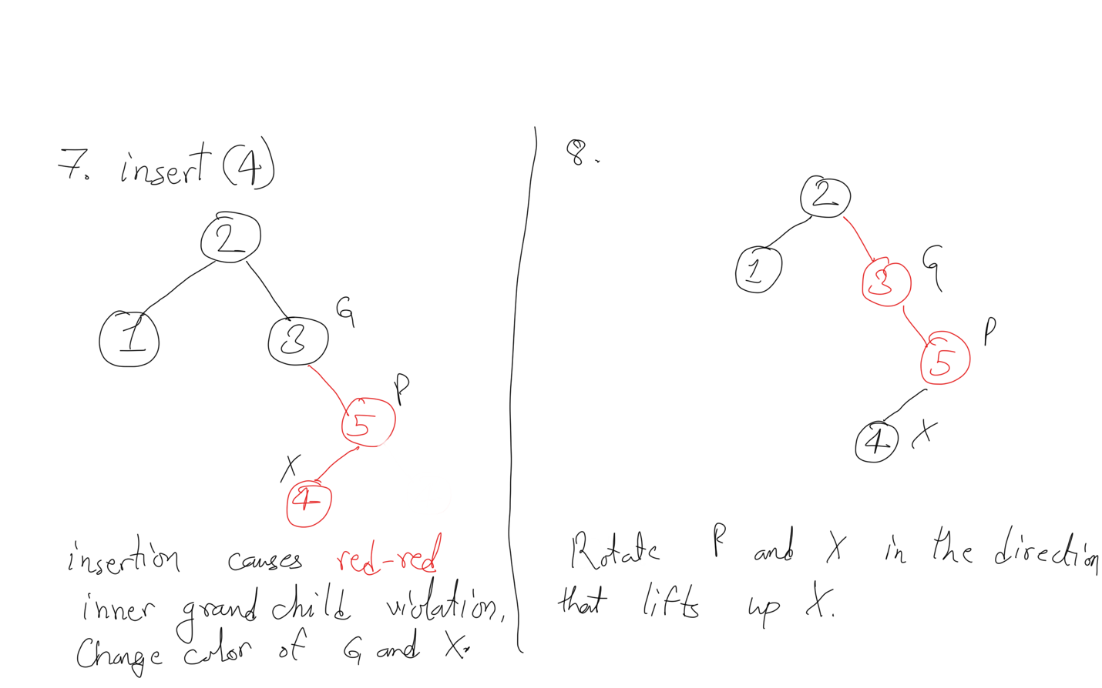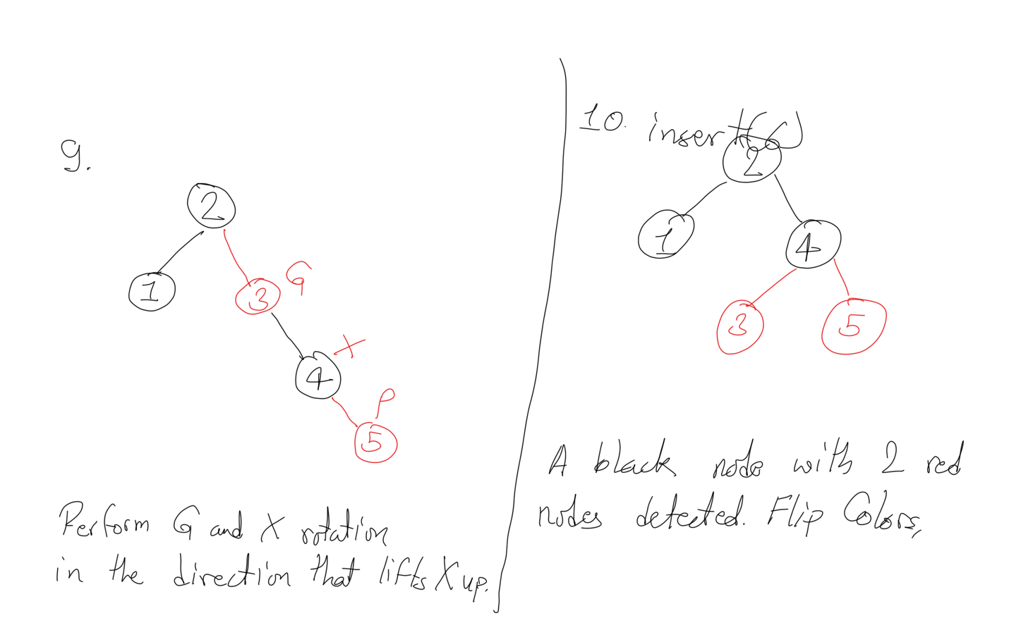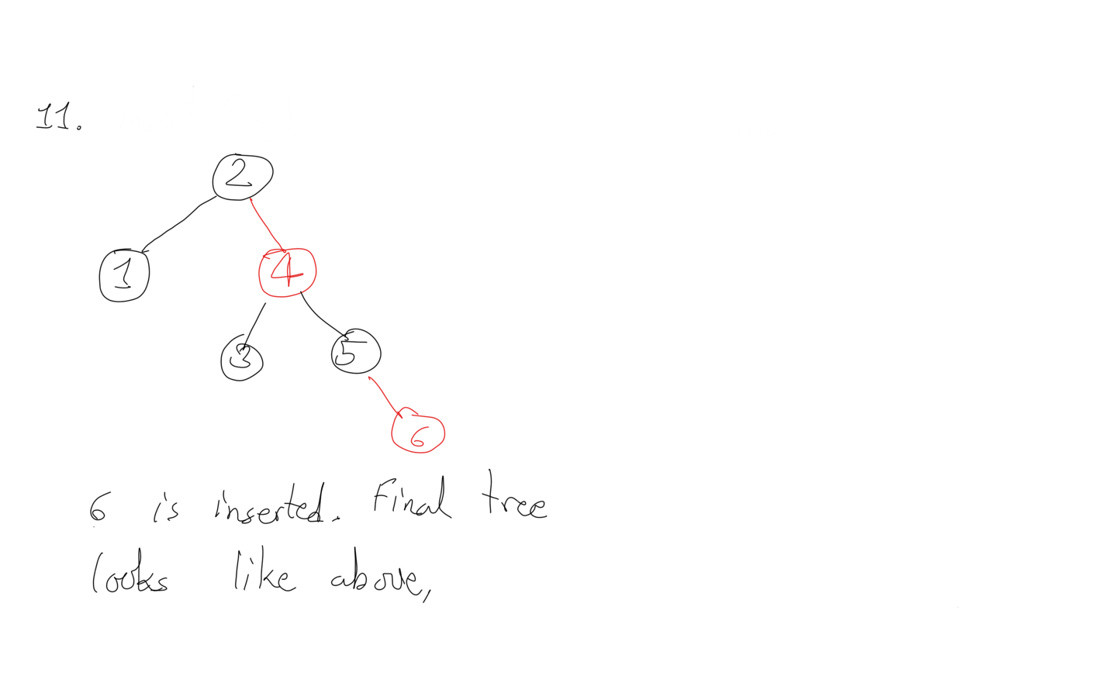

# Answer of 3

Hashmap Implementation:

class Trie {

static class TrieNode {

public Map<Character, TrieNode> children;

public boolean isEndOfWord;

TrieNode() {

children = new HashMap<>();

isEndOfWord = false;

}

}

TrieNode root;

public Trie() {

root = new TrieNode();

}

public void insert(String word) {

TrieNode current = root;

for (var c : word.toCharArray()) {

current = current.children.computeIfAbsent(c,k -> new TrieNode());

}

current.isEndOfWord = true;

}

public boolean search(String word) {

TrieNode current = root;

for (var c : word.toCharArray()) {

current = current.children.getOrDefault(c, null);

if (current == null) {

return false;

}

}

return current.isEndOfWord;

}

public boolean startsWith(String prefix) {

TrieNode current = root;

for (var c : prefix.toCharArray()) {

current = current.children.getOrDefault(c, null);

if (current == null) {

return false;

}

}

return true;

}

}

/**

* Your Trie object will be instantiated and called as such:

* Trie obj = new Trie();

* obj.insert(word);

* boolean param_2 = obj.search(word);

* boolean param_3 = obj.startsWith(prefix);

*/

Array Implementation:

class Trie {

static class TrieNode {

public TrieNode[] children;

public boolean isEndOfWord;

TrieNode() {

children = new TrieNode[26];

isEndOfWord = false;

}

}

TrieNode root;

public Trie() {

root = new TrieNode();

}

public void insert(String word) {

TrieNode current = root;

for (var c : word.toCharArray()) {

int index = c - 'a';

if (current.children[index] == null){

current.children[index] = new TrieNode();

}

current = current.children[index];

}

current.isEndOfWord = true;

}

public boolean search(String word) {

TrieNode current = root;

for (var c : word.toCharArray()) {

int index = c - 'a';

current = current.children[index];

if (current == null) {

return false;

}

}

return current.isEndOfWord;

}

public boolean startsWith(String prefix) {

TrieNode current = root;

for (var c : prefix.toCharArray()) {

int index = c - 'a';

current = current.children[index];

if (current == null) {

return false;

}

}

return true;

}

}

/**

* Your Trie object will be instantiated and called as such:

* Trie obj = new Trie();

* obj.insert(word);

* boolean param_2 = obj.search(word);

* boolean param_3 = obj.startsWith(prefix);

*/