School Lab 2

Write a program that is used by the computer science department to keep track of students, faculty and staff within the department, the courses students take, and the courses faculty teach. The class diagram for this program is as follows:

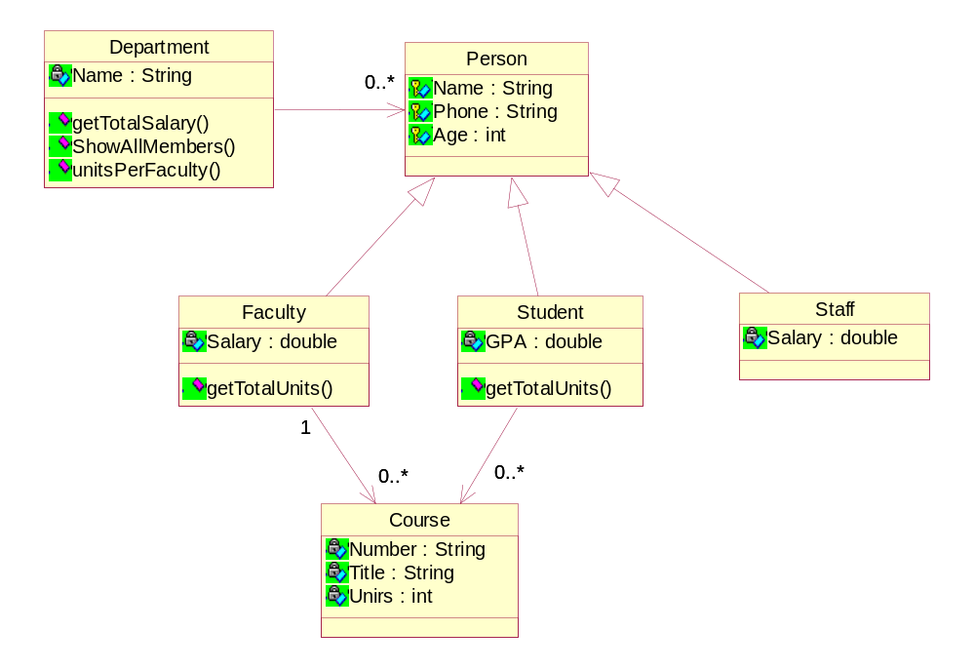

A department has faculty, students and staff. Faculty teaches courses, and students take courses. The Department object has 3 methods:
double getTotalSalary() // computes the sum of all the salaries (per month) paid to faculty and staff. Do this in two ways :

- Use instanceOf
- Use the better approach of polymorphism, by putting this method in the parent (ON A STANDARD EXAM!)

void showAllMembers() // shows the name, phone number, age and type (student, faculty or staff) of all members in the department.

void unitsPerFaculty() // shows a list of all faculty names and the total number of units they teach.
For unitsPerFaculty() do it two different ways. One is use instanceOf, and the other is use getClass().getSimpleName()

Make sure your program reflects the structure of the class diagram shown above.
The class diagram does not show accessor functions for the attributes. Use the java ‘ArrayList’ class to implement a list of objects.

Level 1 – Implement the getTotalSalary functionality.
Level 1 – Implement the showAllMembers functionality.
Level 1 – Implement the unitsPerFaculty functionality.

Use the data below. Data should be hard coded into your application.

Level 2

Add the following feature to the lab :

Suppose staff members also want to take courses. They get a new title: staffstudents. They still get a salary, and they also have a GPA. For all staffstudents we want to keep track of the starting date of the first course they take. All existing functionality should still work, for example getTotalSalary() should also add salaries payed to staffstudents.

Please first show me your class diagram for the solution to this problem!

Level 3

Add the following feature :

The program asks for the name of a faculty member, and the program prints out the names of all students who take classes that are taught by this faculty member.

******************************************************************************

A department has faculty, students and staff. Faculty teaches courses, and students take courses.

You should use the skeleton program below. It does run.

Add the following data into your program to test it.(data is hard coded into your application)

Department: Computer Science
Faculty in the computer science department:
Name | Phone | Age | Salary
Frank Moore | 472-5921 | 43 | 10000
Sam Howard | 472-7222 | 55 | 9500
John Doodle | 472-6190 | 39 | 8600

Students in the computer science department:
Name | Phone | Age | GPA
John Doe | 472-1121 | 22 | 4.0
Mary Jones | 472-7322 | 32 | 3.80
Lee Johnson | 472-6009 | 19 | 3.65

Staff in the computer science department:
Name | Phone | Age | Salary
Frank Gore | 472-3321 | 33 | 4050
Adam Davis | 472-7552 | 50 | 5500
David heck | 472-8890 | 29 | 3600

For level 1 (unitsPerFaculty) up above :

Add the following data into your program to test it.(data is hard coded into your application)

Courses:
Number | Title | Units | Faculty name
CS201 | Programming 1 | 4 | John Doodle
CS360 | Databases | 3 | Sam Howard
CS404 | Compilers | 4 | John Doodle
CS240 | Data structures | 2 | John Doodle
CS301 | Software Engineering | 3 | Sam Howard
CS450 | Advanced Architecture | 5 | Frank Moore

Courses per student:
Student name | Courses
John Doe | CS201, CS360, CS404, CS301
Mary Jones | CS201, CS404, CS450
Lee Johnson | CS201, CS360, CS240, CS450

Skeleton program :

import java.io.*; // for I/O
import java.lang.Integer;
import java.util.ArrayList;

/**
* This is a skeleton class that you can use for guidance in starting the lab.
*
* You should update any comments,
* variable names, etc to follow the class coding conventions.
*/

public class DepartmentApplication
{
public static void main(String[] args) throws IOException
{
Department dept = new Department("ComputerScience");

// The following commented out code will help you
// create the objects that you need.

// CHANGE the code below so that instead of addFaculty,
// addStudent, and addStaff, we have ONLY ONE method,
// addPerson (this replaces the other three methods).

/*******************************************************

// Create faculty objects
Person frankMoore = new Faculty("Frank Moore","472-5921",43,10000);
Person samHoward = new Faculty("Sam Howard","472-7222",55,9500);
Person johnDoodle = new Faculty("John Doodle","472-6190",39,8600);

dept.addPerson (frankMoore);
dept.addFaculty(samHoward);
dept.addFaculty(johnDoodle);

// Create student objects
Person johnDoe = new Student("John Doe","472-1121",22,4.0);
Person maryJones = new Student("Mary Jones","472-7322",32,3.80);
Person leeJohnson = new Student("Lee Johnson","472-6009",19,3.65);

dept.addPerson (johnDoe);
dept.addStudent(maryJones);
dept.addStudent(leeJohnson);

// Create staff objects
Person frankGore = new Staff("Frank Gore","472-3321",33,4050);
Person adamDavis = new Staff("Adam Davis","472-7552",50,5500);
Person davidHeck = new Staff("David Heck","472-8890",29,3600);
dept.addPerson (frankGore);
dept.addStaff(adamDavis);
dept.addStaff(davidHeck);

// Create course objects

/* The below is giving a faculty reference as the last argument. This is a Mistake since it is one directional. The ‘1’ next to the Faculty class in the class diagram is Not implemented in the Course class. It is there only to show us that a course is taught by only one faculty.
However, this mistake below does show us How we could implement the code IF it was two-directional! */

Course cs201 = new Course("cs201","programming",4, johnDoodle);
Course cs360 = new Course("cs360","database",3, samHoward);
Course cs404 = new Course("cs404","compiler",4, johnDoodle);
Course cs240 = new Course("cs240","datastructure",2, johnDoodle);
Course cs301 = new Course("cs301","Software engg",3, samHoward);
Course cs450 = new Course("cs450","Advanced architecture",5,frankMoore);

/*
* The above course objects will go inside either
* a faculty object, or a student object. Not all of the course
* objects go into the same object.
*
* You would have code that looks something like :
* frankMoore.addCourse(cs450);
*
* The addCourse method would have to be written in
* the faculty class. Something similar would be done
* for students.
*/

/********************************************************/

double totsalary = 0;

while(true)
{
putText("Enter first letter of ");
putText("getTotalSalary, showAllMembers, unitsPerFaculty or quit : ");
int choice = getChar();
switch(choice)
{
case 'g':
totsalary=dept.getTotalSalary();
putText("Total sum of all salaries is:");
putText(String.valueOf(totsalary)+"\n");
break;
case 's':
dept.showAllMembers();
break;
case 'u':
dept.unitsPerFaculty();
break;
case 'q': return;
default:
putText("Invalid entry\n");
} // end switch
} // end while
} // end main()
// -------------------------------------------------------------
public static void putText(String s) //writes string s to the screen
{
System.out.println(s);
}
// -------------------------------------------------------------
public static String getString() throws IOException //reads a string from the keyboard input
{
InputStreamReader isr = new InputStreamReader(System.in);
BufferedReader br = new BufferedReader(isr);
String s = br.readLine();
return s;
}
// -------------------------------------------------------------
public static char getChar() throws IOException //reads a character from the keyboard input
{
String s = getString();
return s.charAt(0);
}

//-------------------------------------------------------------
public static int getInt() throws IOException // reads an integers from the keyboard input
{
String s = getString();
return Integer.parseInt(s);
}
// -------------------------------------------------------------
} // end class

Good Luck!

