MongoDB Lab – Day 3 (CRUD Operations)
Name- Bidita Adhikari
Sec – E
Roll No- UG/02/BTCSEAIML/2023/077
Subject- Unstructured Database
Initial Data
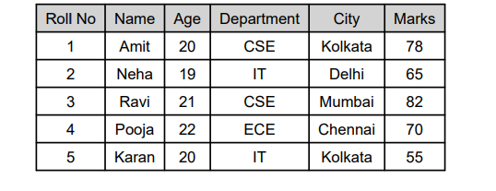

Database Name: collegeDB_`YourRollNo`
Collection Name: students_`YourRollNo
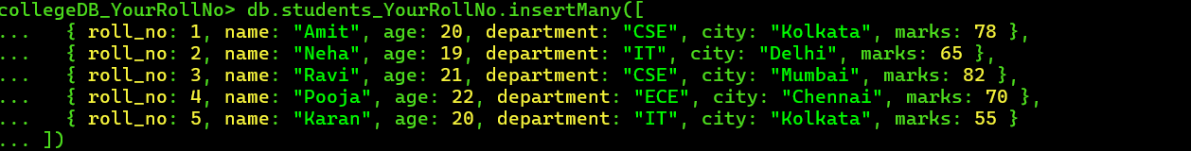

Lab Questions
Q1. Display all student records from the collection.
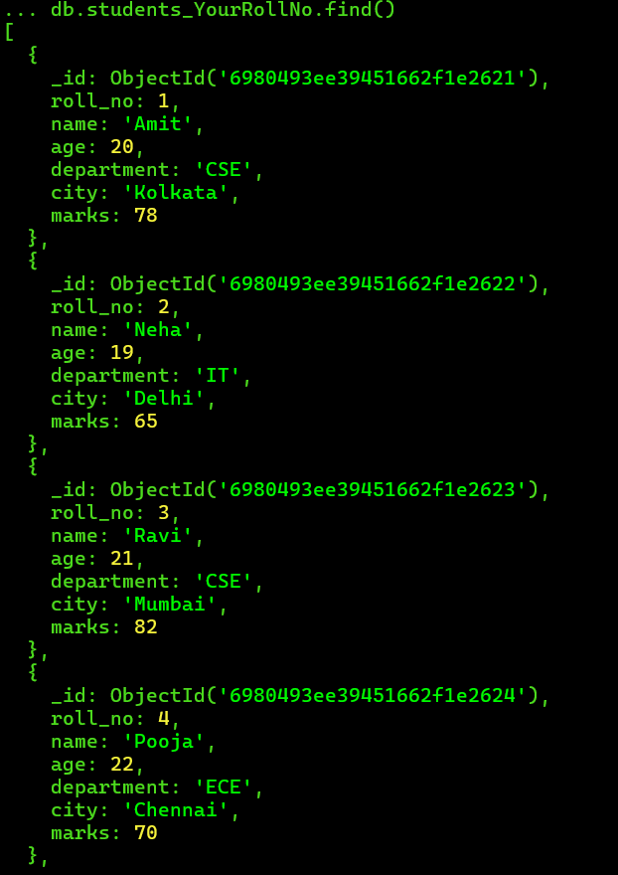
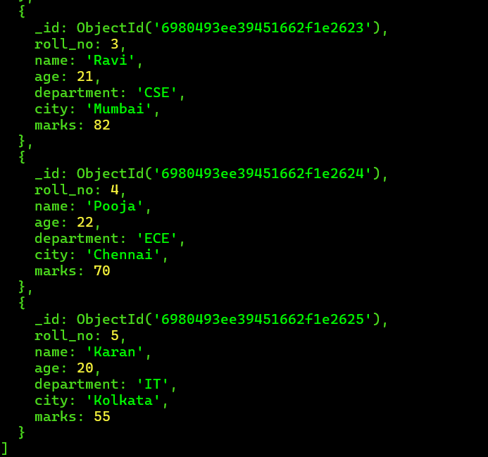
Q2. Display only the name and department of all students.
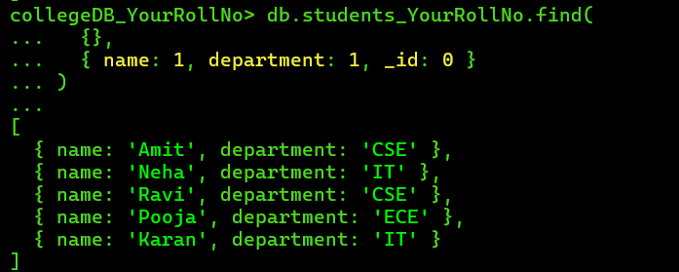

Q3. Find students belonging to the CSE department.
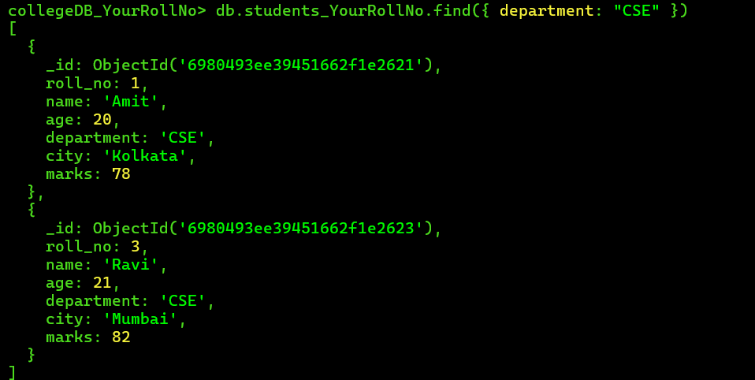

Q4. Find students whose age is greater than 20.
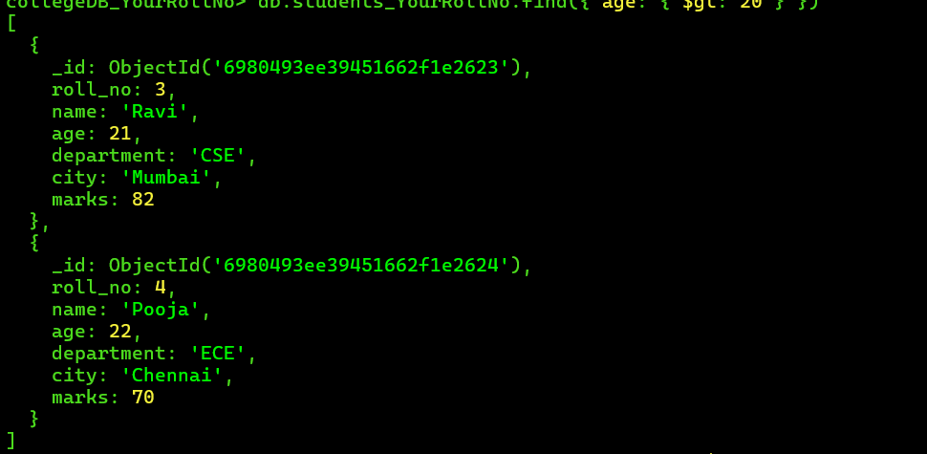

Q5. Find students who scored less than 70 marks.
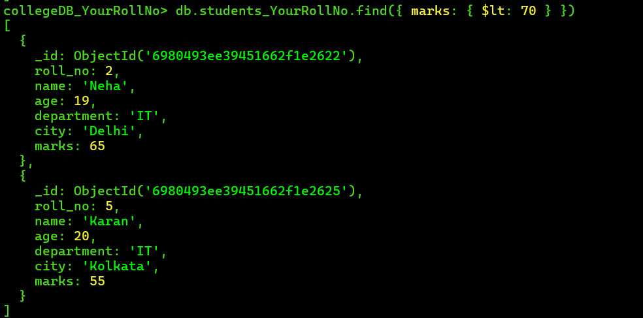
Q6. Display students belonging to Kolkata city.
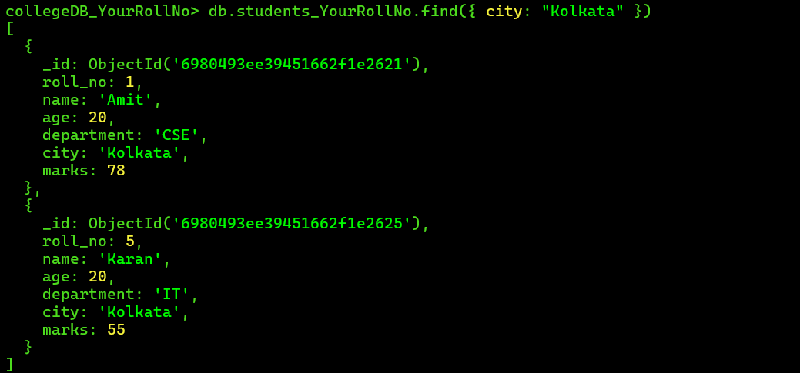
Q7. Sort students by age in ascending order.
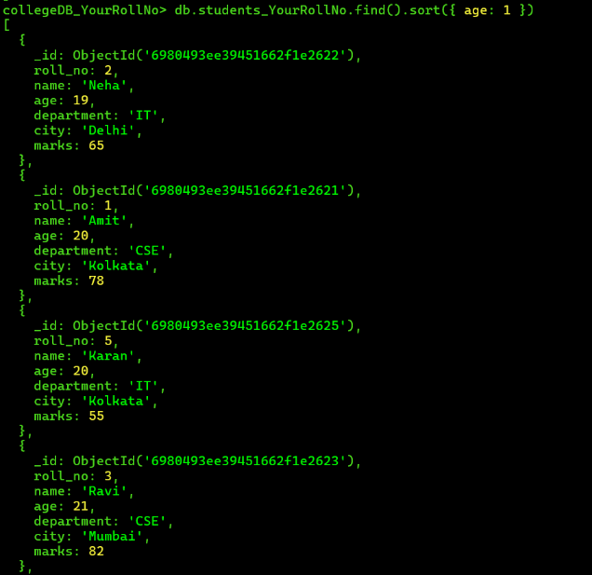
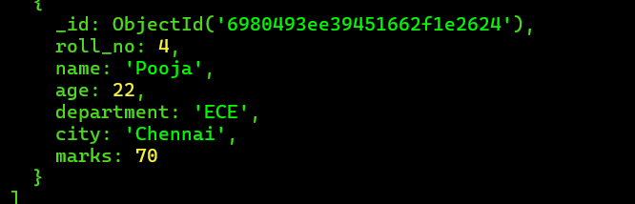
Q8. Sort students by marks in descending order.
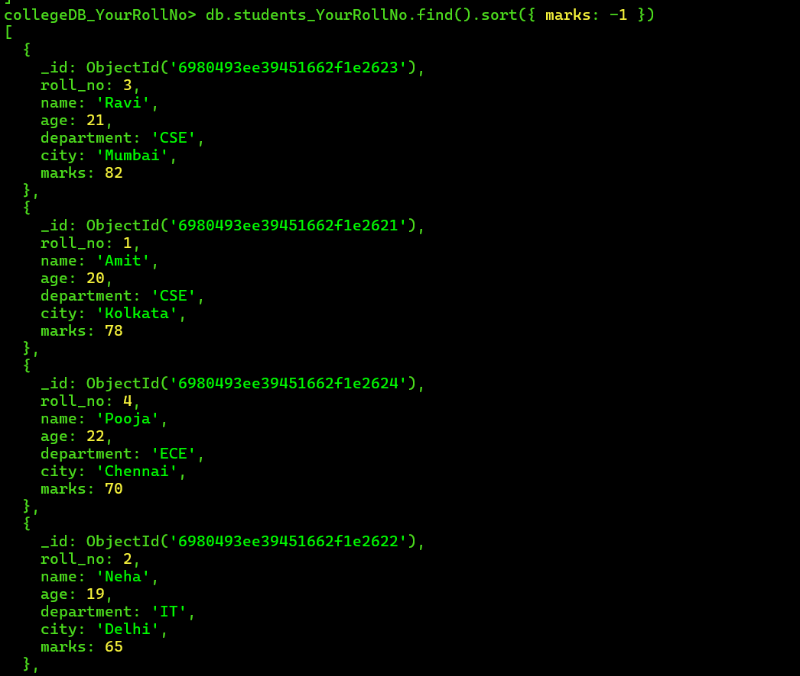
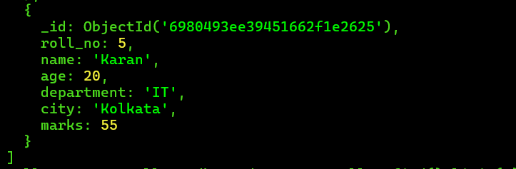

Q9. Display only the first three student records.
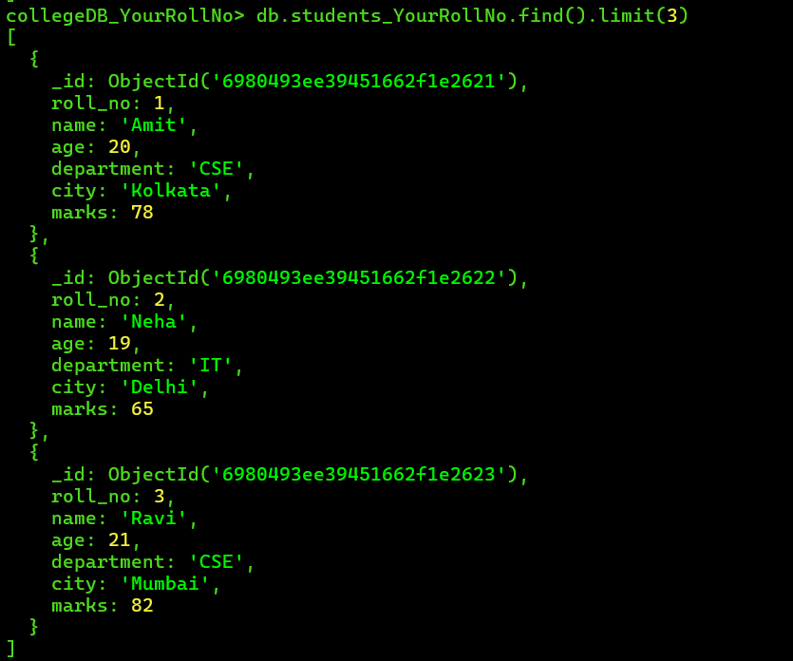
Q10. Update the marks of student Neha to 72.
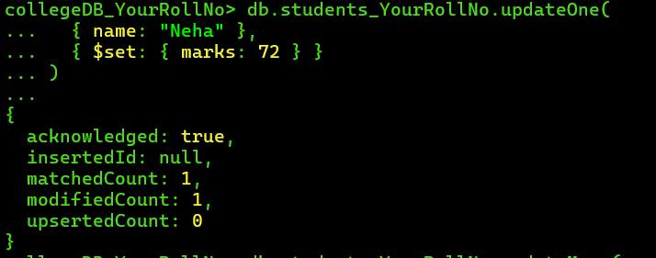
Q11. Increase the marks of all students by 5.
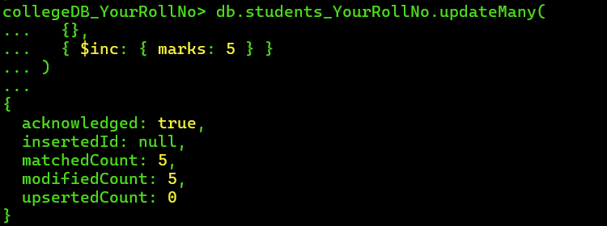
Q12. Delete the student having roll number 5.

Q13. Find students whose age is between 20 and 22.
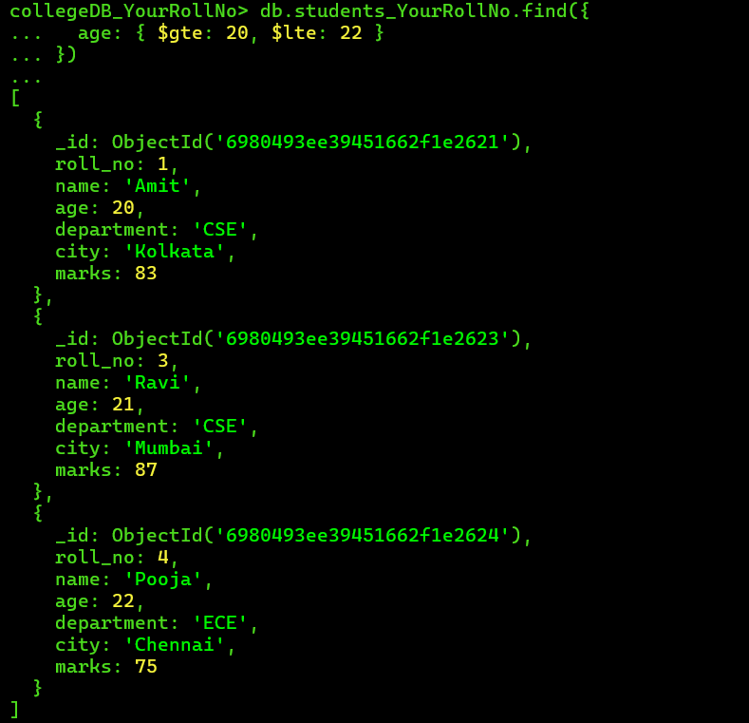

Q14. Display students belonging to either CSE or IT department.
