LAB ASSIGNMENT – 7 (Studio 3t) DATE – 23.03.2026

NAME : Bidita Adhikari
REGISTRATION NO. : AU/2023/0010239
ROLL NO. :UG/02/BTCSEAIML/2023/077
SUBJECT : Unstructured Database Lab SEC: E

Data: { roll: 1, name: "Anu", age: 22, department: "IT", marks: 85 },
{ roll: 2, name: "Riya", age: 21, department: "CSE", marks: 78 },
{ roll: 3, name: "Aman", age: 23, department: "IT", marks: 92 },
{ roll: 4, name: "Neha", age: 20, department: "ECE", marks: 74 },
{ roll: 5, name: "Raj", age: 24, department: "CSE", marks: 88 },
{ roll: 6, name: "Simran", age: 22, department: "IT", marks: 81 },
{ roll: 7, name: "Karan", age: 21, department: "ECE", marks: 69 },
{ roll: 8, name: "Priya", age: 23, department: "CSE", marks: 95 }.
Lab Questions:
Q1. Display all documents.

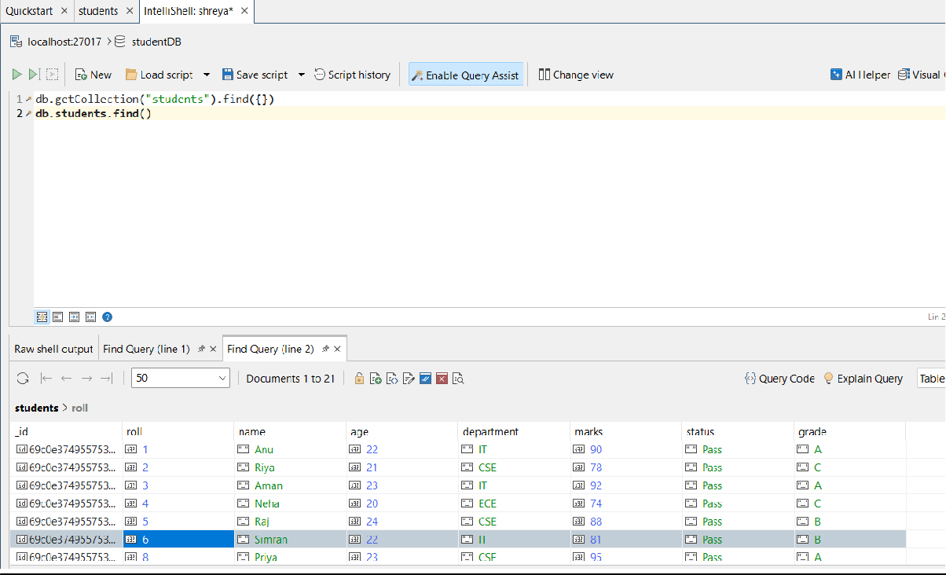

Q2. Find students from IT department.

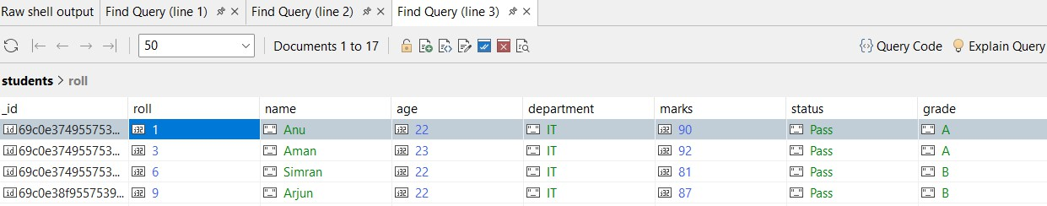

Q3. Find students with marks > 80.

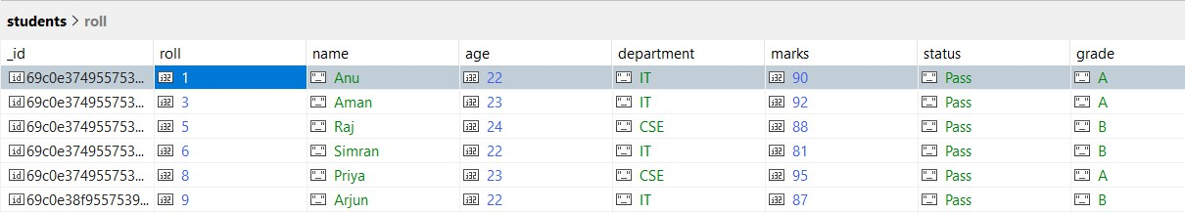

Q4. Insert one new student.

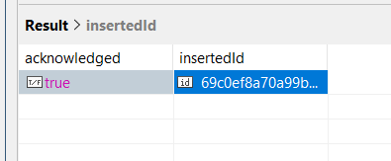

Q5. Update marks of Anu to 90.

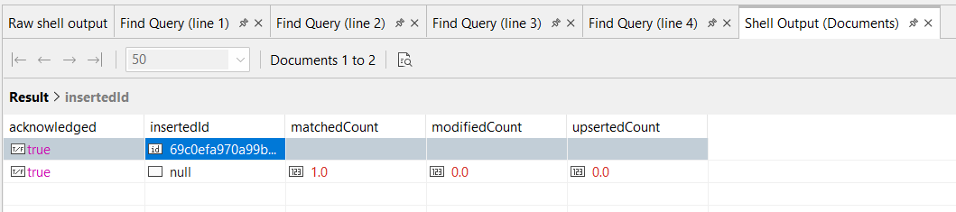

Q6. Add a new field "status: Pass" for all students.

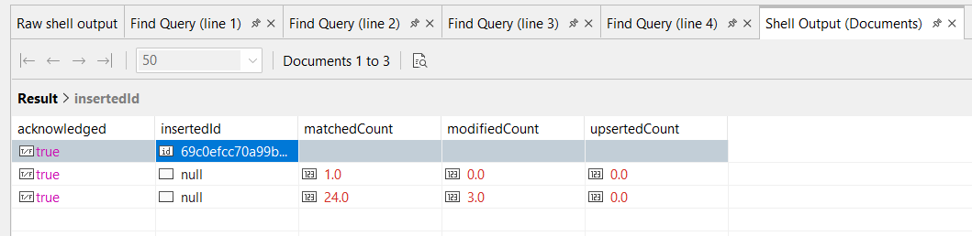

Q7. Delete all students with marks < 70.

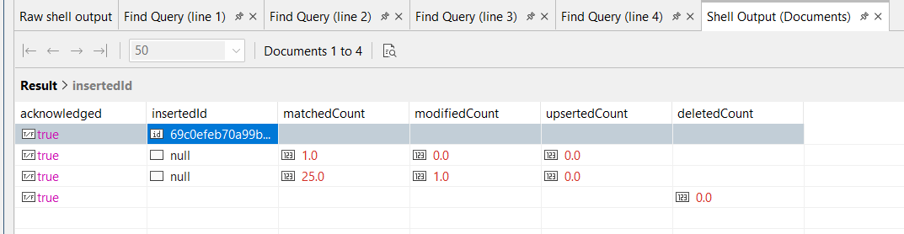

Q8. Count students in CSE department.

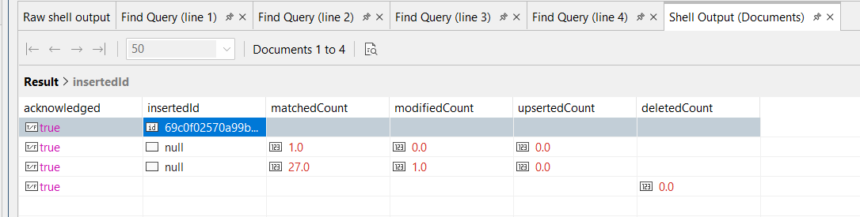

Q9. Find total students in each department.

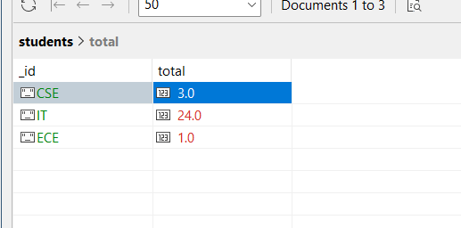

Q10. Find highest marks.

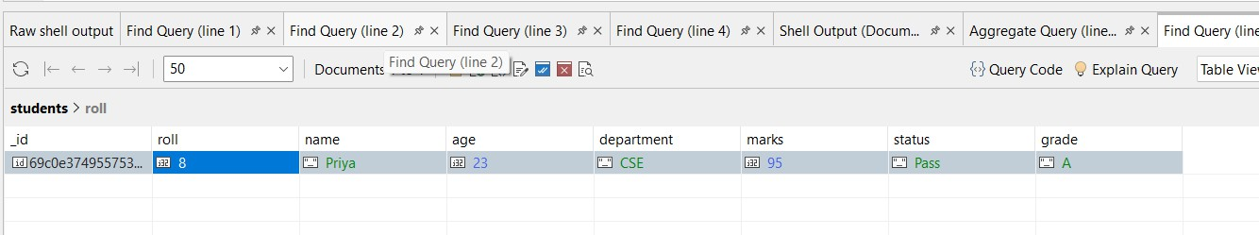

Q11. Find the second highest marks.

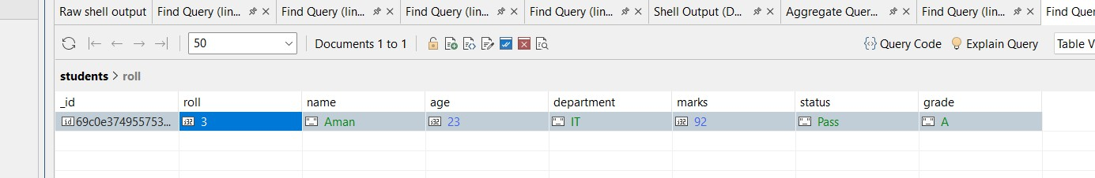

Q12. Find students whose name starts with 'A' and marks > 80.

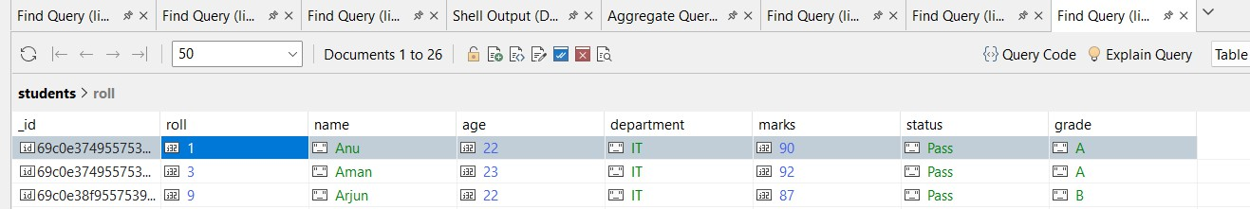

Q13. Display department-wise average marks, only for departments where avg > 80.

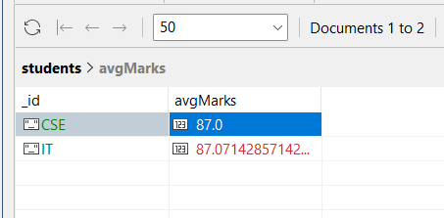

Q14. Find students with marks between 75 and 90, sorted by marks ascending.

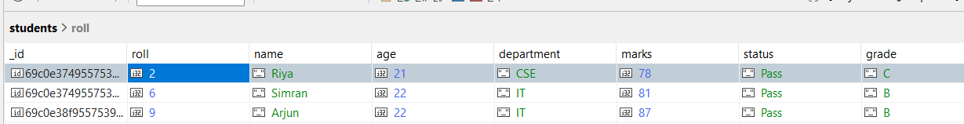

Q15. Add grade field based on marks.

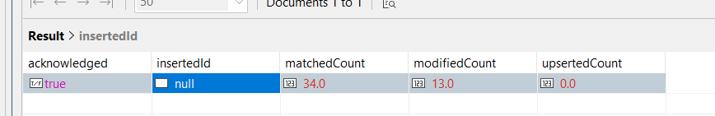

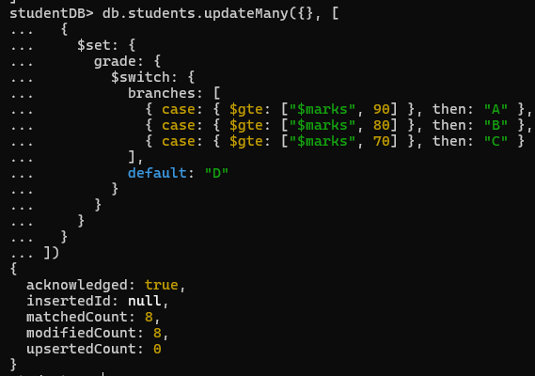

Queries:

- db.students.find()
- db.students.find({ department: "IT" })
- db.students.find({ marks: { $gt: 80 } })
- db.students.insertOne({ roll: 9, name: "Arjun", age: 22, department: "IT", marks: 87 })
- db.students.updateOne(
{ name: "Anu" },
{ $set: { marks: 90 } }
)
- db.students.updateMany({}, { $set: { status: "Pass" } })
- db.students.deleteMany({ marks: { $lt: 70 } })

- db.students.countDocuments({ department: "CSE" })
- db.students.aggregate([
{ $group: { _id: "$department", total: { $sum: 1 } } }
])
- db.students.find().sort({ marks: -1 }).limit(1)
- db.students.find().sort({ marks: -1 }).skip(1).limit(1)
- db.students.find({
name: { $regex: "^A" },
marks: { $gt: 80 }
})
- db.students.find({ marks: { $gte: 75, $lte: 90 }
}).sort({ marks: 1 })
- db.students.updateMany({}, [
{
$set: {
grade: {
$switch: {
branches: [
{ case: { $gte: ["$marks", 90] }, then: "A" },
{ case: { $gte: ["$marks", 80] }, then: "B" },
{ case: { $gte: ["$marks", 70] }, then: "C" }
],

default: "D"
}
}
}
}
])

