Edge-Compute Feasibility of Cooperative Perception Fusion for Connected Autonomous Vehicles
Comprehensive Work Report: Weeks 1 to 4
Ganesh Adhikari | CS 7000 | Advisor: Dr. Liangkai Liu | October 2026
1. Purpose of This Report
This report records everything done on the project so far, from setup through the Week 4 compute profiling. It is meant to be the working record we draw from when writing the final paper, so it keeps the method details, settings and numbers in one place. Results from the early single-scene trial in Week 2 are replaced by the 20-scene results reported here.
2. Research Question and Motivation
Cooperative perception lets connected vehicles share what their sensors see, so each vehicle can detect objects that are hidden from its own view or too far away. Most research in this area measures how much accuracy cooperation adds and how much network bandwidth it uses. Much less work asks whether the fusion model itself is small and fast enough to run on the kind of low-cost computer a vehicle would actually carry.
Research question: Do two established fusion methods, V2VNet and when2com, fit within the memory and compute budget of a Jetson Nano class edge device, and what does each one cost relative to the accuracy it adds over a vehicle working alone?
The project answers this by direct measurement. Each model is run and profiled ourselves, rather than relying on numbers reported in the original papers.
3. Scope and Assumptions
- Models: pretrained, publicly released checkpoints only. No model is trained or retrained.
- Sensor: LiDAR only, since these detectors use LiDAR bird's eye view input and no camera data.
- Vehicle-only setting: evaluation uses five cooperating vehicles and no roadside unit. V2VNet and when2com are vehicle-to-vehicle methods, and every available checkpoint was trained in this setting. Roadside-unit fusion is left as future work.
- Edge budget (Jetson Nano): 4 GB memory and 472 GFLOPS peak compute, taken from NVIDIA's published specification. This peak is for half precision (16-bit); at full precision (32-bit) the peak is about 236 GFLOPS (128 GPU cores at 921.6 MHz, 2 operations per cycle).
- Latency target: under 100 ms per fused detection, matching a 10 Hz LiDAR update rate. This is our own fair assumption for real-time use, not a vendor figure.
- No physical Nano: the models are profiled on a cloud GPU and compared against the Nano's published numbers. The Nano figures are therefore estimates, not hardware benchmarks.
4. Tools and Environment
Item | What we used
Codebase | coperception (github.com/coperception/coperception)
Dataset | V2X-Sim 2.0, CARLA simulated, 20-scene subset
Data preprocessing | Local laptop (MacBook Air M4), CPU only
Evaluation and profiling | Google Colab, NVIDIA Tesla T4 (15 GB)
Software | Python 3.13, PyTorch 2.11 with CUDA
Storage | Google Drive (code, data, checkpoints, results)

The T4 was chosen over larger cloud GPUs because it is the closest available GPU to edge hardware, and it is free on Colab. All three models were measured on the same GPU in the same session so their numbers are directly comparable.
5. Dataset
We converted 20 scenes of V2X-Sim 2.0 into the detector's input format, giving 12,000 preprocessed files. The scenes are split 14 for training, 3 for validation and 3 for testing. Only the 3 test scenes are used for every result in this report, so the numbers come from data the models were not trained on.
Test scene | Frames | Active vehicles
Scene 5 | 100 | 4
Scene 8 | 100 | 5
Scene 19 | 100 | 4
Total | 300

Scenes 5 and 19 contain only four vehicles, so agent 5 has data only in scene 8. This matters for two things: agent 5's accuracy comes from one scene only, and V2VNet's run time depends on how many vehicles are present (Section 9).
6. Models Compared
- Lowerbound: each vehicle detects objects using only its own LiDAR. No sharing. This is the baseline.
- V2VNet: vehicles share intermediate feature maps. A graph neural network passes messages between vehicles over several rounds, using a convolutional GRU to update each vehicle's features.
- when2com: uses an attention mechanism so each vehicle decides which partner to listen to before fusing, aiming to reduce communication.
All three share the same LiDAR backbone (an encoder followed by a decoder) and the same detection heads. Settings follow the codebase's test script: fusion at layer 3, three message-passing rounds for V2VNet, five agents, and when2com in its standard "activated" inference mode with pose warping off. The released detectors are single-class: they detect vehicles and do not separate cars, buses and bikes.
7. Detection Accuracy
Accuracy is measured as mean Average Precision (mAP), the standard detection score. A predicted box counts as correct if it overlaps the true box by at least 50% (IoU 0.5) or, in the stricter case, 70% (IoU 0.7).
7.1 Overall
Model | mAP@0.5 | mAP@0.7 | Change vs lowerbound (@0.5)
Lowerbound (no cooperation) | 0.554 | 0.491 | reference
V2VNet | 0.753 | 0.715 | +0.199
when2com | 0.501 | 0.465 | -0.053

V2VNet improves accuracy by about 36% over a vehicle working alone. when2com does slightly worse than the baseline. We checked whether turning pose warping on would change this, and it did not (0.498 at IoU 0.5 and 0.460 at IoU 0.7), so the gap is not caused by that setting.
7.2 Per agent
Because the checkpoints detect only one class, a per-class breakdown (car, bus, bike) is not possible without retraining. Instead we report accuracy for each of the five vehicles, which shows whether the benefit of cooperation is shared evenly.
Agent | Lowerbound | V2VNet (gain) | when2com (gain)
Agent 1 | 0.545 | 0.750 (+0.204) | 0.535 (-0.010)
Agent 2 | 0.700 | 0.868 (+0.168) | 0.677 (-0.023)
Agent 3 | 0.626 | 0.789 (+0.162) | 0.487 (-0.139)
Agent 4 | 0.335 | 0.589 (+0.254) | 0.278 (-0.057)
Agent 5 | 0.505 | 0.759 (+0.253) | 0.473 (-0.033)
Average | 0.554 | 0.753 (+0.199) | 0.501 (-0.053)
Table: mAP at IoU 0.5 per agent.
Agent | Lowerbound | V2VNet (gain) | when2com (gain)
Agent 1 | 0.504 | 0.733 (+0.229) | 0.495 (-0.009)
Agent 2 | 0.642 | 0.836 (+0.194) | 0.603 (-0.040)
Agent 3 | 0.526 | 0.760 (+0.234) | 0.478 (-0.048)
Agent 4 | 0.273 | 0.508 (+0.235) | 0.264 (-0.008)
Agent 5 | 0.474 | 0.734 (+0.260) | 0.447 (-0.027)
Average | 0.491 | 0.715 (+0.224) | 0.465 (-0.026)
Table: mAP at IoU 0.7 per agent.
- V2VNet improves every vehicle. The largest gains go to agents 4 and 5, the vehicles with the weakest view on their own. Agent 4 rises from 0.335 to 0.589.
- when2com is below the baseline for every vehicle, so its shortfall is consistent rather than caused by one bad case. Agent 3 drops the most at IoU 0.5.
- The same pattern holds at the stricter IoU 0.7.
8. Visual Results
To show what the numbers mean, we rendered detections in bird's eye view for four frames per scene and per vehicle. The vehicle sits at the centre of the circular LiDAR rings. Agent 4 was chosen because it gains the most from cooperation.
How the examples were chosen:
- Agent 4: it has the weakest view alone (mAP@0.5 of 0.335, the lowest of the five vehicles) and gains the most from V2VNet (+0.254, with agent 5 essentially tied at +0.253). The choice was first made from the pictures, where agent 1 showed almost no difference, and the per-agent table later confirmed it. Because agent 4 is the vehicle that benefits most, it shows cooperation at its best and is not a typical case. The per-agent table is the fair summary across all five vehicles.
- Scene 19: one of the three test scenes (5, 8 and 19) and the first one we opened. It has four vehicles.
- Scene 8: the only test scene with all five vehicles present, found when we checked the vehicle counts in every test scene.
- Frames 0 and 50: in scene 19 these showed the clearest difference between the models. The same frames were reused for scene 8 without checking, which is why the differences there are smaller.
8.1 Why these examples were chosen
The pictures are meant to help explain the numbers. They are examples, not a measurement, so we want to be clear about how they were picked and where that picking could favour the models.
Why agent 4. The per-agent table shows how each vehicle scores alone and with V2VNet. Agent 4 has the weakest view on its own (mAP@0.5 of 0.335, the lowest of the five) and gains the most from V2VNet (+0.254, with agent 5 almost tied at +0.253). A vehicle that misses many cars alone, and finds many more with help, is where the difference is easiest to see in a picture. We did not start with agent 4. Our first picture used agent 1, and the three models looked almost the same in that frame, so we moved to agent 4. This means agent 4 is the best case for cooperation and not a typical one. The per-agent tables in Section 7.2 cover all five vehicles and are the fair summary.
Why scenes 19 and 8. The test set has three scenes (5, 8 and 19). We show two. Scene 19 was simply the first one we opened. Scene 8 was added because it is the only test scene in which all five vehicles are present, so it checks that the pattern also holds in the full setting. Scene 5 has four vehicles like scene 19 and is not shown, although its pictures were saved and are available.
Why frames 0 and 50. To keep the run quick and the output small, pictures were saved for every 25th frame only (frames 0, 25, 50 and 75 of each scene). We then picked two of the four. In scene 19, frames 0 and 50 showed the clearest difference between the models, so we used them. We reused the same two frames for scene 8 without comparing the others, which is why the differences in scene 8 look smaller. Frames 25 and 75 were not chosen against and could be shown instead.
How to read them. The pictures illustrate what the accuracy table means: green boxes that carry a red box were found, green boxes with no red box were missed. The evidence for the conclusions is in the tables, which cover all 300 test frames and all five vehicles.
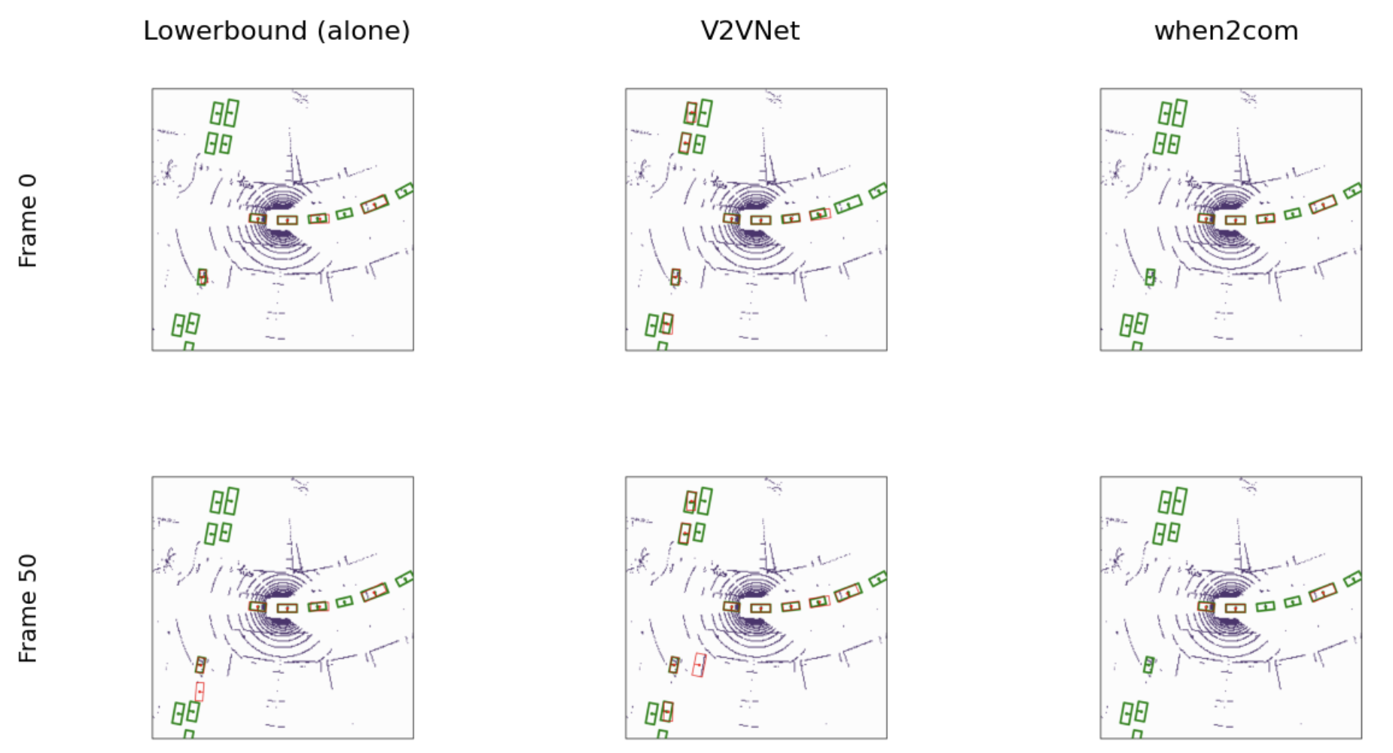
Figure 1. Agent 4, scene 19 (4 vehicles), frames 0 and 50. Green boxes are ground truth, red boxes are detections.
How to read it: each small square is a top-down view around agent 4. The purple dots are its LiDAR points. A green box is a car that is really there. A red box is what the model detected. A green box with a red box on it (it looks brown) is a car that was found. A green box alone is a car that was missed. A red box alone is a false alarm. Our own car is the green box at the centre of the picture, near the middle of the rings, and it is counted among the cars.
Cars found (counted by eye) | Alone | V2VNet | when2com
Frame 0 (14 cars) | 5 | 8 | 4
Frame 50 (14 cars) | 5 (+1 false alarm) | 9 (+1 false alarm) | 3
Table: cars found in Figure 1, including our own car. Small boxes are hard to read, so a count may be off by one.
What the picture shows:
- Our own car is one of the 14. The box at the centre of the rings is agent 4's own vehicle (Section 8.2). All three models find it every time, and they also find the cars on the road right beside it, so cooperation is not needed for those.
- Parked cars on the left are where cooperation helps. The group of four parked cars at the top left and the group at the bottom left are far away and partly hidden. Alone, agent 4 finds none of them. V2VNet finds two at the top left and one at the bottom left in both frames, using what the other vehicles saw.
- V2VNet also reaches further along the road. In frame 50 it finds five cars along the road, against four for the vehicle alone.
- when2com does worse than the vehicle alone. It finds none of the parked cars, misses the single car at the lower left that the other two find, and in frame 50 also loses two cars along the road. This matches its lower score in the tables.
- Cooperation is not perfect. In frame 50 both the vehicle alone and V2VNet draw one red box with no car under it near the lower left car (a false alarm). The cars at the far right end of the road are missed by all three.
- In short: V2VNet finds about 8 to 9 of the 14 cars, the vehicle alone 5, and when2com 3 to 4. The gain comes from far and hidden cars, which is exactly what cooperation is supposed to fix.
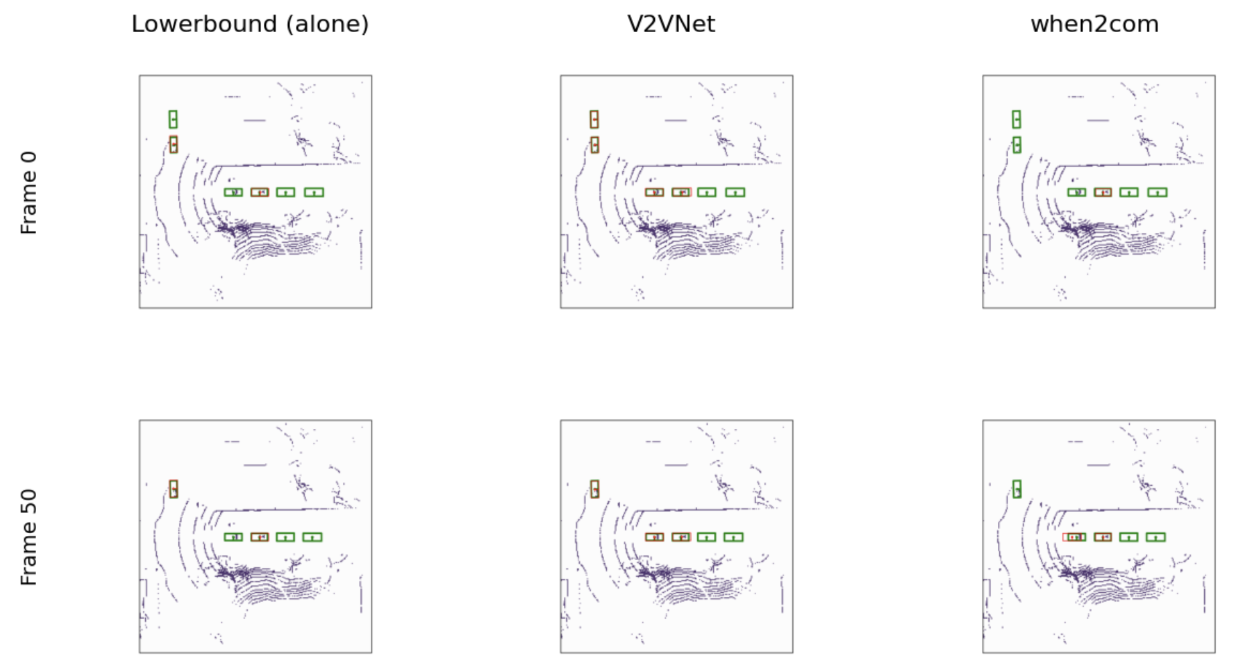
Figure 2. Agent 4, scene 8 (all 5 vehicles), frames 0 and 50. Green boxes are ground truth, red boxes are detections.
Cars found (counted by eye) | Alone | V2VNet | when2com
Frame 0 (6 cars) | 2 | 4 | 1
Frame 50 (5 cars) | 2 | 3 | 2
Table: cars found in Figure 2, including our own car. Small boxes are hard to read, so a count may be off by one.
What the picture shows:
- Same pattern, smaller gap. Scene 8 is the only test scene with all five vehicles. V2VNet again finds the most cars and when2com the fewest, but there are fewer cars in view, so the difference is smaller than in scene 19.
- The two cars at the top left (frame 0). Alone, agent 4 finds only the nearer one. V2VNet finds both. when2com finds neither.
- The row of four cars. The second box is our own car, found by all three models. The first box is the car just behind us: alone misses it, V2VNet finds it, and when2com finds it only in frame 50, with a box wider than the car (a loose fit).
- Frame 50, top left car. The vehicle alone and V2VNet both find it; when2com misses it.
- Cars nobody finds. The two cars ahead of us in the row are missed by every model. We first thought they had no LiDAR points on them, but a recount in the raw grid found points near the nearer one (about 30 cells in its box area), so a lack of points does not explain this miss. The reason is still open (Section 8.2).
- In short: even with all five vehicles sharing, cooperation helps with some cars but not all. The ranking (V2VNet first, the vehicle alone second, when2com last) is the same as in scene 19 and in the tables.
8.2 Our own car in the pictures
We checked whether the vehicle itself appears in the pictures, and it does. This changes how the pictures and the scores should be read.
- It is in the ground truth. In scene 8, frame 0, the saved ground-truth files of agents 1 to 5 each contain a box at about grid cell (127, 131), roughly 1 m from the sensor. The roadside unit (agent 0) has no box at its centre; its nearest box is 9 m away. So the box at the centre is the vehicle carrying the sensor.
- All three models find it every time. The box at the centre is matched in every panel of both figures. It has very few LiDAR cells on it (2 in scene 8 and about 18 in scene 19 in a rough count), so a likely reason is that it sits at the same place in every frame and a model can learn to predict it without seeing it. This has not been tested.
- Effect on the scores. If the evaluation counts this box as a ground-truth car, each model gets one easy correct detection per frame. That would raise all absolute mAP values and shrink the gaps between models, while probably leaving the ranking unchanged. We have not confirmed that the evaluation counts it.
- LiDAR point counts. We counted occupied LiDAR cells inside each ground-truth box in two ways: once in picture coordinates and once in the raw grid. The results agree for some cars and disagree for others (for example the cars ahead in scene 8), so we do not report cell counts per car. The method needs to be fixed and the counts redone before they are used as evidence.
9. Compute Profiling Method
All profiling uses the exact model setup from the evaluation, loads the same checkpoints, and feeds real test frames through the same data pipeline. One shared helper file builds the models and inputs so every measurement uses identical settings.
- Parameters and size: parameters counted directly. Weight size is parameters times 4 bytes (32-bit floats). Checkpoint files are larger because they also store training state, so the weight size is what would actually ship to a vehicle.
- Peak memory: one warm-up pass, then the peak GPU memory of a second pass is recorded. This is memory allocated by PyTorch and does not include the CUDA runtime itself (roughly 300 to 400 MB).
- Latency: 10 warm-up passes, then 50 timed passes, with the GPU synchronised before and after each one. Measured on a 5-vehicle frame (scene 8) and a 4-vehicle frame (scene 5). This covers the network forward pass only, not box decoding or non-maximum suppression.
- FLOPs: counted with PyTorch's built-in FLOP counter on a 5-vehicle frame, with a breakdown by module. It counts convolutions and matrix multiplications, so small operations such as feature warping are slightly under-counted.
- Nano estimate: FLOPs per vehicle divided by the Nano's 472 GFLOPS, at 100% (ideal), 30% and 20% utilisation. Each measured pass processes all five vehicles together, while in a real deployment each vehicle runs its own encoder, fusion step and decoder. So the per-vehicle cost is taken as the total divided by five.
10. Profiling Results
10.1 Model size
Model | Parameters | Weights (32-bit) | Checkpoint file
Lowerbound | 7.90 M | 31.6 MB | 94.9 MB
V2VNet | 21.08 M | 84.3 MB | 190.2 MB
when2com | 31.30 M | 125.2 MB | 287.8 MB

V2VNet is 2.7 times the size of the baseline and when2com is 4 times. In when2com, the attention parts make up about half of the weights (query_key_net 42%, key_net 4%, query_net 3.5%). In V2VNet, the message-passing GRU adds 5.3 M parameters (25%). Even the largest model uses only about 3% of the Nano's 4 GB for its weights.
10.2 Peak memory
Model | Peak GPU memory (5 vehicles) | Share of 4 GB
Lowerbound | 933 MB | 23%
V2VNet | 1,023 MB | 26%
when2com | 1,070 MB | 27%

Roughly 0.9 GB of each peak is temporary feature maps from the shared backbone, and it barely changes between models. Fusion adds only 90 MB (V2VNet) and 136 MB (when2com). Adding the CUDA runtime and the operating system, the largest model still needs well under the Nano's 4 GB. Memory is not the barrier.
10.3 Latency on the T4
Model | 5 vehicles: mean ms (std) | 4 vehicles: mean ms (std) | vs lowerbound
Lowerbound | 97.1 (0.5) | 97.7 (0.7) | 1.00x
V2VNet | 180.7 (3.8) | 161.6 (2.8) | 1.86x
when2com | 187.1 (1.2) | 188.7 (0.8) | 1.93x

- Run-to-run variation is small (standard deviation under 4 ms), so these numbers are reliable.
- V2VNet takes 84 ms (86%) longer than the baseline for its 36% accuracy gain. when2com takes 90 ms (93%) longer and is less accurate.
- V2VNet slows down as vehicles are added, by about 19 ms for the fifth vehicle, because it loops over every vehicle in each message-passing round. when2com stays flat at about 188 ms.
- Even on the T4, a much stronger GPU than the Nano, both fusion models are already about 1.8 times over the 100 ms target.
10.4 Compute (FLOPs)
Model | GFLOPs (5 vehicles) | GFLOPs per vehicle | T4 utilisation
Lowerbound | 155.8 | 31.2 | 19.8%
V2VNet | 318.9 | 63.8 | 21.8%
when2com | 308.4 | 61.7 | 20.4%

The T4 reached only about 20 to 22% of its peak speed on all three models. This is a useful reference point, because it suggests a utilisation of 20 to 30% is a realistic assumption for the Nano as well.
Where the compute goes:
- Lowerbound: the shared backbone is 92% of the work (142.7 GFLOPs).
- V2VNet: the message-passing GRU is 51% (163.1 GFLOPs), more than the entire baseline model. The decoder is 30% and the encoder 14%.
- when2com: the decoder is 63% (193.3 GFLOPs), about twice the decoder work of V2VNet. Its attention network also runs a second encoder-sized pass (46.1 GFLOPs). We have not yet looked into why the decoder does twice the work.
- In both fusion models, the encoder (46.1) and decoder (96.6) together equal the baseline backbone's 142.7 GFLOPs. Each is stored as a full copy of the backbone but only runs half of it, which suggests about half of those weights are never used. We still need to confirm this by counting the parameters that are actually exercised.
10.5 Estimated Jetson Nano time per vehicle
How the estimate is made, using V2VNet as the worked example:
- Count the work. PyTorch's built-in FLOP counter measured the operations in one frame: 318.9 GFLOPs for all five vehicles.
- Split per vehicle. Each test frame runs all five vehicles at once, but a real car runs only its own share: 318.9 / 5 = 63.8 GFLOPs.
- Divide by the Nano's speed. The Nano's published peak is 472 GFLOPS at 16-bit precision: 63.8 / 472 = 135 ms. This is the ideal case, at full speed.
- Adjust for real-world speed. Chips rarely reach their peak. On the T4 our models reached only about 20% of its peak, so we also show 30% and 20%: 135 / 0.30 = 450 ms and 135 / 0.20 = 676 ms. The 32-bit column uses the 32-bit peak of about 236 GFLOPS instead: 63.8 / 236 = 270 ms.
Model | Ideal, 16-bit | At 30%, 16-bit | At 20%, 16-bit | Ideal, 32-bit
Lowerbound | 66 ms | 220 ms | 330 ms | 132 ms
V2VNet | 135 ms | 450 ms | 676 ms | 270 ms
when2com | 131 ms | 436 ms | 653 ms | 261 ms

Only the baseline meets 100 ms, and only in the ideal case. At realistic utilisation, all three models are well over budget, and the two fusion models need roughly 4.5 times the target. The 472 GFLOPS peak applies to half-precision (16-bit) arithmetic. The models currently run at full precision (32-bit), where the Nano's peak is about 236 GFLOPS, so without conversion every estimate doubles. At 32-bit, even the baseline misses 100 ms in the ideal case (132 ms). Converting to 16-bit is therefore a required step, not an optional one.
10.6 Efficiency
Efficiency is the accuracy gain over the baseline (mAP at IoU 0.5) divided by the extra cost.
Model | Gain per extra MB | Gain per extra GFLOP (per vehicle) | Gain per extra ms (T4)
V2VNet | +0.0038 | +0.0061 | +0.0024
when2com | -0.0006 | -0.0017 | -0.0006

V2VNet buys real accuracy for its extra cost. when2com has negative efficiency on every measure: it costs more and delivers less.
11. Key Findings
- V2VNet is the clear winner on accuracy: +0.199 mAP at IoU 0.5 overall, and a gain for every vehicle.
- when2com is larger, slower and less accurate than a vehicle working alone in this setting.
- Memory fits comfortably on a Nano class device. Compute and latency are the real barriers.
- At realistic efficiency, none of the three models meets 100 ms per vehicle on the Nano without optimisation.
- V2VNet is the better starting point for edge deployment, and its message-passing GRU (51% of its compute) is the first target to optimise.
12. Limitations
- Nano figures are estimates from published specifications and an assumed utilisation range, not measurements on the device.
- Profiling processes all five vehicles in one pass; the per-vehicle cost is approximated as one fifth of the total.
- Latency covers the network only, not box decoding or post-processing.
- The test set has three scenes, and agent 5 appears in only one of them.
- Accuracy is for a single vehicle class, because the released detectors are single-class.
- Ground-truth box counts differed slightly between evaluation runs (about 12,900 to 13,000), which has a negligible effect on the scores.
- Results are for the vehicle-only setting without a roadside unit.
- Each vehicle's own car is a ground-truth box at the centre of its view and is detected by all three models. It may raise the absolute scores. We did not score without it.
- Per-car LiDAR point counts are not yet reliable (two counting methods disagree for some cars), so the reasons for missed cars in the pictures are not established.
13. Next Steps
- Recount LiDAR points per car with a validated method before using them as evidence.
- Per-module latency breakdown, to confirm in milliseconds what the FLOP breakdown shows.
- Test fewer message-passing rounds in V2VNet (1 or 2 instead of 3) and measure the trade-off between speed and accuracy.
- Test half-precision inference to see how much it saves and whether accuracy holds.
- Count the parameters that are actually used, to confirm the unused half-backbone finding.
- Find out why when2com's decoder does twice the work of V2VNet's.
- Combine everything into a final feasibility verdict and recommendation, then write the final report.
Appendix: Where the Results Are Stored
Content | Location (Google Drive, CS7000_project)
Accuracy logs | results/<model>_eval/no_rsu/log_test.txt
Figures | results/figures/final_scene19_agent4_2x3.png, final_scene8_agent4_2x3.png
Profiling helper code | profiling/common.py
Size, memory, latency, FLOPs | results/profiling/params_size.json, peak_memory.json, latency.json, flops.json
Summary table | results/profiling/summary.csv

