EXPERIMENT 1
DDL Commands: CREATE, ALTER, TRUNCATE and DROP

Aim: To perform DDL operations using CREATE, ALTER, TRUNCATE and DROP commands in MySQL 8.0.
Software Required: MySQL 8.0 Command Line Client

SQL Program
CREATE DATABASE SQL_Lab;
USE SQL_Lab;

CREATE TABLE Student (
id INT PRIMARY KEY,
name VARCHAR(50),
age INT
);

INSERT INTO Student VALUES
(1, 'Harika', 20),
(2, 'Ravi', 21);

SELECT * FROM Student;

ALTER TABLE Student
ADD department VARCHAR(30);

DESCRIBE Student;

TRUNCATE TABLE Student;
SELECT * FROM Student;

DROP TABLE Student;

Expected Output 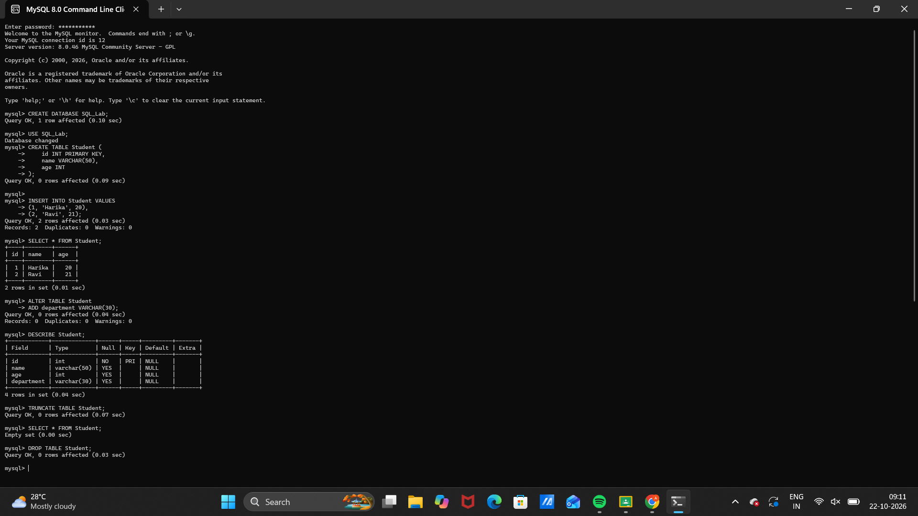

Observation
Execute the SQL statements in MySQL 8.0 Command Line Client. Verify that each statement runs successfully and that the displayed rows match the inserted sample data and query conditions.
Note: TRUNCATE removes all rows but keeps the table structure. DROP removes the table itself. Capture the SELECT output before TRUNCATE and DROP.

Result
Thus, Experiment 1 (DDL Commands: CREATE, ALTER, TRUNCATE and DROP) was performed using MySQL 8.0.

SQL LAB RECORD

