EXPERIMENT 2
DDL Constraints

Aim: To implement PRIMARY KEY, FOREIGN KEY, UNIQUE, CHECK, DEFAULT and NOT NULL constraints.
Software Required: MySQL 8.0 Command Line Client

SQL Program
USE SQL_Lab;

CREATE TABLE Department (
dept_id INT PRIMARY KEY,
dept_name VARCHAR(50) UNIQUE
);

CREATE TABLE Employee (
emp_id INT PRIMARY KEY,
emp_name VARCHAR(50) NOT NULL,
age INT CHECK (age >= 18),
city VARCHAR(30) DEFAULT 'Chennai',
dept_id INT,
FOREIGN KEY (dept_id) REFERENCES Department(dept_id)
);

INSERT INTO Department VALUES
(1, 'CSE'),
(2, 'ECE');

INSERT INTO Employee (emp_id, emp_name, age, dept_id) VALUES
(101, 'Harika', 20, 1),
(102, 'Ravi', 21, 2);

SELECT * FROM Department;
SELECT * FROM Employee;

Expected Output 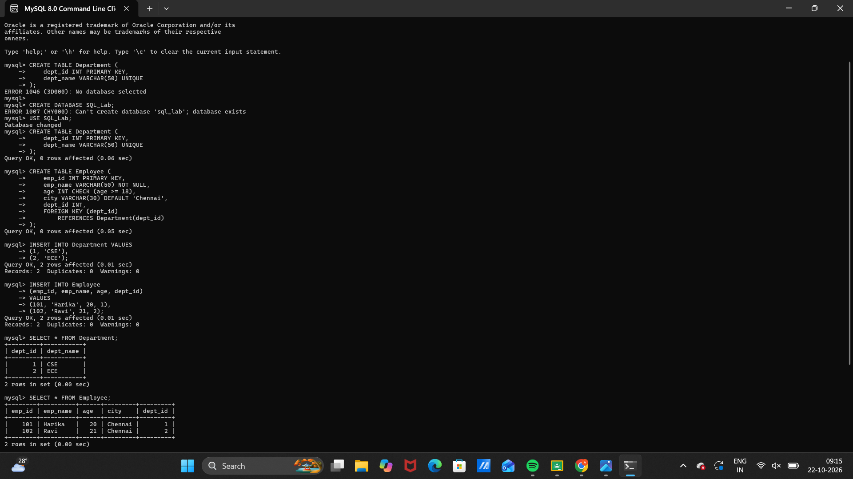

Observation
Execute the SQL statements in MySQL 8.0 Command Line Client. Verify that each statement runs successfully and that the displayed rows match the inserted sample data and query conditions.
Note: If the tables already exist from an earlier run, remove them first or use different table names. MySQL enforces CHECK constraints in MySQL 8.0.16 and later.

Result
Thus, Experiment 2 (DDL Constraints) was performed using MySQL 8.0.

SQL LAB RECORD

