EXPERIMENT 3
DML Commands: INSERT and SELECT

Aim: To insert records into a table and retrieve them using SELECT.
Software Required: MySQL 8.0 Command Line Client

SQL Program
USE SQL_Lab;

CREATE TABLE Books (
book_id INT PRIMARY KEY,
book_name VARCHAR(50),
author VARCHAR(50),
price DECIMAL(8,2)
);

INSERT INTO Books VALUES
(1, 'Wings of Fire', 'A.P.J. Abdul Kalam', 250.00),
(2, 'The Alchemist', 'Paulo Coelho', 300.00),
(3, 'Atomic Habits', 'James Clear', 400.00);

SELECT * FROM Books;

Expected Output 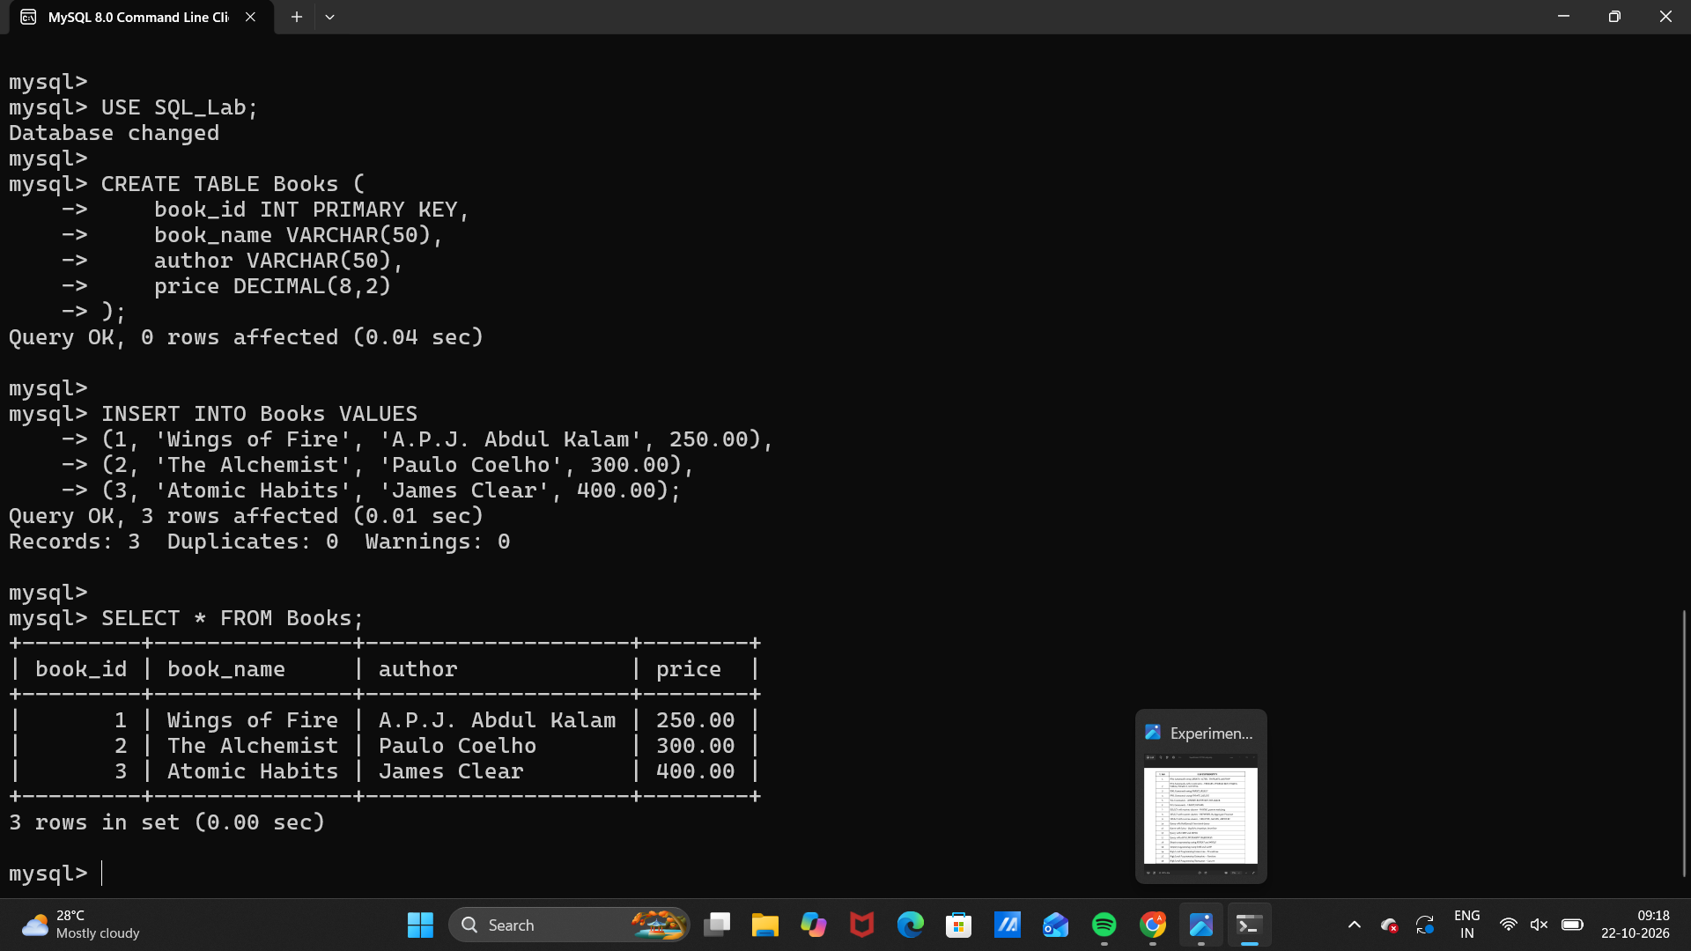Observation
Execute the SQL statements in MySQL 8.0 Command Line Client. Verify that each statement runs successfully and that the displayed rows match the inserted sample data and query conditions.
Note: If you already created Books, skip CREATE TABLE and INSERT to avoid duplicate-table or duplicate-key errors.

Result
Thus, Experiment 3 (DML Commands: INSERT and SELECT) was performed using MySQL 8.0.

SQL LAB RECORD

