EXPERIMENT 4
DML Commands: UPDATE and DELETE

Aim: To modify and remove selected records using UPDATE and DELETE.
Software Required: MySQL 8.0 Command Line Client

SQL Program
USE SQL_Lab;

CREATE TABLE Employees (
emp_id INT PRIMARY KEY,
emp_name VARCHAR(50),
salary INT,
department VARCHAR(30)
);

INSERT INTO Employees VALUES
(101, 'Harika', 25000, 'CSE'),
(102, 'Ravi', 30000, 'ECE'),
(103, 'Priya', 28000, 'CSE');

SELECT * FROM Employees;

UPDATE Employees
SET salary = 35000
WHERE emp_id = 101;

SELECT * FROM Employees;

DELETE FROM Employees
WHERE emp_id = 102;

SELECT * FROM Employees;

Expected Output 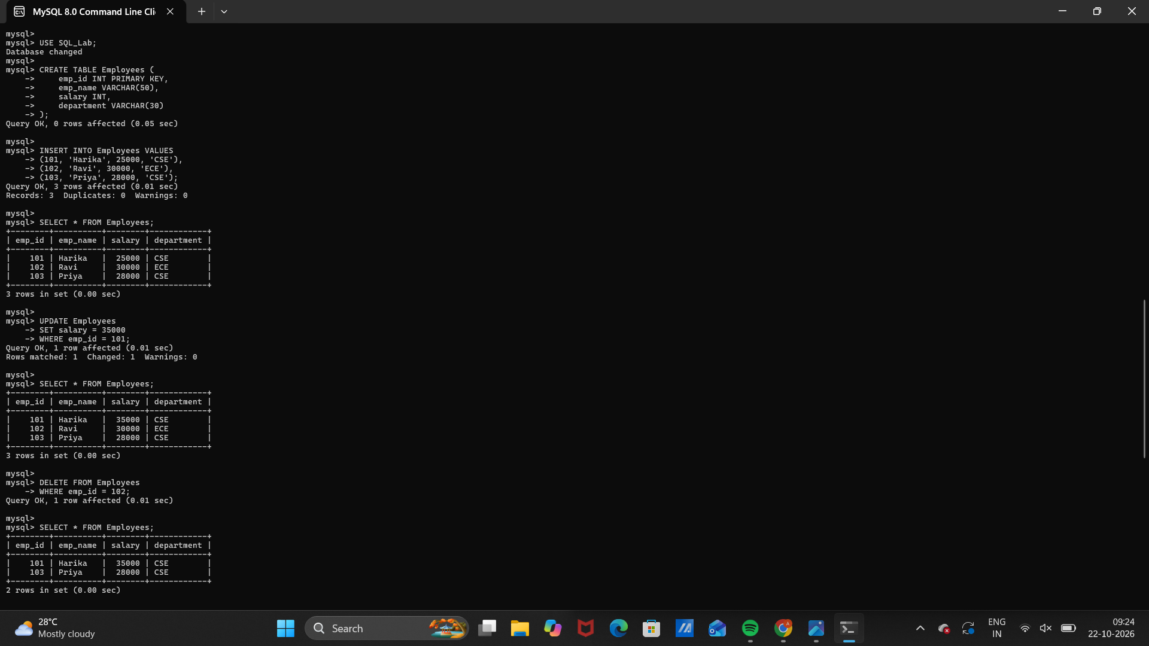

Observation
Execute the SQL statements in MySQL 8.0 Command Line Client. Verify that each statement runs successfully and that the displayed rows match the inserted sample data and query conditions.
Note: Use WHERE to target specific records. Without WHERE, UPDATE or DELETE can affect every row.

Result
Thus, Experiment 4 (DML Commands: UPDATE and DELETE) was performed using MySQL 8.0.

SQL LAB RECORD

