EXPERIMENT 5
TCL Commands: COMMIT, SAVEPOINT and ROLLBACK

Aim: To control transactions using COMMIT, SAVEPOINT and ROLLBACK.
Software Required: MySQL 8.0 Command Line Client

SQL Program
USE SQL_Lab;

CREATE TABLE Accounts (
acc_id INT PRIMARY KEY,
acc_name VARCHAR(50),
balance INT
) ENGINE=InnoDB;

INSERT INTO Accounts VALUES
(1, 'Harika', 5000),
(2, 'Ravi', 3000);

SELECT * FROM Accounts;

START TRANSACTION;
UPDATE Accounts SET balance = 6000 WHERE acc_id = 1;
SAVEPOINT sp1;
UPDATE Accounts SET balance = 4000 WHERE acc_id = 2;
ROLLBACK TO sp1;
SELECT * FROM Accounts;
COMMIT;
SELECT * FROM Accounts;

START TRANSACTION;
UPDATE Accounts SET balance = 7000 WHERE acc_id = 1;
ROLLBACK;
SELECT * FROM Accounts;

Expected Output 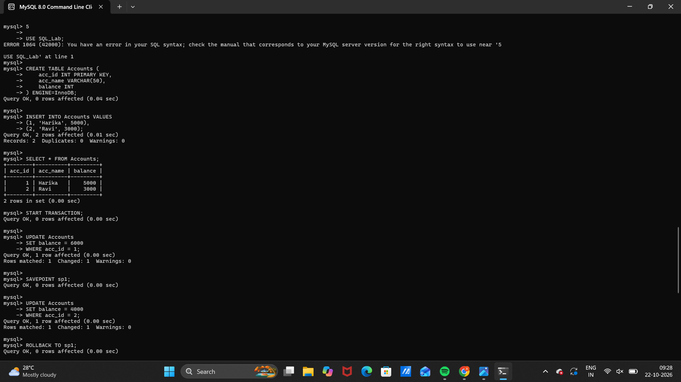

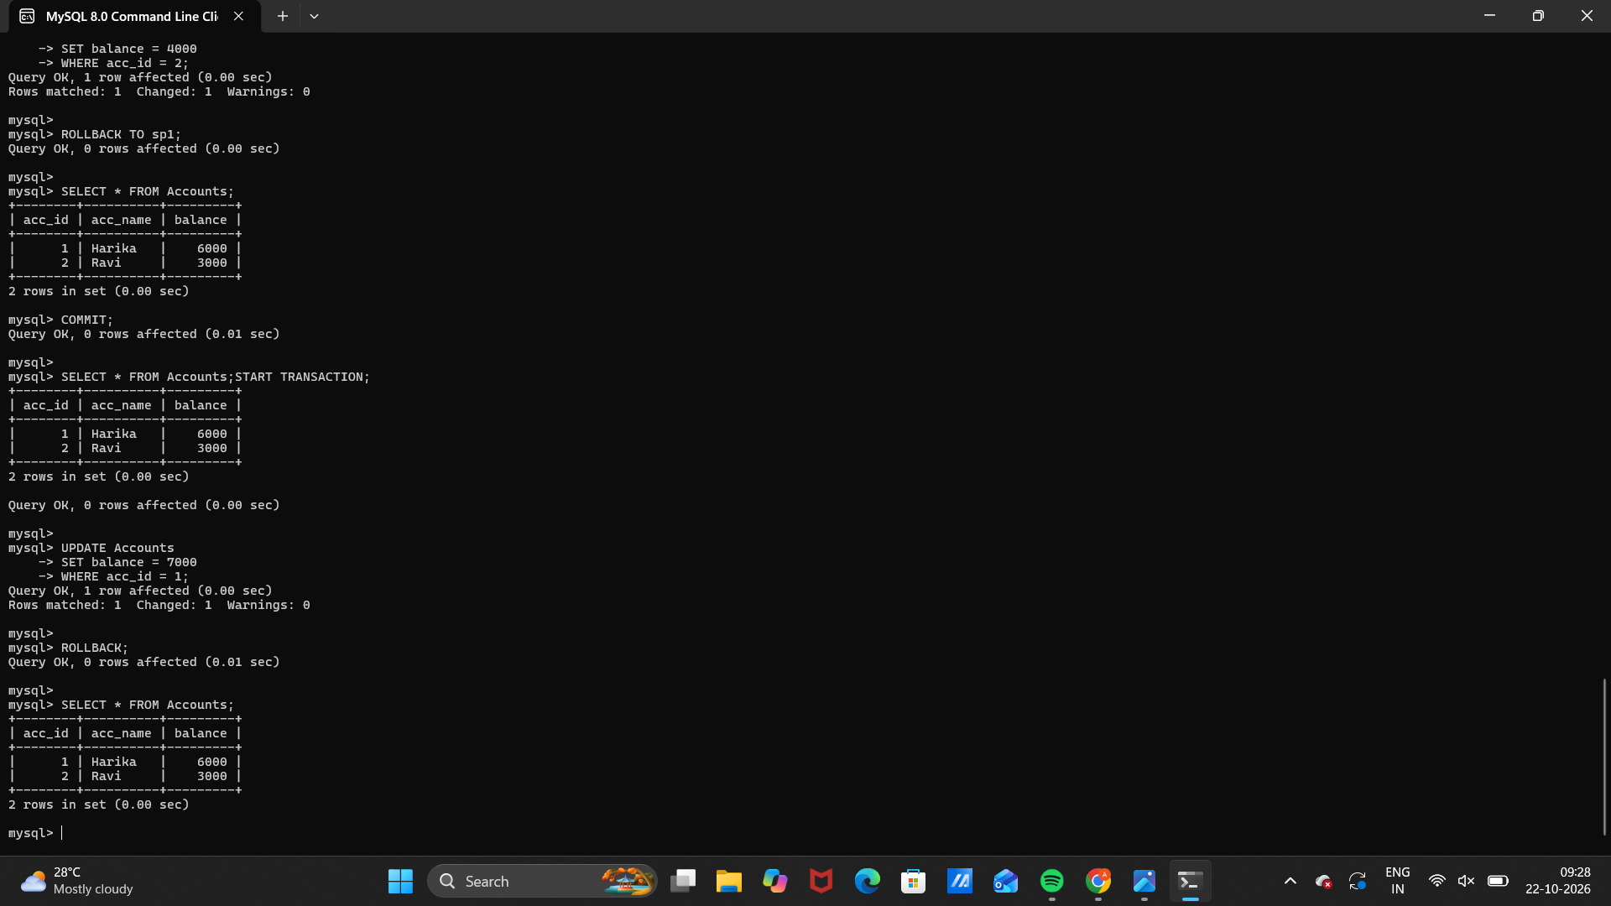Observation
Execute the SQL statements in MySQL 8.0 Command Line Client. Verify that each statement runs successfully and that the displayed rows match the inserted sample data and query conditions.
Note: The table uses InnoDB so transactions are supported. Run the statements in order and capture output after each SELECT.

Result
Thus, Experiment 5 (TCL Commands: COMMIT, SAVEPOINT and ROLLBACK) was performed using MySQL 8.0.

SQL LAB RECORD

