EXPERIMENT 6
DCL Commands: GRANT and REVOKE

Aim: To grant and revoke database privileges for a MySQL user.
Software Required: MySQL 8.0 Command Line Client

SQL Program
USE SQL_Lab;

CREATE USER 'labuser'@'localhost'
IDENTIFIED BY 'Lab@12345';

GRANT SELECT, INSERT
ON SQL_Lab.*
TO 'labuser'@'localhost';

SHOW GRANTS FOR 'labuser'@'localhost';

REVOKE INSERT
ON SQL_Lab.*
FROM 'labuser'@'localhost';

SHOW GRANTS FOR 'labuser'@'localhost';

Expected Output 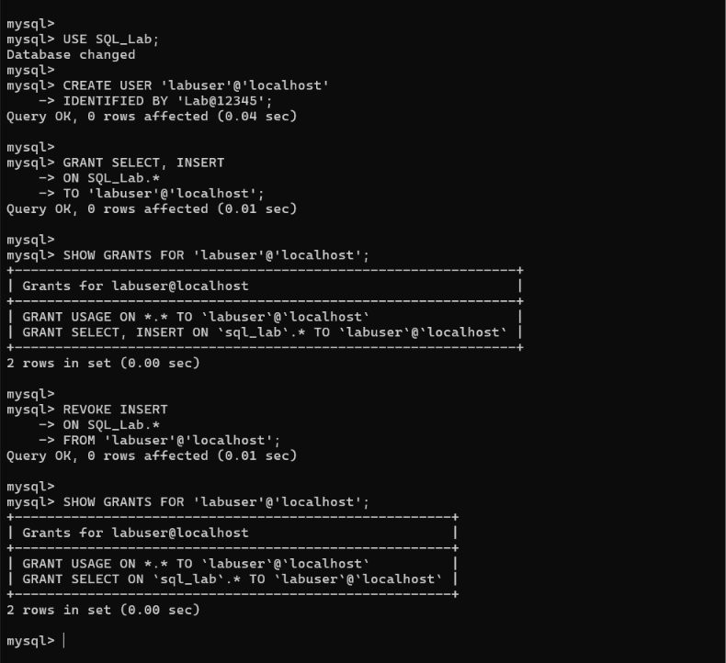Observation
Execute the SQL statements in MySQL 8.0 Command Line Client. Verify that each statement runs successfully and that the displayed rows match the inserted sample data and query conditions.
Note: Creating users and changing privileges requires an account with suitable administrative permissions. If labuser already exists, skip CREATE USER. Avoid using a real or reused password in a shared submission.

Result
Thus, Experiment 6 (DCL Commands: GRANT and REVOKE) was performed using MySQL 8.0.

SQL LAB RECORD

