EXPERIMENT 7
SELECT with WHERE and Pattern Matching

Aim: To filter records using WHERE and perform pattern matching using LIKE.
Software Required: MySQL 8.0 Command Line Client

SQL Program
USE SQL_Lab;

CREATE TABLE Students (
student_id INT PRIMARY KEY,
student_name VARCHAR(50),
department VARCHAR(20),
marks INT
);

INSERT INTO Students VALUES
(1, 'Harika', 'CSE', 85),
(2, 'Ravi', 'ECE', 72),
(3, 'Priya', 'CSE', 90),
(4, 'Kiran', 'EEE', 65),
(5, 'Hari', 'ECE', 78);

SELECT * FROM Students;

SELECT * FROM Students
WHERE marks > 75;

SELECT * FROM Students
WHERE student_name LIKE 'H%';

SELECT * FROM Students
WHERE student_name LIKE '%i';

SELECT * FROM Students
WHERE student_name LIKE '%ar%';

Expected Output 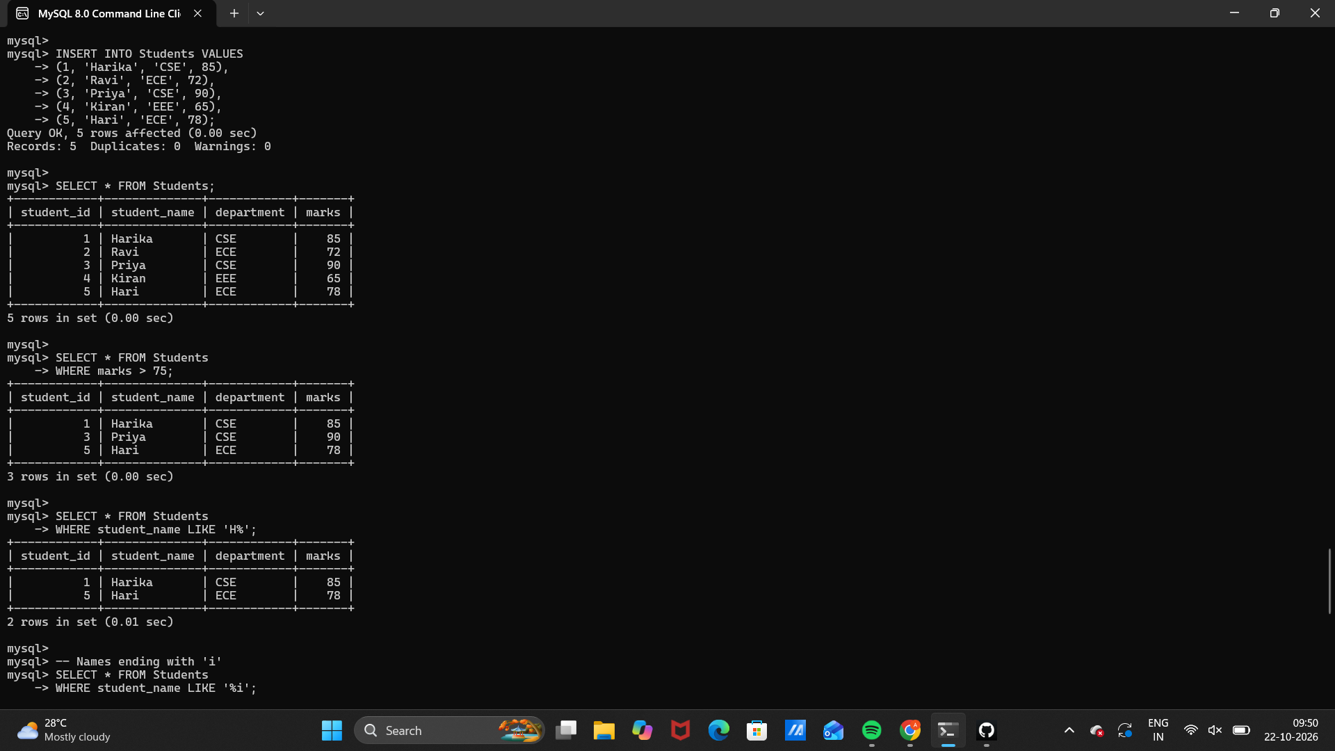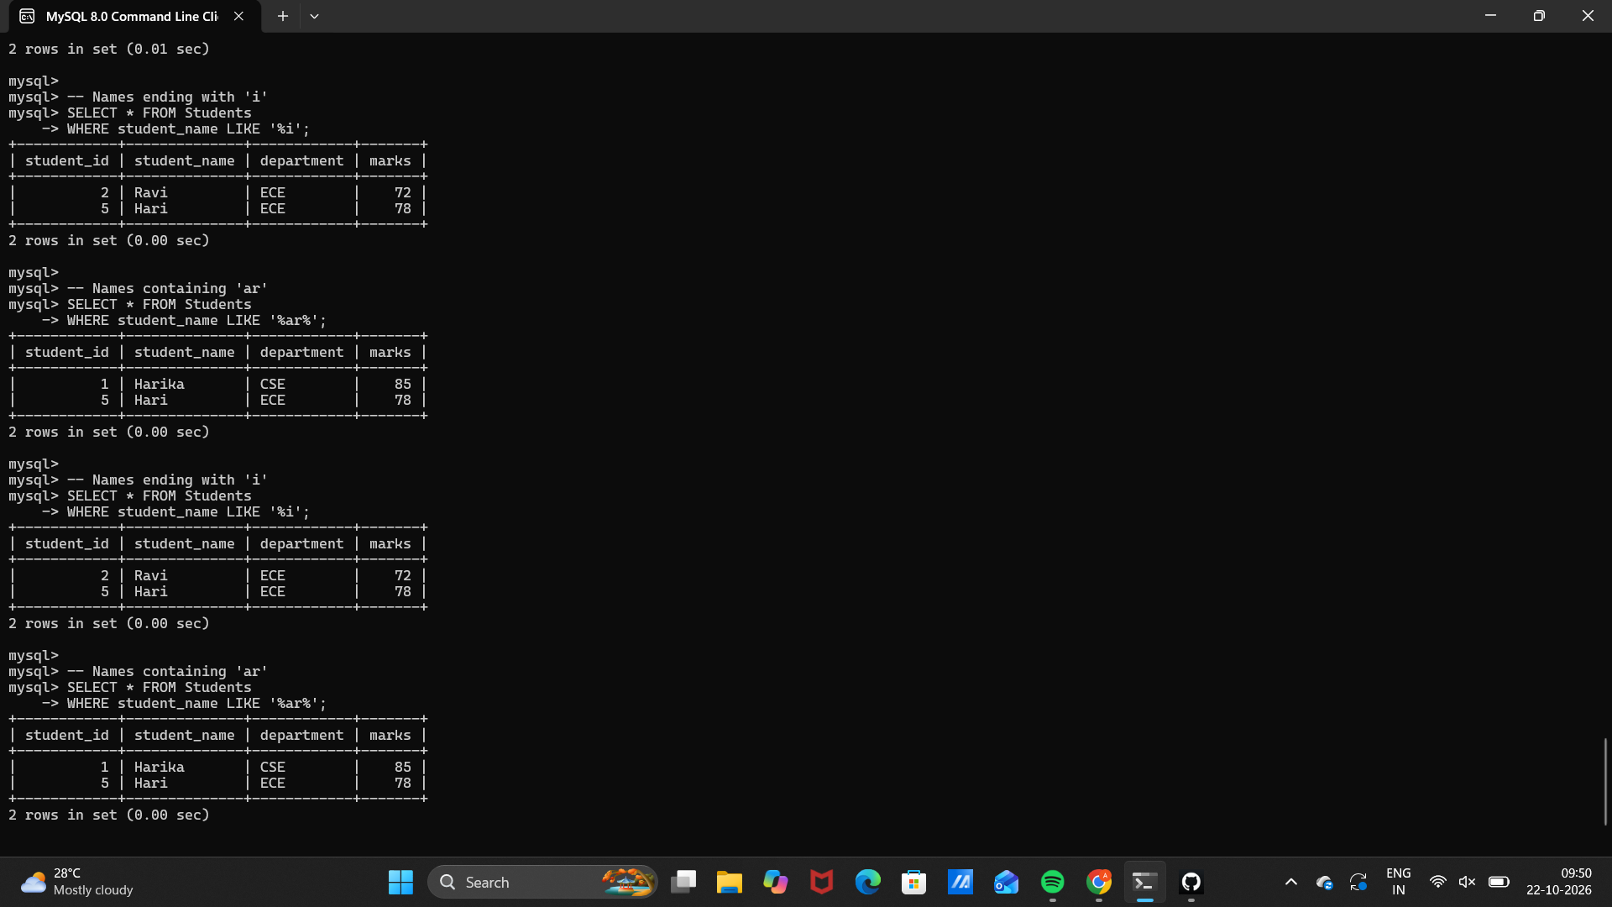

Observation
Execute the SQL statements in MySQL 8.0 Command Line Client. Verify that each statement runs successfully and that the displayed rows match the inserted sample data and query conditions.
Note: In LIKE patterns, % matches zero or more characters and _ matches exactly one character.

Result
Thus, Experiment 7 (SELECT with WHERE and Pattern Matching) was performed using MySQL 8.0.

SQL LAB RECORD

