EXPERIMENT 11
Joins: EquiJoin, INNER JOIN and OUTER JOIN

Aim: To retrieve related records from two tables using different join types.
Software Required: MySQL 8.0 Command Line Client

SQL Program
USE SQL_Lab;

CREATE TABLE Departments (
dept_id INT PRIMARY KEY,
dept_name VARCHAR(30)
);

CREATE TABLE Employees_Join (
emp_id INT PRIMARY KEY,
emp_name VARCHAR(50),
dept_id INT
);

INSERT INTO Departments VALUES
(1, 'CSE'),
(2, 'ECE'),
(3, 'EEE');

INSERT INTO Employees_Join VALUES
(101, 'Harika', 1),
(102, 'Ravi', 2),
(103, 'Priya', 1),
(104, 'Kiran', 4);

-- EquiJoin
SELECT e.emp_id, e.emp_name, d.dept_name
FROM Employees_Join e, Departments d
WHERE e.dept_id = d.dept_id;

-- INNER JOIN
SELECT e.emp_id, e.emp_name, d.dept_name
FROM Employees_Join e
INNER JOIN Departments d
ON e.dept_id = d.dept_id;

-- LEFT OUTER JOIN
SELECT e.emp_id, e.emp_name, d.dept_name
FROM Employees_Join e
LEFT OUTER JOIN Departments d
ON e.dept_id = d.dept_id;

-- RIGHT OUTER JOIN
SELECT e.emp_id, e.emp_name, d.dept_name
FROM Employees_Join e
RIGHT OUTER JOIN Departments d
ON e.dept_id = d.dept_id;

Expected Output

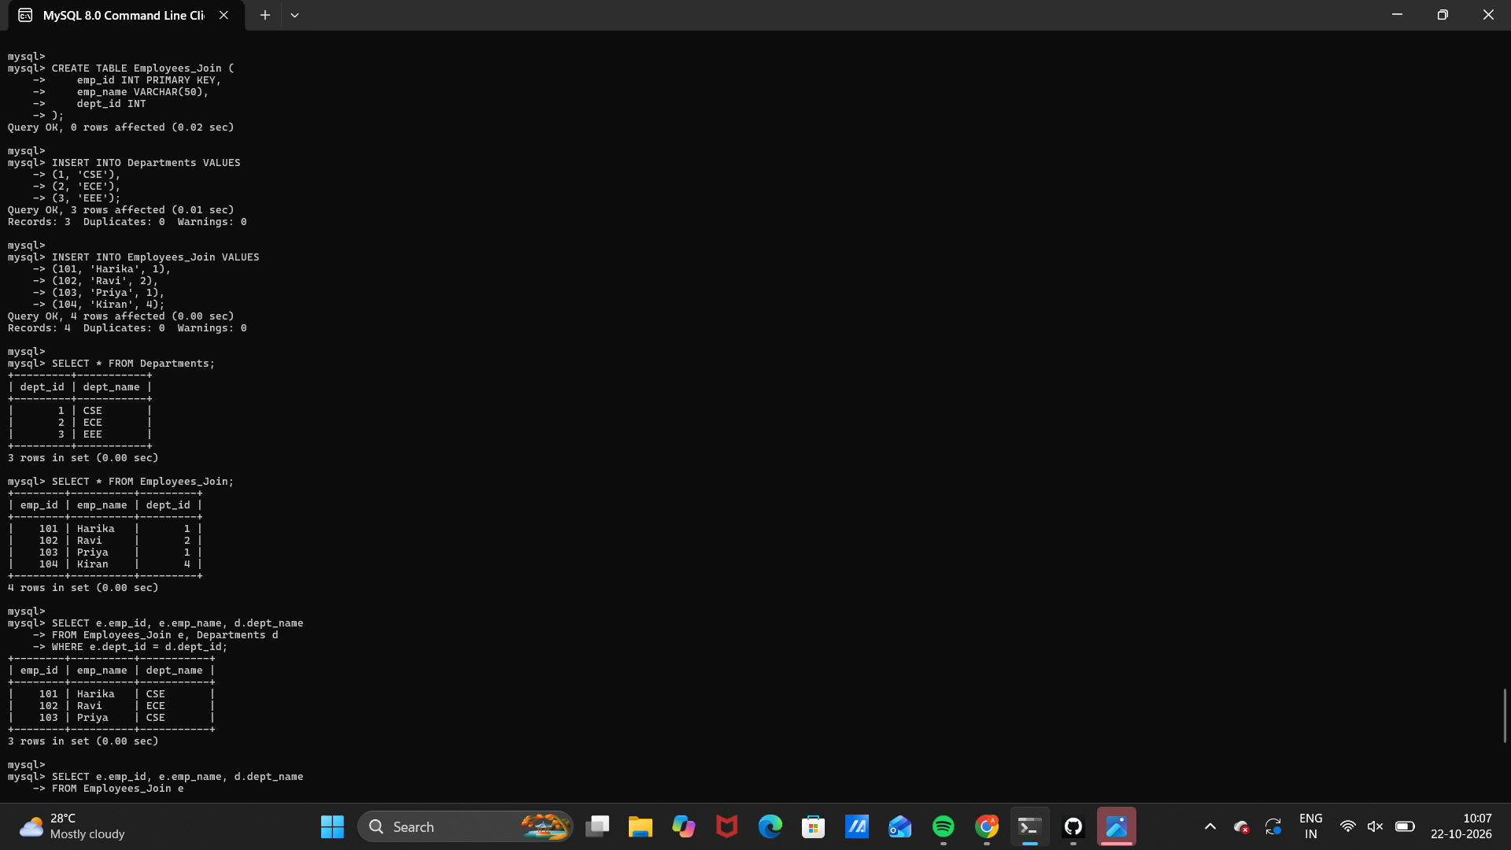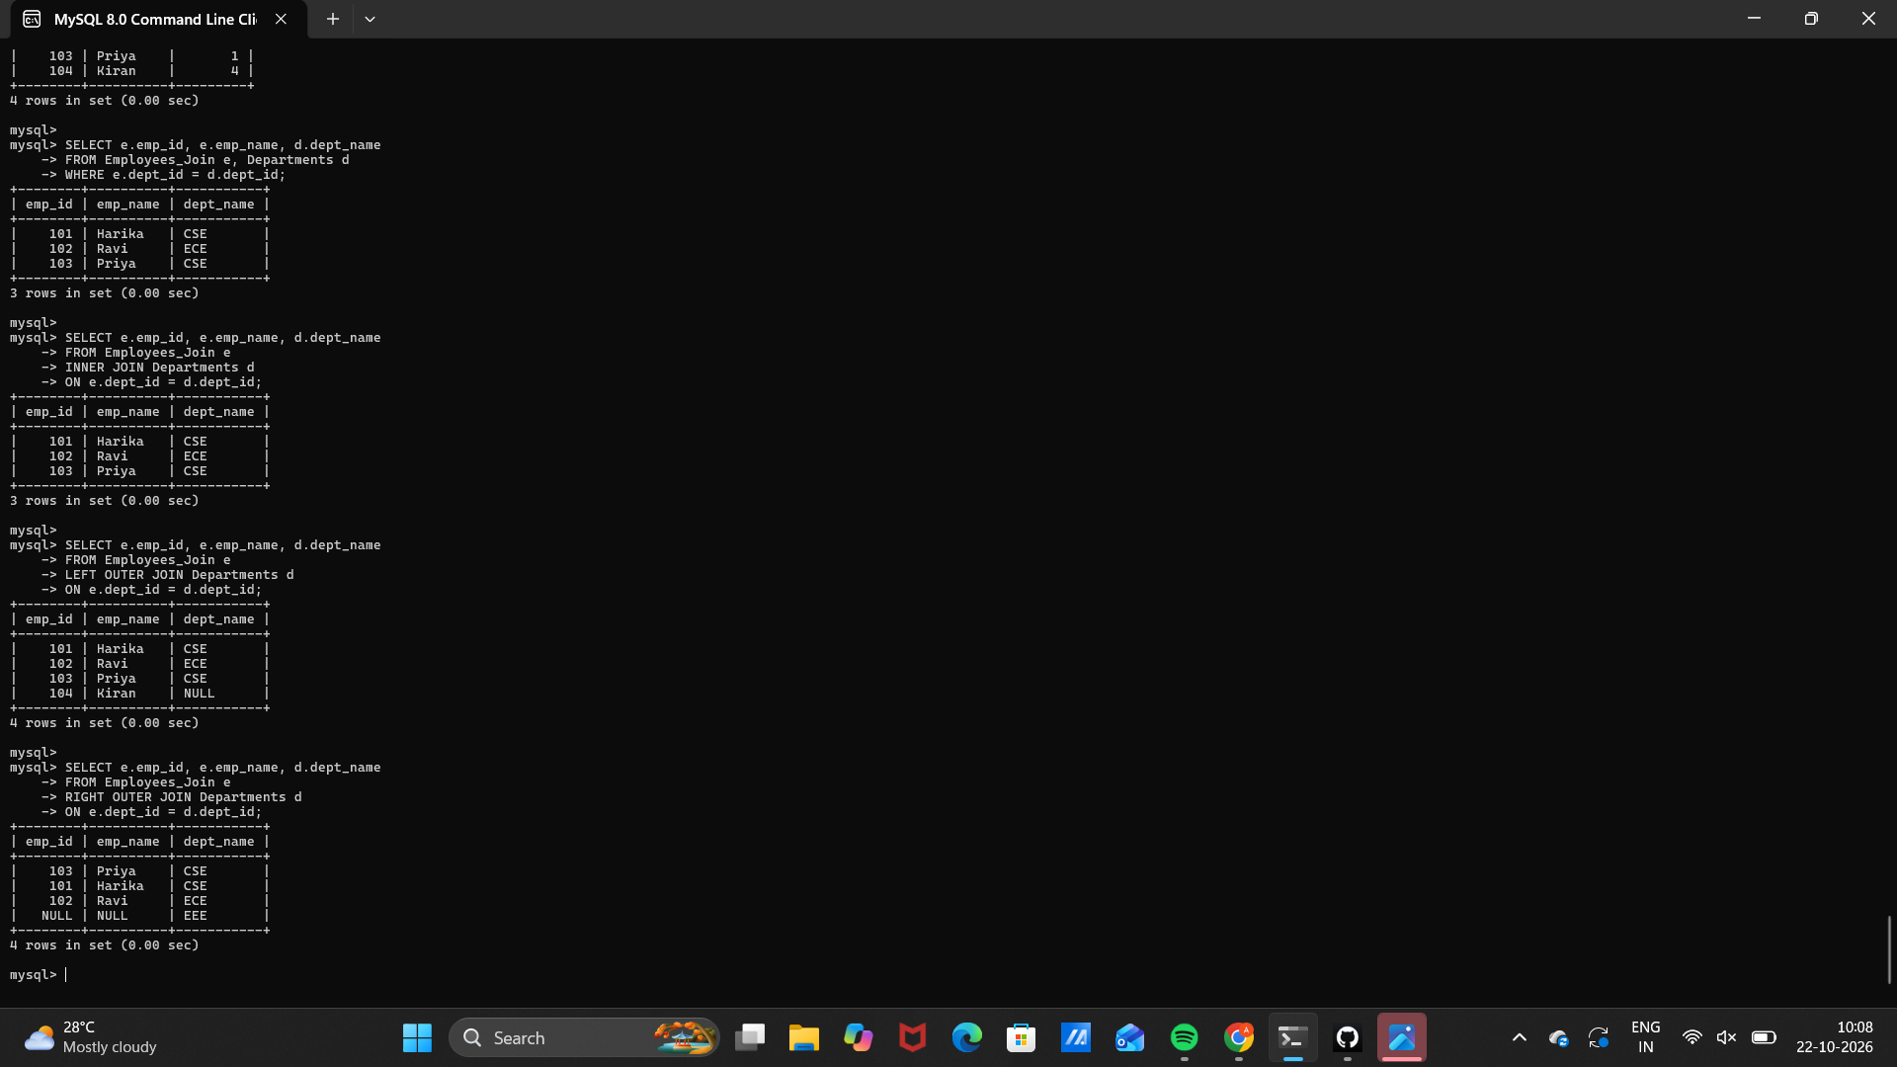 Observation
Execute the SQL statements in MySQL 8.0 Command Line Client. Verify that each statement runs successfully and that the displayed rows match the inserted sample data and query conditions.
Note: MySQL supports LEFT and RIGHT OUTER JOIN. The OUTER keyword is optional. The sample includes an employee with a missing department and a department with no employees.

Result
Thus, Experiment 11 (Joins: EquiJoin, INNER JOIN and OUTER JOIN) was performed using MySQL 8.0.

SQL LAB RECORD

