EXPERIMENT 12
VIEW and INDEX

Aim: To create a view and an index and use them in queries.
Software Required: MySQL 8.0 Command Line Client

SQL Program
USE SQL_Lab;

CREATE VIEW Employee_View AS
SELECT emp_id, emp_name, dept_id
FROM Employees_Join;

SELECT * FROM Employee_View;

CREATE INDEX idx_emp_name
ON Employees_Join(emp_name);

SHOW INDEX FROM Employees_Join;

SELECT * FROM Employee_View
WHERE dept_id = 1;

Expected Output

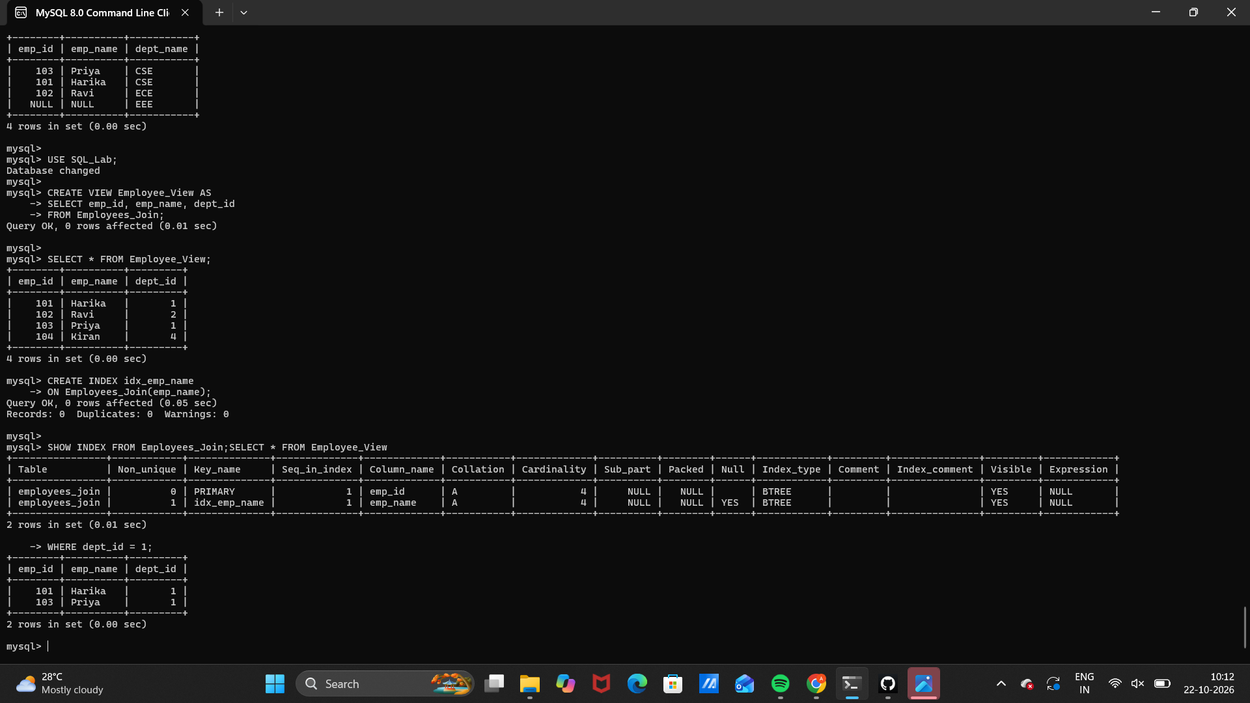 Observation
Execute the SQL statements in MySQL 8.0 Command Line Client. Verify that each statement runs successfully and that the displayed rows match the inserted sample data and query conditions.
Note: This experiment uses Employees_Join from Experiment 11. Run Experiment 11 first if the table does not exist. If Employee_View already exists, drop it before recreating it.

Result
Thus, Experiment 12 (VIEW and INDEX) was performed using MySQL 8.0.

SQL LAB RECORD

