EXPERIMENT 14
WHILE and REPEAT Loops

Aim: To demonstrate WHILE and REPEAT loops in MySQL stored procedures.
Software Required: MySQL 8.0 Command Line Client

SQL Program
USE SQL_Lab;

DROP PROCEDURE IF EXISTS WhileExample;
DELIMITER //

CREATE PROCEDURE WhileExample()
BEGIN
DECLARE i INT DEFAULT 1;

WHILE i <= 5 DO
SELECT i;
SET i = i + 1;
END WHILE;
END //

DELIMITER ;

CALL WhileExample();

DROP PROCEDURE IF EXISTS RepeatExample;
DELIMITER //

CREATE PROCEDURE RepeatExample()
BEGIN
DECLARE i INT DEFAULT 1;

REPEAT
SELECT i;
SET i = i + 1;
UNTIL i > 5
END REPEAT;
END //

DELIMITER ;

CALL RepeatExample();

Expected Output

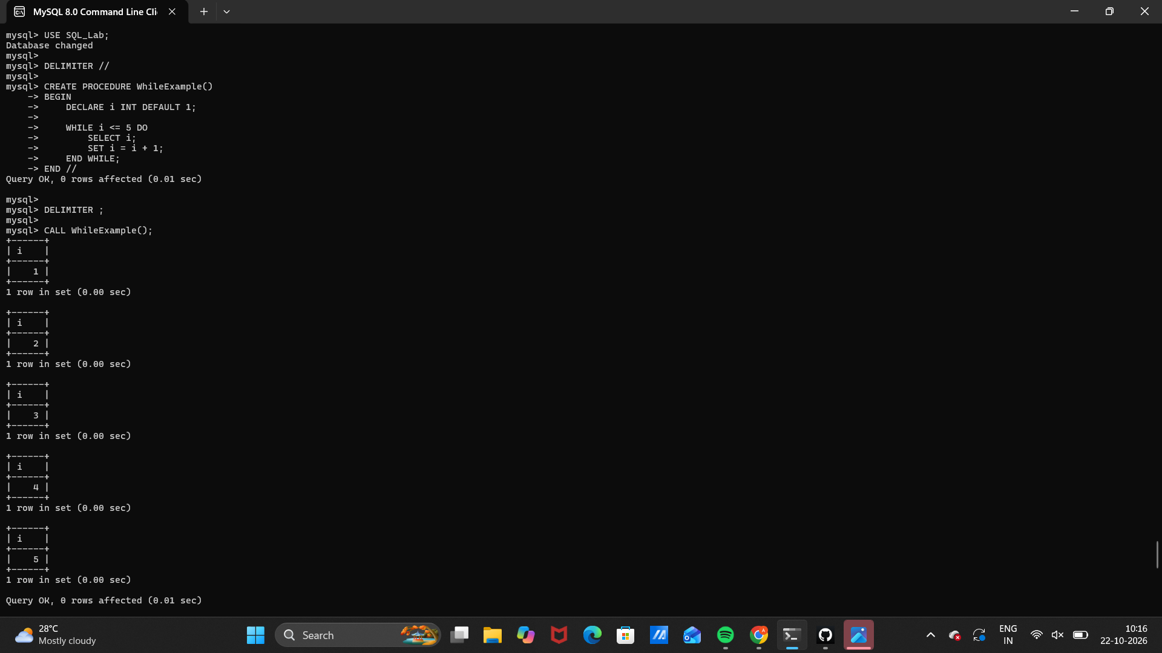 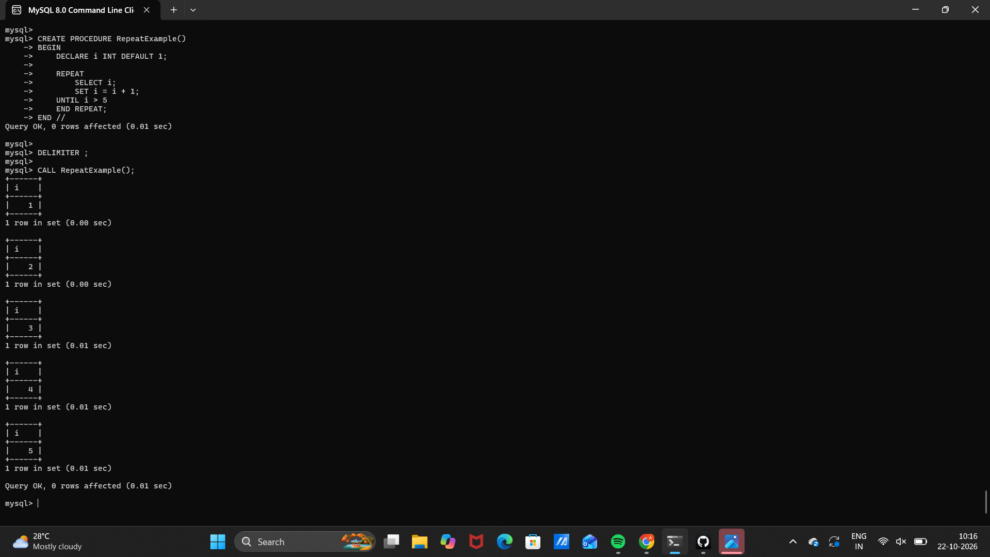Observation
Execute the SQL statements in MySQL 8.0 Command Line Client. Verify that each statement runs successfully and that the displayed rows match the inserted sample data and query conditions.
Note: If a procedure already exists, run DROP PROCEDURE IF EXISTS for that procedure before recreating it.

Result
Thus, Experiment 14 (WHILE and REPEAT Loops) was performed using MySQL 8.0.

SQL LAB RECORD

