EXPERIMENT 15
CASE and LOOP

Aim: To use the CASE expression for grading and LOOP control in a stored procedure.
Software Required: MySQL 8.0 Command Line Client

SQL Program
USE SQL_Lab;

SELECT
student_name,
marks,
CASE
WHEN marks >= 90 THEN 'Excellent'
WHEN marks >= 75 THEN 'Good'
WHEN marks >= 60 THEN 'Average'
ELSE 'Fail'
END AS Grade
FROM Students;

DROP PROCEDURE IF EXISTS LoopExample;
DELIMITER //

CREATE PROCEDURE LoopExample()
BEGIN
DECLARE i INT DEFAULT 1;

my_loop: LOOP
SELECT i;
SET i = i + 1;

IF i > 5 THEN
LEAVE my_loop;
END IF;
END LOOP;
END //

DELIMITER ;

CALL LoopExample();

Expected Output 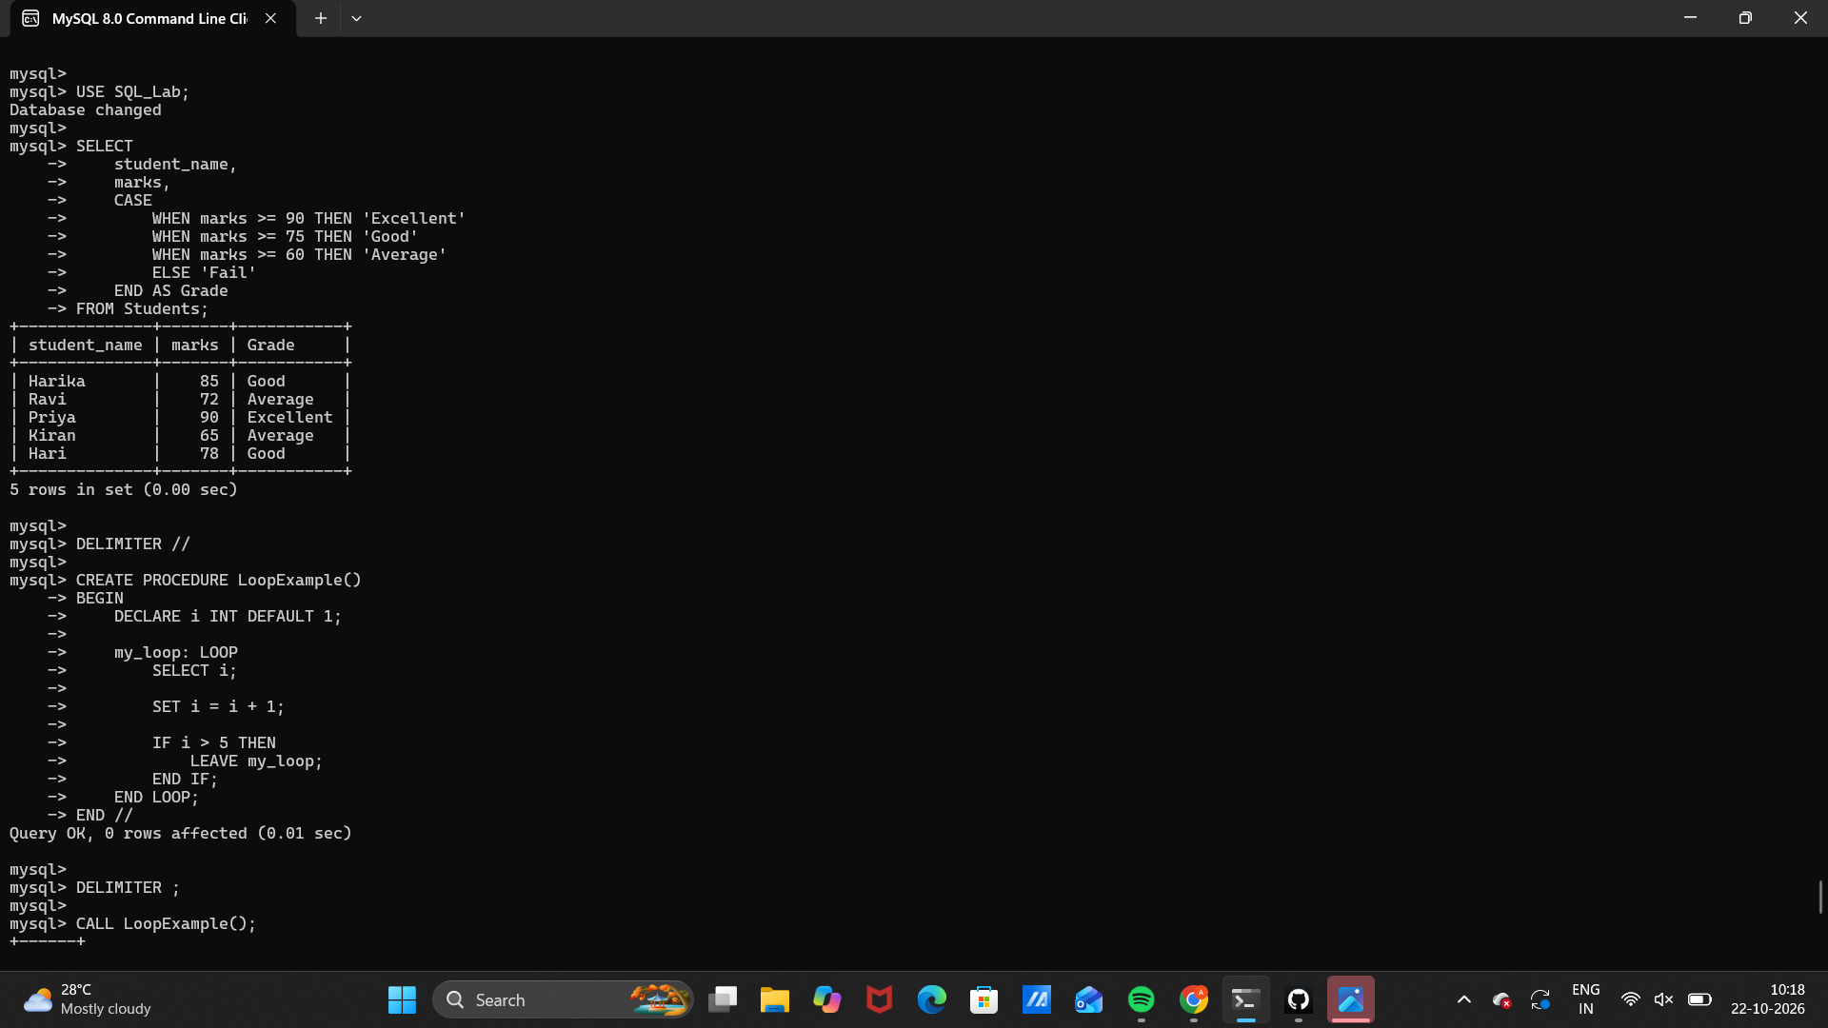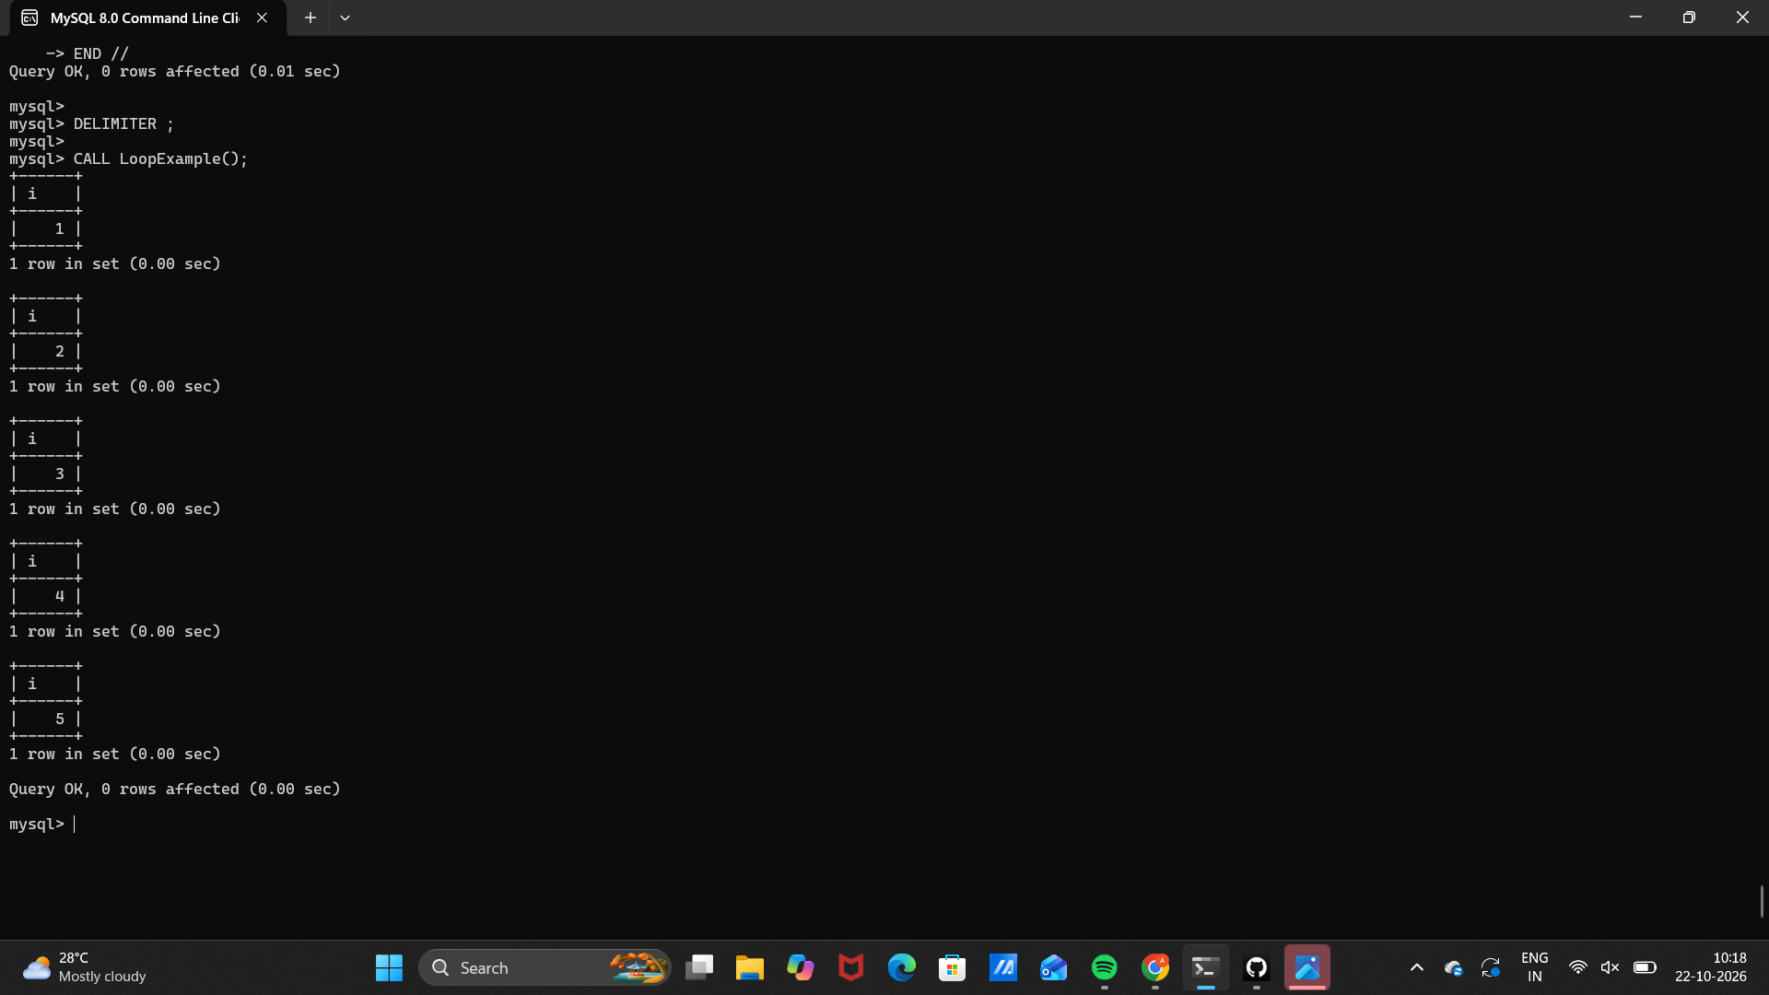 Observation
Execute the SQL statements in MySQL 8.0 Command Line Client. Verify that each statement runs successfully and that the displayed rows match the inserted sample data and query conditions.
Note: The CASE query uses Students from Experiment 7. Run Experiment 7 first if the table does not exist.

Result
Thus, Experiment 15 (CASE and LOOP) was performed using MySQL 8.0.

SQL LAB RECORD

