### **Project Report**

**Course:** CO2214: Practical Work on CO2224  
 **Group Name/Number:** Group Name - 9  
 **Student IDs:** EUSL/TC/IS/2021/COM/10  
 EUSL/TC/IS/2021/COM/62  
 EUSL/TC/IS/2021/COM/50  
 EUSL/TC/IS/2021/COM/89  
 EUSL/TC/IS/2021/COM/92  
 EUSL/TC/IS/2020/COM/106

### **1. Project Overview**

**Project Title:** Modify UI of the Sri Lankan Railway Website for Mobile  
 **Project Type:** Website  
 **Domain:** Transportation  
 **Brief Description:** The goal of this project is to enhance the mobile usability of the Sri Lankan Railway website by redesigning its user interface to be more responsive and user-friendly. The current website has several usability and accessibility issues, particularly for mobile users, which will be addressed in this redesign.  
 **Target Users:** General public of Sri Lanka, including train commuters, tourists, and anyone needing to access railway schedules, bookings, and related services.

### **2. Identification of Existing Design Flaws & Gaps**

#### **2.1 Evaluation Criteria (HCI Issues)**

1. **Small and Unreadable Text**
   * **Problem:** The text on the website is too small, making it difficult for users to read, particularly on mobile devices or for users with visual impairments.
   * **Impact:** Poor readability affects comprehension, causing frustration and limiting accessibility.
   * **Possible Solutions:**
     + Use scalable fonts that adjust to screen size.
     + Increase default font size for better legibility.
2. **Poor Alignment and Inconsistent Spacing**
   * **Problem:** Misaligned text, images, and UI elements, combined with inconsistent spacing, create a disorganized layout.
   * **Impact:** The visual clutter detracts from the user experience and complicates navigation.
   * **Possible Solutions:**
     + Apply consistent margins and padding to create a clean and structured layout.
     + Use a grid system to align elements properly.
3. **Non-Responsive Layout Leading to Content Overflow**
   * **Problem:** The website layout does not adapt to different screen sizes, especially on mobile, leading to content overflow.
   * **Impact:** Mobile users experience cut-off content or have to scroll horizontally, reducing usability.
   * **Possible Solutions:**
     + Implement responsive design techniques using CSS media queries to ensure layout adjusts to all screen sizes.
     + Use flexible grid systems and relative units (e.g., percentages, rems).

#### **2.2 Usability Issues Identified**

* Small and unreadable text
* Poor alignment and inconsistent spacing
* Non-responsive layout leading to content overflow

#### 

#### **2.3 User Experience Problems**

* Complicated navigation structure
* No clear visual hierarchy in content
* Accessibility issues (e.g., low contrast, small clickable areas)

#### **2.4 Screenshots & Examples**

1. **Empty side spaces:** The content is not full-width, leaving too much empty space on mobile screens.

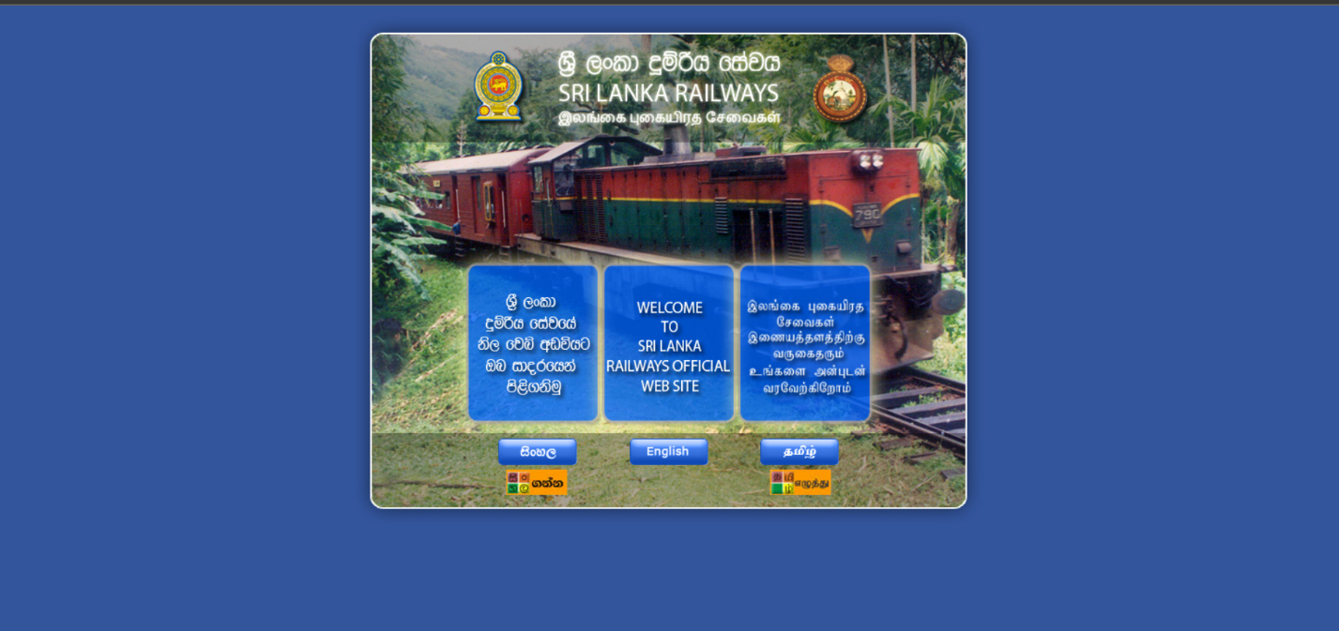

1. **Unsuitable Links and Menus:** Links are not clearly differentiated, making it difficult to navigate.



1. **No zoom in/out functionality:** Interaction is not intuitive on the map interface.





1. **Small and hidden search bar:** Hard to find and use on mobile.



1. **Non-interactive map:** The map of Sri Lanka is static and confusing for users.

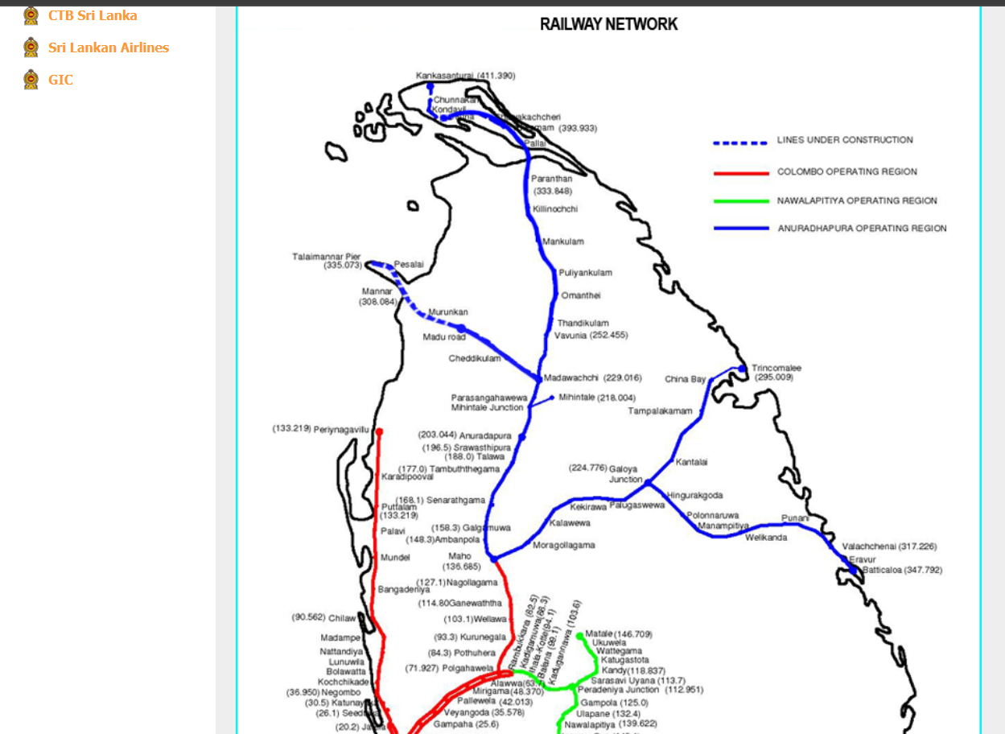

1. **Inconsistent font sizes and spacing:** The font sizes and line spacing are inconsistent, especially between Sinhala and English versions.

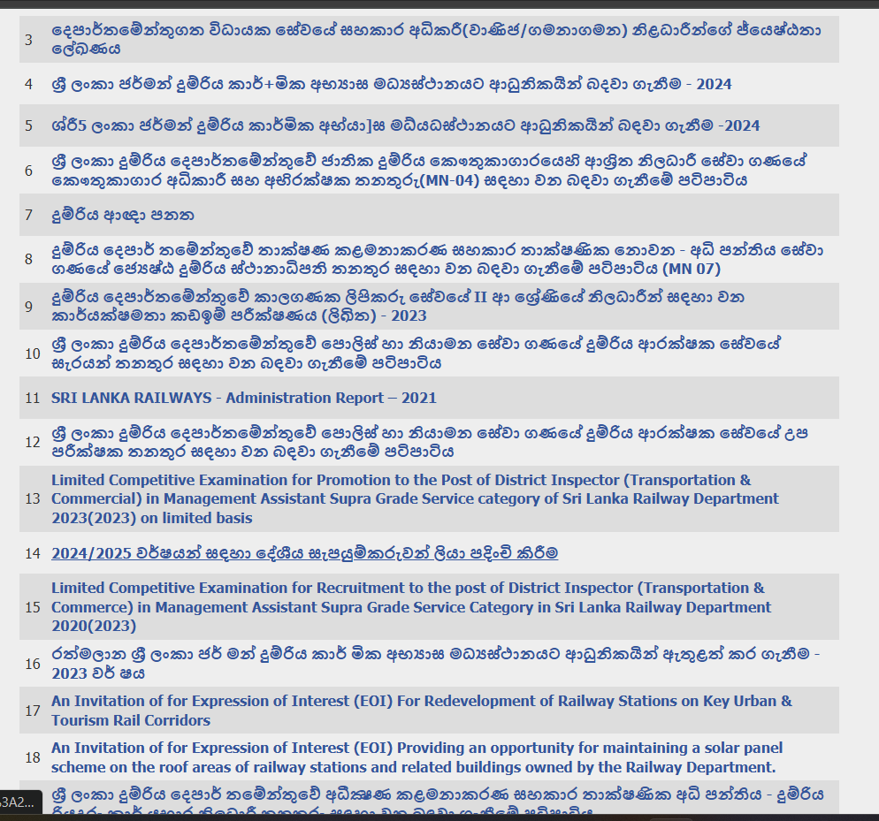

### **3. HCI-Based Design Improvement Suggestions**

#### **3.1 Proposed Improvements**

* **Text Readability:**
  + Increase font sizes and make them scalable.
  + Ensure text is legible on both mobile and desktop screens.
* **Layout and Spacing:**
  + Use consistent alignment and spacing.
  + Apply a flexible grid system to optimize content display.
* **Navigation and Interactivity:**
  + Simplify the navigation structure (e.g., use a hamburger menu).
  + Make buttons and links more distinguishable and touch-friendly.
* **Mobile-First Design:**
  + Optimize the layout for smaller screens and ensure elements are responsive.
  + Use mobile-friendly navigation features like a bottom navigation bar.

#### **3.2 Recommended Usability Fixes**

* **Consistency:**
  + Ensure all UI elements, fonts, and buttons are consistently styled.
* **Feedback:**
  + Implement feedback for user actions (e.g., loading animations, form submission status).

#### **3.3 Accessibility Improvements**

* **Color Contrast:**
  + Use high-contrast color schemes to enhance readability.
  + Avoid excessive use of bright or clashing colors.
* **Font Sizes:**
  + Increase and standardize text size, ensuring readability across all devices.

#### **3.4 Interaction Improvements**

* **Navigation:**
  + Improve the navigation structure by reducing complexity and improving the visual hierarchy.
* **Interactive Map:**
  + Replace the static map with an interactive one that allows users to click and view train routes.

### **4. Redesigned Prototype in Figma**

#### **4.1 Overview of the New Design**

* The redesigned version follows HCI principles of usability, accessibility, and interaction design. The new layout is fully responsive and optimized for mobile use, with improved text readability, intuitive navigation, and clear visual hierarchy.

#### **4.2 Wireframes & Mockups**

* [Insert screenshots of Figma wireframes and mockups of the redesigned UI.]

#### **4.3 User Flow Diagram**

* [Include a diagram showing how users interact with the new version of the website, illustrating the flow from one screen to the next.]

#### **4.4 Prototyping Features Used in Figma**

* Used interactive components like buttons, drop-downs, and feedback mechanisms (e.g., loading animations and tooltips).

### **5. Evaluation & Testing**

#### **5.1 Usability Testing Plan**

* The redesigned website will be tested with real users using tasks like booking tickets and searching for train schedules. User feedback will be collected through surveys and usability testing sessions.

#### **5.2 Expected Outcomes**

* The new design is expected to improve user navigation, increase readability, and enhance overall user satisfaction, particularly on mobile devices.

#### **5.3 Limitations & Future Improvements**

* Future improvements may include performance optimization (e.g., image compression) and additional features like real-time train tracking.

### **6. Conclusion**

#### **6.1 Final Thoughts on the Redesign**

* The project demonstrates how applying HCI principles can improve the usability and accessibility of a digital product. By focusing on user-centered design and responsive layout, the redesigned website provides a better experience for Sri Lankan Railway users.

#### **6.2 How HCI Theory Helped**

* The redesign was guided by principles from Alan Dix’s HCI book, including usability, consistency, feedback, and visibility. These principles helped identify key issues and guided improvements.

#### **6.3 Lessons Learned**

* The importance of considering all types of users (including those with disabilities) and optimizing interfaces for mobile devices were key takeaways from this project.

### **7. References**

* Alan Dix, et al., *Human-Computer Interaction*, 3rd Edition.
* Additional references if applicable.

### **8. Contribution**

| Team members | Contribution |
| --- | --- |
| 2021COM89 | * Create google form and report * Make some pages(mapping,front ) |
| 2020COM106 | * Make some pages(mapping) |
| 2021COM10 | * Make some pages * report |
| 2021COM50 | * Make some pages * Vidieo editing |
| 2021COM62 | * Make some pages * Video editing |
| 2021COM92 | * Make some pages * Presentation slide |

* **Appendices (If applicable):**
  + User Feedback Surveys (if usability tests were conducted)
  + Additional Design Mockups (alternative design approaches explored in Figma)

This version aligns with the template while organizing your project information clearly. You can add screenshots, wireframes, and user feedback where indicated.