High Performance Gene Level Presence/Absence (PA-call) for RNA-Seq

Why Presence/Absence call in transcriptome (RNA-seq):

A core issue in molecular biology is to identify the genes that are expressed in a cell and to measure their expression levels. The expression level of a gene or transcript is a way to characterize its function. For a limited number of genes this can be measured through methods such as northern blotting, PCR, q-PCR, or rt-PCR. However, in genome-wide experiments the gene expression is traditionally measured using high throughput techniques such as microarray, and recently RNA sequencing (RNA-Seq). RNA-Seq has proved to be a better technology because it allows for the discovery of novel transcripts. It has been successfully applied in the study of cancer, host-pathogen interactions, neurodegenerative diseases, and neuropsychiatric diseases¹.

Gene expression is tissue specific, i.e. not all genes are expressed in every tissue. Therefore, the analytics software must be able to determine which genes are expressed (present) and not expressed (absent) in the tissue of interest using the experiment data. In order to do this, it must be able to identify and eliminate the noise in the expression values. In microarray experiments, probes are designed based on the knowledge of the nucleotide sequence of a gene. Gene level presence/absence calls in microarrays can be made using the negative probesets (no hybridization) and cut-offs generated using p-values to eliminate the noise. In RNA-Seq there are no such probesets – the noise needs to be removed algorithmically. The presence/absence call algorithm (PA-call) that is part of the reference based RNA-Seq analysis of the iOMICS² software uses statistical techniques to discover the genes that are not expressed in the samples.

Key points:
We have considered the following key points while developing the algorithm (PA-call) for identification of presence/absence of genes in RNA-seq data,
- Parallel computing technique has been used to calculate the Reads Per Nucleotide (RPN) to reduce the time taken by many folds.
- PA-call works both on single sample (n = 1) and cohort data (n = N) of assembled RNA-seq data to identify the sample level presence/absence.
- Genes are also optionally annotated with tissue level baseline gene expression values from external databases.

The Statistics:
The RNA-Seq reads are aligned to the exonic regions (coding regions) of genes. The number of reads aligning to the exonic region of a gene is proportional to the expression level of the gene and the length of the exonic region. However, due to sequencing errors and the statistical nature of reference assembly, errors are incorporated into the read alignment process. This results in some leakage or spillover in the data. There will be a few reads which will align to genes purely by chance (noise). Similarly, there will also be some reads that will align to the intergenic regions by chance (noise). In order to identify the noise, PA-call uses the feature level Reads Per Nucleotide (RPN) statistic. RPN is defined as,

RPN = R/L where R is the number of reads in a region of length L nucleotides (1)

It may be noted that while, the read alignment by chance at a whole genome level is modeled using Poisson distribution, the RPN distribution is lognormal.

The RPN statistic is calculated for the genic as well as intergenic regions to identify the noise. PA-call models the exonic (collapsed to genic level) and non-coding/intergenic level RPN, and uses these to generate p-values for each gene and to obtain an RPN cut-off. Using this RPN cut-off, the sample level presence/absence of a gene is identified.
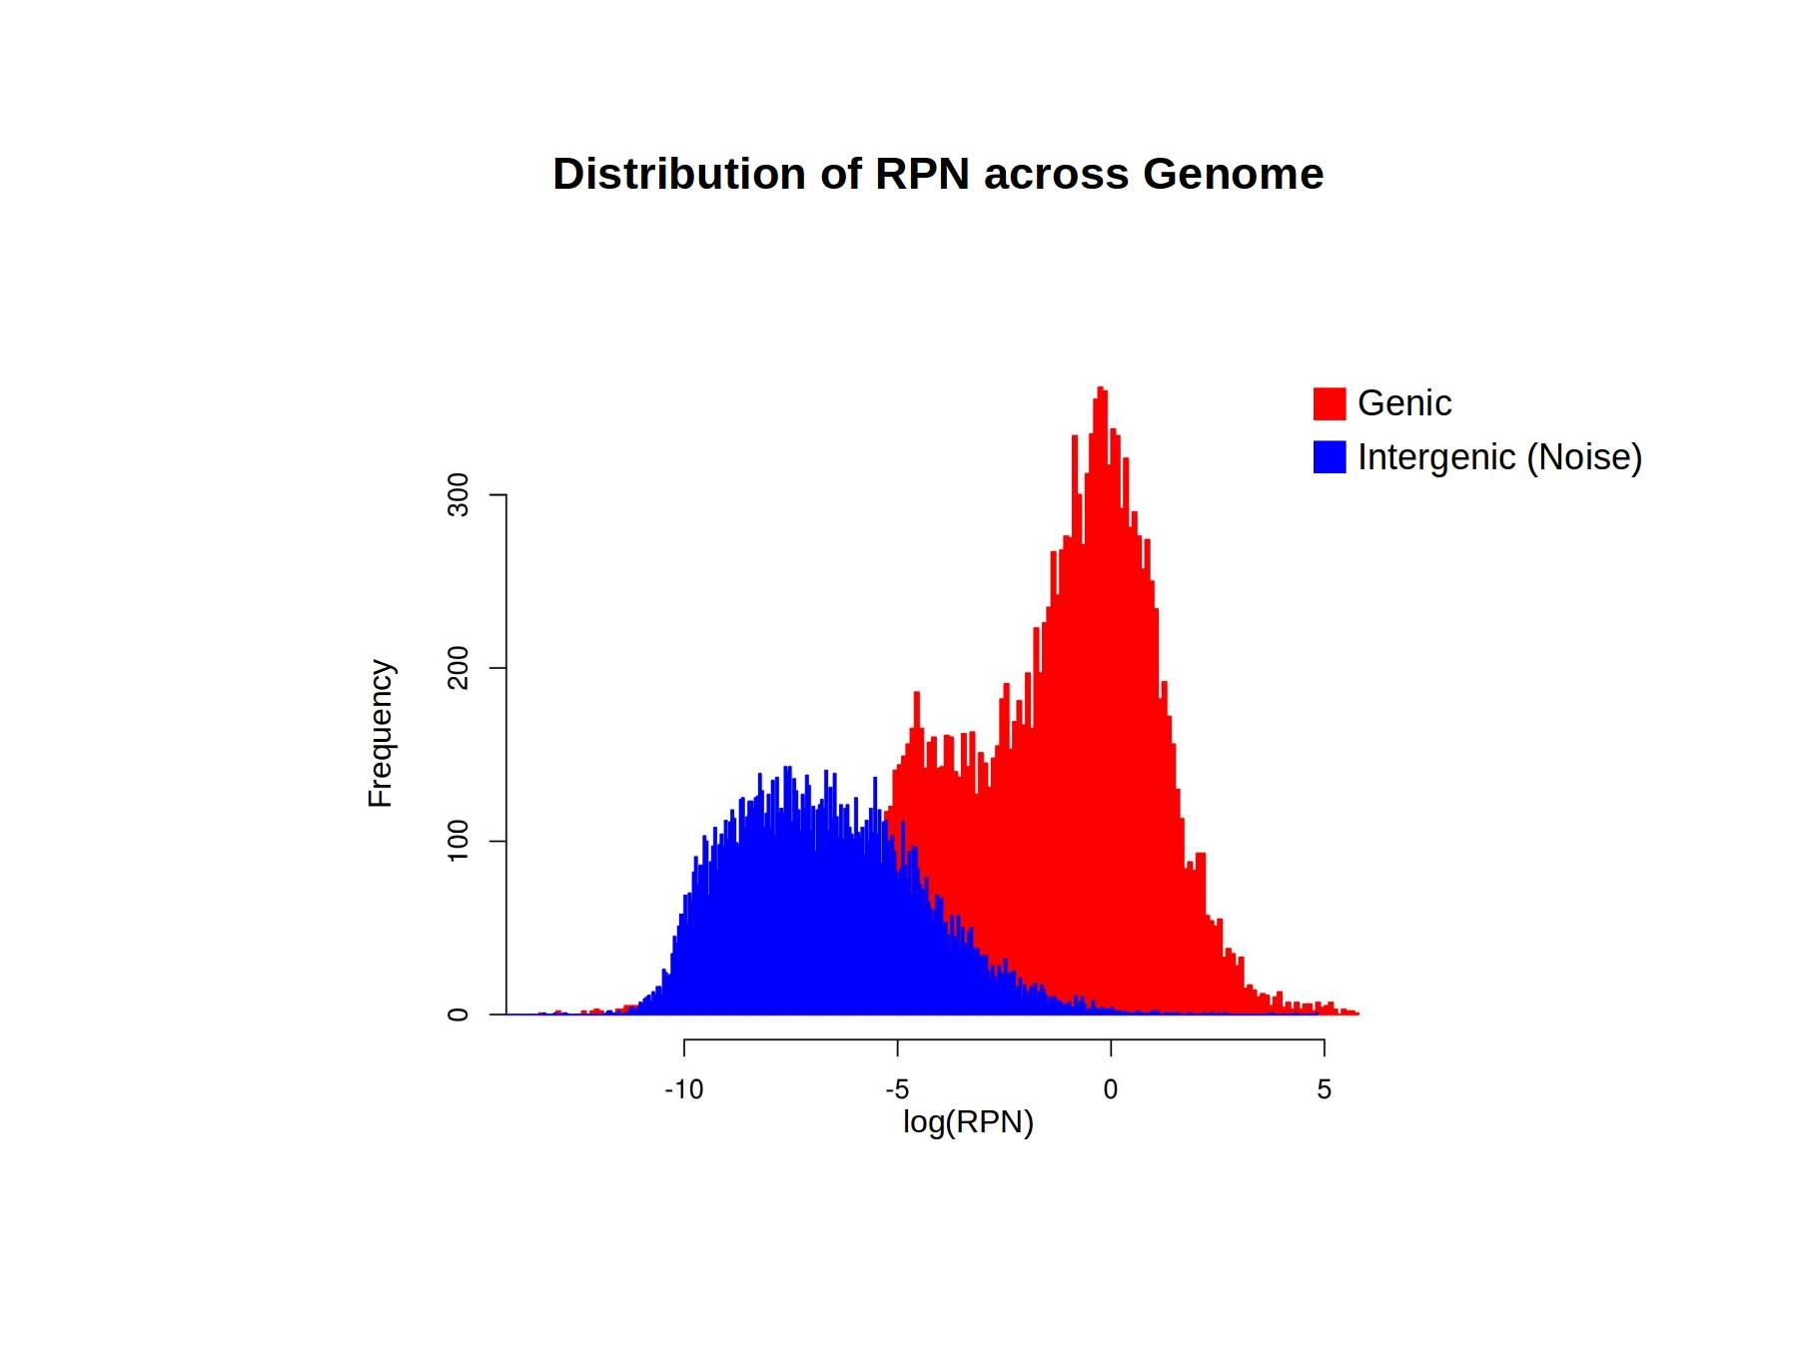

Figure 1: RPN distribution across the genome for genic and intergenic (noise)

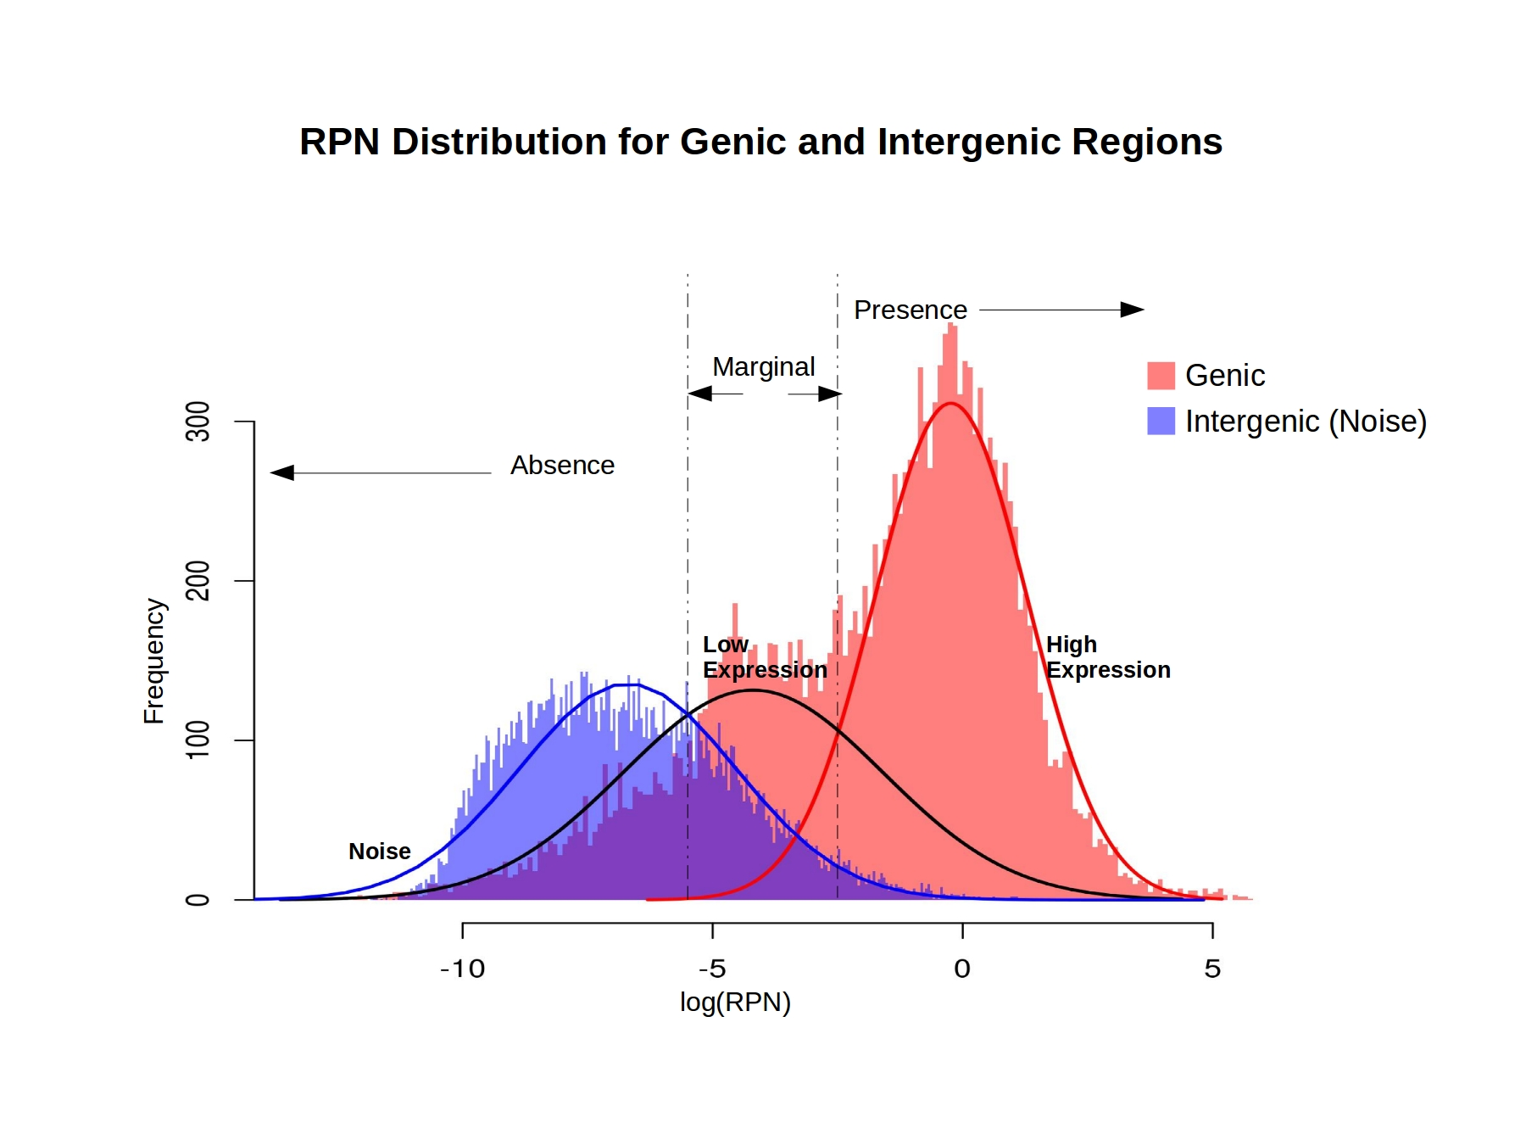

Figure 2: RPN distribution across the genome for genic and intergenic (noise) along with regions of Absence, Marginal, and Presence

Case-study:
In order to test and validate our PA-call algorithm, we have used 20 RNA-seq data of the lymphoblastoid cell lines generated by Lappalainen et. al.³ available from ArrayExpress (E-GEUV-1). The RPN statistical model for each sample resulted in two distributions, viz., genic (red) and intergenic(blue). We further deconstructed the genic distribution into two expression distributions and then using p-value cut offs, identified the gene level presence/absence for the sample. Figure 1 and Figure 2 show the distribution of log RPN for the genic and intergenic regions for the sample HG00096. Table 1 shows a few records from the final PA-call output for this example dataset. This table gives log(RPN), presence/absence call, and the call confidence. If the user specifies the tissue of origin of the RNA-Seq experiment, baseline gene expression (baseline FPKM) will also be extracted from Expression Atlas/Omnia⁴ as seen in the last column of Table 1.

Gene | log(RPN) | Sample PA call | Call Confidence  (1 - p) | Tissue Baseline (FPKM)
ACTL9 | -Inf | A | 1 | -
C140R64 | -10.2146419812 | A | 1 | -
ACTB | 5.7318105034 | P | 0.9999999902 | 3439
RPS29 | 3.7241632036 | P | 0.9999984735 | 63
MBD2 | 1.9461681249 | P | 0.9999332766 | 31
PARN | 0.7630505519 | P | 0.9994225476 | 14
CARD11 | 0.1472238208 | P | 0.9984111854 | 23
OR2T5 | -3.7027823593 | M | 0.8505041566 | 0.1
OR2T3 | -3.7802292327 | M | 0.8738975872 | 0.3
HIST1H3I | -3.8649313979 | M | 0.8996086247 | 0.2

Table 1: A Few records of output table showing the Gene Level Presence/Absence data from iOMICS PA-call along with the tissue level baseline expression

In the above table, “-Inf” in log(RPN) column represents that no reads aligned to the particular gene. Using the log(RPN) cut-off value obtained from the genic and intergenic distributions, Presence/Absence/Marginal calls are identified as shown in column 3. The confidence levels (ranging from 0-1) for these calls are given in the next column. The PA-call results can be compared with the tissue baseline expression values (Column 5) if the tissue of origin is provided by the user.

PA-call in iOMICS Research 4.0:
The PA-call algorithm is integrated in iOMICS RNA-seq app under the “Transcript Assembly and Expression Quantification” stage. iOMICS RNA-seq app supports both reference based and de-novo RNA-Seq assembly and analysis. The different stages of iOMICS RNA-seq app for reference based assembly are “Quality Metrics”, “Splice Aware Alignment”, “Transcript Assembly and Expression Quantification”, “Gene Prediction”, “Gene Fusion”, “Differential Expression Analysis”, and “Function Enrichment Analysis”.

Disclaimer:
This document is strictly private, confidential and personal to its recipients and should not be copied, distributed or reproduced in whole or in part, nor passed to any third party. Thank you for your cooperation.

References:
- Costa V, Aprile M, Esposito R, Ciccodicola A. RNA-Seq and human complex diseases: recent accomplishments and future perspectives. European Journal of Human Genetics. 2013;21(2):134-142.
- iOMICS-Research Version 4.0
- Lappalainen T, Sammeth M, Friedländer MR, et al. Transcriptome and genome sequencing uncovers functional variation in humans. Nature. 2013;501(7468):506-511. doi:10.1038/nature12531.
- Petryszak R, Burdett T, Fiorelli B, et al. Expression Atlas update—a database of gene and transcript expression from microarray- and sequencing-based functional genomics experiments. Nucleic Acids Research. 2014;42(Database issue):D926-D932.

