Resume

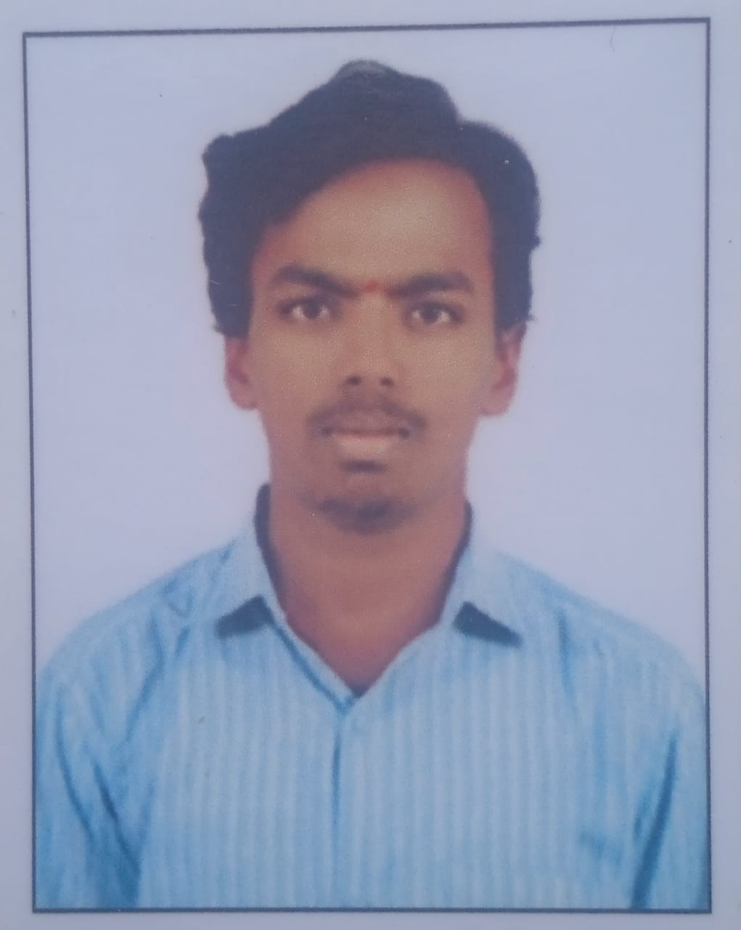

Passport Size

Photo

**Candidate Name**: G.ADHI NARAYANA

Mobile No. 8121905444

Email ID [:](mailto:pavanidalavayi@gmail.com) **adhin336@gmail.com**

**__________________________________________________________________________**

# CAREER OBJECTIVE:

I am seeking a competitive and challenging environment where I can serve your organization and

establish a career for myself.

# ACADEMICS:

* **Graduation Details:-**
  + B.Tech(Electrical & Electronics Engineering)
  + Sree Venkateswara College of Engineering, JNTUA.
  + Percentage:74%
  + Year of passing:2025.

# Diploma:-

* + Diploma(ECE)
  + Acharya College Of Engineering
  + Percentage:74.83%.
  + Year of passing:2021.

# Secondary School:-

* + SR National High School.
  + Percentage-80%.
  + Year of passing:2018.

# PROJECT:

* Tic-Tac-Toe(using python),Quiz Application.

# TECHNICAL SKILLS:

* + Microsoft Word.
  + Excel, Power Point, PowerBI .
  + Programming Languages:- Python**,** SQL

# ACHIEVEMENTS

* Got Core and Advance Python Certificate from Aacharya Coaching Institute.
* Got an Internship Certificate from YHills For Completing the 2 Months Internship under the domain of Machine Learning with Python.
* Got an Participation Certificate for attending the Hackathon which was held by Prathyusha Engineering College.

# PERSONAL DETAILS

* + Date of Birth :16th January 2003
  + Father’s Name: G.VenkateshWarlu
  + Mother’s Name: G.Adi Laxmi
  + Current Address: Kammavaripalli,Eguvanelaturu,B.Mattam,Andhrapradesh.
  + Permanent Address: Kammavaripalli,Eguvanelaturu,B.Mattam,Andhrapradesh.
  + Hobbies: Playing badminton,Chess,Reading Books
  + Nationality: Indian.
  + Languages Known: English, Telugu, Hindi.
  + Any kind of disability: No.
  + Willingness to Relocate: Yes, I will.

# DECLARATION

I hereby declare that all the above-mentioned information is true and correct to the best of my Knowledge.

# Place:

# Kadapa.

**Signature:**

**G.Adhi Narayana.**