**Easy Bus**

Counter Login:

1. Add Dashboard where we can view Todays bus list with destination and Booking status (Available Seats)
2. Bus List > Search Bus > Add the search field (Search by Destination)
3. Booking > Book Seat > 2 ota seat select garyo vani eauta matrai book hunxa with error message

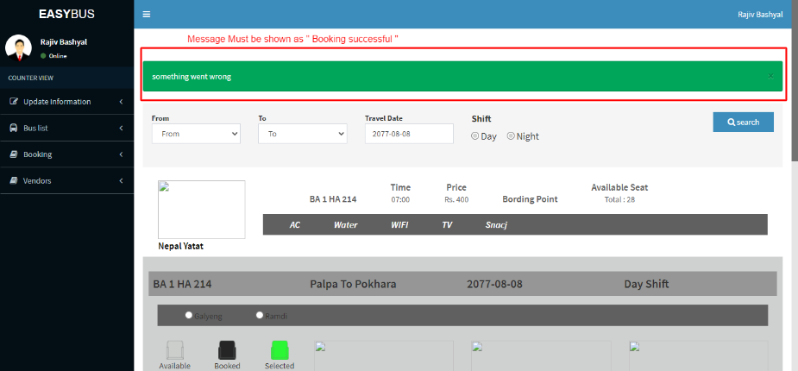

1. Ticket history must be like this

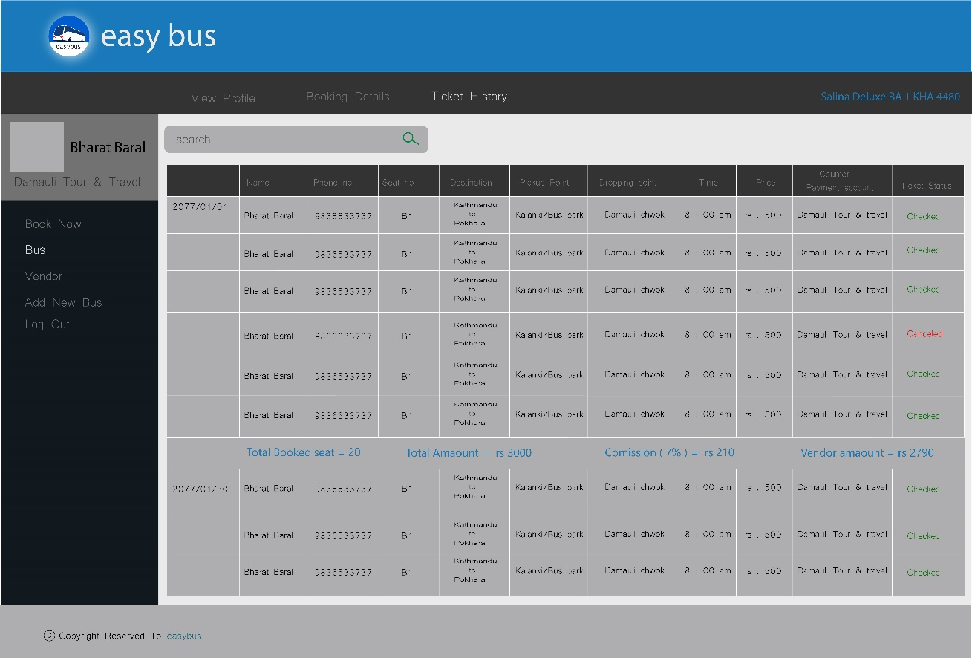

**Counter > Vendor**

1. Listing page ma owner name ma Location tanyako xa (Change to Owner name).
2. 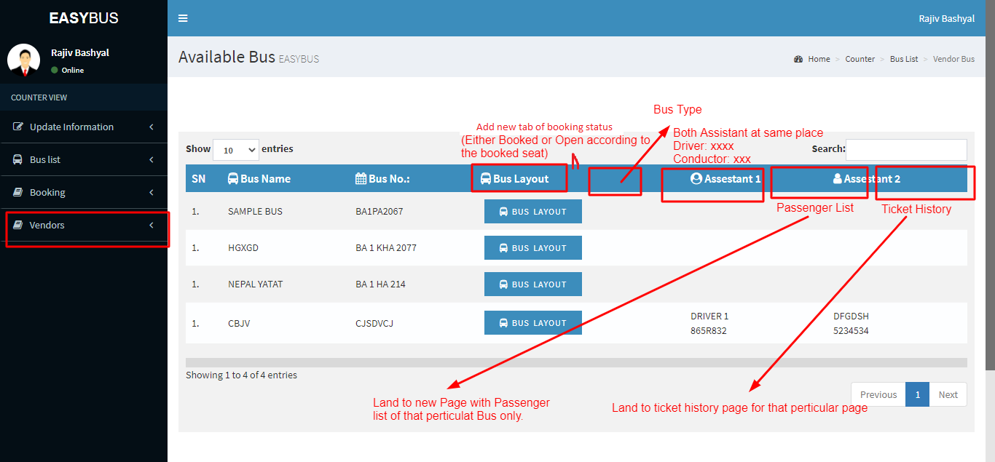After entering to Authorized Bus List >

**Vendor View**

1. Dashboard with Upcoming bus list
2. 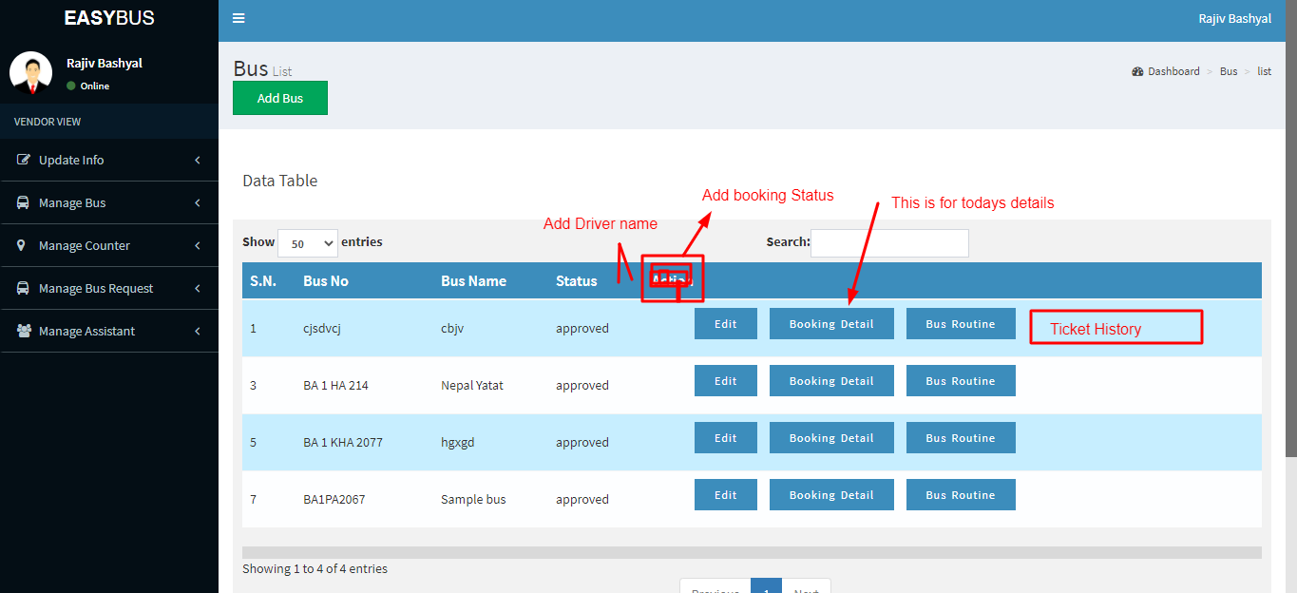Manage Bus > Bus List
3. Booking Details of Bus List:

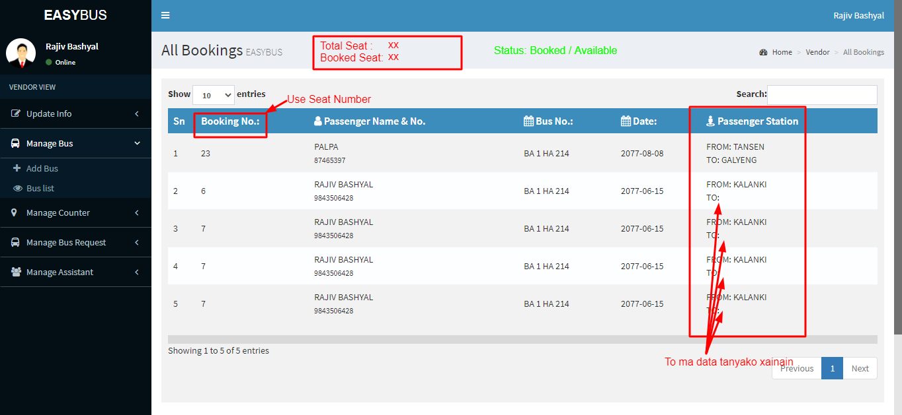

1. Manage counter > All counters > View and Ticket Sale are landed to error page
2. Manage Assistant > Assistant List > Delete Button leads to error page