**CORPORATE INSTITUTE OF SCIENCE & TECHNOLOGY, BHOPAL**



**LAB MANUAL**

**SUBJECT NAME: COMPUTER NETWORKS**

**SUBJECT CODE: CS-602, AD-602**

**SEMESTER: IV**

**INDEX**

|  |  |  |  |  |
| --- | --- | --- | --- | --- |
| **EXP. NO.** | **Name of Experiment** | **Date** | **Remark** | **Signature** |
| **1** | Study of different types of Network cables and Practically implement the cross-wired cable and straight through cable using clamping tool. | **15/02/2024** |  |  |
| **2** | Study of Network Devices in Detail. | **22/02/2024** |  |  |
| **3** | Study of network IP. | **14/03/2024** |  |  |
| **4** | Connect the computers in Local Area Network. | **04/04/2024** |  |  |
| **5** | Study of basic network command and Network configuration commands. | **11/04/2024** |  |  |
| **6** | Configure a Network topology using packet tracer software. | **25/04/2024** |  |  |
| **7** | Configure a Network using Distance Vector Routing protocol. | **09/05/2024** |  |  |
| **8** | Study of Application layer protocols-DNS, HTTP, HTTPS, FTP and TelNet. | **16/05/2024** |  |  |

## EXPERIMENT-1

**Aim**: Study of different types of Network cables and practically implements the cross-wired cable and straight through cable using clamping tool.

**Apparatus (Components):** RJ-45connector, Climping Tool, Twisted pair Cable

**Procedure:** To do these practical following steps should be done:

1. Start by stripping off about 2 inches of the plastic jacket off the end of the cable. Be very careful at this point, as to not nick or cut into the wires, which are inside. Doing so could alter the characteristics of your cable, or even worse render is useless. Check the wires, **one more time** for nicks or cuts. If there are any, just whack the whole end off, and start over.
2. Spread the wires apart, but be sure to hold onto the base of the jacket with your other hand. Youdonotwantthewirestobecomeuntwisteddowninsidethejacket.Category5cable must only have 1/2 of an inch of' untwisted' wire at the end; otherwise it will be 'out of spec'. At this point, you obviously have ALOT more than 1/2 of an inch of un-twisted wire.
3. You have 2 end jacks, which must be installed on your cable. If you are using a pre-made cable, with one of the ends whacked off, you only have one end to install - the crossed over end. Below are two diagrams, which show how you need to arrange the cables for each type ofcableend.Decideatthispointwhichendyouaremakingandexaminetheassociated picture below.

**Diagram shows you how to prepare Cross wired connection**

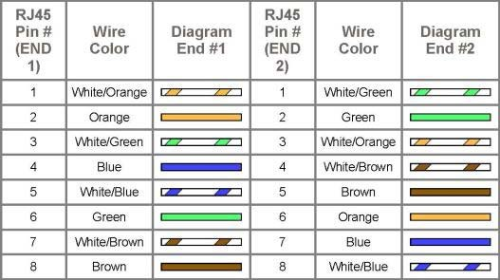

**Diagram shows you how to prepare straight through wired connection**



## EXPERIMENT-2

**Aim:** Study of following Network Devices in Detail.

* + Repeater
  + Hub
  + Switch
  + Bridge
  + Router
  + Gateway

**Apparatus (Software):** No software or hardware needed.

**Procedure:** Following should be done to understand this practical.

1. **Repeater:** Functioning at Physical Layer. A **repeater** is an electronic device that receives a signal and retransmits it at a higher level and/or higher power, or onto the other side of an obstruction,sothatthesignalcancoverlongerdistances.Repeaterhavetwoports,socannot be use to connect for more than two devices

### Hub: An Ethernet hub, active hub, network hub, repeater hub, hub or concentrator

is a device for connecting multiple twisted pair or fiber optic Ethernet devices together and making them act as a single network segment. Hubs work at the physical layer (layer 1) of the OSI model. The device is a form of multiport repeater. Repeater hubs also participate in collision detection, forwarding a jam signal to all ports if it detects a collision.

1. **Switch:** A **network switch** or **switching hub** is a computer networking device that connects network segments. The term commonly refers to a network bridge that processes and routes data at the data link layer (layer2) of the OSI model. Switches that additionally process data at the network layer (layer 3 and above) are often referred to as Layer 3 switches or multilayer switches.
2. **Bridge:** A **network bridge** connects multiple network segments at the data link layer(Layer2)oftheOSImodel.InEthernetnetworks,theterm*bridge*formallymeansadevice thatbehavesaccordingtotheIEEE802.1Dstandard.Abridgeandswitchareverymuch alike; a switch being a bridge with numerous ports. *Switch* or *Layer 2 switch* is often used interchangeably with *bridge*. Bridges can analyze incoming data packets to determine if the bridge is able to send the given packet to another segment of the network.
3. **Router:** A **router** is an electronic device that interconnects two or more computer networks, and selectively interchanges packets of data between them. Each data packet contains address information that a router can use to determine if the source and destination are on the same network, or if the data packet must be transferred from one network to another. Where multiple routers are used in a large collection of interconnected networks, the routers exchange information about target system addresses, so that each router can build up a table showing the preferred paths between any two systems on the interconnected networks.
4. **Gateway:** In a communications network, a network node equipped for interfacing with another network that uses different protocols.
   * A gateway may contain devices such as protocol translators, impedance matching devices, rate converters, fault isolators, or signal translators as necessary to provide system interoperability. It also requires the establishment of mutually acceptable administrative procedures between both networks.
   * A protocol translation mapping gateway interconnects networks with different network protocol technologies by performing the required protocol conversions.

## EXPERIMENT-3

**Aim:** Study of network IP

* + Classification of IP address
  + Subnetting
  + Supernetting

### Apparatus (Software): NA

**Procedure:** Following is required to be study under this practical.

* + Classification of IP address

As how in figure we teach how the IP addresses are classified and when they are used.

|  |  |  |
| --- | --- | --- |
| **Class** | **Address Range** | **Supports** |
| **ClassA** | 1.0.0.1to126.255.255.254 | Supports 16 million hosts on each of 127 networks. |
| **ClassB** | 128.1.0.1to191.255.255.254 | Supports 65,000 hosts on each of 16,000 networks. |
| **ClassC** | 192.0.1.1to223.255.254.254 | Supports 254 hosts on each of 2 million networks. |
| **ClassD** | 224.0.0.0to239.255.255.255 | Reserved for multicast groups. |
| **ClassE** | 240.0.0.0to254.255.255.254 | Reserved. |

* + Subnetting

Why we Develop subnetting and How to calculate subnet mask and how to identify subnet address.

* + Supernetting

Why we develop supernetting and How to calculate supernet mask and how to identify supernet address.

## EXPERIMENT-4

**Aim:** Connect the computers in Local Area Network.

### Procedure: On the host computer

On the host computer, follow these steps to share the Internet connection:

1. Log on to the host computer as Administrator or as Owner.
2. Click **Start**, and then click **Control Panel**.

### Click Network and Internet Connections.

1. Click **Network Connections**.
2. Right-click the connection that you use to connect to the Internet. For example, if you connect to the Internet by using a modem, right-click the connection that you want under Dial-up / other network available.
3. Click **Properties**.
4. Click the **Advanced** tab.
5. Under **Internet Connection Sharing**, select the **Allow other network users to connect through this computer's Internet connection** check box.
6. If you are sharing a dial-up Internet connection, select the **Establish a dial-up connection whenever a computer on my network attempts to access the Internet** check box if you want to permit your computer to automatically connect to the Internet.
7. Click **OK**. You receive the following message:

When Internet Connection Sharing is enabled, your LAN adapter will be set to use IP address 192.168.0.1. Your computer may lose connectivity with other computers on your network. If these other computers have static IP addresses, it is a good idea to set them to obtain their IP addresses automatically. Are you sure you want to enable Internet Connection Sharing?

1. Click **Yes**.

The connection to the Internet is shared to the computers on the local area network ( LAN).

The network adapter that is connected to the LAN is configured with a static IP address of 192.168.0.1 and a subnet mask of 255.255.255.0

### On the client computer

To connect to the Internet by using the shared connection, you must confirm the LAN adapter IP configuration, and then configure the client computer. To confirm the LAN adapter IP configuration, follow these steps:

1. Log on to the client computer as Administrator or as Owner.

### Click Network and Internet Connections.

1. Click **Network Connections**.
2. Right-click **Local Area Connection** and then click **Properties**.
3. Click the **General** tab, click **Internet Protocol (TCP/IP)** in the **connection uses the following items** list, and then click **Properties**.
4. In the **Internet Protocol (TCP/IP) Properties** dialog box, click **Obtain an IP address automatically** (if it is not already selected), and then click **OK**.

**Note:** You can also assign a unique static IP address in the range of 192.168.0.2 to 192.168.0.254. For example, you can assign the following static IP address, subnet mask, and default gateway:

1. IPAddress192.168.31.202
2. Subnetmask255.255.255.0
3. Defaultgateway192.168.31.1
4. In the **Local Area Connection Properties** dialog box, click **OK**.
5. Quit Control Panel.

## EXPERIMENT-5

**Aim:** Study of basic network command and Network configuration commands.

**Apparatus (Software):** Command Prompt And Packet Tracer.

**Procedure:** To do this EXPERIMENT- follows these steps:

In this EXPERIMENT- students have to understand basic networking commands e.g. ping, tracert etc.

All commands related to Network configuration which includes how to switch to privilege mode and normal mode and how to configure router interface and how to save this configuration to flash memory or permanent memory.

This commands includes

* Configuring the Router commands
* General Commands to configure network
* Privileged Mode commands of a router
* Router Processes & Statistics
* IP Commands
* Other IP Commands e.g. show ip route etc.

### ping:

ping (8) sends an ICMP ECHO_REQUEST packet to the specified host. If the host responds, you get an ICMP packet back. Sound strange? Well, you can “ping” an IP address to see if a machine is alive. If there is no response, you know something is wrong.

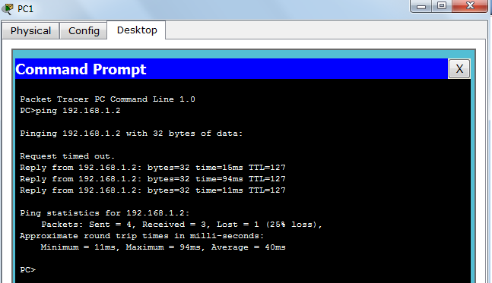

### Traceroute:

Tracert is a command which can show you the path a packet of information takes from your computer to one you specify. It will list all the routers it passes through until it reaches its destination, or fails to and is discarded. In addition to this, it will tell you how long each 'hop' from router to router takes.

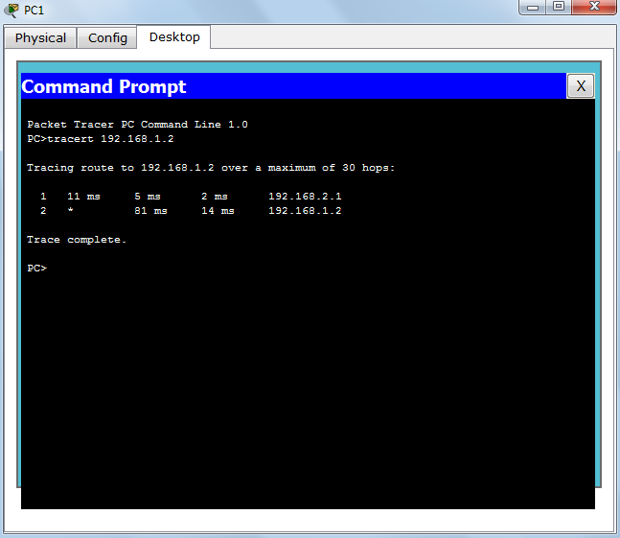

### nslookup:

Displays information from Domain Name System (DNS) name servers.

NOTE: If you write the command as above it shows as default your pc's server name firstly.

### pathping:

A better version of tracert that gives you statics about packet lost and latency.

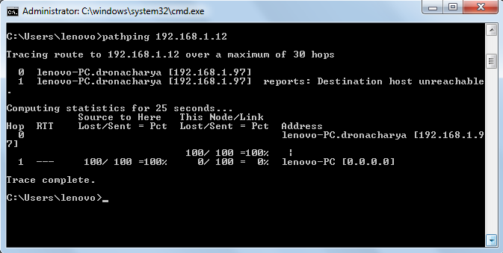

# Getting Help

In any command mode, you can get a list of available commands by entering a question mark (?). Router>**?**

To obtain a list of commands that begin with a particular character sequence, type in those characters followed immediately by the question mark (?).

Router#**co?**

Configure connect copy

To list keywords or arguments, enter a question mark in place of a keyword or argument. Include a space before the question mark.

Router#**configure?**

memory Configure from NV memory network Configure from a TFTP network host terminal

Configure from the terminal

You can also abbreviate commands and keywords by entering just enough characters to make the command unique from other commands. For example, you can abbreviate the **show** command to **sh**.

# Configuration Files

Any time you make changes to the router configuration, you must save the changes to memory because if you do not they will be lost if there is a system reload or power outage. There are two types of configuration files: the running (current operating) configuration and the startup configuration.

Use the following privileged mode commands to work with configuration files.

* **Configure terminal**– modify the running configuration manually from the terminal.
* **Show running-config**–display the running configuration.
* **Show startup-config**–display the startup configuration.
* **Copy running-config startup-config**– copy the running configuration to the startup configuration.
* **Copy startup-config running-config**–copy the startup configuration to the running configuration.
* **Erase startup-config**–erase the startup-configuration in NVRAM.
* **Copy tftp running-config**–load a configuration file stored on a Trivial File Transfer Protocol (TFTP) server into the running configuration.
* **Copy running-config tftp**– store the running configuration on a TFTP server.

# IP Address Configuration

Take the following steps to configure the IP address of an interface. Step 1: Enter privileged EXEC mode:

Router> **enable** password

Step2:Enter the **configure terminal** command to enter global configuration mode. Router#**config terminal**

Step3: Enter the **interface** type slot/port (for Cisco7000series) or **interface** type port (for Cisco 2500 series) to enter the interface configuration mode.

Example:

Router (config)#**interfaceethernet0/1**

Step4:Enter the IP address and subnet mask of the interface using the **ip address** ip address subnetmask command.

Example,

Router (config-if)#**ipaddress 192.168.10.1255.255.255.0**

Step5: Exit the configuration mode by pressing Ctrl-Z Router (config-if)#**[Ctrl-Z]**

## EXPERIMENT-6

**Aim:** Configure a Network topology using packet tracer software.

**Apparatus (Software):** Packet tracer Software

**Procedure:** To implement this practical following network topology is required to be configured using the commands learned in previous practical.

After configuring the given network a packet should be ping from any one machine to another.

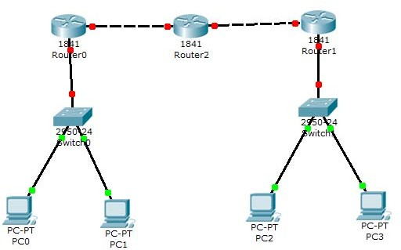

# Router0 Configuration Command:.........

Continue with configuration dialog? [yes/no]: no

Press RETURN to get started! Router>

Router>Enable Router#config t

Enter configuration commands, one per line. End with CNTL/Z.

Router(config)#hostname router0 router0(config)#interface fastethernet 0/0

router0(config-if)#ip address 192.168.1.1 255.255.255.0 router0(config-if)#description router0 fast ethernet 0/0 router0(config-if)#no shutdown

%LINK-5-CHANGED: Interface FastEthernet0/0, changed state to up router0(config-if)#exit

router0(config)#interface fastethernet 0/1 router0(config-if)#description router0 fastethernet 0/1 router0(config-if)#no shutdown

%LINK-5-CHANGED: Interface FastEthernet0/1, changed state to up router0(config-if)#exit

router0(config)#exit

%SYS-5-CONFIG_I: Configured from console by console router0#show running-config

Building configuration...

Current configuration:437bytes

!

version12.4

noservicepassword-encryption

!

hostnamerouter0

!

!

!

!

!

ipsshversion1

!

!

interface FastEthernet0/0description router0 fastethernet 0/0

ipaddress192.168.1.1255.255.255.0

duplexauto speed auto

!

interface FastEthernet0/1description router0 fastethernet 0/1 no ip address

duplexauto speed auto

!

interfaceVlan1 no ip address

shutdown

!

ipclassless

!

!

!

!

!

linecon0

linevty04 login

!

!

end

router0# router0#

router0#copy running-config startup-config Destination filename [startup-config]?

Building configuration... [OK]

router0#

## EXPERIMENT-7

**Aim:** Configure a Network using Distance Vector Routing protocol.

* RIP

**Apparatus (Software):**packet tracer software

### Procedure:

1. Develop a Topology shown in figure given below.

3. Configure all Routers

4. Implement RIP protocols in Router to configure Network.

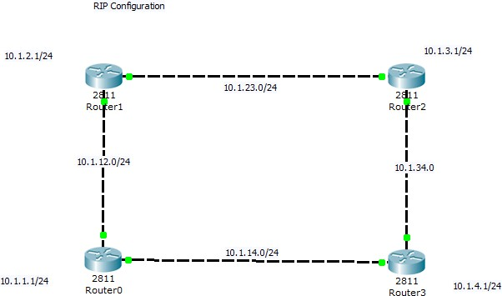

**Router0configuration.....**

Continue with configuration dialog? [yes/no]:no

Press RETURN to get started! Router>

Router>en Router#configt

Enter configuration commands, one per line. End with CNTL/Z.

Router(config)#hostnamerouter0 router0(config)#intlo0

%LINK‐5‐CHANGED:InterfaceLoopback0,changed state to up

%LINEPROTO‐5‐UPDOWN: Line protocol on Interface Loopback0, changed state to up router0(config‐if)#ipaddress10.1.1.1255.255.255.0

router0(config‐if)#intf0/0

router0(config‐if)#ip address 10.1.12.1 255.255.255.0 router0(config‐if)#noshut

%LINK‐5‐CHANGED:InterfaceFastEthernet0/0,changed state to up router0(config‐if)#intf0/1

router0(config‐if)#ip address 10.1.14.1 255.255.255.0 router0(config‐if)#noshut

%LINK‐5‐CHANGED:InterfaceFastEthernet0/1,changed state to up router0(config‐if)#end

%SYS‐5‐CONFIG_I: Configured from console by console

router0#wr

Building configuration... [OK]

router0# router0#

%LINEPROTO‐5‐UPDOWN:Line protocol on Interface FastEthernet0/0,changed state to up

%LINEPROTO‐5‐UPDOWN:LineprotocolonInterfaceFastEthernet0/1, changed state to up

router0con0 is now available

Press RETURN to get started. router0>

router0>en router0#configt

Enter configuration commands, one per line. End with CNTL/Z. router0(config)#routerrip

router0(config‐router)#net 10.0.0.0 router0(config‐router)# router0(config‐router)#end

%SYS‐5‐CONFIG_I: Configured from console by console

router0#showiproute

Codes: C ‐connected, S ‐static, I ‐IGRP, R ‐RIP, M ‐mobile, B ‐BGPD‐EIGRP,EX‐EIGRPexternal,O‐OSPF,IA‐OSPFinterarea

N1 ‐OSPF NSSA external type 1, N2‐OSPF NSSAexternaltype 2 E1‐OSPF externaltype 1,E2‐OSPF externaltype2,E ‐EGP

i‐IS‐IS,L1‐IS‐ISlevel‐1,L2‐IS‐ISlevel‐2,ia‐IS‐ISinterarea

*‐candidatedefault,U‐per‐userstaticroute,o‐ODR P ‐periodic downloaded static route

Gateway of last resort is not set

10.0.0.0/24issubnetted,3subnets

C10.1.1.0isdirectlyconnected,Loopback0

C10.1.12.0isdirectlyconnected,FastEthernet0/0 C10.1.14.0isdirectlyconnected,FastEthernet0/1 router0#

router0#

**Router1Configuration.....**

Continue with configuration dialog? [yes/no]: no

Press RETURN to get started!

Router>enable Router#configt

Enter configuration commands, one per line. End with CNTL/Z. Router(config)#intlo0

%LINK‐5‐CHANGED:InterfaceLoopback0, changed state to up

%LINEPROTO‐5‐UPDOWN: Line protocol on Interface Loopback0, changed state to up Router(config‐if)#ip address 10.1.2.1 255.255.255.0

Router(config‐if)#noshut Router(config‐if)#intf0/1

Router(config‐if)#ip address 10.1.23.1 255.255.255.0 Router(config‐if)#noshut

%LINK‐5‐CHANGED:InterfaceFastEthernet0/1, changed state to up Router(config‐if)#int f0/0

Router(config‐if)#ip address 10.1.12.2 255.255.255.0 Router(config‐if)#noshut

%LINK‐5‐CHANGED:InterfaceFastEthernet0/0, changed state to up

%LINEPROTO‐5‐UPDOWN: Line protocol on Interface FastEthernet0/0, changed state to up Router(config‐if)#end

%SYS‐5‐CONFIG_I: Configured from console by console

Router#wr

Building configuration... [OK]

Router# Router# Router#

%LINEPROTO‐5‐UPDOWN:LineprotocolonInterfaceFastEthernet0/1, changed state to up

Router con0 is now available

Press RETURN to get started. Router>

Router>en Router#cont

%Ambiguouscommand:"cont"Router#cot

%Ambiguouscommand:"cot"Router#conft

Enter configuration commands, one per line.End with CNTL/Z. Router(config)#routerrip

Router(config‐router)#net 10.0.0.0 Router(config‐router)# Router(config‐router)# Router(config‐router)#end

%SYS‐5‐CONFIG_I: Configured from console by console

Router#

**Router2Configuration.....**

Continue with configuration dialog? [yes/no]: no

Press RETURN to get started! Router>en

Router#configt

Enter configuration commands, one per line. End with CNTL/Z. Router(config)#intlo0

%LINK‐5‐CHANGED:InterfaceLoopback0, changed state to up

%LINEPROTO‐5‐UPDOWN: Line protocol on Interface Loopback0, changed state to up Router(config‐if)#ip address 10.1.3.1 255.255.255.0

Router(config‐if)#no shut Router(config‐if)#intf0/0

Router(config‐if)#ip address 10.1.23.2 255.255.255.0 Router(config‐if)#noshut

%LINK‐5‐CHANGED:InterfaceFastEthernet0/0, changed state to up

%LINEPROTO‐5‐UPDOWN: Line protocol on Interface FastEthernet0/0, changed state to up Router(config‐if)#int f0/1

Router(config‐if)#ip address 10.1.34.1 255.255.255.0 Router(config‐if)#noshut

%LINK‐5‐CHANGED:InterfaceFastEthernet0/1, changed state to up Router(config‐if)#End

%SYS‐5‐CONFIG_I: Configured from console by console

Router#wr

Building configuration... [OK]

Router# Router# Router#

%LINEPROTO‐5‐UPDOWN:LineprotocolonInterfaceFastEthernet0/1, changed state to up

Routercon0isnowavailable

Press RETURN to get started.

Router> Router>Router>en

Router#showiproute

Codes: C ‐connected, S ‐static, I ‐IGRP, R ‐RIP, M ‐mobile, B ‐BGPD‐EIGRP,EX‐EIGRPexternal,O‐OSPF,IA‐OSPFinterarea

N1 ‐OSPF NSSA external type 1, N2‐OSPF NSSAexternaltype 2 E1‐OSPF externaltype 1,E2‐OSPF externaltype2,E ‐EGP

i‐IS‐IS,L1‐IS‐ISlevel‐1,L2‐IS‐ISlevel‐2,ia‐IS‐ISinterarea

*‐candidatedefault,U‐per‐userstaticroute,o‐ODR P ‐periodic downloaded static route

Gateway of last resort is not set 10.0.0.0/24 is subnetted, 3 subnets

C10.1.3.0isdirectlyconnected,Loopback0

C10.1.23.0isdirectlyconnected,FastEthernet0/0 C10.1.34.0isdirectlyconnected,FastEthernet0/1 Router#configt

Enter configuration commands, one per line .End with CNTL/Z. Router(config)#routerrip

Router(config‐router)#net 10.0.0.0 Router(config‐router)#end

%SYS‐5‐CONFIG_I: Configured from console by console

Router#

Router#Router#showiproute

Codes: C ‐connected, S ‐static, I ‐IGRP, R ‐RIP, M ‐mobile, B ‐BGPD‐EIGRP,EX‐EIGRPexternal,O‐OSPF,IA‐OSPFinterarea

N1 ‐OSPF NSSA external type 1, N2‐OSPF NSSAexternaltype 2 E1‐OSPF externaltype 1,E2‐OSPF externaltype2,E ‐EGP

i‐IS‐IS,L1‐IS‐ISlevel‐1,L2‐IS‐ISlevel‐2,ia‐IS‐ISinterarea

*‐candidatedefault,U‐per‐userstaticroute,o‐ODR P ‐periodic downloaded static route

Gateway of last resort is not set 10.0.0.0/24 is subnetted, 7 subnets

R 10.1.1.0[120/2]via10.1.23.1,00:00:19,FastEthernet0/0

R 10.1.2.0[120/1]via10.1.23.1,00:00:19,FastEthernet0/0

C 10.1.3.0isdirectlyconnected, Loopback0

R 10.1.12.0[120/1]via10.1.23.1,00:00:19,FastEthernet0/0

R 10.1.14.0[120/2]via10.1.23.1,00:00:19,FastEthernet0/0

C 10.1.23.0isdirectlyconnected,FastEthernet0/0

C 10.1.34.0 is directly connected, FastEthernet0/1 Router#

Router# Router#

**Router3Configuration.......**

Continue with configuration dialog? [yes/no]: no

PressRETURNtogetstarted! Router>

Router>en Router#configt

Enter configuration commands, one per line.End with CNTL/Z. Router(config)#intlo0

%LINK‐5‐CHANGED:InterfaceLoopback0, changed state to up

%LINEPROTO‐5‐UPDOWN: Line protocol on Interface Loopback0, changed state to up Router(config‐if)#int f0/0

Router(config‐if)#ip address 10.1.34.2 255.255.255.0 Router(config‐if)#noshut

%LINK‐5‐CHANGED:InterfaceFastEthernet0/0, changed state to up

%LINEPROTO‐5‐UPDOWN: Line protocol on Interface FastEthernet0/0, changed state to up Router(config‐if)#

Router(config‐if)#intf0/1

Router(config‐if)#ip address 10.1.14.2 255.255.255.0 Router(config‐if)#noshut

%LINK‐5‐CHANGED:InterfaceFastEthernet0/1, changed state to up

%LINEPROTO‐5‐UPDOWN: Line protocol on Interface FastEthernet0/1, changed state to up Router(config‐if)#end

%SYS‐5‐CONFIG_I: Configured from console by console

Router#wr

Building configuration... [OK]

Router# Router#

Router#showiproute

Codes: C ‐connected, S ‐static, I ‐IGRP, R ‐RIP, M ‐mobile, B ‐BGPD‐EIGRP,EX‐EIGRPexternal,O‐OSPF,IA‐OSPFinterarea

N1 ‐OSPF NSSA external type 1, N2‐OSPF NSSAexternaltype 2 E1‐OSPF externaltype 1,E2‐OSPF externaltype2,E ‐EGP

i‐IS‐IS,L1‐IS‐ISlevel‐1,L2‐IS‐ISlevel‐2,ia‐IS‐ISinterarea

*‐candidatedefault,U‐per‐userstaticroute,o‐ODR P ‐periodic downloaded static route

Gatewayoflastresortisnotset

10.0.0.0/24issubnetted,2subnets

C10.1.14.0isdirectlyconnected,FastEthernet0/1 C10.1.34.0isdirectlyconnected,FastEthernet0/0 Router#conft

Enter configuration commands, one per line.End with CNTL/Z. Router(config)#routerrip

Router(config‐router)#net 10.0.0.0 Router(config‐router)#

Router(config‐router)#end

%SYS‐5‐CONFIG_I:Configured from console by console

Router#showiproute

Codes: C ‐connected, S ‐static, I ‐IGRP, R ‐RIP, M ‐mobile, B ‐BGPD‐EIGRP,EX‐EIGRPexternal,O‐OSPF,IA‐OSPFinterarea

N1 ‐OSPF NSSA external type 1, N2‐OSPF NSSAexternaltype 2 E1‐OSPF externaltype 1,E2‐OSPF externaltype2,E ‐EGP

i‐IS‐IS,L1‐IS‐ISlevel‐1,L2‐IS‐ISlevel‐2,ia‐IS‐ISinterarea

*‐candidatedefault,U‐per‐userstaticroute,o‐ODR P ‐periodic downloaded static route

Gateway of a stresort is not set 10.0.0.0/24 is subnetted, 7 subnets

R 10.1.1.0[120/1]via10.1.14.1,00:00:09,FastEthernet0/1

R 10.1.2.0[120/2]via10.1.34.1,00:00:14,FastEthernet0/0

[120/2]via10.1.14.1,00:00:09,FastEthernet0/1

R 10.1.3.0[120/1]via10.1.34.1,00:00:14,FastEthernet0/0

R 10.1.12.0[120/1]via10.1.14.1,00:00:09,FastEthernet0/1

C 10.1.14.0isdirectlyconnected,FastEthernet0/1

R 10.1.23.0[120/1]via10.1.34.1,00:00:14,FastEthernet0/0

C 10.1.34.0 is directly connected, FastEthernet0/0 Router#

## EXPERIMENT-8

**Aim:** Study of Application layer protocols-DNS, HTTP, HTTPS, FTP and TelNet.

**Apparatus (Software):** No software or hardware needed.

**Procedure:** Following should be done to understand this practical.

The application layer is present at the top of the OSI model. It is the layer through which users interact. It provides services to the user. [**Application layer**](https://www.geeksforgeeks.org/application-layer-in-osi-model/) performs several kinds of functions which are requirement in any kind of application or communication process.

### Application Layer Protocol in Computer Network

### 1. TELNET

Telnet stands for the **[TELetype NETwork](https://www.geeksforgeeks.org/introduction-to-telnet/)**. It helps in terminal emulation. It allows Telnet clients to access the resources of the Telnet server. It is used for managing files on the internet. It is used for the initial setup of devices like switches. The telnet command is a command that uses the Telnet protocol to communicate with a remote device or system. Port number of telnet is 23.

**Command**

telnet [\\RemoteServer]

\\RemoteServer

: Specifies the name of the server

to which you want to connect

### 2. FTP

FTP stands for [**File Transfer Protocol**](https://www.geeksforgeeks.org/file-transfer-protocol-ftp-in-application-layer/). It is the protocol that actually lets us transfer files. It can facilitate this between any two machines using it. But FTP is not just a protocol but it is also a program.FTP promotes sharing of files via remote computers with reliable and efficient data transfer. The Port number for FTP is 20 for data and 21 for control.

**Command**

ftp machinename

### 9. DNS

It stands for [**Domain Name System**](https://www.geeksforgeeks.org/domain-name-system-dns-in-application-layer/). Every time you use a domain name, therefore, a DNS service must translate the name into the corresponding IP address. For example, the domain name www.abc.com might translate to 198.105.232.4.   
The Port number for DNS is 53.

**Command**

ipconfig /flushdns

### 11. HTTP/HTTPS

HTTP stands for [**Hypertext Transfer Protoco**l](https://www.geeksforgeeks.org/http-full-form/) and HTTPS is the more secured version of HTTP, that’s why HTTPS stands for Hypertext Transfer Protocol Secure. This protocol is used to access data from the World Wide Web. The Hypertext is the well-organized documentation system that is used to link pages in the text document.

* HTTP is based on the client-server model.
* It uses TCP for establishing connections.
* HTTP is a stateless protocol, which means the server doesn’t maintain any information about the previous request from the client.
* HTTP uses port number 80 for establishing the connection.