Project-Based Assessment Manual
Domain-Specific Generative AI Chatbot Using APIs
1. Introduction
This Project-Based Assessment evaluates students’ ability to solve real-world problems using innovative AI-driven solutions, with a strong focus on Generative AI technologies. Students are required to design and implement a domain-specific AI chatbot or propose a patent-oriented AI solution. This manual provides concise guidelines for project execution, evaluation, and final assessment.
The assessment emphasizes:
- Practical AI skills
- Creativity and innovation
- Responsible and domain-aware AI usage
- Societal impact
2. Assessment Objective
The objective of this assessment is to enable students to:
- Identify meaningful real-world problems
- Apply Generative AI tools to address domain-specific needs
- Demonstrate technical competence in API-based AI systems
- Communicate design choices and technical decisions effectively
3. Project Description
Domain-Specific AI Chatbot
Develop a chatbot tailored to a specific domain such as healthcare, education, agriculture, finance, law, or e-commerce. The chatbot must utilize Generative AI APIs and demonstrate domain customization.
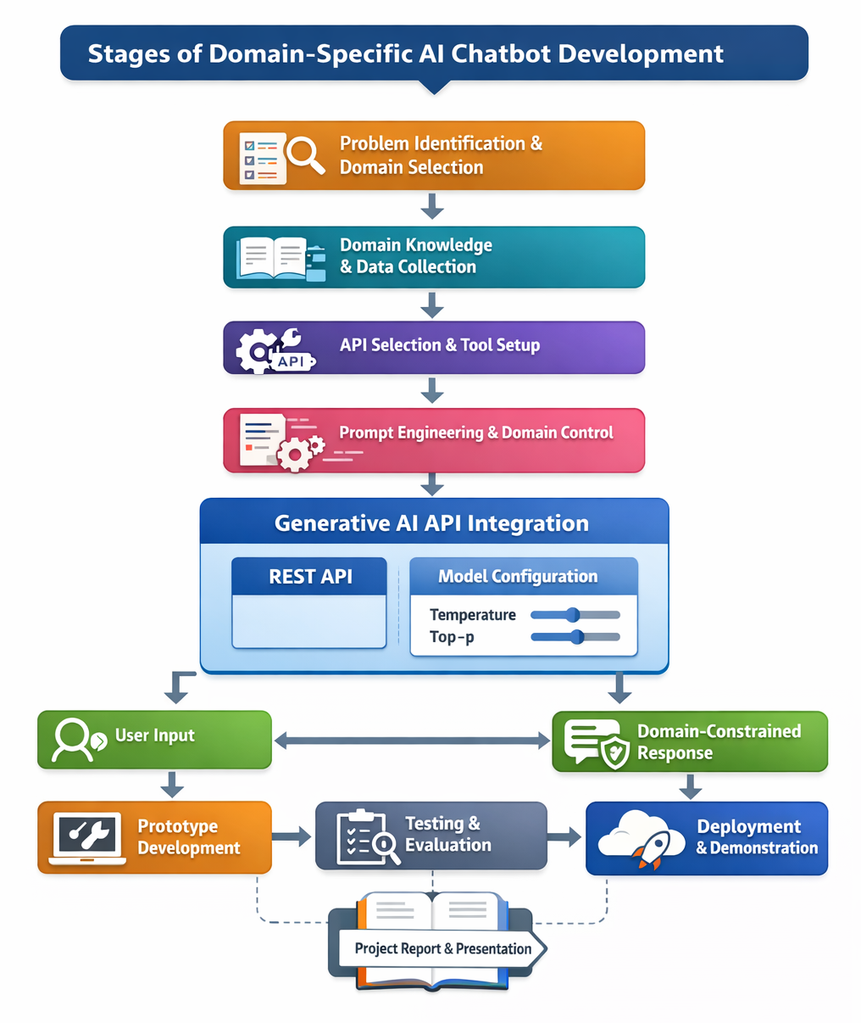
4. Scope and Requirements
Mandatory Requirements
- Clear domain definition
- Use of at least one Generative AI API
- Domain-constrained and meaningful responses
- Working prototype (app or notebook-based)

Optional Enhancements
- Conversation memory
- Document-based Q&A
- Multilingual support
- Simple user interface
5. Tools and Technologies
Students may use:
- Generative AI APIs (OpenAI, Gemini, Claude, Hugging Face)
- Programming languages: Python (recommended), JavaScript
- Frameworks: Streamlit, Flask, FastAPI, Gradio
6. Data Collection and Domain Knowledge Preparation
Although the chatbot uses Generative AI APIs, students are expected to demonstrate domain understanding through basic data collection and preparation. This does not require building datasets or training models.
Data collection may include:
- Collecting domain FAQs from trusted websites
- Identifying common user queries and intents
- Referring to government portals, textbooks, standards, or manuals
- Curating sample questions and expected answers
The purpose of data collection is to:
- Improve prompt quality
- Define system instructions accurately
- Ensure domain-relevant and reliable responses
Students must explain what information sources were studied and how domain knowledge influenced prompt design.
7. Model Configuration Awareness
Students must demonstrate understanding of model behavior control parameters, specifically:
Temperature
- Controls randomness and creativity in responses
- Low values produce deterministic and factual answers
- High values increase creativity and variation
Top-p (Nucleus Sampling)
- Controls the probability mass of token selection
- Lower values restrict output to safer responses
- Higher values allow broader expression
Students should justify chosen values based on the application domain and demonstrate response differences using varied settings.
7. Deliverables
Students must submit:
- Project Report (PDF)
- Source Code / Notebook
- Application Link
- Presentation Slides
8. Evaluation Criteria (30 Marks)
1. Problem Identification & Innovation (10 Marks)
- Problem clarity and relevance (4)
- Domain specificity and originality (4)
- Societal impact (2)
2. Technical Execution & Skill Demonstration (10 Marks)
- API integration and system design (5)
- Prompt engineering and domain control (2)
- Model configuration understanding (Temperature & Top-p) (3)
3. Presentation & Q&A (10 Marks)
- Clarity of explanation (4)
- Demo effectiveness (3)
- Depth of understanding during Q&A (3)
9. Academic Integrity
- Projects must be original
- Proper attribution for tools and APIs is required
- Students must demonstrate understanding of their work during evaluation

Chatbot-Based Project Evaluation Questionnaire (INT428)
Student Name: ____________________________
Roll Number: ____________________________
Branch & Semester: ____________________________
Project Title: ____________________________
Guide/Faculty Name: ____________________________

Section A: Project Overview
Q1. Type of Chatbot Developed
(Select one)
☐ Rule-based
☐ Retrieval-based
☐ Generative (LLM-based)
☐ Hybrid
Question Note:
This describes the core logic of your chatbot, whether it follows predefined rules, retrieves answers, generates responses using an AI model, or combines multiple approaches.
Q2. Platform Used for Deployment
(Select all that apply)
☐ Web Application
☐ Mobile Application
☐ Desktop Application
☐ Messaging Platform (WhatsApp/Telegram/Slack)
☐ Cloud API only (no UI)
Question Note:
Mention where the chatbot is hosted and accessible by users.
Q3. Deployment Link / Access Details
Deployment URL / App Link: ______________________

Question Note:
Provide the live link, GitHub Pages URL, cloud endpoint, or app access details if deployed.

Section B: Model & API Details
Q4. Type of API Used
(Select one)
☐ OpenAI API
☐ Google Gemini API
☐ Azure OpenAI API
☐ Custom REST API
☐ Local Model API
Question Note:
This refers to the service/API used to communicate with the chatbot model.

Q5. Model Name Used
Model Name: ______________________
Question Note:
Specify the exact model used (e.g., GPT-4, GPT-3.5, LLaMA, Gemini Pro, etc.).

Q6. Model Version
Model Version / Release: ______________________
Question Note:
Mention the version or release identifier of the model, if available.

Section C: Context & Data Handling
Q7. Contextual Memory Usage
(Select one)
☐ No memory (single-turn chatbot)
☐ Session-based memory
☐ Long-term memory (database/vector store)
☐ Hybrid memory approach
Question Note:
Contextual memory defines how the chatbot remembers past user interactions.

Q8. Flow of Data in the Chatbot
Briefly explain the data flow:

Question Note:
Describe how user input flows from UI → backend → model → response → user.

Section D: Model Configuration & Behavior
Q9. Model Parameters Used
(Fill if applicable)
Parameter | Value | Not Applicable
Temperature | ______ | ☐
Top-p / Probability | ______ | ☐
Input Token Limit | ______ | ☐
Output Token Limit | ______ | ☐
Question Note:
These parameters control creativity, randomness, and response length of the chatbot, could be discovered from Run settings or Playground settings if using AI studio.
Q10. Thinking Level & Role Assignment
(Select appropriate options)
Thinking Level:
☐ Basic (direct answers)
☐ Intermediate (context-aware reasoning)
☐ Advanced (multi-step reasoning)

Role Assigned to Model:
☐ Assistant
☐ Tutor
☐ Customer Support Agent
☐ Domain Expert
Question Note:
Thinking level defines the reasoning depth, while role assignment defines how the chatbot behaves in responses.

Section E: Technology Stack
Q11. Technology Stack Used
(Mention tools & frameworks)
Frontend: ______________________
Backend: ______________________
Database / Vector Store: ______________________
Cloud / Hosting: ______________________

Question Note:
Specify the complete technical stack used to build and deploy the chatbot.

Section F: Implementation Evidence (Screenshots & Code)
Q12. API Call Screenshot
Paste a code snippet showing the chatbot making a successful API request and receiving a response.
Question Note:
The code snippet should clearly show:
- Model/API response
- User input or prompt
- Successful request execution
Q13. Chatbot Working Interface Screenshot
Paste a screenshot of the chatbot’s user interface while interacting with a user.
Question Note:
The screenshot should show:
- User input
- Chatbot response
- Platform used (web/app/messaging)
Q14. GitHub Repository Link
- Repository URL: ______________________
- Question Note:
Provide only if the project code is hosted publicly.
Declaration
I confirm that the information provided above is accurate to the best of my knowledge.
Student Signature: ______________________
Date: ______________________

