**Adhish Bahl**

**2347203**

**1MCA A**

**Python Lab 1**

**Part I**

**Q1) Write a paragraph about introducing you and your selected domain (include Full Name, domain name, register number, year …….).**

**Write a python program to count the frequency of any specific word (in your domain) in the paragraph.**

Code:

name = "Adhish Bahl"

regNo = 2347203

course = "1MCA B"

domain = "Online Retail Store for Exclusive Sneakers"

domainDescription = "Hii, My name is Adhish Bahl (2347203), from 1MCA-B. This is my Python Lab program 1. My domain is Online Retail Store for Exclusive Sneakers. In this domain, the basic idea behind everthing is to provide the access to exclusive sneakers that are not available in India. This works as the company buys the exclusive sneakers, that are not available in India, from different cuntries and then sell those exclusive sneakers to the Indian people. This solves a very big gap that exist in the India Sneaker market. The gap of some sneakers that are not available in India to making them available in India."

para = domainDescription.lower()

wordToFind = input("Enter the word to get the count: ")

countOfWord = para.count(wordToFind)

print("Domain Description: ", domainDescription, "\n")

print("Occurance of \"", wordToFind, "\" in the domain Description = ", countOfWord, " times.")

Output:



**Q2) Write a python program to display all the datatypes of selected specific elements in the paragraph. (For example:– name - string, reg.no - int, marks - float, etc.)**

Code:

domainDescription = "Hii, My name is Adhish Bahl, 2347203, from 1MCA-B. This is my Python Lab program 1. I got 9.39 GCPA in my undergrade degree. My domain is Online Retail Store for Exclusive Sneakers. In this domain, the basic idea behind everthing is to provide the access to exclusive sneakers that are not available in India. This works as the company buys the exclusive sneakers, that are not available in India, from different cuntries and then sell those exclusive sneakers to the Indian people. This solves a very big gap that exist in the India Sneaker market. The gap of some sneakers that are not available in India to making them available in India."

words = domainDescription.split(" ")

for i in words:

    for j in i:

        if (ord(j) >= 48 and ord(j) <= 57):

            if "." in i:

                print(i, " is float.")

                break

            else:

                print(i, " is Integer.")

                break

        else:

            print(i, " is String")

            break

Output:

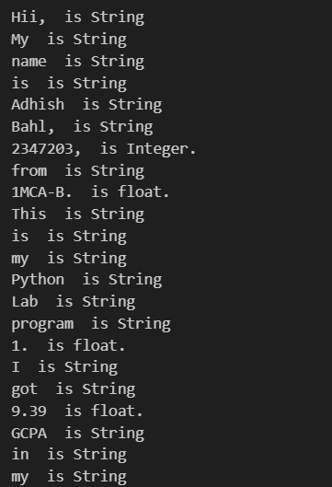

**Q3) Write a python program to count the number of alphabets, numeric and other special symbols in the paragraph.**

Code:

alphabets = 0

digits = 0

specialCh = 0

choice = 0

domainDescription = "Hii, My name is Adhish Bahl (2347203), from 1MCA-B. This is my Python Lab program 1. My domain is Online Retail Store for Exclusive Sneakers. In this domain, the basic idea behind everthing is to provide the access to exclusive sneakers that are not available in India. This works as the company buys the exclusive sneakers, that are not available in India, from different cuntries and then sell those exclusive sneakers to the Indian people. This solves a very big gap that exist in the India Sneaker market. The gap of some sneakers that are not available in India to making them available in India."

customString =""

while(choice != 1 and choice != 2):

    choice = int(input("Choose one:\n1. Enter my own string\n2. Check count from domain description"))

if choice == 1:

    customString = input("Enter your String")

    for i in range(len(customString)):

        if((ord(customString[i]) >= 65 and ord(customString[i]) <= 90) or (ord(customString[i]) >= 97 and ord(customString[i]) <= 122)):

            alphabets = alphabets + 1

        elif(ord(customString[i]) >= 48 and ord(customString[i]) <= 57):

            digits = digits + 1

        else:

            specialCh = specialCh + 1

elif choice == 2 :

    for i in range(len(domainDescription)):

        if((ord(domainDescription[i]) >= 65 and ord(domainDescription[i]) <= 90) or (ord(domainDescription[i]) >= 97 and ord(domainDescription[i]) <= 122)):

            alphabets = alphabets + 1

        elif(ord(domainDescription[i]) >= 48 and ord(domainDescription[i]) <= 57):

            digits = digits + 1

        else:

            specialCh = specialCh + 1

print("\nTotal count of\nAlphabets: ", alphabets, "\nDigits: ", digits, "\nSpecial Charectors: ", specialCh)

Output:

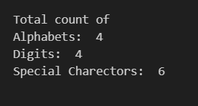

**Part II**

**Q1) Create a Set with elements that consists of various data types (int, float, string, Boolean, etc. from your domain) and perform the functions pop(), clear(), discard() and del. Write the insights as docstring.**

Code:

randomSet = {"Adhish", 51637, "Nike", 10245.36, True, 486323, 6153.51, False, "Air Force"}

print("Initial Set: ", randomSet)

poppedElement = randomSet.pop()

print("\nAfter using .pop(): ", randomSet, "\nElement removed is: ", poppedElement)

poppedElement = randomSet.discard(51637)

print("\nAfter using .discard(51637): ", randomSet)

poppedElement = randomSet.discard("Nike")

print("\nAfter using .discard(\"Nike\"): ", randomSet)

randomSet.clear()

print("\nAfter using .clear(): ", randomSet)

del randomSet

print("\nAfter using del: Set is deleted and hence it does not exist")

Output:

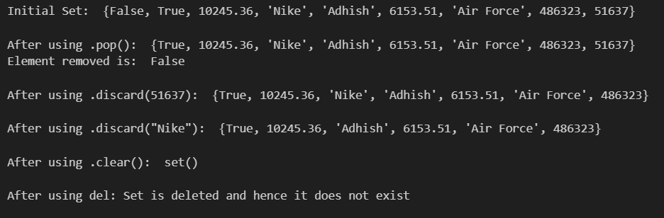

**Q2) Update the Set with minimum 5 string attributes of your domain and arrange the Set in descending order.**

Code:

randomSet = set()

for i in range(6):

    tempVar = input("Give an element for the set: ")

    randomSet.add(tempVar)

print("Initial Set: ", randomSet)

print("\nAfter Ascending Sorting the set: ", sorted(randomSet))

print("\nAfter Descending Sorting the set: ", sorted(randomSet, reverse=True))

Output:

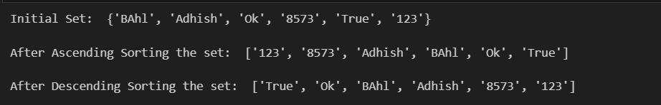

**Q3) Create a Tuple and Execute the packing and unpacking operations of tuples using the attributes of your domain.**

Code:

def packingUnpackingTuple():

    domainTuple = ("Nike", "Order Placed", "Air Jorden", "Addidas", "BLue", "Exclusive", "Shipped")

    print("Original Tuple:", domainTuple)

    firstTerm, secondTerm, thirdTerm, fourthTerm, fifthTerm, sixthTerm, seventhTerm = domainTuple

    print("\nUnpacked Variables:")

    print("First Term:", firstTerm)

    print("Second Term:", secondTerm)

    print("Third Term:", thirdTerm)

    print("Fourth Term:", fourthTerm)

    print("Fifth Term:", fifthTerm)

    print("Sixth Term:", sixthTerm)

    print("Seventh Term:", seventhTerm)

packingUnpackingTuple()

Output:

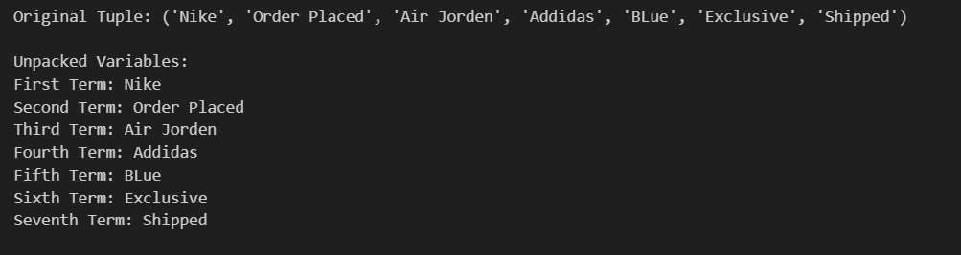

**Q4) Enter your domain name as characters and count any number of characters and print the count (for example – (‘p’,’r’,’o’,’g’,’r’,’a’,’m’) count of ‘r’ = 2)**

Code:

def countLetter(domain, letter):

    countOfLetter = domain.lower().count(letter.lower())

    return(countOfLetter)

domain = input("Enter your Domain Name: ")

letter = input("Enter the letter you want to count")

totalCount = countLetter(domain, letter)

print("Domain Name: ", domain, "\nLetter to count in Domain: ", letter, "\nCount of letter in the domain name: ", totalCount)

Output:

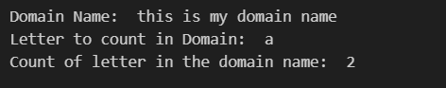

**Q5) Enter your domain name, execute all the slicing possibilities and also negative indexing.**

Code:

def slicingAndIndexing(domainName):

    print("Original Domain Name:", domainName)

    print("\nPositive Slicing:")

    print("Slicing from index 2 to 8:", domainName[2:8])

    print("Slicing from index 0 to 3:", domainName[:3])

    print("Slicing from index 7 to the end:", domainName[7:])

    print("Slicing from index 5 to 15 with step 3:", domainName[5:15:3])

    print("\nNegative Slicing:")

    print("Slicing from the end -10 to the end -3:", domainName[-10:-3])

    print("Slicing from the end -10 to the end -3 with step 2:", domainName[-10:-3:2])

    print("\nPositive Indexing:")

    print("first character:", domainName[0])

    print("10th character:", domainName[9])

    print("\nNegative Indexing:")

    print("Last character:", domainName[-1])

    print("5th charector from last character:", domainName[-5])

domainName = input("Enter your Domain Name: ")

slicingAndIndexing(domainName)

Output:

