Introduction:
In today’s world, where people are increasingly inclined toward home remedies and natural cures for common health problems, there is a lack of a dedicated platform to easily discover them. This web platform addresses that gap by allowing users to search and find categorized natural remedies in one centralized place, making holistic health solutions simple and accessible to find.

Objectives:
The primary objective of this project is to design and develop a streamlined, accessible web application that enables users to discover homemade and Ayurvedic remedies without clutter or unnecessary complexity. The platform aims to bridge the gap between traditional wellness practices and digital convenience by providing an intuitive, category-driven search system for everyday health conditions. Additionally, the application incorporates a collaborative ecosystem where registered users can contribute traditional remedies, supported by a rigorous administrative moderation workflow to review, validate, and approve submissions before publication. Through secure role-based access control, structured ingredient indexing, and user engagement features such as submission tracking and feedback mechanisms, the project seeks to deliver a reliable, safe, and community-enriched repository for holistic healthcare solutions.

Modules:
1. User Authentication & Profile Module
- Enables new visitors to register with standard credentials and securely log into their personal dashboard.
- Provides profile management where users can track account status, including acquiring a "Verified Contributor" badge.
- Manages secure session termination and password reset workflows via Django’s authentication system.
2. Remedy Discovery & Search Module (Public User Panel)
- Offers open, keyword-based search across common ailments, presenting symptoms, and kitchen ingredients.
- Categorizes natural treatments by bodily systems (e.g., Digestive, Respiratory, ENT) and Ayurvedic Dosha types (Vata, Pitta, Kapha).
- Displays comprehensive remedy breakdowns including required raw ingredients, step-by-step preparation, safe dosage guidelines, and precautions.
3. Community Contribution & Management Module (Registered User Panel)
- Allows authenticated users to suggest traditional or inherited home remedies using a structured submission form.
- Features a personal "My Contributions" dashboard to monitor the review status of submitted remedies (Pending, Approved, or Declined).
- Grants authors the capability to edit, update, or withdraw their submitted remedies before or after administrative review.
4. Administrative Moderation & Curation Module (Admin Panel)
- Provides a centralized portal to directly publish official, pre-verified Ayurvedic cures into the system.
- Offers review controls to inspect, edit, approve, or reject crowdsourced remedies to ensure health safety and authenticity.
- Tracks overall platform metrics, including total registered users, active remedy counts, and pending submission queues.
5. User Verification & Trust Module (Admin Panel)
- Evaluates contributor credibility based on submission accuracy and community activity.
- Grants administrators the authority to assign a "Verified Contributor" badge/symbol to trustworthy profiles.
- Restricts or flags accounts exhibiting spamming tendencies or sharing hazardous medical advice.

Software & Hardware requirements:

1. Hardware Requirements
- Processor: Dual-Core x86_64 CPU (Intel Core i3 / AMD Ryzen 3 or higher).
- System Memory (RAM):
  - Minimum: 4 GB
  - Recommended: 8 GB (to simultaneously run Django development server, MySQL server, and modern IDEs smoothly).
- Hard Disk Space: Minimum 1 GB free disk space (for Python virtual environment, MySQL database files, and project assets).
- Peripherals: Standard keyboard, mouse, and an active internet connection (for package installation and asset CDN delivery).
2. Software Requirements
- Operating System: Windows 10/11, Ubuntu/Linux (20.04 LTS or later), or macOS (Cross-platform compatibility).
- Programming Language / Runtime: Python 3.10+.
- Web Framework: Django 4.x / 5.x.
- Database Management System (DBMS): MySQL Server 8.0+ / MySQL Workbench.
- Database Connector: mysqlclient or PyMySQL.
- Frontend Technologies:
  - HTML5 & CSS3
  - Bootstrap 4, templates (via Healthcouch template)
  - JavaScript
  - FontAwesome & Flaticon (icon libraries)
- Code Editor / IDE: Visual Studio Code or PyCharm.
- Web Browser: Google Chrome, Mozilla Firefox, or Microsoft Edge (with Developer Tools enabled).
Data Flow Diagrams(DFD) :

Level 0:

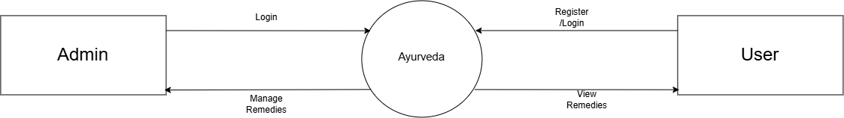

Level 1:

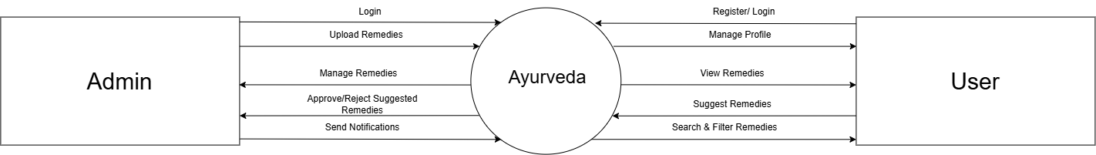

Table Definition:

- Table Name: admin

Key | Column Name | Data Type | Column width | Remark
pri | Id | int | 11 | Auto Increment
 | admin_email | varchar | 191
 | admin_password | varchar | 191

- Table Name: Register

Key | Column Name | Data Type | Column Width | Remark
pri | id | int | 11 | Auto Increment
 | Name | varchar | 255
 | Email | varchar | 255
 | Contact | long int

- Table Name : login_cred

Key | Column Name | Data Type | Column Width | Remark
pri | id | int | 11 | Auto Increment
 | Email | varchar | 255
 | Password | varchar | 255

- Table Name : remedies

Key | Column Name | Data Type | Column Width | Remark
pri | id | int | 11 | Auto Increment
 | Name | varchar | 255
 | Issues | varchar | 255
 | image | varchar
 | video | varchar
 | Benefits | varchar | 255

ER Diagram :

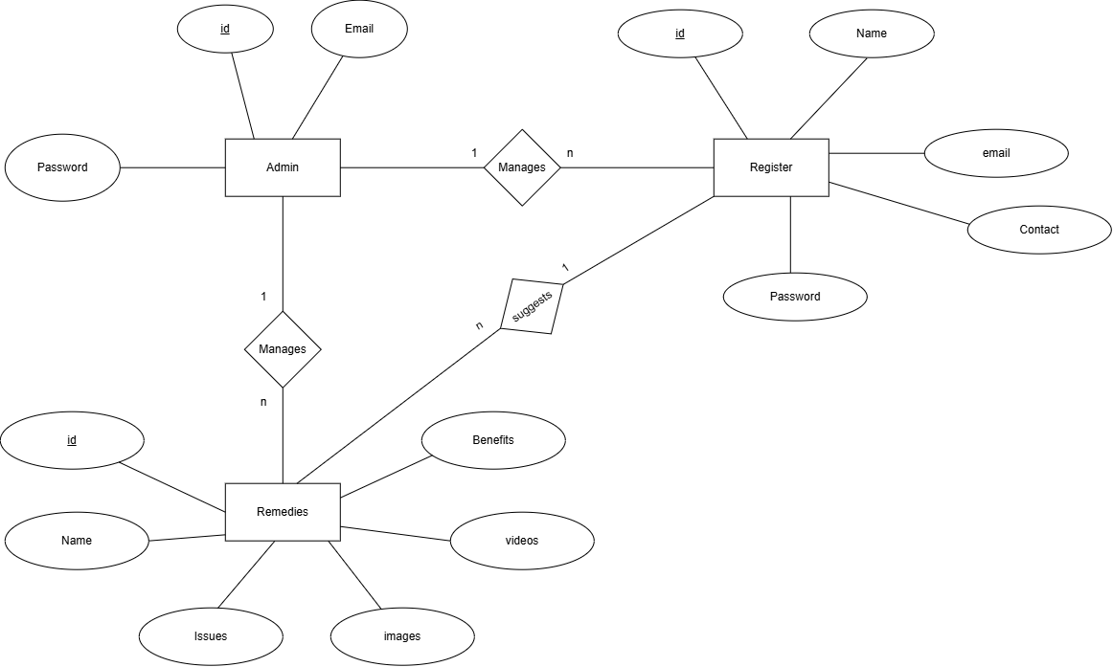

Conclusions:

In an age where people are eagerly returning to traditional roots for everyday wellness, this project turns age-old Ayurvedic knowledge into something accessible, structured, and easy to use. Built on Django and backed by a relational MySQL database, the platform cuts through the usual internet clutter, giving anyone quick access to natural home remedies for common troubles like sinus issues, headaches, or upset stomachs. By keeping browsing open to everyone while inviting registered users to share their own family-passed cures, it strikes a natural balance between open learning and community wisdom. Most importantly, having a dedicated admin review every user submission means bad advice gets filtered out, so the remedies people find are genuine, practical, and safe.
From a development perspective, bringing this project to life provided hands-on experience with core software principles—from implementing Django's MVT pattern and managing relational database schemas to handling user authentication and responsive UI design. While the current build solves the immediate need for a clean, verified remedy portal, the platform also leaves plenty of room to grow. Down the road, adding features like regional language support, direct consultations with certified Ayurvedic practitioners, or an intelligent symptom-matching tool can take it from a handy college project to a comprehensive digital sanctuary for holistic living.

