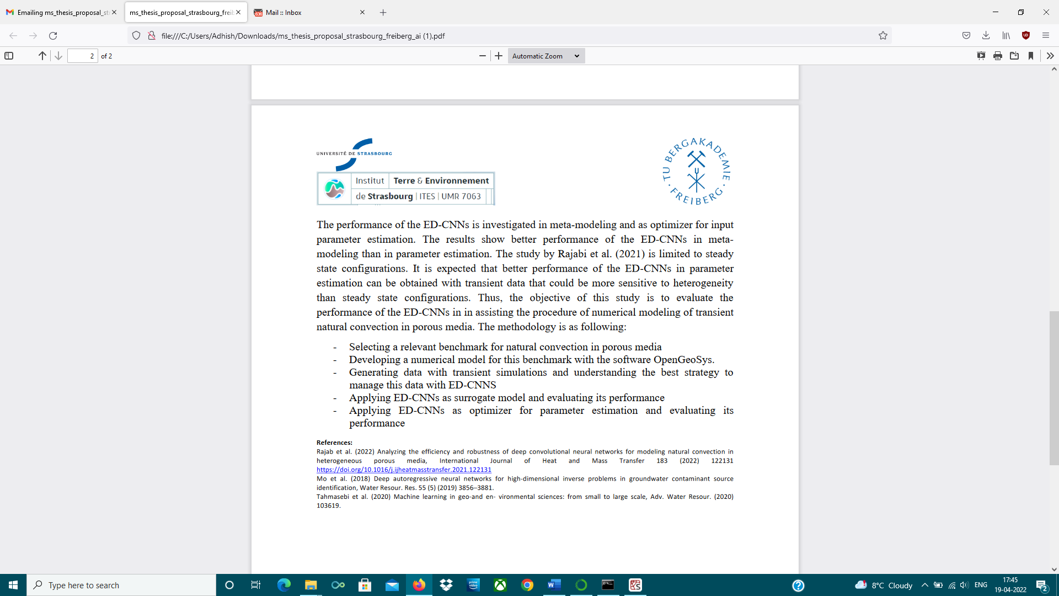Master Thesis  
Artificial Intelligence in Physics and Engineering:  
A new implementation of deep convolutional neural networks for modelling transient natural convection in porous media

Master Thesis Student:

* Adhish Guli Virupaksha (Matrkl. Nr. 65032)

Supervisors:

* Prof. Dr. Thomas Nagel (Full Professor, Chair of Soil Mechanics and foundation Engineering Technische Universität Bergakademie Freiberg)
* Prof. Marwan FAHS (Research Associate Professor, University of Strasbourg)
* Prof. Haibing Shao (Staff Scientist (Tenure-Track), Group Leader HCER UFZ Leipzig)

Contact:

* [thomas.nagel@ifgt.tu-freiberg.de](mailto:thomas.nagel@ifgt.tu-freiberg.de)
* [fahs@unistra.fr](mailto:fahs@unistra.fr) +33 (0)3 68 85 04 48
* [haibing.shao@ufz.de](mailto:haibing.shao@ufz.de) +49 341 235 1884

Abstract:

Deep learning neural networks (DLNNs) have yielded innovative/transformative results in diverse scientific disciplines. Several studies used DLNNs as surrogate models to replace mechanistic models in applications involving repetitive simulations such as parameter estimation, uncertainty analysis or optimization problems (Mo et al., 2019; Tahmasebi et al., 2020). They showed that, compared to traditional and standard interpolators, DLNNs are more robust in representing complex nonlinear processes, capturing hidden information, and learning advanced representations.

Encoder-Decoder Convolutional Neural Networks (ED-CNNs) are a specialized DLNN architecture well-suited for image-to-image regression. Recently, Rajabi et al. (2021) investigated the performance of ED-CNNs in assisting the procedure of numerical modeling of natural convection in porous media. In that paper, the ED-CNNs are applied to develop a methodology for image-to-image regression. The performance of the ED-CNNs is investigated in meta-modeling and as optimizer for input parameter estimation. The results show better performance of the ED-CNNs in meta-modeling than in parameter estimation. The study by Rajabi et al. (2021) is limited to steady state configurations. It is expected that better performance of the ED-CNNs in parameter estimation can be obtained with transient data that could be more sensitive to heterogeneity than steady state configurations.

Thus, the objective of this study is to evaluate the performance of the ED-CNNs in assisting the procedure of numerical modeling of transient natural convection in porous media. The methodology is as following:

* Selecting a relevant benchmark for natural convection in porous media.
* Developing a numerical model for this benchmark with the software OpenGeoSys.
* Generating data with transient simulations and understanding the best strategy to manage this data with ED-CNNs.
* Applying ED-CNNs as surrogate model and evaluating its performance.
* Applying ED-CNNs as optimizer for parameter estimation and valuating its performance.

References:

Rajab et al. (2022) Analyzing the efficiency and robustness of deep convolutional neural networks for modeling natural convection in heterogeneous porous media, International Journal of Heat and Mass Transfer 183 (2022) 122131  
<https://doi.org/10.1016/j.ijheatmasstransfer.2021.122131>

Mo et al. (2018) Deep autoregressive neural networks for high-dimensional inverse problems in groundwater contaminant source identification, Water Resour. Res. 55 (5) (2019) 3856–3881.

Tahmasebi et al. (2020) Machine learning in geo-and en- vironmental sciences: from small to large scale, Adv. Water Resour. (2020) 103619.