23CS2049-Web Technology Lab │URK24CS1261
Ex. No. 6 | JAVASCRIPT - STYLES AND ANIMATIONS
Date of Exercise | ____________________
GitHub Host Link | https://github.com/adhishm-0/web-technology-lab/tree/main/exp%206

Aim
To create webpages using JavaScript styles, timing events, Date objects, classes and objects, and animations.

Description
This experiment demonstrates five programs: a digital clock, a changing background color, mouse-based font resizing, a moving car animation, and student record display with birth-year classification. Runnable files are provided in the accompanying source folder.

IMPORTANT COMMANDS USED :
- setInterval() and setTimeout() — schedule repeated or delayed code
- clearInterval() and clearTimeout() — stop scheduled actions
- Date(), getHours(), getMinutes(), getSeconds() — read current time
- element.style.property — changes an element’s CSS style
- addEventListener() — responds to mouse and button actions
- class, constructor(), new — define and create objects
- document.getElementById(), textContent — access and update page content

Procedure
- Create index.html, style.css, and script.js.
- Add one section and result area for each question.
- Use Date and setInterval() for the clock.
- Generate RGB values and update the background every 30 seconds.
- Use mouseover and mouseout to resize the paragraph.
- Move the car with setTimeout() and stop it on button click.
- Create Student objects and categorize students by birth year.
- Open the page in a browser and verify each output.

Question 1: Digital Clock

Program Code
HTML:
<output id="clock" aria-live="polite"></output>

JavaScript:
function displayTime() {
const now = new Date();
const pad = value => String(value).padStart(2, "0");
document.getElementById("clock").textContent =
`${pad(now.getHours())}:${pad(now.getMinutes())}:${pad(now.getSeconds())}`;
}
displayTime();
window.setInterval(displayTime, 1000);

Program Output
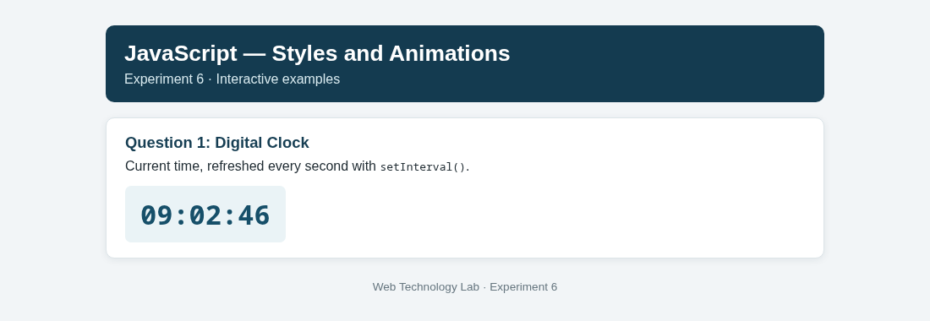
Output 1: The program displays the result for digital clock.

Question 2: Dynamic Background Color

Program Code
HTML:
<button id="changeColor">Change Color Now</button>
<span id="colorValue"></span>

JavaScript:
function setBackgroundColor() {
const rgb = Array.from({ length: 3 }, () => Math.floor(Math.random() * 256));
const color = `rgb(${rgb.join(", ")})`;
document.body.style.backgroundColor = color;
document.getElementById("colorValue").textContent = color;
}
setBackgroundColor();
window.setInterval(setBackgroundColor, 30000);
document.getElementById("changeColor").addEventListener("click", setBackgroundColor);

Program Output
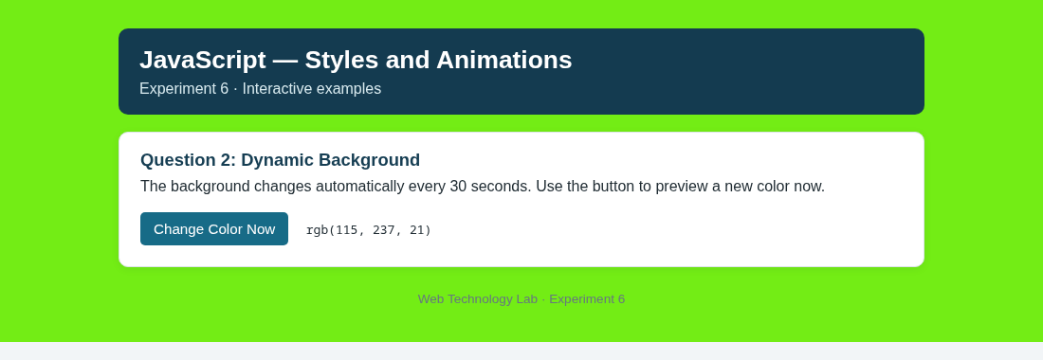
Output 2: The program displays the result for dynamic background color.

Question 3: Mouse Font Size

Program Code
HTML:
<p id="zoomText">Move the pointer over this paragraph to enlarge it.</p>

JavaScript:
const zoomText = document.getElementById("zoomText");
zoomText.addEventListener("mouseover", () => { zoomText.style.fontSize = "28px"; });
zoomText.addEventListener("mouseout", () => { zoomText.style.fontSize = "16px"; });

Program Output
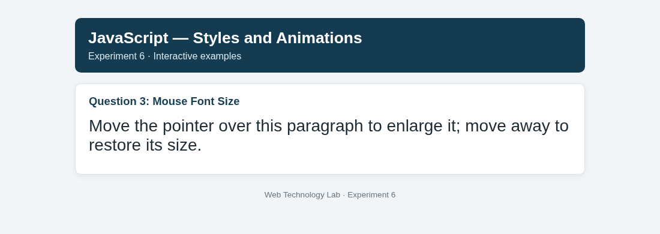
Output 3: The program displays the result for mouse font size.

Question 4: Move and Stop the Car

Program Code
HTML and CSS:
<div id="track"><span id="car" role="img" aria-label="car">🚗</span></div>
<button id="moveCar">Move</button><button id="stopCar">Stop</button>
<style>
#track { position: relative; width: 560px; height: 76px; overflow: hidden; }
#car { position: absolute; left: 0; top: 12px; font-size: 42px; }
</style>

JavaScript:
const car = document.getElementById("car");
const track = document.getElementById("track");
let animationTimer = null;
function moveRight() {
const maxLeft = track.clientWidth - car.offsetWidth;
const nextLeft = car.offsetLeft + 2;
if (nextLeft >= maxLeft) { car.style.left = `${maxLeft}px`; animationTimer = null; return; }
car.style.left = `${nextLeft}px`;
animationTimer = window.setTimeout(moveRight, 20);
}
function startCar() { if (animationTimer === null) moveRight(); }
function stopCar() {
if (animationTimer !== null) window.clearTimeout(animationTimer);
animationTimer = null;
}
document.getElementById("moveCar").addEventListener("click", startCar);
document.getElementById("stopCar").addEventListener("click", stopCar);

Program Output
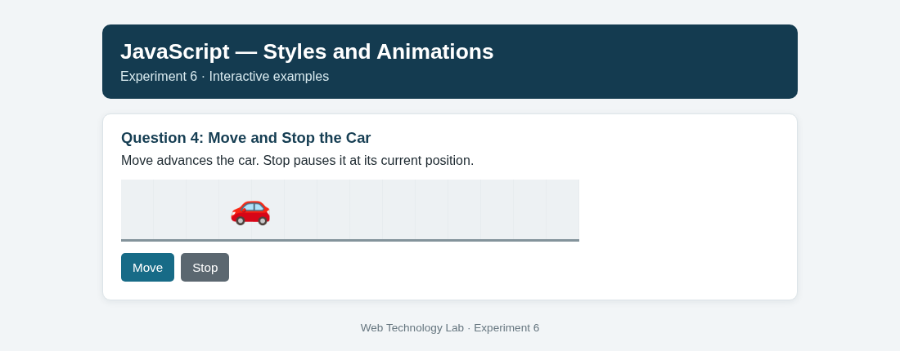
Output 4: The program displays the result for move and stop the car.

Question 5: Student Records and Birth-Year Category

Program Code
HTML:
<ul id="studentList"></ul>

JavaScript:
class Student {
constructor(name, regno, yearOfBirth) {
this.name = name; this.regno = regno; this.yearOfBirth = yearOfBirth;
}
}
const students = [
new Student("John", "UR13CS129", 1995), new Student("Joseph", "UR13CS456", 1998),
new Student("Maya", "UR13CS789", 2002), new Student("Arun", "UR13CS231", 2004)
];
const studentList = document.getElementById("studentList");
students.forEach(student => {
const category = student.yearOfBirth < 2000 ? "Born before 2000" : "Born after 2000";
const item = document.createElement("li");
item.textContent = `${student.name}'s Register Number is ${student.regno} — ${category}`;
studentList.appendChild(item);
});

Program Output
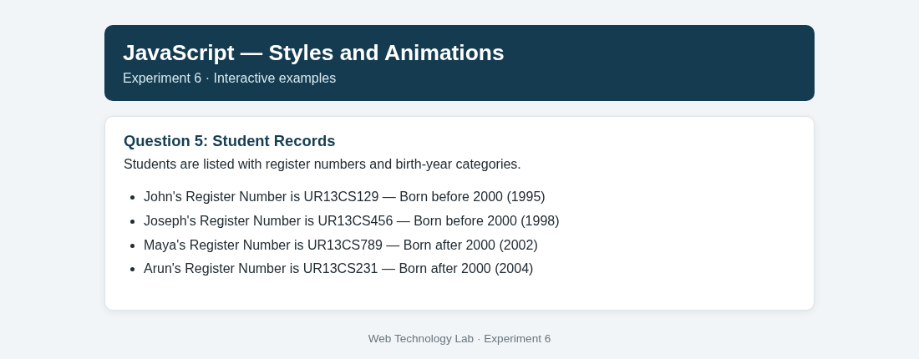
Output 5: The program displays the result for student records and birth-year category.

Result
All five JavaScript programs were implemented successfully. The runnable webpage displays the clock, changes its background, responds to pointer movement, animates the car, and lists students by birth-year category. Browser output screenshots are included above.

