23CS2049-Web Technology Lab │ URK24CS1261
Ex. No. 7 | JAVASCRIPT - WORKING WITH JQUERY
Date of Exercise | ____________________
GitHub Host Link | https://github.com/adhishm-0/web-technology-lab/tree/main/EXP7

Aim
To create an interactive website using jQuery actions for budget calculation, cake order calculation, and car customization.

Description
jQuery is a JavaScript library that simplifies HTML traversal, manipulation, event handling, animation, and Ajax. This experiment uses jQuery selectors and event handlers to calculate a budget allocation, calculate cake order costs, and customize a car preview. The budget percentages must total 100%. The cake example uses the prices and 9% tax from the laboratory cake order exercise; a selectable tip is added after tax.

IMPORTANT COMMANDS USED :
- $(document).ready() / $(function(){}) — run code after the page is ready
- $(selector) — select page elements
- val() — read or set input values
- text() and html() — update page content
- on() — attach event handlers
- css() — change a selected element’s style
- addClass(), removeClass(), toggle() — update element state

Procedure
- Create index.html, style.css, and script.js.
- Load jQuery 3.6.0 and wait for document ready.
- Create a budget form with amount, percentage inputs, and result fields.
- Calculate cake subtotal, tax, tip, and total from selected quantities.
- Create the car preview and paint, wheel, tint, and spoiler controls.
- Use jQuery events and selectors to update calculations and the live preview.
- Open the webpage in a browser and verify all three questions.

Question 1: Budget Calculator

Program code
HTML:
<input id="budgetAmount" type="number" placeholder="Monthly amount">
<input id="rentPercent" type="number" value="30">
<input id="accessoriesPercent" type="number" value="25">
<input id="emergencyPercent" type="number" value="15">
<input id="savingPercent" type="number" value="30">
<button id="evaluateBudget">Evaluate My Money</button>
<strong id="rentValue"></strong><strong id="accessoriesValue"></strong>
<strong id="emergencyValue"></strong><strong id="savingValue"></strong>
jQuery:
$("#budgetForm").on("submit", function (event) {
event.preventDefault();
const amount = Number($("#budgetAmount").val());
const percentages = ["#rentPercent", "#accessoriesPercent", "#emergencyPercent", "#savingPercent"]
.map(selector => Number($(selector).val()));
if (amount <= 0 || percentages.some(value => value < 0 || value > 100) ||
percentages.reduce((sum, value) => sum + value, 0) !== 100) {
window.alert("Enter a positive amount and percentages that add up to 100%.");
return;
}
$("#rentValue").text(money(amount * percentages[0] / 100));
$("#accessoriesValue").text(money(amount * percentages[1] / 100));
$("#emergencyValue").text(money(amount * percentages[2] / 100));
$("#savingValue").text(money(amount * percentages[3] / 100));
});

Program Output
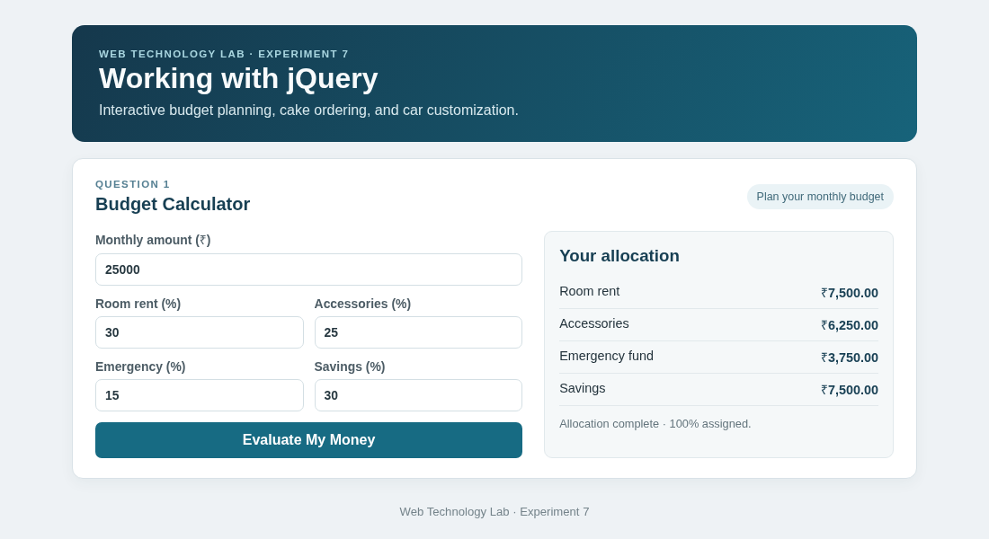
Output 1: The page displays the completed budget calculator example.

Question 2: Cake Order Calculator

Program code
HTML:
<input id="smallQty" type="number" min="0" value="1">
<input id="mediumQty" type="number" min="0" value="2">
<input id="largeQty" type="number" min="0" value="1">
<select id="tipPercent"><option value="10">10%</option></select>
<button id="calculateCake">Calculate order</button>
<strong id="cakeSubtotal"></strong><strong id="cakeTax"></strong>
<strong id="cakeTip"></strong><strong id="cakeTotal"></strong>
jQuery:
function calculateCakeOrder() {
const small = Number($("#smallQty").val());
const medium = Number($("#mediumQty").val());
const large = Number($("#largeQty").val());
const subtotal = small * 100 + medium * 200 + large * 400;
const tax = subtotal * 0.09;
const afterTax = subtotal + tax;
const tip = afterTax * Number($("#tipPercent").val()) / 100;
$("#cakeSubtotal").text(money(subtotal));
$("#cakeTax").text(money(tax));
$("#cakeTip").text(money(tip));
$("#cakeTotal").text(money(afterTax + tip));
}
$("#calculateCake, #smallQty, #mediumQty, #largeQty, #tipPercent")
.on("click input change", calculateCakeOrder);

Program Output
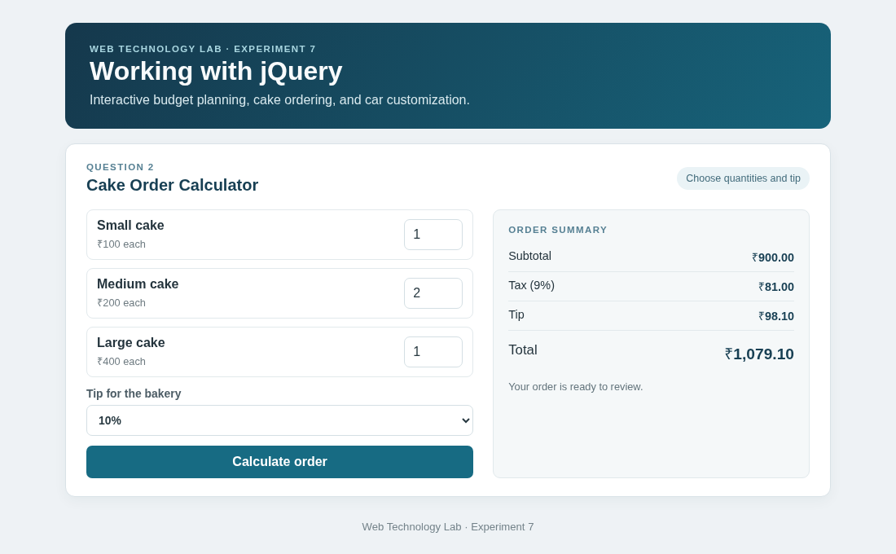
Output 2: The page displays the completed cake order calculator example.

Question 3: Car Body Workshop

Program code
HTML:
<svg id="carPreview"><path id="carBody" fill="#187da1"/><!-- car body and parts --></svg>
<button class="swatch" data-color="#c94b4b" data-name="Racing red">Red</button>
<select id="wheelFinish"><option value="#d2a745">Gold alloy</option></select>
<input id="windowTint" type="range" min="0" max="80" value="20">
<input id="spoilerToggle" type="checkbox"> Add rear spoiler
jQuery:
$(".swatch").on("click", function () {
$("#carBody").css("fill", $(this).data("color"));
$("#paintName").text($(this).data("name"));
$(".swatch").removeClass("active");
$(this).addClass("active");
});
$("#wheelFinish").on("change", function () {
$(".wheel circle:nth-child(2)").css("fill", $(this).val());
});
$("#windowTint").on("input", function () {
const tint = Number($(this).val());
$("#tintValue").text(`${tint}%`);
$("#carPreview path").filter(function () {
return $(this).attr("fill") === "#bfe8f4";
}).css("fill", `rgba(18, 49, 65, ${tint / 100})`);
});
$("#spoilerToggle").on("change", function () {
$("#spoiler").toggle(this.checked);
});

Program Output
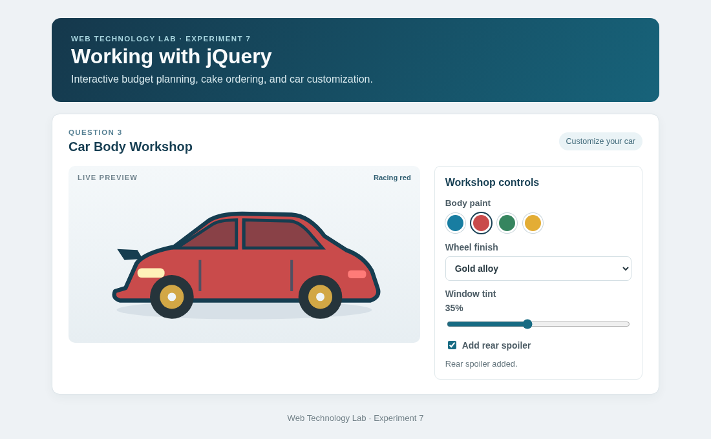
Output 3: The page displays the completed car body workshop example.

Result
The jQuery web application was implemented successfully. It validates and allocates a budget, calculates a cake order, and updates the car workshop preview through interactive jQuery actions.

