Ex. No. 9 | WORKING WITH MONGODB USING SHELL COMMANDS
Date of Exercise | 13/10/2026
GitHub Host Link | https://github.com/adhishm-0/web-technology-lab/tree/main/EXP9
Objective
To perform database operations such as creating a database and collections, inserting and retrieving documents, updating and deleting records, querying data, sorting results, and counting documents using MongoDB Shell commands.
Description
MongoDB is a NoSQL, document-oriented database that stores BSON documents in collections. MongoDB Shell (mongosh) is a JavaScript-based command-line interface for database operations. The experiment uses mongosh to create collections, insert and retrieve records, apply conditions, update and delete data, sort results, and count documents.
IMPORTANT COMMANDS USED :
• use databaseName — select or create a database
• db.createCollection() — create a collection
• insertOne() / insertMany() — add documents
• find() / findOne() — retrieve matching documents
• updateOne() / updateMany() with $set and $inc — modify records
• deleteOne() / deleteMany() — remove records
• sort(), limit(), countDocuments() — sort, limit, and count
• $gt, $lt, $gte, $lte, $in — query operators
Procedure
1. Start mongosh and connect to a MongoDB server.
2. Select the database and create the required collection.
3. Insert the sample documents for each question.
4. Retrieve records with find() and apply the requested filters.
5. Update records and verify the change with a follow-up query.
6. Delete matching records and display the remaining documents.
7. Sort, limit, and count documents as required.
The output panels show captured mongosh results from the sample MongoDB databases. Run the JavaScript files in a MongoDB shell to execute the commands.

Question 1: Student Database Management
Program code
// Question 1 — Student Database Management
use CollegeDB;
if (!db.getCollectionNames().includes("students")) db.createCollection("students");
const students = db.students;
students.insertOne({ rollNo: 101, name: "Arun", department: "CSE", age: 20, mark: 85 });
students.insertMany([
{ rollNo: 102, name: "Priya", department: "IT", age: 21, mark: 92 },
{ rollNo: 103, name: "Kumar", department: "CSE", age: 19, mark: 78 },
{ rollNo: 104, name: "Divya", department: "ECE", age: 20, mark: 88 },
{ rollNo: 105, name: "Ravi", department: "CSE", age: 22, mark: 67 }
]);
print("All student records:"); printjson(students.find({}, { _id: 0 }).toArray());
print("Student with roll number 103:"); printjson(students.findOne({ rollNo: 103 }, { _id: 0 }));
print("Students scoring above 80:"); printjson(students.find({ mark: { $gt: 80 } }, { _id: 0
}).toArray());
print("Update Arun's marks:"); printjson(students.updateOne({ rollNo: 101 }, { $set: { mark: 90 } }));
print("Delete Ravi by roll number:"); printjson(students.deleteOne({ rollNo: 105 }));
print("Remaining students:"); printjson(students.find({}, { _id: 0 }).toArray());
Program Output
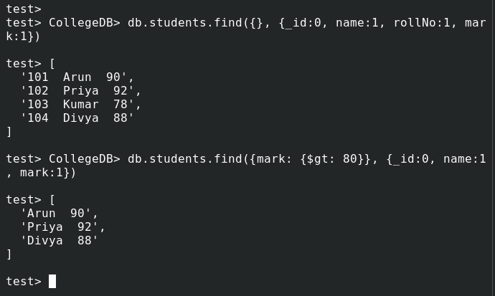
Output 1: CollegeDB and students: insertion, retrieval, queries, update, and delete.

Question 2: Employee Database
Program code
// Question 2 — Employee Database
use EmployeeDB;
if (!db.getCollectionNames().includes("employees")) db.createCollection("employees");
const employees = db.employees;
employees.insertMany([
{ employeeId: 201, name: "Meera", department: "HR", salary: 42000, experience: 4 },
{ employeeId: 202, name: "Rohan", department: "IT", salary: 58000, experience: 6 },
{ employeeId: 203, name: "Asha", department: "Sales", salary: 38000, experience: 3 },
{ employeeId: 204, name: "Vikram", department: "IT", salary: 72000, experience: 9 },
{ employeeId: 205, name: "Nila", department: "HR", salary: 46500, experience: 5 }
]);
print("All employees:"); printjson(employees.find({}, { _id: 0 }).toArray());
print("Employees earning more than Rs. 40,000:");
printjson(employees.find({ salary: { $gt: 40000 } }, { _id: 0 }).toArray());
print("Update employee 203 salary to Rs. 41,000:");
printjson(employees.updateOne({ employeeId: 203 }, { $set: { salary: 41000 } }));
print("Employees by descending salary:");
printjson(employees.find({}, { _id: 0 }).sort({ salary: -1 }).toArray());
print("Employees in IT:", employees.countDocuments({ department: "IT" }));
Program Output
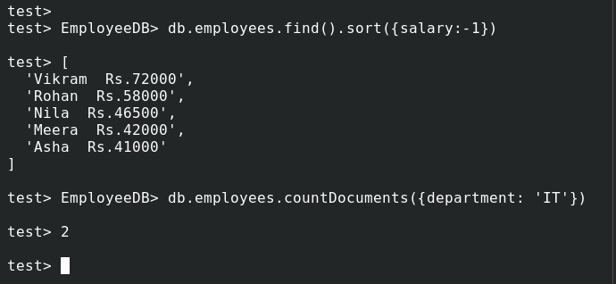
Output 2: EmployeeDB: salary filters, update, descending sort, and department count.

Question 3: Product Database
Program code
// Question 3 — Product Database
use ProductDB;
if (!db.getCollectionNames().includes("products")) db.createCollection("products");
const products = db.products;
products.insertMany([
{ productId: 301, name: "Keyboard", category: "Accessories", price: 850, stock: 24 },
{ productId: 302, name: "Mouse", category: "Accessories", price: 550, stock: 0 },
{ productId: 303, name: "Headphones", category: "Audio", price: 1800, stock: 12 },
{ productId: 304, name: "Monitor", category: "Display", price: 12500, stock: 8 },
{ productId: 305, name: "Webcam", category: "Accessories", price: 1950, stock: 5 },
{ productId: 306, name: "Speaker", category: "Audio", price: 2300, stock: 14 }
]);
print("Accessories:"); printjson(products.find({ category: "Accessories" }, { _id: 0 }).toArray());
print("Products priced Rs. 500–2,000:");
printjson(products.find({ price: { $gte: 500, $lte: 2000 } }, { _id: 0 }).toArray());
print("Increase keyboard stock by 10:");
printjson(products.updateOne({ productId: 301 }, { $inc: { stock: 10 } }));
print("Delete out-of-stock products:"); printjson(products.deleteMany({ stock: 0 }));
print("Five most expensive products:");
printjson(products.find({}, { _id: 0 }).sort({ price: -1 }).limit(5).toArray());
Program Output
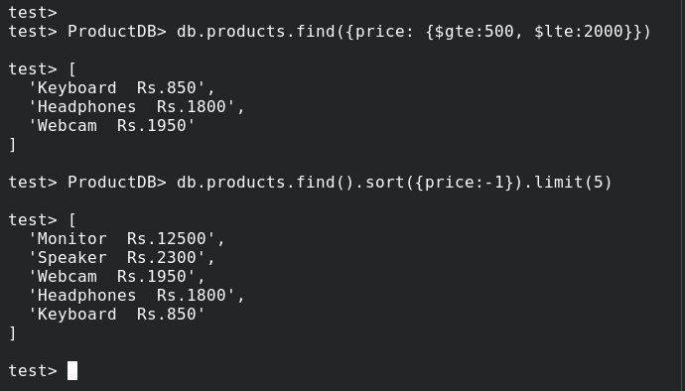
Output 3: ProductDB: category and price filters, stock update, deletion, and top five.

Question 4: Library Database
Program code
// Question 4 — Library Database
use LibraryDB;
if (!db.getCollectionNames().includes("books")) db.createCollection("books");
const books = db.books;
books.insertMany([
{ bookId: 401, title: "Algorithms", author: "Cormen", category: "Computing", price: 950 },
{ bookId: 402, title: "Clean Code", author: "Robert Martin", category: "Computing", price: 780 },
{ bookId: 403, title: "Dune", author: "Frank Herbert", category: "Fiction", price: 620 },
{ bookId: 404, title: "Pride and Prejudice", author: "Jane Austen", category: "Classic", price: 500 },
{ bookId: 405, title: "The Hobbit", author: "J. R. R. Tolkien", category: "Fantasy", price: 700 }
]);
print("Books by Cormen:"); printjson(books.find({ author: "Cormen" }, { _id: 0 }).toArray());
print("Computing books:"); printjson(books.find({ category: "Computing" }, { _id: 0 }).toArray());
print("Update Dune price to Rs. 680:");
printjson(books.updateOne({ bookId: 403 }, { $set: { price: 680 } }));
print("Books alphabetically by title:");
printjson(books.find({}, { _id: 0 }).sort({ title: 1 }).toArray());
print("Total books:", books.countDocuments());
Program Output
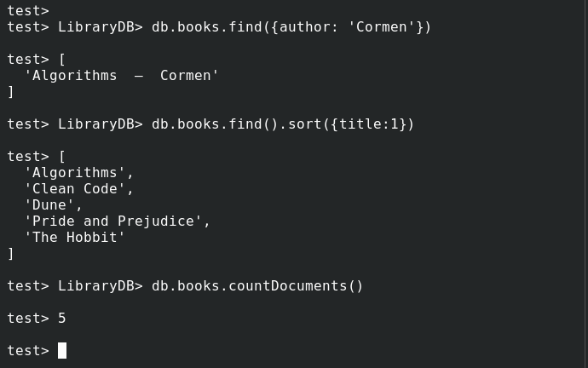
Output 4: LibraryDB: author and category searches, price update, title sort, and count.

Question 5: Query Operations
Program code
// Question 5 — Query Operations on students
use CollegeDB;
if (!db.getCollectionNames().includes("students")) {
db.createCollection("students");
db.students.insertMany([
{ rollNo: 101, name: "Arun", department: "CSE", age: 20, mark: 85 },
{ rollNo: 102, name: "Priya", department: "IT", age: 21, mark: 92 },
{ rollNo: 103, name: "Kumar", department: "CSE", age: 19, mark: 78 },
{ rollNo: 104, name: "Divya", department: "ECE", age: 20, mark: 88 },
{ rollNo: 105, name: "Ravi", department: "CSE", age: 22, mark: 67 }
]);
}
const students = db.students;
print("Students with marks >= 75:");
printjson(students.find({ mark: { $gte: 75 } }, { _id: 0 }).toArray());
print("Students younger than 21:");
printjson(students.find({ age: { $lt: 21 } }, { _id: 0 }).toArray());
print("Students in CSE or IT:");
printjson(students.find({ department: { $in: ["CSE", "IT"] } }, { _id: 0 }).toArray());
print("Top three students by marks:");
printjson(students.find({}, { _id: 0 }).sort({ mark: -1 }).limit(3).toArray());
print("Add 5 marks to all CSE students:");
printjson(students.updateMany({ department: "CSE" }, { $inc: { mark: 5 } }));
printjson(students.find({}, { _id: 0 }).toArray());
Program Output
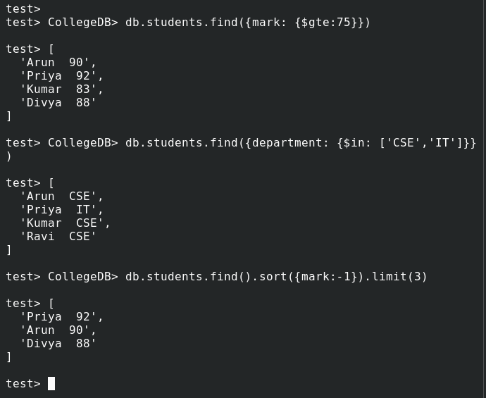
Output 5: Student queries using $gte, $lt, $in, sort(), limit(), and updateMany().

Result
MongoDB Shell commands were prepared for database and collection creation, document insertion and retrieval, conditional queries, record updates and deletions, sorting, limiting, and counting documents.

