1. Use the package RcmdrPlugin.IPSUR.

data(RcmdrTestDrive)

and perform the below operations:

1. **Calculate the average salary by gender and smoking status.**

**ANSWER:**

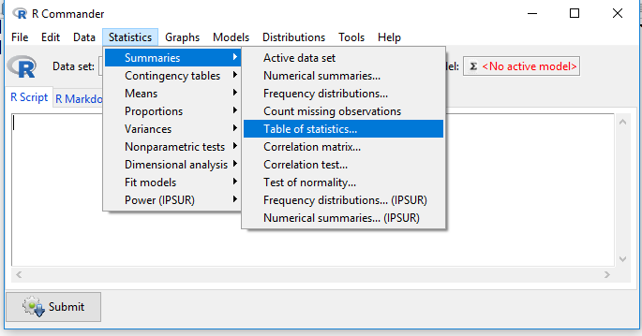

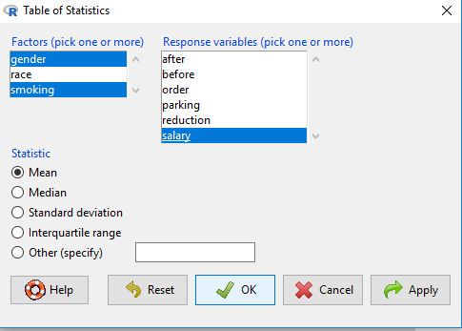

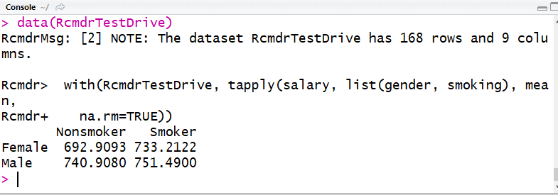

1. **Which gender has the highest mean salary?**

**ANSWER:**

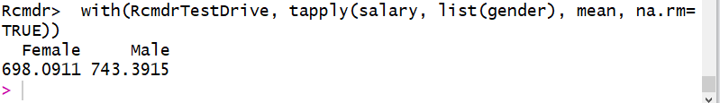

**MALE is having the highest mean salary.**

1. **Report the highest mean salary.**

**ANSWER:**

**Highest mean salary according to gender is 743.3915.**

**Highest mean salary according to gender and smoking status is 751.49.**

1. **Compare the spreads for the genders by calculating the standard deviation of salary by gender.**

**ANSWER:**

