library(RcmdrPlugin.IPSUR)

data(RcmdrTestDrive)

Perform the below operations:

**1. Compute the measures of central tendency for salary and reduction which variable has highest center?**

**ANSWER:**

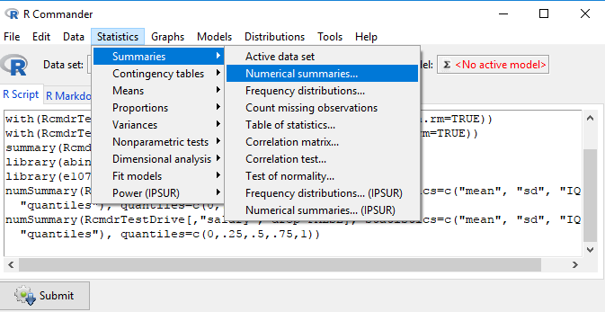

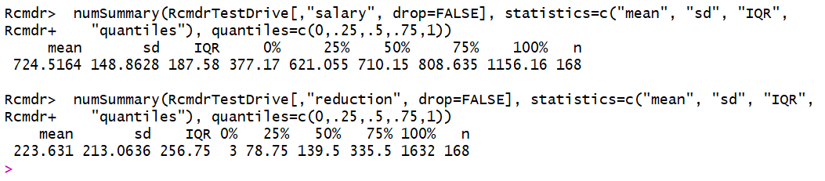

Salary has highest center.

**2. Which measure of center is more appropriate for before and after?**

**ANSWER:**

Mean is most appropriate measure of center for before and after.

