ALGORITHM

The algorithm for down sampling an image consists of two main parts. First phase of the algorithm is smoothing the image using a Gaussian Filter. Then the filtered image is downsampled using a down sampling algorithm.

FILTERING ALGORITHM

For filtering the image, a 3x3 kernel is used. This kernel is weighted such that the kernel is symmetric in all directions (i.e. Gaussian). This kernel is shown in the figure below.

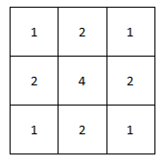

*3x3 Gaussian Kernel*

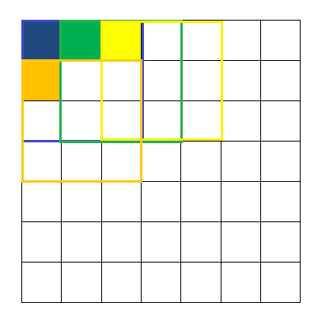This kernel is initiated at the top left corner of the image and then traversed throughout the image horizontally. While the kernel is traversed, the value of the pixel values averaged using the overlapping weights of the kernel is stored at the top left corner pixel of the pixel block overlapping that kernel at the time. This pixel corresponds to the assigned RAM location. The following diagram describes the motion of the kernel and the location (hypothetical) of data storage.

The colored pixel contains the weighted average sum of the pixel block squared by the similar color.

DOWN SAMPLING ALGORITHM

After smoothing, the image is down sampled to the ratio 1:2. For this a pixel from each noon overlapping block of four pixels is taken and stored as the desired down sampled image. The following figure shows the (hypothetical) storage of the down sampled image.

Memory Allocation

Original Image

Down Sampled Image

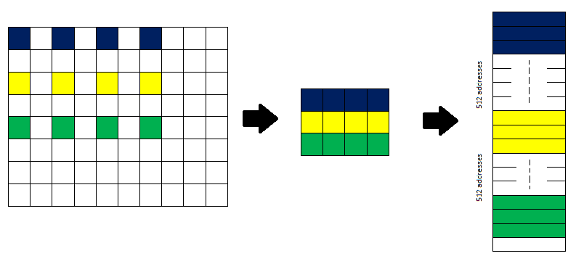

As shown in the diagram, adjacent pixels vertically below are spaced 512 addresses. This is so because although the down sampled image is depicted in a 2D array, in memory it is stored as a 1D array.