

**FPGA Based Processor Design**

**Down Sample an Image**

Dias, K. M. G. D. A. W. 140125B

Fernando, H. D. 140154L

Fernando, W. A. S. C. 140163M

Rasanka, D. V. Y. 140517E

This is submitted as a partial fulfillment for the module

EN3030: Electronic Circuits and System Design

Department of Electronic and Telecommunication Engineering

University of Moratuwa

28th of August, 2017

TABLE OF CONTENTS

1. INTRODUCTION **........................................................................................................................................ 3**

1.1 CPU AND PROCESSOR DESIGN ......................................................................................................... 3

1.2 PROBLEM STATEMENT ..................................................................................................................... 4

1.3 GENERAL OVERVIEW OF THE SOLUATION ....................................................................................... 6

2. INSTRUCTION SET ARCHITECTURE RISC AND CISC ........................................................................................... **7**

2.1 GENERAL ARCHITECTURE................................................................................................................. 7

2.2 DATA PATH ....................................................................................................................................... 8

2.3 INSTRUCTION SET ............................................................................................................................ 9

2.4 FETCH, DECODE, EXCUTION CYCLE ................................................................................................. 10

3. MODULES **................................................................................................................................................ 20**

3.1 REGISTERS ....................................................................................................................................... 20

3.2 DEMULTIPLEXER.............................................................................................................................. 22

3.3 ALU ................................................................................................................................................. 22

3.4 CLOCK DIVIDER ............................................................................................................................... 23

3.5 STATE MACHINE.............................................................................................................................. 24

3.6 PROCESSOR .................................................................................................................................... 25

3.7 COMMUNICATION RELATED MODULES......................................................................................... 25

3.8 MEMORY MODULES....................................................................................................................... 26

3.9 TOP MODULE ................................................................................................................................. 26

3.10 RTL VIEW OF THE PROCESSOR..................................................................................................... 27

3.11 RTL VIEW OF THE TOP MODULE................................................................................................... 28

4. ALGORITHMS **.......................................................................................................................................... 30**

4.1 FILTERING ALGORITHM .................................................................................................................. 30

4.2 DOWN SAMPLING ALGORITHM...................................................................................................... 34

4.3 ASSEMBLY CODE FOR THE ALGORITHM.......................................................................................... 38

5. TESTING, SIMULATION AND MODIFICATION................................................................................................... **41**

5.1 TESTING AND SIMULATION............................................................................................................. 41

5.2 MODIFICATIONS............................................................................................................................. 45

6. RESULT ANALYZING AND VERIFICATION......................................................................................................... **46**

6.1 GENERATE REFERENCE OUTPUT IMAGE ........................................................................................ 46

6.2 RESULTS VERIFICATION AND ANALYSIS.......................................................................................... 46

6.3 ERROR ANALYSIS ............................................................................................................................ 47

7. DESIGN SUMMARY **................................................................................................................................. 49**

8. REFERENCES.................................................................................................................................................... **56**

9. APPENDIXES **.......................................................................................................................................... 57**

1. INTRODUCTION

The objective of this project is to design a task specific microprocessor and CPU (Central Processing Unit) model to down-sample an image after eliminating its high frequency components and simulate the processor design using the Verilog hardware description language (HDL), and finally to implement it in hardware using programmable logic device such as Field Programmable Gate Array (FPGA). As an approach, design of an Instruction Set Architecture (ISA) and devising a suitable algorithm to down-sample the image are undertaken. The document describes the algorithm used to eliminate the high frequency components of the image, down-sample of the image and the ISA of the processor to be implemented on FPGA.

* 1. CPU AND PROCESSOR DESIGN

The architecture of the processor is such that the processing unit contains ALU, control unit and memory apart from the input and output of the system.

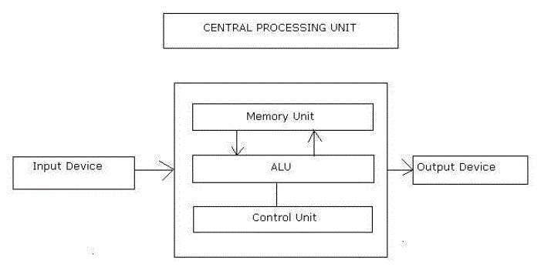

The following sections discuss the implementation of the processor with a collection of submodules mainly forming the units shown above. We designed 2 processors to down sample an image. One is based on the Reduced Instruction Set Architecture (RISC) which is faster in nature and tries to complete on operation in one clock cycle. The other one is based on Complex Instruction Set Architecture (CISC) which is more commonly used in most of the computers. We try to optimise both the design with the knowledge we have on processors, their architecture and FPGA. This document provides the summary and details where needed about the process of completing the task, which is down-sampling an image using a processor implemented on FPGA.

* 1. PROBLEM STATEMENT

Problem state identifies the problem to be addressed in detail.

The main requirement is to design a CPU and a microprocessor for filtering and down sampling a given image converting the 512 x 512 pixel image to a 256 x 256 pixel image. The CPU should communicate with the computer in order to receive the image. Then it should save the received image in the main memory, as no such need for a secondary memory and process the image in order to down-sample. Afterwards, the CPU should send back the pixel values of the down-sampled image back to the computer Matlab programme to display the image. The task can be achieved by dividing the task into sub tasks.

**Take input and store in the RAM**

Matlab software generates a 1D array using the 2D image so that it can be transmitted to the RAM in FPGA board by Universal Asynchronous Receive and Transmit (UART) protocol byte by byte. UART protocol should be implemented inside the processor to receive and transmit data. RAM memory should be accessed and the pixel values should be stored one after the other in the memory. Transmission and receive of the pixel values is a major concern in the project. Apart from transmitting the image to the designed processor, there may be a need to transfer the instructions written in assembly language equivalent programme to down-sample the image.

**Filter the image**

Simplest way to down-sample the image is to take every other pixel from the received image and then transmit the pixel values. The issue with this method is that it cannot preserve the qualities of the original image. High frequency components in are the cause of the mentioned issue. This issue can be slightly overcome by averaging the near pixel value and then down-sampling the image but still it would not yield a good outcome. Therefore, in order to obtain a reduced image with the features identical to the original image, the image should be filtered in order to eliminate the high frequency components from the image. This task can be done by using Gaussian filter implantation in the FPGA. After processing the raw data with Gaussian filter, processed data can be stored in the same primary memory.

**Down sample the filtered image**

After filtering the original image, in this section we consider down sampling the filtered image. As given in the requirements in this process image has to be down sampled into half of the size. Down-sampling process also should be implemented on the FPGA and after doing the down sampling process; data can be stored in the primary memory by overwriting the data written to the memory.

**Send back the image and display**

After doing the given tasks to the original image the processed data should be returned serially to back to the computer and the down-sampled image should be displayed. UART transmitter should be implemented on the FPGA in order to transmit the processed data from FPGA to the computer. Serial communication software (or Matlab) can be used to collect the data.

**Down-sample image using Matlab**

Apart from receiving the image, Matlab software should be used to down-sample image so that the results can be compared to access the quality of the image down-sampled inside the designed processor on FPGA board.

* 1. OVERVIEW OF THE SOLUTION

Field Programmable Gate Array can be used to design a processor capable of down-sampling an image after eliminating the high frequency components of the image. Atlys Spartan-6 FPGA board is used to implement the designed processor.

The first and foremost task is to design the UART receiving model so that the image can be transferred to the RAM inside the FPGA using serial communication. Then, a processor is specifically designed to handle the arithmetic and logical operations needed to perform the required operations. ISA is capable of addressing the operations required for the implementation of the algorithm.

Design can be done by dividing the complex solution into smaller sub modules.

The procedure can be identified as design of ISA and processor architecture, model the designed architecture using Verilog HDL, test the correctness of the implementation by simulation results, and implement the design in the FPGA board.

The solution includes receive the image through UART and writing the data in the memory, filter and down-sample the image using the designed processor, and send the down-sampled image back to the computer.

The effectiveness of the solution can be verified by carrying out an error analysis using MATLAB.

1. INSTRUCTION SET ARCHITECTURE (ISA) - CISC

Instruction architecture defines the architecture of the design in detail. This section includes details about the general architecture of a processing unit, data path and how the components are connected in register transfer level, instruction set itself and the procedure of the instruction execution.

* 1. GENERAL ARCHITECTURE

The processor is specifically designed to down sample an image of the size 512 x 512. The processor ISA designed so that it adheres to the requirement of the storage of all the pixel values and constraints of the FPGA board elements.

**Data Memory** - A data RAM which consists of 512 x 512, i.e. 218 memory locations with a width of 8 bits (1 Byte) to store the pixels of the image. The selection of the width of the memory was based on the pixel value range 0-255 of the image and depth of the memory was based on the number of pixel values in the image.

**Instruction Memory** - An instruction RAM which consists of instructions to be executed with 65536 memory locations and a width of 1 Byte same as in the DRAM. This basically contains the assembly code of the algorithm for filtering and down sampling the image.

**Memory Address Register (MAR)** – A 24 bit address register to select an address of the data RAM so that the data can be either read or write to the selected location of the data RAM.

**Programme Counter (PC)** – A 16 bit program counter which keeps the address of the next instruction in the instruction memory. PC selects the memory location of the instruction memory so that the instruction can be loaded to the Instruction Register.

**Instruction Register (IR)** – An 8 bit register to store the instructions that are read from the Instruction Memory. Instructions then are taken to the control store or state machine to generate the control signals to the units.

**Accumulator (AC)** – A 24 bit accumulator has direct access to the ALU via A bus. AC is the most widely used register in the ISA.

**R, R1, R2, R3, R4** - Four 24 bit General Purpose Registers. These registers are used to store the intermediate variables used in the processing of the image.

**Arithmetic and Logic Unit (ALU)** –A 16 bit ALU performs different arithmetic and logical operations needed to filter and down-sample the image. A, B busses are used to input data in to the ALU and C bus gives the output. AC is directly connected to the ALU.

**State Machine / Control Store** –It generates all the control signals for the processor and makes the decision based on the given instruction. (From IR)

**BUS** – 24 bit wire which carries the data parallel from registers, Data memory, Instruction Memory, and ALU.

**Reduced Instruction Set Architecture (RISC)**

Since our group successfully completed the task using 2 different processors the below 5 pages corresponds to the processor design using RISC architecture.

**Instruction formats**

1. RRR type

|  |  |  |  |  |  |  |  |  |  |  |  |  |  |  |  |  |  |  |  |  |  |  |  |
| --- | --- | --- | --- | --- | --- | --- | --- | --- | --- | --- | --- | --- | --- | --- | --- | --- | --- | --- | --- | --- | --- | --- | --- |
| 23 | 22 | 21 | 20 | 19 | 18 | 17 | 16 | 15 | 14 | 13 | 12 | 11 | 10 | 9 | 8 | 7 | 6 | 5 | 4 | 3 | 2 | 1 | 0 |

Opcode Reg A Reg B Reg C Unused

1. RI type

|  |  |  |  |  |  |  |  |  |  |  |  |  |  |  |  |  |  |  |  |  |  |  |  |
| --- | --- | --- | --- | --- | --- | --- | --- | --- | --- | --- | --- | --- | --- | --- | --- | --- | --- | --- | --- | --- | --- | --- | --- |
| 23 | 22 | 21 | 20 | 19 | 18 | 17 | 16 | 15 | 14 | 13 | 12 | 11 | 10 | 9 | 8 | 7 | 6 | 5 | 4 | 3 | 2 | 1 | 0 |

Opcode Reg A Immediate

1. I type

|  |  |  |  |  |  |  |  |  |  |  |  |  |  |  |  |  |  |  |  |  |  |  |  |
| --- | --- | --- | --- | --- | --- | --- | --- | --- | --- | --- | --- | --- | --- | --- | --- | --- | --- | --- | --- | --- | --- | --- | --- |
| 23 | 22 | 21 | 20 | 19 | 18 | 17 | 16 | 15 | 14 | 13 | 12 | 11 | 10 | 9 | 8 | 7 | 6 | 5 | 4 | 3 | 2 | 1 | 0 |

Opcode Immediate

**Architecture**

Data Memory (RAM) – 8M x 16 bits

Instruction Memory (ROM) – 4K x 24 bits

MAR – 24-bit Register

PC – 24-bit Register

Accumulator (AC, R0) – 24-bit Register

R1 – R7 General Purpose Registers – 24-bit

**Instruction Set - RISC**

|  |  |  |
| --- | --- | --- |
| **Instruction** | **Opcode** | **operation** |
| NOP | 00000 | No operation |
| LOAD | 00001 | Reg A ← RAM[MAR] |
| STORE | 00010 | RAM[MAR] ← Reg B |
| MOVE | 00011 | Reg A ← Reg B |
| LDMAR | 00100 | MAR ← Reg A |
| LDMARI | 00101 | MAR ← signed immediate (19-bit) |
| LOADI | 00110 | Reg A ← signed immediate (16-bit) |
| LDACI | 00111 | AC ← signed immediate (19-bit) |
|  |  |  |
| ADD | 01000 | Reg A ← Reg B + Reg C |
| SUB | 01001 | Reg A ← Reg B - Reg C |
| MUL | 01010 | Reg A ← Reg B << Reg C |
| DIV | 01011 | Reg A ← Reg B >> Reg C |
| INC | 01100 | Reg A ← Reg A + 1 |
| DEC | 01101 | Reg A ← Reg A - 1 |
| NEG | 01110 | Reg A ← -Reg B |
| NOT | 01111 | Reg A ← Reg B (NOT) Reg C |
| AND | 10000 | Reg A ← Reg B (AND) Reg C |
| OR | 10001 | Reg A ← Reg B (OR) Reg C |
| XOR | 10010 | Reg A ← Reg B (XOR) Reg C |
|  |  |  |
| JGT | 10011 | If ALU out > 0 then PC ← IMM19 else PC ← PC + 1 |
| JEQ | 10100 | If ALU out = 0 then PC ← IMM19 else PC ← PC + 1 |
| JGE | 10101 | If ALU out >= 0 then PC ← IMM19 else PC ← PC + 1 |
| JLT | 10110 | If ALU out < 0 then PC ← IMM19 else PC ← PC + 1 |
| JNE | 10111 | If ALU out != 0 then PC ← IMM19 else PC ← PC + 1 |
| JLE | 11000 | If ALU out <= 0 then PC ← IMM19 else PC ← PC + 1 |
| JMP | 11001 | PC ← IMM19 (Unconditional Jump) |

**Data path**

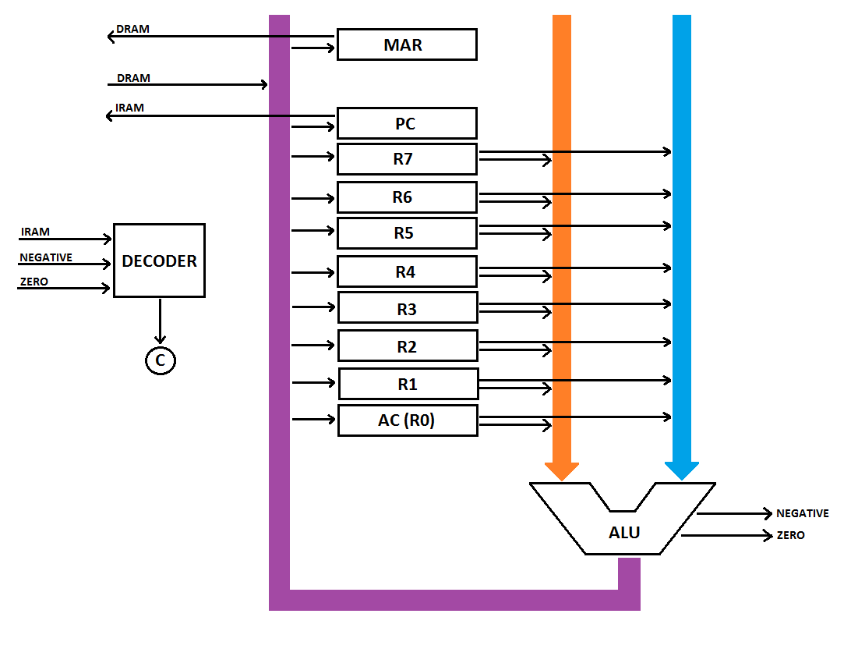

RISC Architecture Processor Design

**Arithmetic and Logic Unit (ALU)**

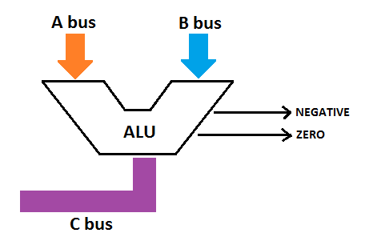

|  |  |  |
| --- | --- | --- |
| Opcode | ALU control bits | Operation |
| - | 0000 | No Operation |
| 01000 | 0001 | ADD (A + B) |
| 01001 | 0010 | SUB (A – B) |
| 01010 | 0011 | MUL (A << B) |
| 01011 | 0100 | DIV (A >> B) |
| 01100 | 0101 | INC (A + 1) |
| 01101 | 0110 | DEC (A – 1) |
| 01110 | 0111 | NEG (–A) |
| 01111 | 1000 | NOT (!A) |
| 10000 | 1001 | AND (A & B) |
| 10001 | 1010 | OR (A | B) |
| 10010 | 1011 | XOR (A ^ B) |

**If ALU output = 0, then Z = 1 else Z = 0**

**If ALU output < 0, the N = 1 else N = 0**

**Jump Logic**

|  |  |  |  |  |
| --- | --- | --- | --- | --- |
| Opcode | Operation | Z flag | N flag | Jump |
| JGT | If ALU out > 0 | 0 | 0 | PC ← Reg A |
| JEQ | If ALU out = 0 | 1 | x | PC ← Reg A |
| JGE | If ALU out >= 0 | x | 0 | PC ← Reg A |
| JLT | If ALU out < 0 | 0 | 1 | PC ← Reg A |
| JNE | If ALU out != 0 | 0 | x | PC ← Reg A |
| JLE | If ALU out <= 0 | 1/0 | 1 | PC ← Reg A |
| JMP | Unconditional Jump | x | x | PC ← Reg A |

**Control bits**

Depending on the opcode and ALU flags the decoder will generate the control bits

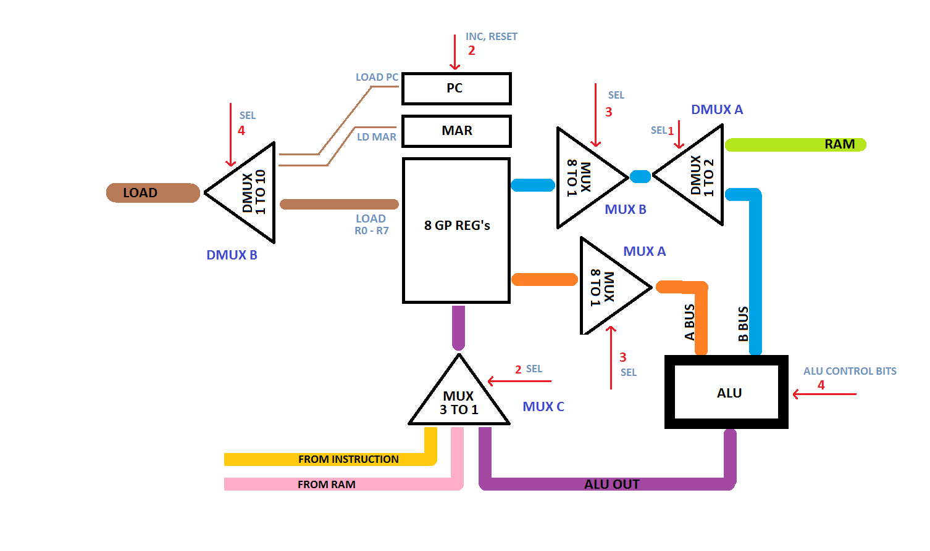

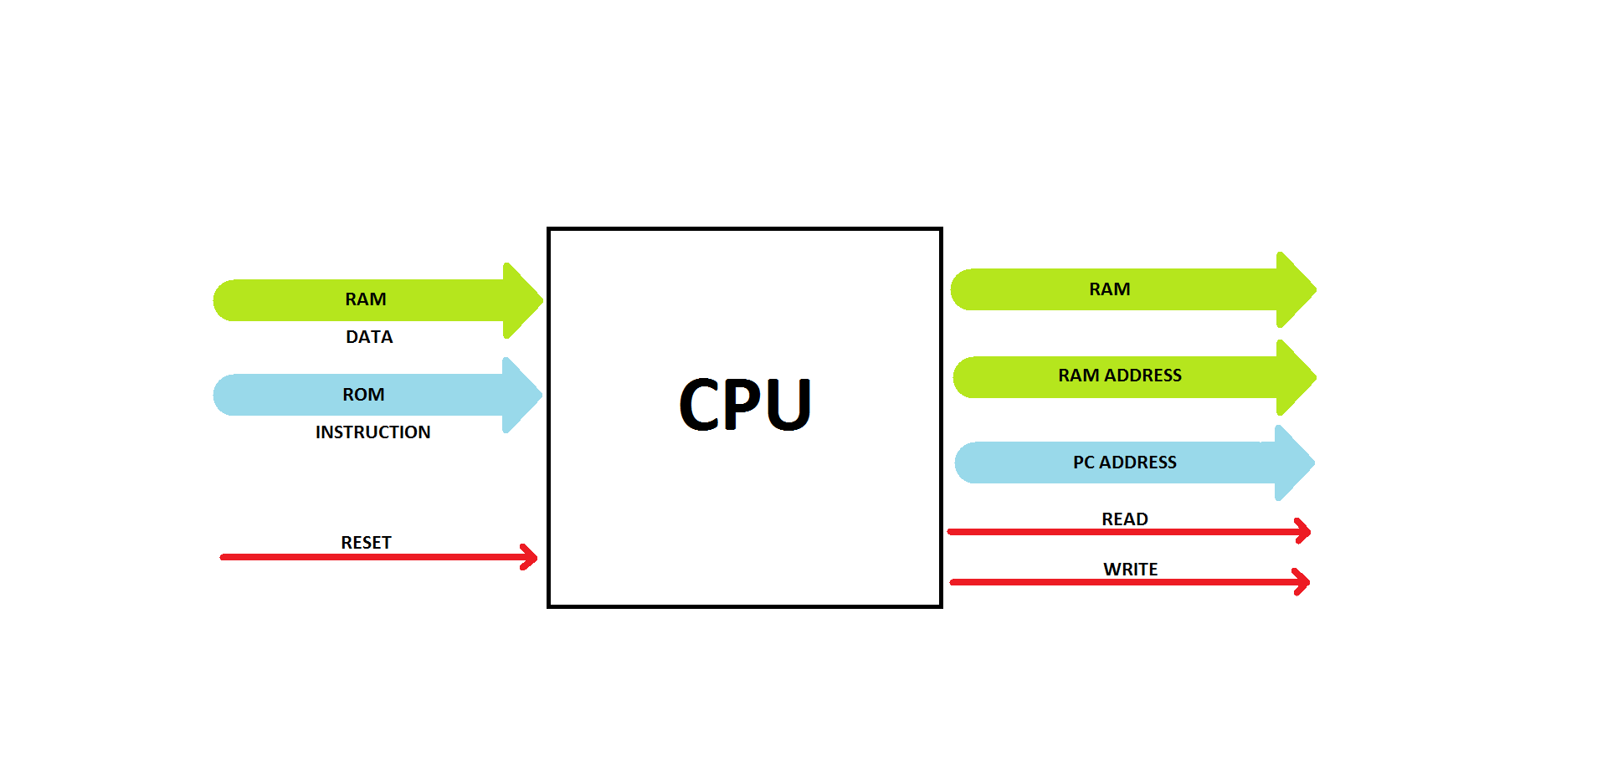

**Design of the RISC processor**

* 1. INSTRUCTION SET - CISC

|  |  |  |
| --- | --- | --- |
| Instruction | Instruction Code | Operation |
| NOP | 8 | No operation |
| LDAC | 8 Ґ | AC ← DRAM [Ґ]; r is a 24 bit location in MAR |
| LDACV | 8 V (16 bit) | AC ← V, V is loaded from IRAM |
| STAC | 8 Ґ | DRAM [Ґ] ← AC; r is a 24 bit location in MAR |
| MVACMAR | 8 | MAR ← AC |
| MVACR | 8 | R ← AC |
| MVACR1 | 8 | R1 ← AC |
| MVACR2 | 8 | R2 ← AC |
| MVACR3 | 8 | R3 ← AC |
| MVACR4 | 8 | R4 ← AC |
| MOVR | 8 | AC ← R |
| MOVR1 | 8 | AC ← R1 |
| MOVR2 | 8 | AC ← R2 |
| MOVR3 | 8 | AC ← R3 |
| MOVR4 | 8 | AC ← R4 |
| JUMP | 8 Ґ (16 bit) | GOTO IRAM [Ґ], Ґ is 16 bits |
| JMPZ | 8 Ґ (16 bit) | IF (Z=1) THEN GOTO IRAM [Ґ], Ґ is 16 bits |
| JMNZ | 8 Ґ (16 bit) | IF (Z=0) THEN GOTO IRAM [Ґ], Ґ is 16 bits |
| ADD | 8 | AC ← AC + R |
| ADDV | 8 V(16 bit) | AC ← AC + V, V is loaded from IRAM |
| SUB | 8 | AC ← AC – R  IF (AC – R = 0), THEN Z = 1, ELSE Z = 0 |
| SUBV | 8 V(16 bit) | AC ← V – AC, V is loaded from IRAM  IF (AC – V = 0), THEN Z = 1, ELSE Z = 0 |
| INAC | 8 | AC ← AC + 1 |
| DEAC | 8 | AC ← AC – 1 |
| MUL2 | 8 | AC ← AC << 1 |
| MUL4 | 8 | AC ← AC << 2 |
| MUL512 | 8 | AC ← AC << 9 |
| DIV16 | 8 | AC ← AC >> 4 |
| INR1 | 8 | R1 ← R1 + 1 |
| INR2 | 8 | R2 ← R2 + 1 |
| ADDR3 | 8 | AC,R3 <- AC+R3 |
| CLAC | 8 | AC ← 0; Z ← 1 |
| AND | 8 | AC ← AC and R |
| OR | 8 | AC ← AC or R |
| XOR | 8 | AC ← AC xor R |
| NOT | 8 | AC ← AC’ |
| ADDR3 | 8 | AC, R3 ← AC + R3 |

* 1. DATAPATH OF THE DESIGN - CISC

The data path was designed taking the ISA and Mic-1 architecture into consideration. CISC processor.

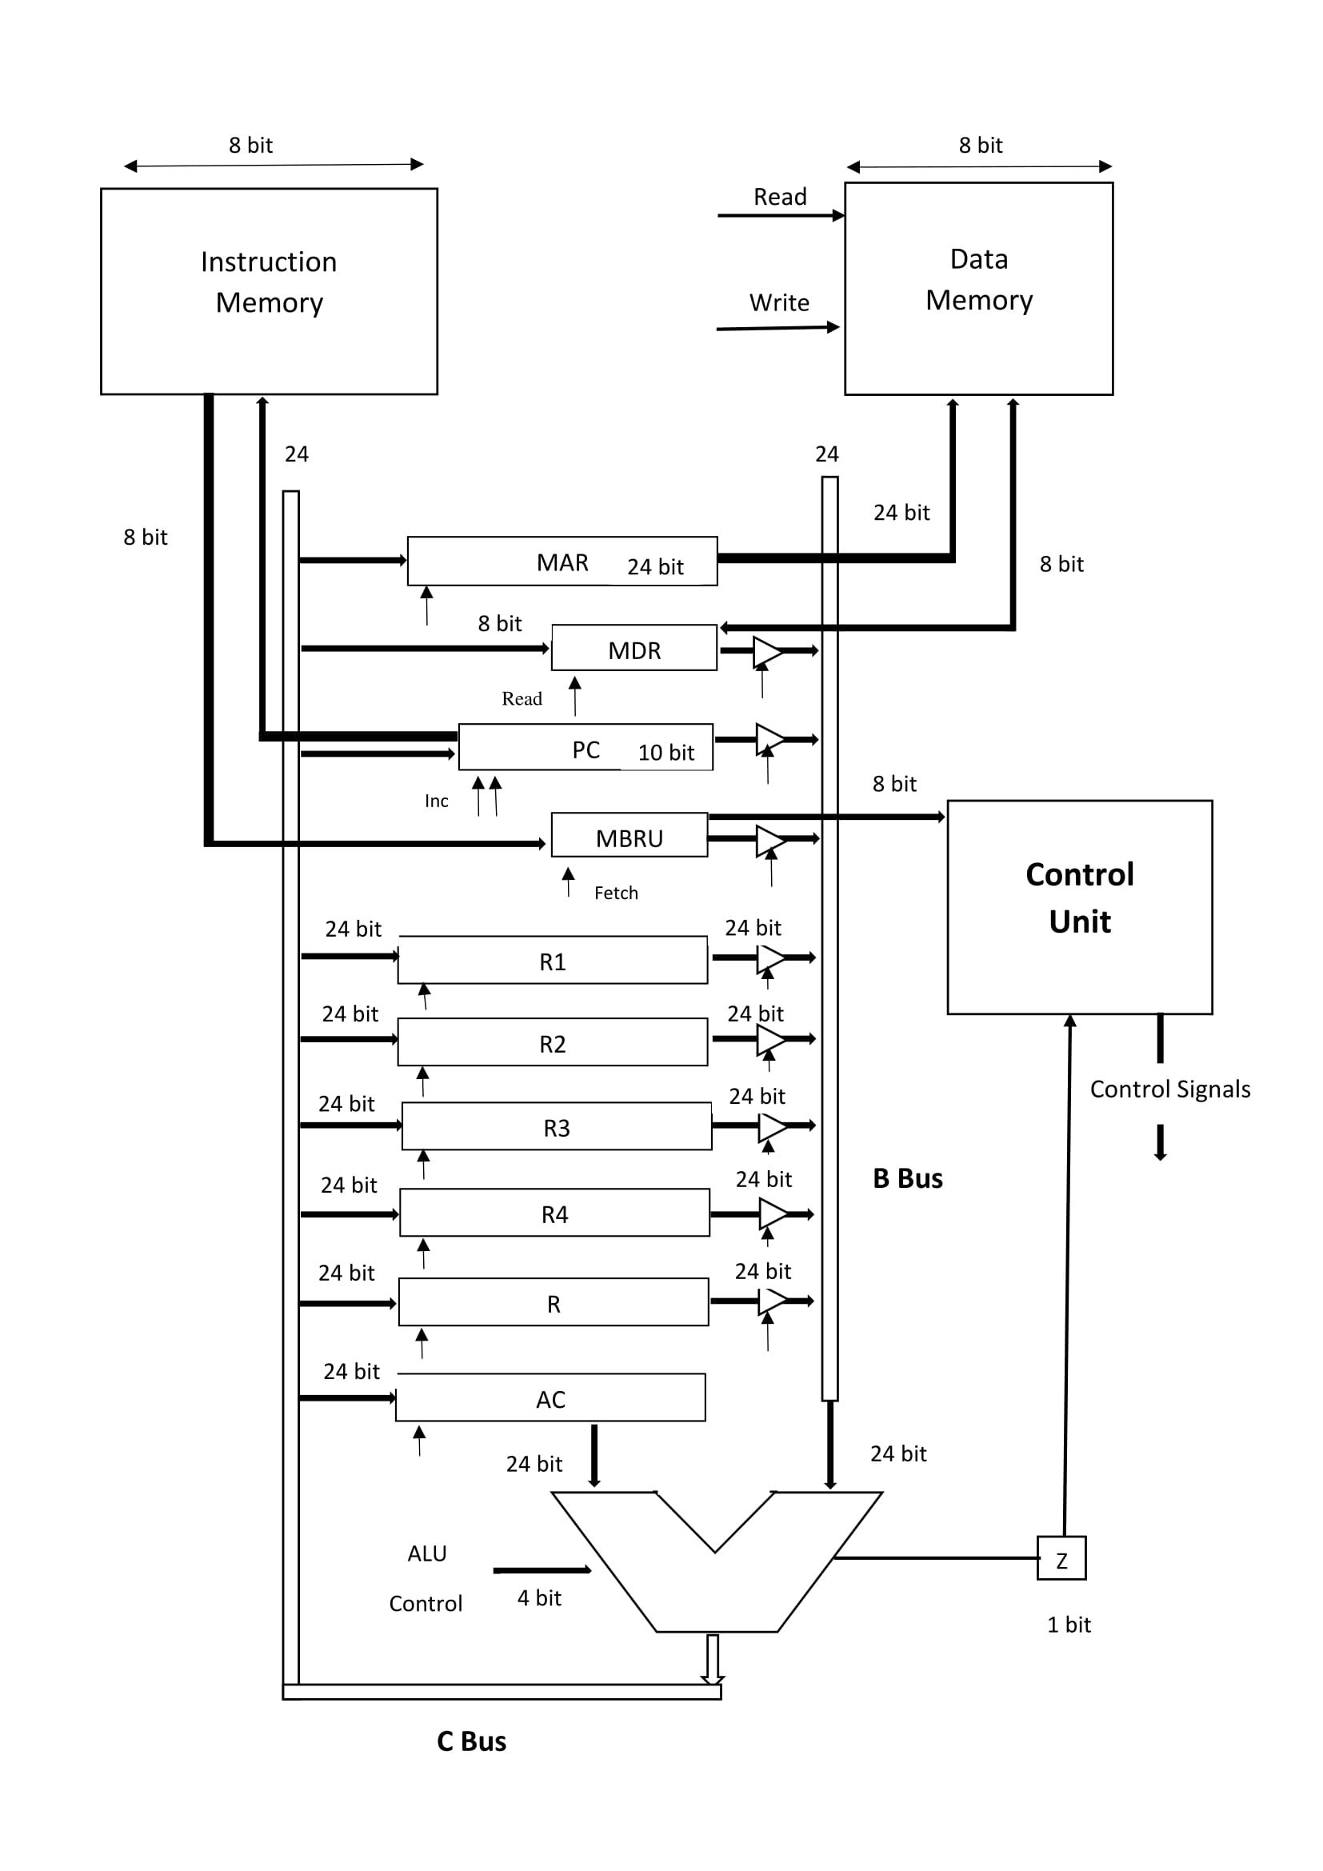

* 1. INSTRUCTION CYCLE

An instruction cycle (sometimes called a fetch–decode–execute cycle) is the basic operational process of a computer. It is the process by which a computer retrieves a program instruction from its memory, determines what actions the instruction dictates, and carries out those actions. This cycle is repeated continuously by a computer's central processing unit (CPU). In simpler CPUs the instruction cycle is executed sequentially, each instruction being processed before the next one is started.

Fetch

The next instruction is fetched from the memory address that is currently stored in the program counter (PC), and stored in the instruction register (IR). At the end of the fetch operation, the PC points to the next instruction that will be read at the next cycle. Fetch cycle consists of only 2 states. Fetch cycle is run by the state machine with FETCH1 being set as the next state at the beginning.

FETCH1: MBRU ← Imem[pc]; fetch

FETCH2: PC ← PC+1

Decode

Decode of instructions is the next task of the CPU after fetching instructions from the instruction memory. The CPU has to differentiate between the instructions fetched from the instruction memory in order to invoke the correct execution cycle. This task is done by the state machine or the control unit of the processor. Memory Bus Register Unsigned (MBRU) inputs the fetched instruction to the control unit and the control unit decodes the instruction to output the control signals of the relevant state followed by the next states of the instruction or returns to fetch cycle if the instruction has only one state.

Execute

**NOP Instruction**

NOP instruction is used to do nothing. This instruction is useful to skip a clock cycle or two in order to wait until the data is ready at the end point.

**LDAC Instruction**

This instruction consists of two states.

LDAC1: MDR ← DRAM [MAR], read

LDAC2: AC ← MDR

1st state sends the read signal to the data memory and the MDR. This state involves loading the data from the address given in the previous state (AR) to AC. Then CPU moves to the fetch routine.

**LDACV Instruction**

This instruction consists of two states.

LDACV1: MBRU ← IRAM [PC], fetch

LDACV2: PC ← PC+1; AC ← MBRU

LDACV3: AC ← AC<<8; MBRU ← IRAM [PC], fetch

LDACV4: PC ← PC+1; AC ← AC+MBRU

1st state sends the fetch signal to the IR and it is loaded with the value stored in the instruction RAM. 2­nd state increments PC to point to the next instruction and the moves the fetched value to the accumulator. Since the value is represented by 16 bits, the 3rd state involves fetching the second value from the instruction memory and in the final step the first and second values fetched are concatenated. CPU moves to the fetch routine after the completion of 4 states.

**STAC Instruction**

This instruction consists of 2 states.

STAC1: MDR ← AC

STAC2: DRAM [MAR] ← MDR; write

This involves copying the contents of the AC to the memory address in the data memory pointed by the MAR. Write data memory address should be available in the MAR. Move the data from the address stored register to the MAR register first before invoking this command.

**MVACR1, MVACR2, MVACR3, MVACR4, MVACR and MVACMAR Instructions**

These instructions consist of only one state. The CPU copies the contents of the AC to R1, R2, R3, R or MAR and moves to fetch routine.

MVACR11: R1←AC

MVACR21: R2←AC

MVACR31: R3←AC

MVACR41: R4←AC

MVACR1: R←AC

MVACMAR1: MAR←AC

**MOVR, MOVR1, MOVR2, MOVR3 and MOVR4 Instructions**

These instructions involve only one state. The CPU copies the contents of the R1, R2, R3 or R to AC and moves to fetch routine.

MOVR11: AC←R1

MOVR21: AC←R2

MOVR31: AC←R3

MOVR41: AC←R4

MOVR1: AC←R

**JUMP Instruction**

Four states are involved in the jump instruction. In the 2nd and 3rd states, jump address stored in the instruction is loaded into AC. Then value of AC is copied to PC. Then the CPU moves back to fetch routine with the new address loaded.

JUMP1: MBRU ← IRAM [PC], fetch

JUMP2: PC ← PC+1; AC ← MBRU

JUMP3: AC ← AC<<8; MBRU ← IRAM [PC], fetch

JUMP4: PC ← AC+MBRU

**JMPZ Instruction**

If Z flag equals to 0, PC is incremented by 2 and the CPU move to fetch routine and start to fetch the next instruction to be executed.

If Z=1;

JMPZN1: PC ← PC+1

JMPZN2: PC ← PC+1

If Z flag equals to zero, four states are involved. In the 2nd and 3rd states, jump address stored in the instruction is loaded into AC. Then value of AC is copied to PC. Then the CPU moves back to fetch routine with the new address loaded.

If Z=1;

JUMP1: MBRU ← IRAM [PC], fetch

JUMP2: PC ← PC+1; AC ← MBRU

JUMP3: AC ← AC<<8; MBRU ← IRAM [PC], fetch

JUMP4: PC ← AC+MBRU

**JMNZ Instruction**

If z flag equals to 1, PC is incremented by 2 and the CPU move to fetch routine and start to fetch the next instruction to be executed.

If Z=1;

JMNZY1: PC ← PC+1

JMNZY2: PC ← PC+1

If z flag equals to zero, four states are involved. In the 2nd and 3rd states, jump address stored in the instruction is loaded into AC. Then value of AC is copied to PC. Then the CPU moves back to fetch routine with the new address loaded.

If Z=0;

JUMP1: MBRU ← IRAM [PC], fetch

JUMP2: PC ← PC+1; AC ← MBRU

JUMP3: AC ← AC<<8; MBRU ← IRAM [PC], fetch

JUMP4: PC ← AC+MBRU

**INAC and DEAC Instructions**

INAC1: AC ← AC+1

INAC Instruction involves the CPU to add 1 to the contents of AC and write back to AC.

DEAC1: AC ← AC-1

This instruction is straightforward which involves subtracting 1 from the contents of AC and writing back to AC.

After the states described above, the CPU moves to the fetch routine.

**SUB and ADD Instructions**

SUB1: AC ← AC-R

SUB instruction relates to subtracting the contents of R from AC and writing back to AC.

ADD1: AC ← AC+R

ADD instruction adds the contents of R to AC and writes back to AC.

Then the CPU moves to fetch routine and starts fetching the next instruction from the instruction memory.

**ADDV Instruction**

This instruction consists of five states which add a value resides in the immediate memory location in IRAM to AC and writes back to AC, i.e. the states involves the value in the memory location which is next to “ADDV” is added to AC and written back to AC.

ADDV1: R ← AC; MBRU ← IRAM [PC], fetch

ADDV2: PC ← PC+1; AC ← MBRU

ADDV3: AC ← AC<<8; MBRU ← IRAM [PC], fetch

ADDV4: PC ← PC+1; AC ← MBRU

ADDV5: AC←AC+R

**SUBV Instruction**

This instruction consists of 2 states which add a value resides in the immediate memory location in IRAM to AC and writes back to AC.

SUBV1: R ← AC; MBRU ← IRAM [PC], fetch

SUBV2: PC ← PC+1; AC ← MBRU

SUBV3: AC ← AC<<8; MBRU ← IRAM [PC], fetch

SUBV4: PC ← PC+1; AC ← AC+MBRU

SUBV5: AC←AC-R

The value in the AC register is subtracted from the value in the memory location which is next to “SUBV” and written back to AC.

**DIV and MUL2, MUL4, MUL512 Instructions**

These 2 instructions consist of one state which divides the contents of AC by 2 and multiplies by 4 then writes back to AC.

DIV1: AC ← AC>>1

MUL21: AC ← AC<<1

MUL41: AC ← AC<<2

MUL5121: AC ← AC<<8

MUL5122: AC ← AC<<1

**INR1 and INR2 Instructions**

These 2 instructions consist of one state which divides the contents of AC by 2 and multiplies by 4 then writes back to AC.

INR11 AC ← R1

INR12: AC ← AC+1

INR13: R1 ← AC

INR21: AC ← R2

INR22: AC ← AC+1

INR23: R2 ← AC

**ADDR3 Instruction**

ADDR31: AC, R3 ← AC + R3

This instruction adds the value stored in R3 to the value stored in AC and puts the new value in both AC and R3 register. This is an operation specific instruction for down-sample an image.

**CLAC Instruction**

CLAC1: AC ← 0; Z ← 1

The CLAC instruction can be executed by one state. It involves the CPU to clear the contents of the accumulator and start fetching the next instruction from the instruction memory.

1. MODULES
   1. Registers

24 bit register

Data out

Load

GPR 24 bit register

Data in

***Block Diagram of 24 bit Register***

The register modules are used to store data temporally during the process cycle. Each register can store 3 Bytes of data. Data stored in the register is always available at the data out and it is connected to de-multiplexer so that it can select which data should be read to the bus. These registers don’t have any increment flag. If the stored values of these registers need to be incremented it has to go through an ALU increment operation and write back to the register. As in the figure this register has 16 bit input port and 16 bit output port. If the load flag is ‘1’, it can write the data available in data in to the register at the positive edge of the clock.

Load C

Data out

GPR 8 bit register

C in

Inc

***Block Diagram of 24 bit Register with increment***

Only difference is that this module contains an increment flag with in it. Therefore when the value of the register needed to be incremented by ‘1’, it doesn’t need to go through an ALU operation and write back. This can be done easily by enabling the increment flag of the register. Then at the positive edge of the clock if the increment flag is high value of that register will get incremented.

Programme Counter (PC)

Mem out

Data in

Inc

Load

PC

Data out

The program counter keeps the address of the instruction to be executed. The size of the PC is 9 bits because the program memory has only 512 memory locations unlike the other registers having 8 bits or 24 bits. This increment signal is used to increment the value of this register by “1” without needing to send its value through the ALU. If the PC inc is high at the positive edge of the clock, the register value is incremented. The PC is used in every fetch cycle, therefore the PC inc signal reduces the number of clock cycles.

Instruction Register (MBRU)

Data out

Load

MBRU 8 bit register

Data in

Instruction Register keeps instructions carried from the instruction memory pointed by the Programme Counter, at the positive edge of the clock if the read signal is high then it stores the instruction. Therefore IR is also slightly different from the other registers since it is the only register to have a read.

Accumulator (AC)

ALU

Load

AC 24 bit register

Data in

Accumulator is different from the other registers because its output is directly connected to the ALU as one of ALU’s inputs and AC has a clear command in order to reset its value. AC is used in almost all the ALU operations. The reset signal is used to reduce the number of clocks used and reduce the complexity of the software programme.

Memory Address Register (MAR) and General Purpose Registers.

Data out

Load

MAR 24 bit register

Data in

Data out

Load

GPR 24 bit register

Data in

MAR and general purpose registers are 24 bit registers that has input from C bus whereas. All the registers output to the B bus module which is a multiplexer whereas MAR outputs are directly connected to the data memory as MAR points to the location of the data memory where we need to read/write and MDR contains the data that needs to be written to the RAM.

Memory Data Register (MDR)

Memory

Load C

Data out

MDR 8 bit register

C in

Load M

MDR is an 8 bit register. It has inputs from C bus and Data memory. Its output is connected to B bus and the Data memory. Its connections with the data memory is bi-directional.

* 1. ALU

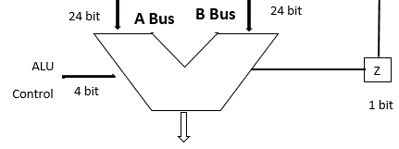

3.4 CLOCK DIVIDER

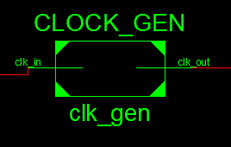

This module reduces the frequency of the original clock. There is an inbuilt 100MHz clock in the Spartan 6 FPGA development board. In one processing cycle we had to read the data from registers and perform arithmetic operations through ALU and output the values between the negative and positive edges of the each clock cycle. Therefore for a 100MHz clock this gap is 5ns. This is not sufficient to perform all the tasks required. Therefore it is necessary to increase the time gap between positive and negative edges of the clock. This module takes the original clock as the input and returns the divided clock (12.5MHz) as the output. All the components of the processor use this divided clock as their input.

3.2 CONTROL STORE

Control store decodes the instruction and releases the control signals in the design. This module is in the CISC design and the decoding of signals of the RISC design was discussed in the previous section.

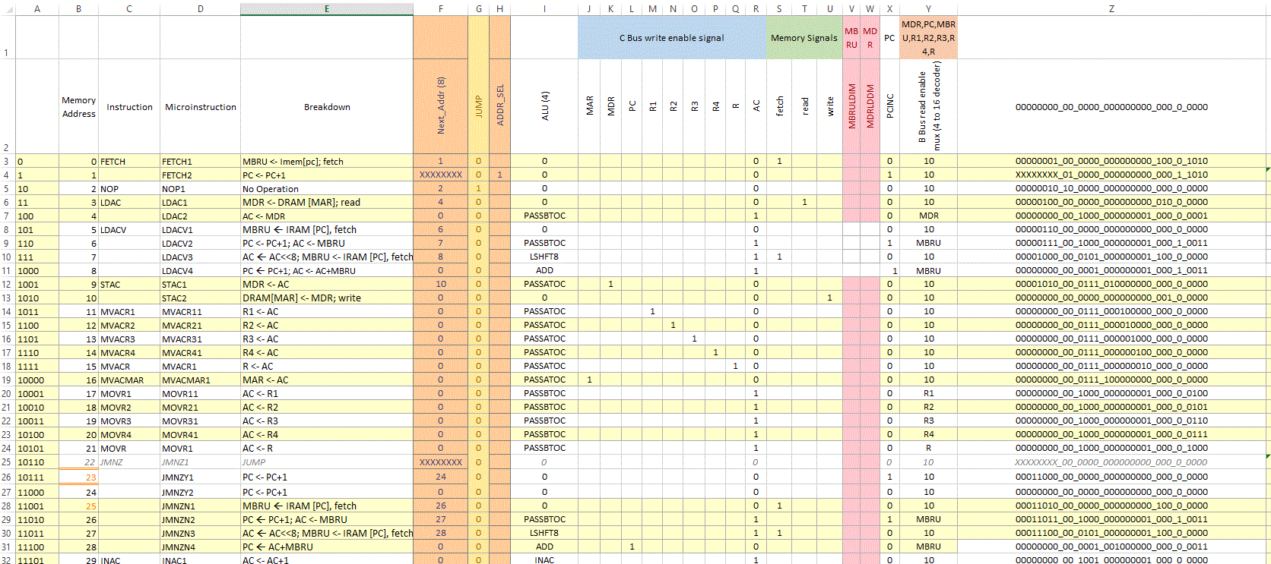

3.5 DEMULTIPLEXER

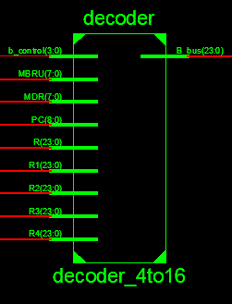

In the processor architecture there is only one data bus. Therefore it can only read data from one register at a time to the bus. This implementation has been done by using a de-multiplexer. There are few de-multiplexers used inside the processor module as well as outside the processor module. Inside the processor module there are two multiplexers. One of that mux connected to all registers (MAR, PC, R1, R2, R3 etc.). Other side of the de-mux connected to another multiplexer. That mux is connected to RAM module and C bus. Therefore this configuration allows to read data from RAM or ALU output to any the registers and pass data through other way.

3.6 PROCESSOR

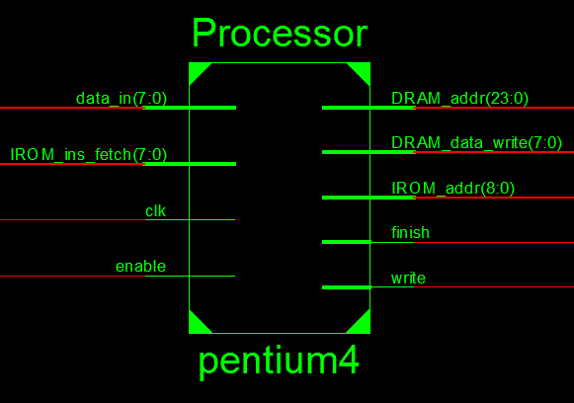

The processor module contains the all the instances of the modules used for the processing part. This does not contain instances of memory modules and communication modules. This has four inputs which is clock, processor enable, DRAM, and IROM.

* Clock - this gives clock pulse for the synchronization
* Enable – this is used to enables the module
* DRAM – this gives image data to the processor from the Data RAM (8 bit)
* IROM – this gives IROM data to the processor (8 bit)

This module has five output data paths which are write, finish, DRAM_addr, IROM_addr and DRAM_data_Write

* write -Write enable signal
* finish -Indicate the end of the processing to the IO module
* DRAM_addr - gives memory location of the DRAM (24 bit)
* IROM_addr -gives memory location of the IRAM (9 bit)
* DRAM_data_write -gives the data which needs to be written in to the DRAM (8 bit)

3.7 COMMUNICATION RELATED MODULES

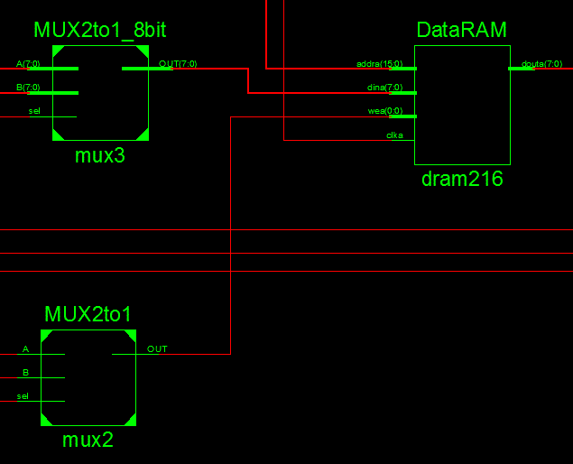

The above mux configuration changes the routing configuration between the processor and the UART modules so that when the trancieving with the computer takes place, the memory interacts with the UART modules and when the processing takes place, the processor gets to interact with the memory modules. This could have been done easily using a dual port RAM but unfortunately we have already done the design using single port RAM. Therefore, we had to use the mux configuration shown above to change the memory module interation with the processor and the UART modules accordingly.

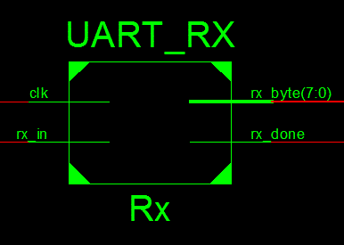 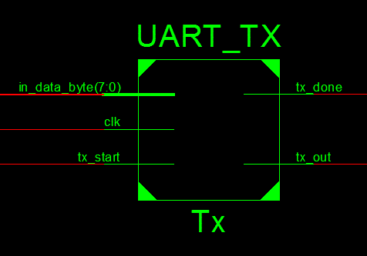

The receiver UART module interacts with the computer in the input side and the output side is connected to the memory module to store the result. Actually, the rx_done Boolean output is sent to IO_controller in order to save the received byte to the memory. Rx_byte is directly connected to the data memory module.

This module was used to receive the serial data and output one byte (8 bits) at a time. We used ‘rx_in’ pin to receive the data bit by bit and when it receives 8 bits, it generates 8 bit width word and returns it. Then the same time setting the output of the ‘rx_done_tick’ is high.

UART_TX modules works in the same way but input output interaction is changed. This module is used to transmit the pixel data from the FPGA to the computer via serial data communication. It has three inputs and two outputs. We have to set the ‘tx_start’ pin as high to stat the module. The “in_data_byte” input takes the 8 bit word at a time and transmits one bit by bit via ‘tx_out’ output pin. When it finishes transmitting all the 8 bits of a particular byte it sets the ‘tx_done’ output as high.

3.8 MEMORY MODULES

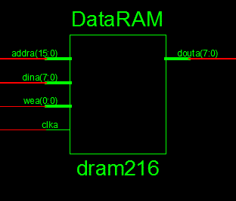 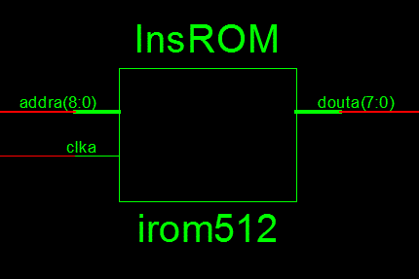

Instruction memory is a read only memory and the data memory is a random access memory. Both these memory modules are made with the use of memory avaiable in the FPGA using the software available without writing code. The data and instruction memories are single port memories. The design would have been better if dual port memories have used.

InsROM module is used to store instruction in the memory. Instructions are coded by assembly language. Whenever the processor needs instructions it fetches instructions from this instruction memory (InsROM). This module consists of instructions to be executed with 512 memory locations with 9 bits width. This memory contains the assembly code of the algorithm for filtering and down sampling the image. This module has only two inputs and one data output. Inputs are used to feed the clock signal into the module and other input is used to input the memory location of the instruction. The output of the module has 8 bit width. We have instructions below 256. Therefore 8 bit width data path is sufficient to give the output signal what we need.

DataRAM module is the main data memory which is used for store data of the image and store the processed image data. First read the data from the UART-Rx module and all the data units are saved in the dram module for further operations. This module has 65536 memory locations of 8 bit width to store the pixels of the image. Every pixel has integer values which is in the range of 0 to 255. Therefore 8 bit width of a memory unit enough to store the pixels in dram module. This ram module has four input data paths and one output data path. “Din” input is used to give input data which has 8 bit data stream and “address” path gives the address of the memory location which the dram has to read or write data. This input contains a 16 bit data stream because the dram module has 65536 memory locations. “wea” is a one input which has one bit, is used write data to the memory from dina data path. There is a “clka” input which is used to input the clock signal which is given by the clock_gen module. “douta” is the output of this module. It is used to give output data to the data bus when request from the control unit.

3.9 TOP MODULE

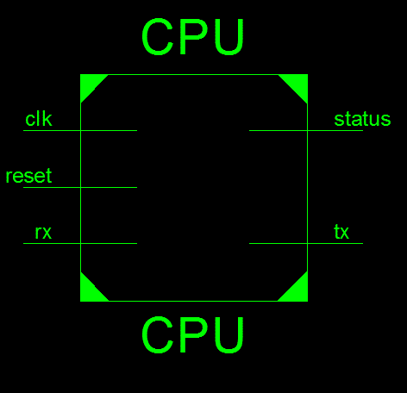

This module is used to connect processing and communicating modules. All the instances have been created inside this module. This module used a clock signal and a reset pin as its inputs. Also it uses the ‘rx’ pin for receiving the data coming serially. This has one output which is ‘tx’ to transmit the data serially. This contains instances of Processor, UART_RX, UART_TX and IO Module. The following figure shows the internal connected structure of the top module.

3.10 RTL VIEW OF TOP MODULE

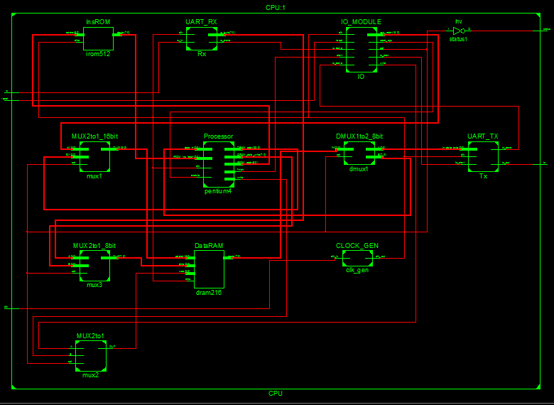

3.11 RTL VIEW OF THE TOP PROCESSOR

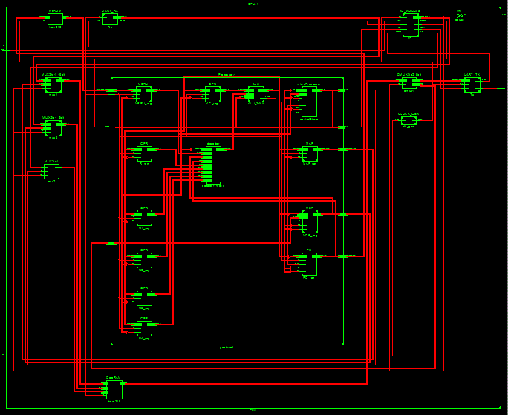

The following diagram shows the structure of the processor shown in the data path diagram in the previous section.

1. ALGORITHM

ALGORITHM

The algorithm for down sampling an image consists of two main parts. First phase of the algorithm is smoothing the image using a Gaussian Filter. Then the filtered image is down-sampled using a down sampling algorithm.

FILTERING ALGORITHM

For filtering the image, a 3x3 kernel is used. This kernel is weighted such that the kernel is symmetric in all directions (i.e. Gaussian). This kernel is shown in the figure below.

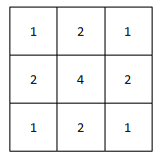

*3x3 Gaussian Kernel*

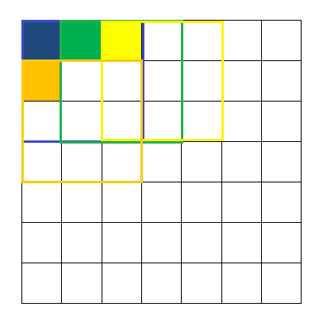

This kernel is initiated at the top left corner of the image and then traversed throughout the image horizontally. While the kernel is traversed, the value of the pixel values averaged using the overlapping weights of the kernel is stored at the top left corner pixel of the pixel block overlapping that kernel at the time. This pixel corresponds to the assigned RAM location. The following diagram describes the motion of the kernel and the location (hypothetical) of data storage.

The coloured pixel contains the weighted average sum of the pixel block squared by the similar colour.

DOWN SAMPLING ALGORITHM

After smoothing, the image is down sampled to the ratio 1:2. For this a pixel from each noon overlapping block of four pixels is taken and stored as the desired down sampled image. The following figure shows the (hypothetical) storage of the down sampled image.

Original Image

Memory Allocation

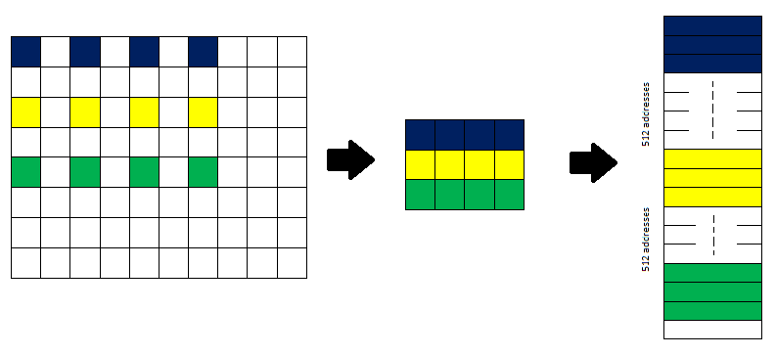

Down Sampled Image

As shown in the diagram, adjacent pixels vertically below are spaced 512 addresses. This is so because although the down sampled image is depicted in a 2D array, in memory it is stored as a 1D array.

% Read and map the 2D image to a 1D memory array  
close all;  
image = imread('C:\Users\adhit\Desktop\Processor Design\Matlab Code\Emacs_512.png'); % Read the image and save 2D array  
image = rgb2gray(image);  
memory_array = uint16(image(:)); % Make 1D array, convert to 16 bit since registers are 16   
imshow(image); % Display Image  
imwrite(image, 'C:\Users\adhit\Desktop\Processor Design\Matlab Code\gray.png'); % Write gray scale image  
% Gaussian filter the image  
total = 0; % Initialize the totoal variable  
  
for j = 1:1:510 % Loop through rows  
 for i = 2:1:511 % Loop through columns  
 x = j*512+i;  
 % Convolve with the gaussian filter  
 total = total + memory_array(x-1)*2;  
 total = total + memory_array(x)*4;  
 total = total + memory_array(x+1)*2;  
 total = total + memory_array(x+513);  
 total = total + memory_array(x+512)*2;  
 total = total + memory_array(x+511);  
 total = total + memory_array(x-513);  
 total = total + memory_array(x-512)*2;  
 total = total + memory_array(x-511);  
 total = total/16; % Normalize the total value  
 memory_array(x-513) = total; % Store the filtered value in the memory  
 total=0;  
 end  
end

figure, memory_array = uint8(memory_array);  
filtered_image = memory_array; % Convert to uint8 format  
c = reshape(filtered_image,512,512); % Generate 2d array from vector  
imshow(c); % Display the filtered image

% Downsample the filtered image  
k = 1; % Set writing memory address  
for j = 0:1:255 % loop going through rows  
 for i = 0:1:255 % loop going through columns  
 y = 2*512*j + 2*i + 1; % Map every other pixel to RAM address in memory   
 memory_array(k) = memory_array(y); % Overwrite the pixel values with every other   
 k = k+1; % Increment writing memory address  
 end  
end  
  
figure, downsampled_image = memory_array(1:65536); % Bytes relevant to 256*256   
c = reshape(downsampled_image,256,256); % Reshape the 1D array to an image  
imshow(c); % Display the filted image



Original Image 512 x 512 size



Filtered Image 512 x 512 size



Down-sampled image 256 x 256 size

[*Published with MATLAB® R2014b*](http://www.mathworks.com/products/matlab)

Assembly Code of the Algorithm

Shown below is the assembly code used to run in the CISC processor to down-sample the image. Since we used an interpreter to convert the assembly code to the machine code, writing the assembly code was much easier and the conversion to machine code every time there was a change in the assembly code saved a lot of time.

CLAC

MVACR1

MVACR2

L1

CLAC

MVACR3

// Calculation of the first pixel value

MOVR2

MUL4

MUL2

MVACR

MOVR1

ADD

// First pixel

MVACR4

MVACMAR

LDAC

MVACR3

// Second pixel

MOVR4

INAC

MVACMAR

LDAC

MUL2

ADDR3

MOVR4

INAC

INAC

MVACMAR

LDAC

ADDR3

// Go to the second pixel line

MOVR4

ADDV 8

MVACR4

MVACMAR

LDAC

MUL2

ADDR3

// Multiply middle pixel by 4

MOVR4

INAC

MVACMAR

LDAC

MUL4

ADDR3

MOVR4

INAC

INAC

MVACMAR

LDAC

MUL2

ADDR3

// Go to the third pixel line

MOVR4

ADDV 8

MVACR4

MVACMAR

LDAC

ADDR3

MOVR4

INAC

MVACMAR

LDAC

MUL2

ADDR3

MOVR4

INAC

INAC

MVACMAR

LDAC

ADDR3

// Calculate the pixel store address

MOVR2

MUL4

MUL2

MVACR

MOVR1

ADD

MVACMAR

// Calculate the final convolutio value and store it

MOVR3

DIV

STAC

INR1

SUBV 6

JMNZ L1

CLAC

MVACR1

INR2

SUBV 6

JMNZ L1

// Choose pixels

CLAC

MVACR1

MVACR2

MVACR3

L2

MOVR2

// Multiply by 512, Image_size x 2, 16

MUL4

MUL4

MVACR

MOVR1

MUL2

ADD

MVACMAR

LDAC

MVACR

MOVR3

MVACMAR

MOVR

STAC

MOVR3

INAC

MVACR3

INR1

// Substract Image_size/2

SUBV 4

JMNZ L2

CLAC

MVACR1

INR2

// Substract Image_size/2

SUBV 4

JMNZ L2

FINISH

NOP

Code of the interpreter – Conversion of the Assembly code to the machine code

This code was written in python to generate the binary machine code of the above shown assembly code. This setting makes life easy so that the software programmer does not have to worry about translating the programme line by line to the machine code.

import os

UINS = {

'FETCH' :'0',

'FINISH' :'2',

'LDAC' :'3',

'LDACV' :'5',

'STAC' :'9',

'MVACR1' :'11',

'MVACR2' :'12',

'MVACR3' :'13',

'MVACR4' :'14',

'MVACR' :'15',

'MVACMAR' :'16',

'MOVR1' :'17',

'MOVR2' :'18',

'MOVR3' :'19',

'MOVR4' :'20',

'MOVR' :'21',

'JMNZ' :'22',

'JMNZY' :'23',

'JMNZN' :'25',

'INAC' :'29',

'DEAC' :'30',

'ADD' :'31',

'SUB' :'32',

'ADDV' :'33',

'SUBV' :'38',

'DIV' :'43',

'MUL2' :'44',

'MUL4' :'45',

'MUL512' :'46',

'INR1' :'48',

'INR2' :'51',

'CLAC' :'54',

'ADDR3' :'55',

'NOP' :'57'

}

def Translate(filename):

a_code = []

m_code = []

jumps = {}

n = 0

with open(filename) as fp:

for line in fp:

x = line.strip()

if len(x) > 0:

if not (x[0] == '/' and x[1] == '/'):

if (x[0] == 'L' and x[1] != 'D'):

jumps.update({x: str(n)})

else:

a_code.append(x)

if(len(x) > 3 and x[0] == 'A' and x[1] == 'D' and x[2] == 'D' and x[3] == 'V'): #ADDV instruction

n = n+3

#print n

elif(len(x) > 3 and x[0] == 'S' and x[1] == 'U' and x[2] == 'B' and x[3] == 'V'): #SUBV instruction

n = n+3

#print n

elif(len(x) > 3 and x[0] == 'J' and x[1] == 'M' and x[2] == 'N' and x[3] == 'Z'): #SUBV instruction

n = n+3

#print n

else:

n = n+1

for x in range(0, len(a_code)):

if "//" in a_code[x]:

t = a_code[x].split("//")

a_code[x] = t[0].strip();

print a_code

print jumps

for x in range(0, len(a_code)):

if(a_code[x] in UINS.keys()):

m_code.append(UINS[a_code[x]])

elif(a_code[x][0] == 'J' and a_code[x][1] == 'M' and a_code[x][2] == 'N'): #JMNZ instruction

temp = a_code[x].split(' ')

m_code.append(UINS[temp[0]])

m_code.append( str(int(jumps[temp[1]])/256) )

m_code.append( str(int(jumps[temp[1]])%256) )

elif(a_code[x][0] == 'A' and a_code[x][1] == 'D' and a_code[x][2] == 'D'): #ADDV instruction

temp = a_code[x].split(' ')

m_code.append(UINS[temp[0]])

m_code.append(str(int(temp[1])/256))

m_code.append(str(int(temp[1])%256))

elif(a_code[x][0] == 'S' and a_code[x][1] == 'U' and a_code[x][2] == 'B'): #ADDV instruction

temp = a_code[x].split(' ')

print temp

m_code.append(UINS[temp[0]])

m_code.append(str(int(temp[1])/256))

m_code.append(str(int(temp[1])%256))

print m_code

# output machine code to .mcode file

out = 'memory_initialization_radix=10;\nmemory_initialization_vector=\n'

for x in m_code:

out += x + ",\n"

out = out[:-2] + ';';

out = out.strip()

f = filename.split('.')

outname = f[0] + ".coe"

file = open(outname, 'w')

file.write(out)

file.close();

path = os.path.dirname(os.path.realpath(__file__))

for file in os.listdir(path):

if file.endswith(".navo"):

Translate(os.path.join(path, file))

1. TESTING, SIMULATION AND MODIFICATION

5.1 TESTING AND SIMULATION

To test and simulate the modules individually and as one unit, we write different Verilog modules for the simulation. We test each and every module we write. Below is the code we wrote to test the final CPU module. Test simulation results gives the intended output justifying the operation of the processor.

module CPU_TEST;

// Inputs

reg clk;

reg enable;

// Outputs

wire finish;

// Instantiate the Unit Under Test (UUT)

CPU uut (

.enable(enable),

.clk(clk),

.finish(finish)

);

initial begin

// Initialize Inputs

clk = 0;

enable = 0;

// Wait 100 ns for global reset to finish

#200;

// Add stimulus here

enable = 1;

#50

enable = 0;

end

always begin

#50

clk = ~clk;

end

endmodule

We run the simulation in iSim simulator and see the irregularities and changes that should be done in the algorithm. We use an 8x8 image to justify the operation of the 2 processors we made.

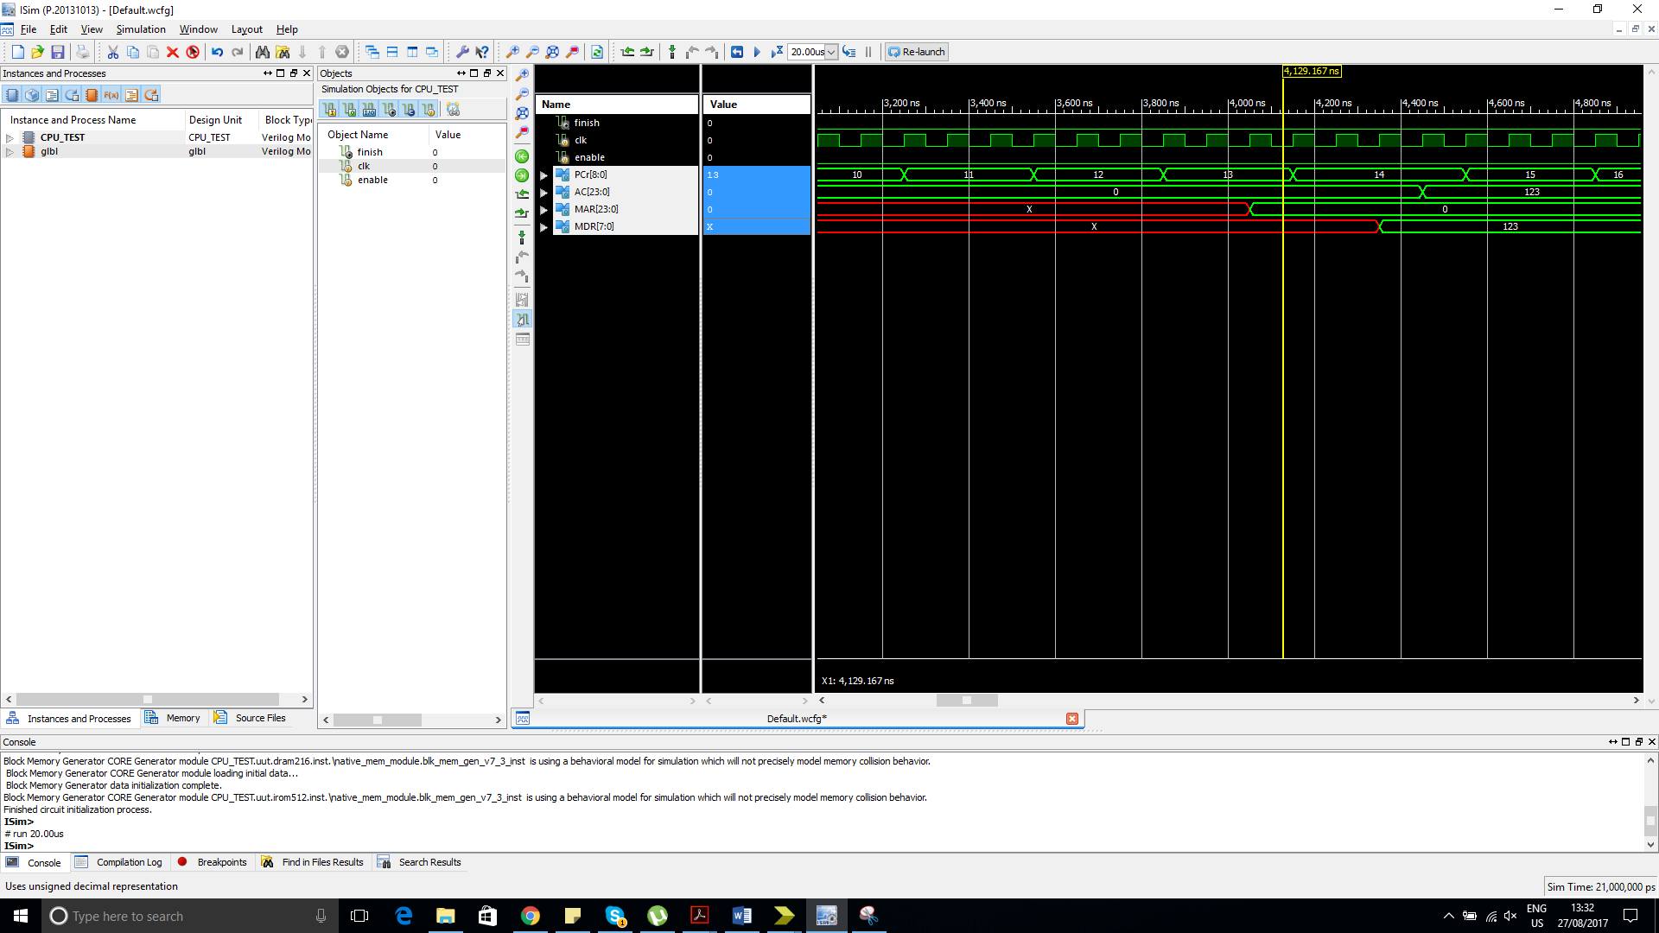

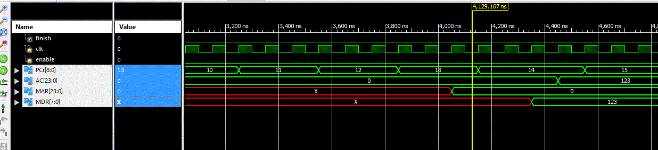

We use the values shown in PC, MAR, MDR and AC mainly for the justification and bugging and debugging. We see that the changes in the specified registers are as expected after debugging and correctly implementing the programme.

We used an 8x8 image to test and verify the down-sampling process of the algorithm. Below image shows the simulation results of the algorithm. Same simulation process is carried out in both the processors. Therefore, only one simulation corresponding to one processor is shown in the following steps.

Before processing the algorithm

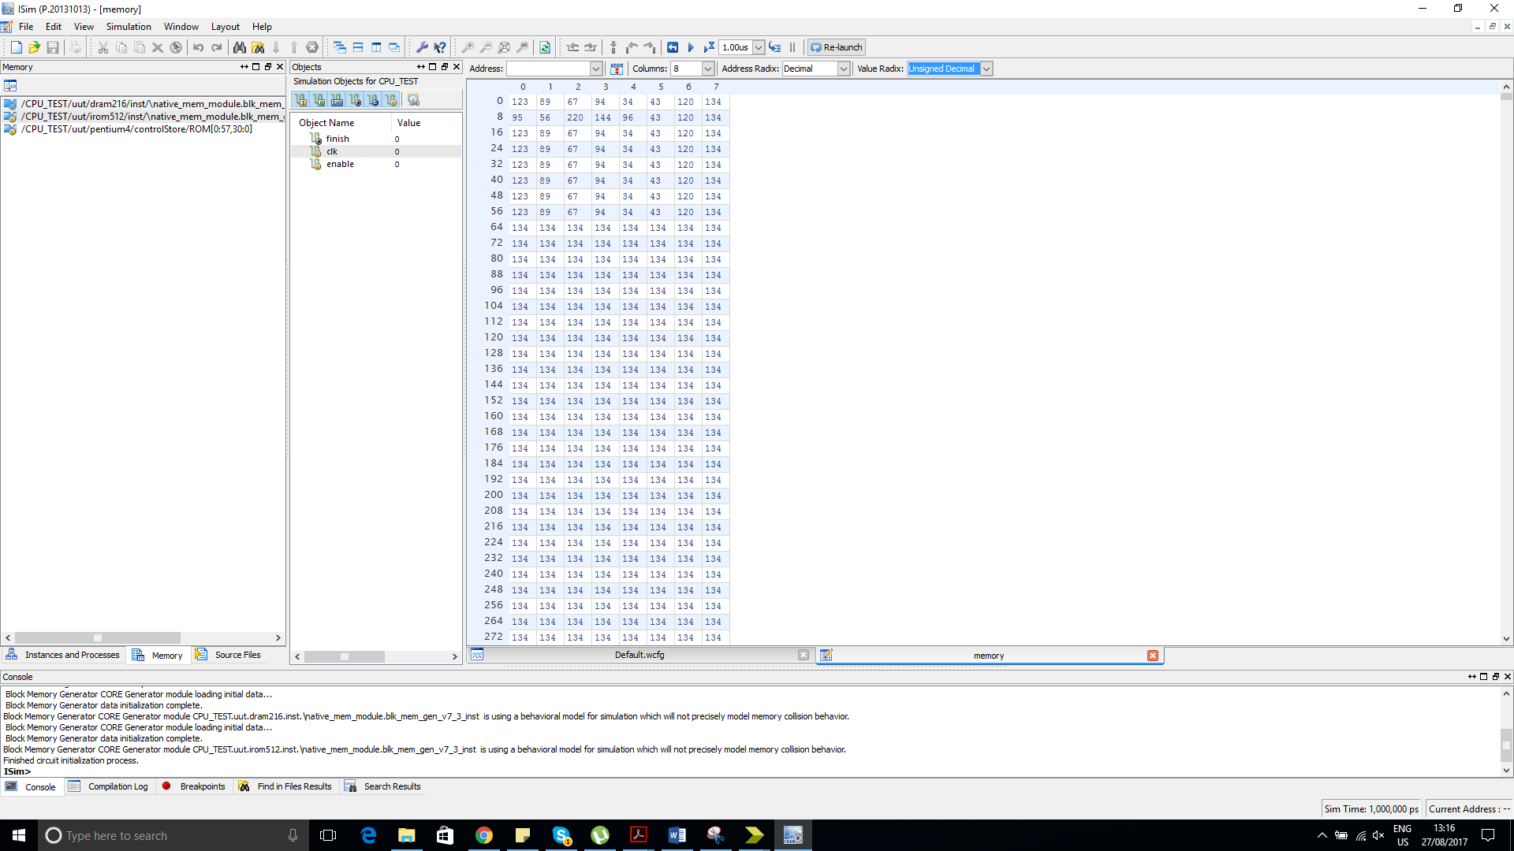

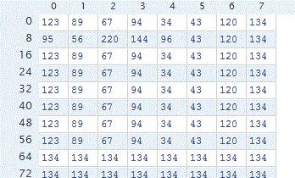

8x8 image before any processing takes place

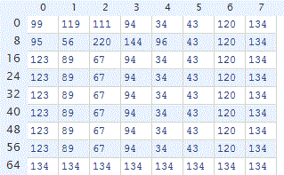

First 3 slots are changed with the application of the Gaussian filtering. It is seen that it gives the correct Gaussian filtered pixel result.

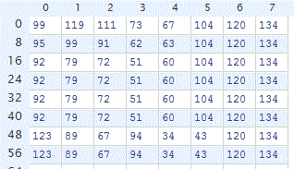

Now the Gaussian filtering process has ended giving the correct Gaussian filtered image as the result. You can see the Gaussian filtered image in the square corresponding to 6x6 region. 0,0 value corresponds to the 1,1 pixel. We used this mechanism in order to keep the memory usage as low as possible and to keep the process as simple as possible.

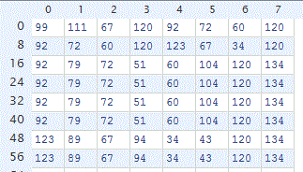

The above image shows the final 4x4 image produced by the complete process.

**By running the simulation, we see that the number of clock cycles taken in the RISC processor is 4 times lower than the CISC processor but the resource usage of the CISC processor is much lower than the RISC processor.**

5.2 MODIFICATIONS

1. We designed the processor such that it gave the correct results with the simulation but when we implemented the system using the memory generator in ISE the design started to behave in a bizarre manner. This was due to our implementation in the RAM module and the implementation in the memory generator RAM module. We wrote our RAM modules such that it gives the output when the input changes but in their memory implementation, they output the data at the positive edge of the clock cycle, so we had to add some clocks in our microprocessor design in order to make available the data at the output.
2. In the CISC design, we had to change the microinstruction a few times in order to get the desired output.
3. In the RISC design, since the number of changes we have to make in order to make the instruction RAM compatible with the memory block generated by the block memory generator, we used the memory block we wrote since that was convenient at the moment because it would not affect the performance of the processor.
4. In the CISC design, some of the microinstruction could be run in parallel. We changed the control store instructions such that those instruction could be run in parallel to reduce the number of clock cycles taken to complete the given task or rather any task run by the processor.
5. We modified the transmission code in python and the transmission speed, i.e, baud rate of the IO module in order to obtain a quick result. The processing time taken to down-sample the image was very low compared to the transmission time from the computer to FPGA and FPGA to the computer. Therefore, we carefully changed the speed of the IO module so that we can obtain the image quicker, this change we did to our own standard unlike the usual bit transmission speed used like 9600.
6. We tried to do the down-sampling to a 512x512 image but the resources available in Spartan 6 board was not enough to cater the memory needs of the system. One way to overcome this problem was to cut the original 512x512 image into 4 pieces such that each piece is 256x256 and transmit those 4 images separately to the FPGA and then receive the image iteratively and combine the final result in the computer. But we did not implement the design as such because then there will be an error at the edged when we stich the 4 received images from the FPGA and that would be an iteration of the same process. Therefore, we did it to an image with size 256x256. Both the 2 processors we designed are capable of down-sampling a 512x512 image because the register size is 24bit but this could not be done because of the memory constraint.
7. RESULT ANALYZING AND VERIFICATION

The error analysis plays an important role in the verification process since this is the final step verifying the operation of the processor implemented in FPGA. We do this in comparison with Gaussian filtered image and down-sampled image in OpenCV and the received image from the FPGA. We deduct one image from the other image and take the absolute value and then add all the absolute values in order to arrive at a final figure as the error value. We see that the received image from the RISC based processor yields zero absolute error while the CISC processor yields a much higher absolute error since it gives an image that is slanted.

The steps of the verification process and the resulting images are shown and discussed in the following sections.

6.1 GENERATE REFERENCE OUTPUT IMAGE

The following diagram shows the steps involved in the generation of the reference image.

Input image -> Gaussian Filter -> Down-sampled Image -> Comparison with the received image

6.2 RESULTS VERIFICATION AND ANALYSIS

This section shows a comparison between the images taken from the FPGA based processor and the image obtained using MATLAB/ OpenCV in Python.

**Results from the RISC based Processor**



**Original Image**

** **

**Reference Gaussian filtered image from OpenCV Filtered Image obtained from the FPGA**

** **

**Down sampled image from OpenCV** **Down sampled image obtained from the FPGA**

We used integer processing in the same algorithm we implemented using OpenCV. This processor gave no error at all. Total time taken for the completion of the task was around 7 seconds with a transmission bit rate of 200000. We did not use the standard transmission bit rates in order to obtain a maximum speed.

We checked the accuracy of the RISC based processor a few times and it gave no absolute error every time we checked.

**Results from the CISC based Processor**



**Original Image**

 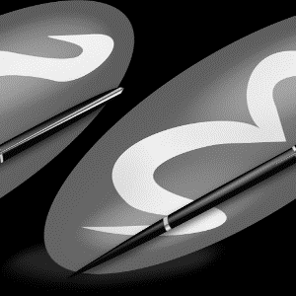

**Down-sampled image using OpenCV Down-sampled Image obtained using the FPGA**

The CISC based processor produced an image shown as above every time we run the process. This may have happened due to a wrong implementation of the assembly code algorithm and hence producing an image with wrong indexes. We did not try our best to correct this at the last moment since the other processor gave 100% accurate results, 3 of the group members were to go abroad for their internship programme and because of that there was not enough time to debug and correct it.

6.3 SUMMARY REPORT

**It is noticed that the resource usage in the RISC processor is twice as the resource usage in the CISC processor.**

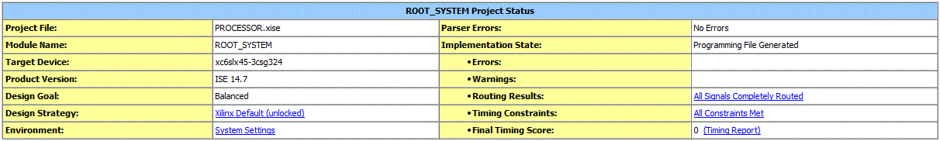

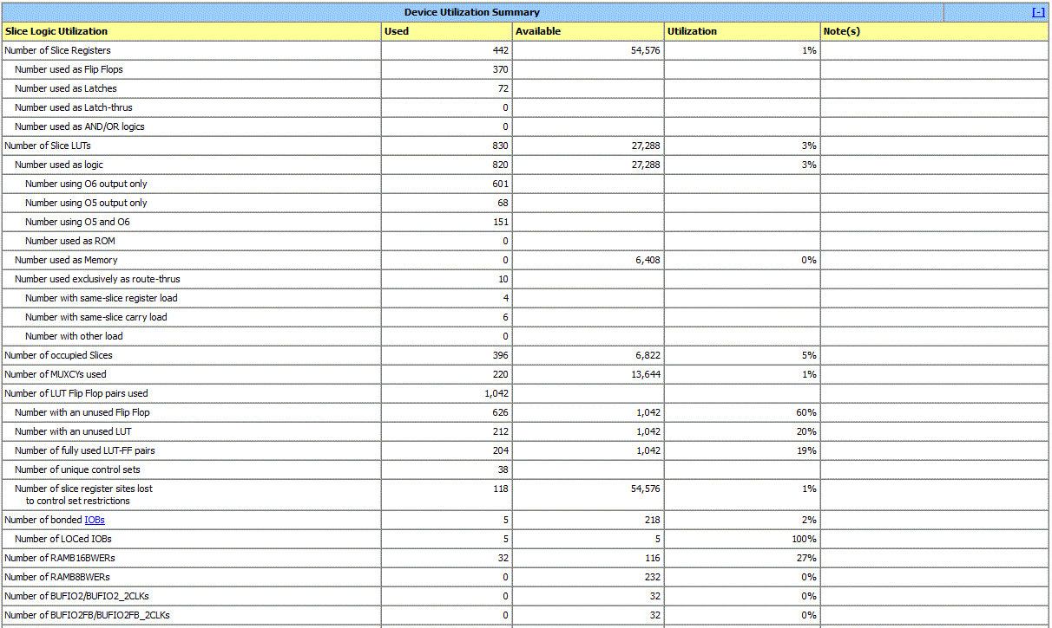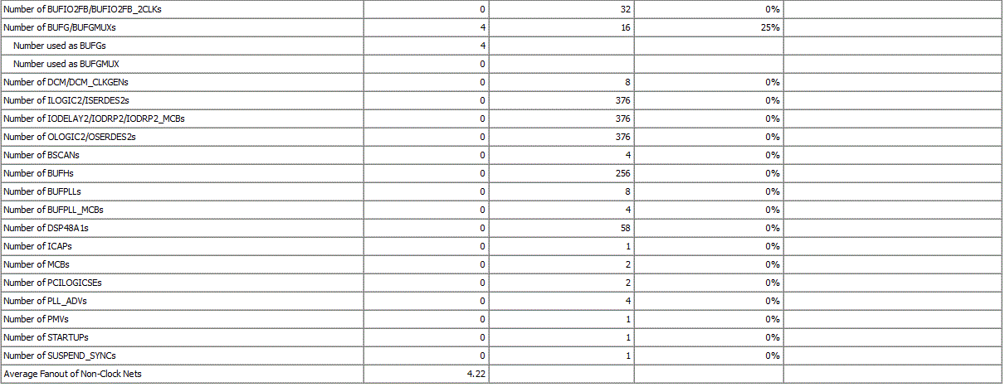

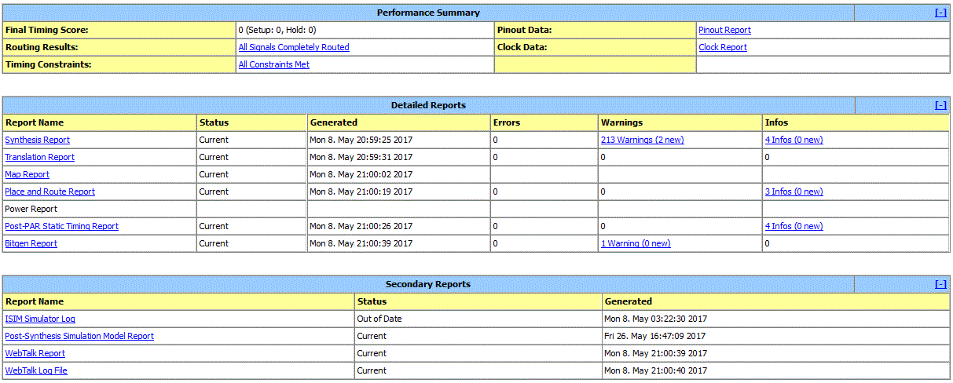

=========================================================================

HDL Synthesis Report

Macro Statistics

# Adders/Subtractors : 2

3-bit adder : 1

4-bit adder : 1

# Registers : 3

3-bit register : 1

4-bit register : 1

8-bit register : 1

# Multiplexers : 11

1-bit 2-to-1 multiplexer : 2

3-bit 2-to-1 multiplexer : 1

4-bit 2-to-1 multiplexer : 7

4-bit 4-to-1 multiplexer : 1

# FSMs : 1

Advanced HDL Synthesis Report

Macro Statistics

# RAMs : 1

64x31-bit single-port distributed Read Only RAM : 1

# Adders/Subtractors : 8

17-bit adder : 2

24-bit addsub : 1

24-bit subtractor : 1

3-bit adder : 2

33-bit adder : 2

# Counters : 2

8-bit up counter : 1

9-bit up counter : 1

# Registers : 363

Flip-Flops :363

# Comparators : 8

17-bit comparator greater : 1

3-bit comparator greater : 2

33-bit comparator greater : 4

8-bit comparator greater : 1

# Multiplexers : 58

1-bit 2-to-1 multiplexer : 15

1-bit 8-to-1 multiplexer : 1

16-bit 2-to-1 multiplexer : 2

17-bit 2-to-1 multiplexer : 4

24-bit 2-to-1 multiplexer : 20

3-bit 2-to-1 multiplexer : 4

33-bit 2-to-1 multiplexer : 10

8-bit 2-to-1 multiplexer : 2

# FSMs : 5

=========================================================================

Final Register Report

Macro Statistics

# Registers : 352

Flip-Flops : 352

Timing Report

This analysis gives the timing report of the design. The clock of the design was set according to the timing analysis report results and actual performance of the professor. The clock of the processor was set to 12.5 MHz considering the input arrival time and the output required time. Detailed analysis of the timing constrains is shown below.

Timing Summary:

---------------

Speed Grade: -3

Minimum period: 12.860ns (Maximum Frequency: 77.760MHz)

Minimum input arrival time before clock: 3.937ns

Maximum output required time after clock: 5.387ns

Maximum combinational path delay: 6.925ns

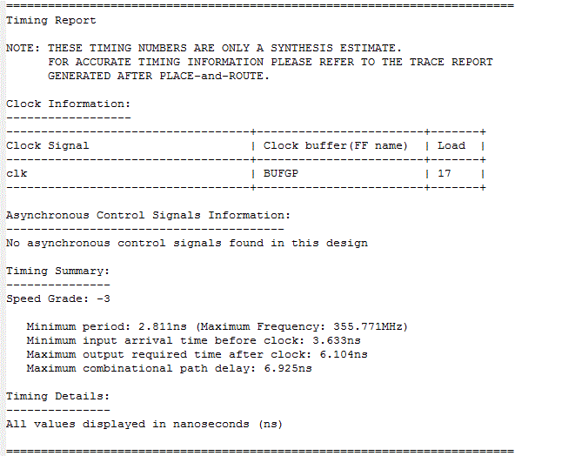

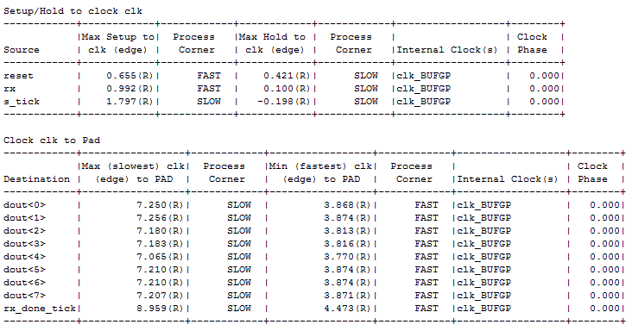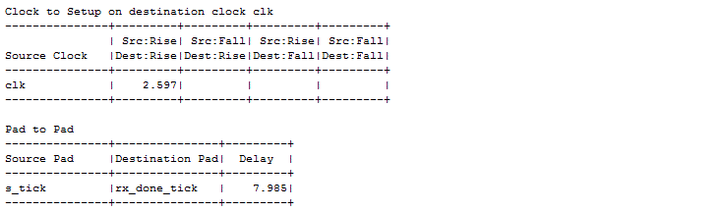

Timing Details:

---------------

All values displayed in nanoseconds (ns)

=========================================================================

Timing constraint: Default period analysis for Clock 'clk'

Clock period: 2.811ns (frequency: 355.771MHz)

Total number of paths / destination ports: 132 / 20

-------------------------------------------------------------------------

Delay: 2.811ns (Levels of Logic = 2)

Source: s_reg_2 (FF)

Destination: s_reg_3 (FF)

Source Clock: clk rising

Destination Clock: clk rising

Data Path: s_reg_2 to s_reg_3

Gate Net

Cell:in->out fanout Delay Delay Logical Name (Net Name)

---------------------------------------- ------------

FDC:C->Q 5 0.447 0.943 s_reg_2 (s_reg_2)

LUT4:I1->O 12 0.205 0.909 Mmux_s_next411 (Mmux_s_next41)

LUT5:I4->O 1 0.205 0.000 Mmux_s_next42 (s_next<3>)

FDC:D 0.102 s_reg_3

----------------------------------------

Total 2.811ns (0.959ns logic, 1.852ns route)

(34.1% logic, 65.9% route)

=========================================================================

**Timing constraint: Default OFFSET IN BEFORE for Clock 'clk'**

Total number of paths / destination ports: 41 / 34

-------------------------------------------------------------------------

Offset: 3.633ns (Levels of Logic = 3)

Source: s_tick (PAD)

Destination: s_reg_3 (FF)

Destination Clock: clk rising

Data Path: s_tick to s_reg_3

Gate Net

Cell:in->out fanout Delay Delay Logical Name (Net Name)

---------------------------------------- ------------

IBUF:I->O 6 1.222 0.992 s_tick_IBUF (s_tick_IBUF)

LUT4:I0->O 12 0.203 0.909 Mmux_s_next411 (Mmux_s_next41)

LUT5:I4->O 1 0.205 0.000 Mmux_s_next42 (s_next<3>)

FDC:D 0.102 s_reg_3

----------------------------------------

**Total 3.633ns (1.732ns logic, 1.901ns route)**

(47.7% logic, 52.3% route)

=========================================================================

**Timing constraint: Default OFFSET OUT AFTER for Clock 'clk'**

Total number of paths / destination ports: 14 / 9

-------------------------------------------------------------------------

Offset: 6.104ns (Levels of Logic = 3)

Source: s_reg_2 (FF)

Destination: rx_done_tick (PAD)

Source Clock: clk rising

Data Path: s_reg_2 to rx_done_tick

Gate Net

Cell:in->out fanout Delay Delay Logical Name (Net Name)

---------------------------------------- ------------

FDC:C->Q 5 0.447 0.943 s_reg_2 (s_reg_2)

LUT4:I1->O 12 0.205 1.156 Mmux_s_next411 (Mmux_s_next41)

LUT4:I0->O 1 0.203 0.579 Mmux_rx_done_tick11 (rx_done_tick_OBUF)

OBUF:I->O 2.571 rx_done_tick_OBUF (rx_done_tick)

----------------------------------------

**Total 6.104ns (3.426ns logic, 2.678ns route)**

(56.1% logic, 43.9% route)

=========================================================================

**Timing constraint: Default path analysis**

Total number of paths / destination ports: 1 / 1

-------------------------------------------------------------------------

Delay: 6.925ns (Levels of Logic = 4)

Source: s_tick (PAD)

Destination: rx_done_tick (PAD)

Data Path: s_tick to rx_done_tick

Gate Net

Cell:in->out fanout Delay Delay Logical Name (Net Name)

---------------------------------------- ------------

IBUF:I->O 6 1.222 0.992 s_tick_IBUF (s_tick_IBUF)

LUT4:I0->O 12 0.203 1.156 Mmux_s_next411 (Mmux_s_next41)

LUT4:I0->O 1 0.203 0.579 Mmux_rx_done_tick11 (rx_done_tick_OBUF)

OBUF:I->O 2.571 rx_done_tick_OBUF (rx_done_tick)

----------------------------------------

**Total 6.925ns (4.199ns logic, 2.726ns route)**

(60.6% logic, 39.4% route)

Summary

**Timing constraint: Default OFFSET IN BEFORE for Clock 'clk'**

**Total 3.633ns (1.732ns logic, 1.901ns route)**

(47.7% logic, 52.3% route)

**Timing constraint: Default OFFSET OUT AFTER for Clock 'clk'**

**Total 6.104ns (3.426ns logic, 2.678ns route)**

(56.1% logic, 43.9% route)

**Timing constraint: Default path analysis**

**Total 6.925ns (4.199ns logic, 2.726ns route)**

(60.6% logic, 39.4% route)

**Distribution amongst logic and routing is nearly 50%. And the maximum is around 7 nanoseconds. This corresponds to 77.42 MHz. Since we are trying to optimise the design by trying to release the signals at the negative clock edge and doing the operation in the positive clock edge, the maximum of clock frequency achievable is around 35 MHz. We set the frequency to 12.5 MHz considering all the other actual timing constraints that may be not included in timing analysis of place and route report.**

**Furthermore, the performance of the processor is mostly decided by the time taken in receiving and transferring the image from and to the computer. Compared to this time, the processing time is below 5% of the total operational time. Therefore, setting the clock frequency of the processor even below 12.5MHz still will not matter.**

**Minimum delay after place and route setting - 8.959(R)**

**After place and route clock has a slower clock at 9ns. Therefore, setting of 12.5MHz clock is further justified.**

8. REFERENCES

[1] Andrew S. Tanenbaum, “Structured Computer organization”, 5th edition, Pearson Prentice Hall,Pearson Education, Inc., Upper Saddle River, NJ 07458, 2006, pp.51-331.

<https://eleccompengineering.files.wordpress.com/2014/07/structured_computer_organization_5th_edition_801_pages_2007_.pdf>

[2]Xilinx Inc., “Spartan-6 FPGA Data Sheet: DC and Switching Characterises”, DS162 (v3.1.1) January 30, 2015.

<http://www.xilinx.com/support/documentation/data_sheets/ds162.pdf>

[3] DigilentInc., “Atlys FPGA Board Reference Manual”, April 11, 2016.

<https://reference.digilentinc.com/_media/atlys:atlys:atlys_rm.pdf>

[4] Deepak Kumar Tala, “Verilog Tutorial”.

<http://asic-world.com/>

[5] <http://www.aw-bc.com/info/carpinelli/sample.pdf>

[6]Bryan H.Fletcher, “FPGA Embedded Processors”, Embedded Training program, Embeddd Systems Conference San Francisco, 2005, ETP-367.

<http://www.xilinx.com/products/design_resources/proc_central/.../ETP-367paper.pdf>

**APPENDICES**

**APPENDIX I: SUPPLIMENTARY PYTHON CODES**

**APPENDIX I-A: Image Down Sampling**

import cv2

import numpy as np

import time

from PIL import Image

image = cv2.imread('lena-256x256.jpg')

image = cv2.cvtColor(image, cv2.COLOR_RGB2GRAY)

kernel = [ [1,2,1], [2,4,2], [1,2,1]]

memory = []

for x in range(0, 256):

for y in range(0, 256):

memory.append(image[x][y])

#print memory

for j in range(1, 254+1):

for i in range(1, 254+1):

x = j*256 + i

total = 0

total += memory[x] * 4;

total += memory[x-1] * 2;

total += memory[x+1] * 2;

total += memory[x+256] * 2;

total += memory[x-256] * 2;

total += memory[x+257];

total += memory[x+255];

total += memory[x-257];

total += memory[x-255];

total = total / 16

#print x - 9

memory[x-257] = total

count = 0

result = ''

for i in image:

result += 'memory[' + str(count) + '] = ' + str(i) + ';\n'

count += 1

#print result

print 'Memory after gaussian filtered'

#for m in memory:

#print m

# sampling the gaussian filtered image

k = 0

for j in range(0, 127+1):

for i in range(0, 127+1):

y = 2*256*j + 2*i

memory[k] = memory[y]

k = k + 1

print 'Memory after sampled'

for m in memory:

print m

p = 128

result = np.zeros(shape=(p, p))

k = 0

for x in range(0, p):

for y in range(0, p):

result[x][y] = memory[k]

k = k + 1

print result[0][0]

result = np.array(result, dtype = np.uint8)

cv2.imshow('Original image', image)

cv2.imshow('Downsmpled image', result)

cv2.waitKey(0)

**APPENDIX I-B: Compiler**

import os

OPCODE = { 'NOP' :'00000',

'LOAD' :'00001',

'STORE' :'00010',

'MOVE' :'00011',

'LDMAR' :'00100',

'LDMARI' :'00101',

'LOADI' :'00110',

'LDACI' :'00111',

'ADD' :'01000',

'SUB' :'01001',

'MUL' :'01010',

'DIV' :'01011',

'INC' :'01100',

'DEC' :'01101',

'NEG' :'01110',

'NOT' :'01111',

'AND' :'10000',

'OR' :'10001',

'XOR' :'10010',

'JGT' :'10011',

'JEQ' :'10100',

'JGE' :'10101',

'JLT' :'10110',

'JNE' :'10111',

'JLE' :'11000',

'JMP' :'11001',

'FIN' :'11010'}

PREDEF = { 'AC' :'000',

'R1' :'001',

'R2' :'010',

'R3' :'011',

'R4' :'100',

'R5' :'101',

'R6' :'110',

'R7' :'111'}

def Translate(filename):

# This function will convert assembly code to machine code

a_code = []

m_code = []

SYMBOL = {}

SYMBOL_COUNT = 16;

with open(filename) as fp:

for line in fp:

x = line.strip()

if len(x) > 0:

if not (x[0] == '/' and x[1] == '/'):

a_code.append(x);

for x in range(0, len(a_code)):

if "//" in a_code[x]:

t = a_code[x].split("//")

a_code[x] = t[0].strip();

print a_code

# replace (xxx)

for x in range(0, len(a_code)):

if a_code[x][0] == '(':

label = a_code[x][1:-1]

# count the instruction number

count = 0;

for x in range(0, len(a_code)):

if a_code[x][1:-1] == label:

break

if not a_code[x][0] == '(':

count += 1

SYMBOL.update({label:str(count)})

a_code[x] = '('

a_code = filter(lambda x: x is not '(', a_code)

# split opcode and arguments

for x in range(0, len(a_code)):

a_code[x] = a_code[x].replace(',', ' ') ## remove ','

a_code[x] = a_code[x].split(' ')

a_code[x] = [var for var in a_code[x] if var]

# replace symbols and variable names

for x in range(0, len(a_code)):

for y in range(0, len(a_code[x])):

if a_code[x][y][0] == '@':

if a_code[x][y][1:] in SYMBOL:

a_code[x][y] = SYMBOL[a_code[x][y][1:]]

print SYMBOL

for x in a_code:

print x

# translate assembly code to machine code

for x in range(0, len(a_code)):

instruction = ''

opcode = a_code[x][0]

# no operation instruction

if opcode == 'NOP':

instruction = format(0, '024b')

elif opcode == 'FIN':

instruction = OPCODE[opcode] + format(0, '019b')

# I type instructions

elif opcode == 'LDACI':

instruction = OPCODE[opcode] + format(int(a_code[x][1]), '019b')

elif opcode == 'LDMARI':

instruction = OPCODE[opcode] + format(int(a_code[x][1]), '019b')

# RI type instructions

elif opcode == 'LOADI':

instruction = OPCODE[opcode] + PREDEF[a_code[x][1]] + format(int(a_code[x][2]), '016b')

# jump instructions

elif opcode[0] == 'J': # all jump instruction opcode starts with J

instruction = OPCODE[opcode] + format(int(a_code[x][1]), '019b')

# R type instructions

# LOAD, STORE, LDMAR, INC, DEC instructions

elif opcode == 'LOAD' or opcode == 'STORE' or opcode == 'LDMAR' or opcode == 'INC' or opcode == 'DEC':

instruction = OPCODE[opcode] + PREDEF[a_code[x][1]] + format(0, '016b')

# RR instructions

# MOVE, NEG instructions

elif opcode == 'MOVE' or opcode == 'NEG':

instruction = OPCODE[opcode] + PREDEF[a_code[x][1]] + PREDEF[a_code[x][2]] + format(0, '013b')

# RRR type instructions

else:

instruction = OPCODE[opcode] + PREDEF[a_code[x][1]] + PREDEF[a_code[x][2]] + PREDEF[a_code[x][3]] + format(0, '010b')

m_code.append(instruction)

for ins in m_code:

print ins

# output machine code to .mcode file

var_name = 'memory'

index = 0

out = ''

for x in m_code:

out += var_name + '[' + str(index) + '] = 24\'b' + x + ";\n"

#out += x + ",\n"

index += 1

out = out.strip()

f = filename.split('.')

outname = f[0] + ".mcode"

file = open(outname, 'w')

file.write(out)

file.close();

path = os.path.dirname(os.path.realpath(__file__))

for file in os.listdir(path):

if file.endswith(".asm"):

Translate(os.path.join(path, file))

**APPENDIX I-C: Image Communication with the Processor**

import cv2

import numpy as np

import serial

import time

s = serial.Serial('COM3', 250000);

image = cv2.imread('lena-256x256.jpg')

image = cv2.cvtColor(image, cv2.COLOR_RGB2GRAY)

#for x in range(0, 256):

# for y in range(0, 256):

# print image[x][y]

#cv2.imshow('image', img)

#cv2.waitKey(0)

print 'Sending data...'

L = 256

p = L/2

t1 = time.time()

for x in range(0, L):

for y in range(0, L):

s.write(bytearray([image[x][y]]))

#time.sleep(0.0001)

t = time.time() - t1

print 'Done!'

print 'Elapsed time ' + str(t) + ' s'

print 'Receiving data...'

rx_count = 0

rx_img = []

t2 = time.time()

while(1):

raw = s.read()

rx_img.append(raw)

#print ord(raw),

rx_count = rx_count + 1

if rx_count == p*p:

break

t = time.time() - t2

total_t = time.time() - t1

print 'Done!.'

print 'Elapsed time ' + str(t) + ' s'

print 'Total time ' + str(total_t) + ' s'

result = np.zeros(shape=(p, p))

k = 0

for x in range(0, p):

for y in range(0, p):

result[x][y] = map(ord, rx_img[k])[0]

k = k + 1

#print result[x][y]

result = np.array(result, dtype = np.uint8)

#img2 = image.copy()

#downSamImage = cv2.pyrDown(img2)

# Gaussian filtering the image

kernel = [ [1,2,1], [2,4,2], [1,2,1]]

memory = []

for x in range(0, 256):

for y in range(0, 256):

memory.append(int(image[x][y]))

#print memory

for j in range(1, 254+1):

for i in range(1, 254+1):

x = j*256 + i

total = 0

total += memory[x] * 4;

total += memory[x-1] * 2;

total += memory[x+1] * 2;

total += memory[x+256] * 2;

total += memory[x-256] * 2;

total += memory[x+257];

total += memory[x+255];

total += memory[x-257];

total += memory[x-255];

total = total / 16

#print x - 257

memory[x-257] = total

# sampling the gaussian filtered image

k = 0

for j in range(0, 127+1):

for i in range(0, 127+1):

y = 2*256*j + 2*i

memory[k] = memory[y]

k = k + 1

downSamImage = np.zeros(shape=(p, p))

k = 0

for x in range(0, p):

for y in range(0, p):

downSamImage[x][y] = memory[k]

k = k + 1

#print result[x][y]

downSamImage = np.array(downSamImage, dtype = np.uint8)

# calculating the error

nonZeroPxCount = 0

maxErrorPx = 0

for x in range(0, p):

for y in range(0, p):

absVal = abs(int(downSamImage[x][y]) - int(result[x][y]))

#print str(downSamImage[x][y]) + ' ' + str(result[x][y]) + ' ' + str(absVal)

# count non zero pixels

if absVal != 0:

nonZeroPxCount += 1

if absVal > maxErrorPx:

maxErrorPx = absVal

print 'Non zero pixel count ' + str(nonZeroPxCount)

print 'Maximum error ' + str(maxErrorPx)

# displaying the images

print 'Displaying the images.'

cv2.imshow('Original image', image)

cv2.imshow('Python', downSamImage)

cv2.imshow('FPGA', result)

cv2.waitKey(0)

**APPENDIX II: INPUT-OUTPUT MODULE**

**APPENDIX II-A: 2to1 Mux (16 bit)**

module MUX2to1_16bit(

input [15:0] A,B,

input sel,

output reg [15:0] OUT

);

always @(A or B or sel) begin

case(sel)

1'b0: OUT = A;

1'b1: OUT = B;

endcase

end

endmodule

**APPENDIX II-B: 2to1 Mux (8 bit)**

module MUX2to1_8bit(

input [7:0] A,B,

input sel,

output reg [7:0] OUT

);

always @(A or B or sel) begin

case(sel)

1'b0: OUT = A;

1'b1: OUT = B;

endcase

end

endmodule

**APPENDIX II-C: 2to1 Mux**

module MUX2to1(

input A, B,

input sel,

output reg OUT

);

always @(A or B or sel) begin

case(sel)

1'b0: OUT = A;

1'b1: OUT = B;

endcase

end

endmodule

**APPENDIX II-D: 1to2 Demux (8 bit)**

module DMUX1to2_8bit(

input [7:0] IN,

input sel,

output reg [7:0] A,B

);

always @(IN or sel) begin

case(sel)

1'b0: A = IN;

1'b1: B = IN;

endcase

end

endmodule

**APPENDIX II-E: UART Transmitter (TX)**

module UART_TX(

input clk, tx_start,

input [7:0] in_data_byte,

output tx_out, tx_done

);

parameter CLOCKS_PER_BIT = 50; // 9600 baud rate (100 MHz / 9600) 10417 **** 115200 baud rate 868 *** 109 for 12.5 MHz

parameter IDLE = 3'b000;

parameter START = 3'b001;

parameter DATA_TX = 3'b010;

parameter STOP = 3'b011;

parameter CLEANUP = 3'b100;

parameter DELAY = 2; // 50 milli second delay = 5000000

reg [2:0] state = 0;

reg [7:0] data_byte = 0;

reg [32:0] clock_count = 0;

reg [2:0] tx_bit_index = 0;

reg tx_data = 1'b1;

reg tx_data_done = 1'b0;

always @(posedge clk)

begin

case(state)

IDLE:

begin

tx_data <= 1'b1;

clock_count <= 0;

tx_bit_index <= 0;

if(tx_start)

begin

tx_data_done <= 0;

data_byte <= in_data_byte;

state <= START;

end

else

begin

state <= IDLE;

end

end

START:

begin

tx_data <= 1'b0;

if(clock_count < CLOCKS_PER_BIT - 1)

begin

clock_count <= clock_count + 1;

state <= START;

end

else

begin

clock_count <= 0;

state <= DATA_TX;

end

end

DATA_TX:

begin

tx_data <= data_byte[tx_bit_index];

if(clock_count < CLOCKS_PER_BIT - 1)

begin

clock_count <= clock_count + 1;

state <= DATA_TX;

end

else

begin

if(tx_bit_index < 7)

begin

clock_count <= 0;

tx_bit_index <= tx_bit_index + 1;

state <= DATA_TX;

end

else

begin

clock_count <= 0;

tx_bit_index <= 0;

state <= STOP;

end

end

end

STOP:

begin

tx_data <= 1'b1;

if(clock_count < CLOCKS_PER_BIT - 1)

begin

clock_count <= clock_count + 1;

state <= STOP;

end

else

begin

clock_count <= 0;

state <= CLEANUP;

end

end

CLEANUP:

begin

if(clock_count < DELAY - 1)

begin

clock_count <= clock_count + 1;

end

else

begin

state <= IDLE;

clock_count <= 0;

tx_data_done <= 1;

end

end

default:

state <= IDLE;

endcase

end

assign tx_out = tx_data;

assign tx_done = tx_data_done;

endmodule

**APPENDIX II-F: UART Receiver (RX)**

module UART_RX(

input clk, rx_in,

output [7:0] rx_byte,

output rx_done

);

parameter CLOCKS_PER_BIT = 50; // 9600 baud rate (100 MHz / 9600) 10417 **** 115200 baud rate 868

parameter IDLE = 3'b000;

parameter START = 3'b001;

parameter DATA_RX = 3'b010;

parameter STOP = 3'b011;

parameter CLEANUP = 3'b100;

parameter DELAY = 1; // delay 8680 clock cycles

reg [2:0] state = 0;

reg [7:0] data_byte = 0;

reg [32:0] clock_count = 0;

reg [2:0] rx_bit_index = 0;

reg rxdone = 0;

assign rx_byte = data_byte;

assign rx_done = rxdone;

always @(posedge clk)

begin

case(state)

IDLE:

begin

if(rx_in == 1'b0)

begin

rxdone <= 1'b0;

data_byte <= 0;

state <= START;

end

else

begin

rx_bit_index <= 0;

clock_count <= 0;

state <= IDLE;

end

end

START:

begin

if(clock_count < ((CLOCKS_PER_BIT/2) - 1) )

begin

clock_count <= clock_count + 1;

state <= START;

end

else

begin

clock_count <= 0;

state <= DATA_RX;

end

end

DATA_RX:

begin

if(clock_count < CLOCKS_PER_BIT - 1)

begin

clock_count <= clock_count + 1;

state <= DATA_RX;

end

else

begin

data_byte[rx_bit_index] <= rx_in;

if(rx_bit_index < 7)

begin

rx_bit_index <= rx_bit_index + 1;

state <= DATA_RX;

clock_count <= 0;

end

else

begin

rx_bit_index <= 0;

clock_count <= 0;

state <= STOP;

end

end

end

STOP:

begin

if(clock_count < CLOCKS_PER_BIT - 1)

begin

clock_count <= clock_count + 1;

state <= STOP;

end

else

begin

state <= CLEANUP;

clock_count <= 0;

end

end

CLEANUP:

begin

if(clock_count < DELAY - 1)

begin

clock_count <= clock_count + 1;

end

else

begin

rxdone <= 1'b1;

state <= IDLE;

clock_count <= 0;

end

end

default:

state <= IDLE;

endcase

end

endmodule

**APPENDIX II-G: IO Module**

module IO_MODULE(

input clk,

input reset,

input start,

input rx_done,

output reg tx_start,

input tx_done,

output reg [15:0] ram_addr,

output reg write,

output reg reset_cpu,

output sel

);

parameter RAM_LEN = 65536;

parameter IDLE_RX = 0;

parameter RX_1 = 1;

parameter RX_2 = 2;

parameter RX_3 = 3;

parameter WAIT_RX = 4;

parameter IDLE_TX = 5;

parameter TX_1 = 6;

parameter TX_2 = 7;

parameter TX_3 = 8;

parameter TX_4 = 9;

parameter WAIT_TX = 10;

reg [3:0] STATE_RX = IDLE_RX;

reg [3:0] STATE_TX = IDLE_TX;

reg [16:0] write_addr = 0;

reg [16:0] read_addr = 0;

reg select = 0;

assign sel = select;

initial

begin

reset_cpu <= 1'b0;

end

always @(posedge clk) begin

case(STATE_RX)

IDLE_RX:

begin

if(rx_done) begin

ram_addr <= write_addr;

STATE_RX <= RX_1;

end

else begin

write <= 0;

STATE_RX <= IDLE_RX;

end

if(reset) begin

write_addr <= 0;

select <= 0;

end

else begin

write_addr <= write_addr;

//select <= select;

end

end

RX_1:

begin

write <= 1;

STATE_RX <= RX_2;

end

RX_2:

begin

write <= 0;

write_addr <= write_addr + 1;

STATE_RX <= RX_3;

end

RX_3:

begin

if(write_addr == RAM_LEN) begin

reset_cpu <= 1;

select <= 1;

STATE_RX <= WAIT_RX;

end

else begin

reset_cpu <= 0;

//select <= select;

STATE_RX <= WAIT_RX;

end

end

WAIT_RX: // wait until rx_done goes high

begin

//reset_cpu <= 0;

if(~rx_done) begin

STATE_RX <= IDLE_RX;

end

else begin

STATE_RX <= WAIT_RX;

end

if(reset) begin

write_addr <= 0;

select <= 0;

end

else begin

write_addr <= write_addr;

//select <= select;

end

end

default:

STATE_RX <= IDLE_RX;

endcase

case(STATE_TX)

IDLE_TX:

begin

if(start) begin

read_addr <= 0;

select <= 0;

STATE_TX <= TX_1;

end

else begin

read_addr <= 0;

//select <= select;

STATE_TX <= IDLE_TX;

end

end

TX_1:

begin

ram_addr <= read_addr;

STATE_TX <= TX_2;

end

TX_2:

begin

tx_start <= 1;

STATE_TX <= TX_3;

end

TX_3:

begin

tx_start <= 0;

STATE_TX <= TX_4;

end

TX_4:

begin

if(tx_done) begin

if(read_addr < RAM_LEN - 1) begin

read_addr <= read_addr + 1;

STATE_TX <= TX_1;

end

else begin

read_addr <= 0;

STATE_TX <= WAIT_TX;

end

end

else begin

STATE_TX <= TX_4;

end

end

WAIT_TX:

begin

if(~start) begin

STATE_TX <= IDLE_TX;

end

else begin

STATE_TX <= WAIT_TX;

end

end

default:

STATE_TX <= IDLE_TX;

endcase

end

endmodule

**APPENDIX III: PROCESSOR-I**

**APPENDIX III-A: General Purpose Register**

module GPR(

input clk, load,

input [23:0] C_bus,

output reg [23:0] d_out

);

always@(posedge clk)

begin

if(load) d_out <= C_bus;

end

end module

**APPENDIX III-B: Memory Address Register (MAR)**

module MAR(

input clk, load,

input [23:0] C_bus,

output reg [23:0] data_addr

);

always@(posedge clk)

begin

if(load) data_addr <= C_bus;

end

endmodule

**APPENDIX III-C: Memory Data Register (MDR)**

module MDR(

input clk, load, read,

input [7:0] C_bus,

input [7:0] data_in,

output reg [7:0] data_out

);

always@(posedge clk)

begin

if(load) data_out <= C_bus;

if(read) data_out <= data_in;

end

endmodule

**APPENDIX IID: Programme Counter (PC)**

module PC(

input enable, clk, load, inc,

input [8:0] C_bus,

output reg [8:0] ins_addr

);

reg state = 0;

initial

begin

ins_addr <= 0;

end

always @(posedge enable)

begin

state <= 1;

//ins_addr <= 9'b0;

end

always@(posedge clk)

begin

if (state)

begin

//if(enable) ins_addr <= 9'b0;

if(load) ins_addr <= C_bus[8:0];

else if(inc) ins_addr <= ins_addr + 9'b000000001;

end

end

endmodule

**APPENDIX III-E: Memory Buffer Register Unit (MBRU)**

module MBRU(

input clk, fetch,

input [7:0] ins_in,

output reg [7:0] ins_out

);

always@(posedge clk)

begin

if(fetch)

begin

ins_out <= ins_in;

end

end

endmodule

APPENDIX IIF: 4to16 Decoder

module decoder (

input [23:0] R1, R2, R3, R4, R,

input [8:0] PC,

input [7:0] MBRU, MDR,

input [3:0] b_control,

output reg [23:0] B_bus

);

always @(b_control or R1 or R2 or R3 or R4 or R or PC or MBRU or MDR)

case(b_control)

4'd1: B_bus <= {16'b0, MDR};

4'd2: B_bus <= {15'b0, PC};

4'd3: B_bus <= {16'b0, MBRU};

4'd4: B_bus <= R1;

4'd5: B_bus <= R2;

4'd6: B_bus <= R3;

4'd7: B_bus <= R4;

4'd8: B_bus <= R;

default: B_bus <= 24'b0;

endcase

endmodule

**APPENDIX III-G: Control Store**

module microProcessor (

input enable, clk, Z_flag, addr_sel, JUMP,

input [7:0] addr, MBRU,

output reg [30:0] MIR

);

reg [1:0] state = 2'b00;

reg start = 1'b0;

reg [7:0] next_addr = 0;

reg [30:0] ROM[0:57];

parameter JMNZ1 = 8'd22, JMNZY1 = 8'd23, JMNZN1 = 8'd25, FETCH2 = 8'd1;

//parameter JMPZY1 = 9'd50, JMPZN1 = 9'd48;

/*

always @(posedge enable)

begin

next_addr <= 8'b0;

end

*/

initial begin

MIR = 31'b0;

end

always @(posedge enable)

begin

start = 1'b1;

//MIR = 31'b0;

//state = 2'b00;

end

always @(posedge clk)

if(start)

begin

case(state)

2'b00: state = 2'b01;

2'b01: state = 2'b10;

2'b10: state = 2'b11;

2'b11: state = state;

default: state = state;

endcase

end

always @(negedge clk)

begin

if(state == 2'b11)

begin

case(addr)

FETCH2: MIR = {MBRU, ROM[FETCH2][22:0]};

JMNZ1: if(Z_flag == 1'b0) MIR = ROM[JMNZN1];

else MIR = ROM[JMNZY1];

default: MIR = ROM[addr];

endcase

end

end

/*

always @(negedge clk)

begin

if(addr_sel) next_addr = MBRU;

else next_addr = addr;

end

always @(next_addr)

begin

if(enable == 1'b1)

begin

case(next_addr)

JMNZ1: if(Z_flag == 1'b0) MIR = ROM[JMNZN1];

else MIR = ROM[JMNZY1];

default: MIR = ROM[next_addr];

endcase

end

else

begin

MIR = ROM[0];

end

end

*/

initial

begin

ROM[0] = 31'b00000001_00_0000_000000000_100_1_1010;

ROM[1] = 31'bXXXXXXXX_01_0000_000000000_000_0_1010;

ROM[2] = 31'b00111001_10_0000_000000000_000_0_0000;

ROM[3] = 31'b00000100_00_0000_000000000_010_0_0000;

ROM[4] = 31'b00000000_00_1000_000000001_000_0_0001;

ROM[5] = 31'b00000110_00_0000_000000000_000_1_0000;

ROM[6] = 31'b00000111_00_1000_000000001_000_0_0011;

ROM[7] = 31'b00001000_00_0101_000000001_100_1_0000;

ROM[8] = 31'b00000000_00_0001_000000001_000_0_0011;

ROM[9] = 31'b00001010_00_0111_010000000_000_0_0000;

ROM[10] = 31'b00000000_00_0000_000000000_001_0_0000;

ROM[11] = 31'b00000000_00_0111_000100000_000_0_0000;

ROM[12] = 31'b00000000_00_0111_000010000_000_0_0000;

ROM[13] = 31'b00000000_00_0111_000001000_000_0_0000;

ROM[14] = 31'b00000000_00_0111_000000100_000_0_0000;

ROM[15] = 31'b00000000_00_0111_000000010_000_0_0000;

ROM[16] = 31'b00000000_00_0111_100000000_000_0_0000;

ROM[17] = 31'b00000000_00_1000_000000001_000_0_0100;

ROM[18] = 31'b00000000_00_1000_000000001_000_0_0101;

ROM[19] = 31'b00000000_00_1000_000000001_000_0_0110;

ROM[20] = 31'b00000000_00_1000_000000001_000_0_0111;

ROM[21] = 31'b00000000_00_1000_000000001_000_0_1000;

ROM[22] = 31'bXXXXXXXX_00_0000_000000000_000_0_0000;

ROM[23] = 31'b00011000_00_0000_000000000_000_1_0000;

ROM[24] = 31'b00111000_00_0000_000000000_000_1_0000; //00111000_00_0001_001000000_000_0_0011 00000000_00_0001_001000000_000_0_0011

ROM[25] = 31'b00011010_00_0000_000000000_100_1_0000;

ROM[26] = 31'b00011011_00_1000_000000001_000_0_0011;

ROM[27] = 31'b00011100_00_0101_000000001_100_0_0000;

ROM[28] = 31'b00111000_00_0001_001000000_000_0_0011; //00111000_00_0001_001000000_000_0_0011 00000000_00_0001_001000000_000_0_0011

//

ROM[56] = 31'b00000000_00_0000_000000000_000_0_0000;

//

ROM[29] = 31'b00000000_00_1001_000000001_000_0_0000;

ROM[30] = 31'b00000000_00_1010_000000001_000_0_0000;

ROM[31] = 31'b00000000_00_0001_000000001_000_0_1000;

ROM[32] = 31'b00000000_00_0010_000000001_000_0_1000;

ROM[33] = 31'b00100010_00_0111_000000010_100_1_0000;

ROM[34] = 31'b00100011_00_1000_000000001_000_0_0011;

ROM[35] = 31'b00100100_00_0101_000000001_100_1_0000;

ROM[36] = 31'b00100101_00_1000_000000001_000_0_0011;

ROM[37] = 31'b00000000_00_0001_000000001_000_0_1000;

ROM[38] = 31'b00100111_00_0111_000000010_100_1_0000;

ROM[39] = 31'b00101000_00_1000_000000001_000_0_0011;

ROM[40] = 31'b00101001_00_0101_000000001_100_1_0000;

ROM[41] = 31'b00101010_00_1000_000000001_000_0_0011;

ROM[42] = 31'b00000000_00_0010_000000001_000_0_1000;

ROM[43] = 31'b00000000_00_0110_000000001_000_0_0000;

ROM[44] = 31'b00000000_00_0011_000000001_000_0_0000;

ROM[45] = 31'b00000000_00_0100_000000001_000_0_0000;

ROM[46] = 31'b00101111_00_0101_000000001_000_0_0000;

ROM[47] = 31'b00000000_00_0011_000000001_000_0_0000;

ROM[48] = 31'b00110001_00_1000_000000001_000_0_0100;

ROM[49] = 31'b00110010_00_1001_000000001_000_0_0000;

ROM[50] = 31'b00000000_00_0111_000100000_000_0_0000;

ROM[51] = 31'b00110100_00_1000_000000001_000_0_0101;

ROM[52] = 31'b00110101_00_1001_000000001_000_0_0000;

ROM[53] = 31'b00000000_00_0111_000010000_000_0_0000;

ROM[54] = 31'b00000000_00_1011_000000001_000_0_0000;

ROM[55] = 31'b00000000_00_0001_000001001_000_0_0110;

ROM[57] = 31'b00111001_00_0000_000000000_000_0_0000;

end

endmodule

**APPENDIX III-H: Arithmetic Logic Unit (ALU)**

module ALU(

input [23:0] A_bus,

input [23:0] B_bus,

input [3:0] oper,

output reg [23:0] C_bus,

output reg Z_flag

);

parameter ADD = 4'b0001, SUB = 4'b0010, PASSATOC = 4'b0111, PASSBTOC = 4'b1000,

INCAC = 4'b1001, DECAC = 4'b1010, LSHFT1 = 4'b0011, LSHFT2 = 4'b0100,

LSHFT8 = 4'b0101, RSHFT4 = 4'b0110, RESET = 4'b1011;

always@(B_bus or oper or A_bus)

case(oper)

ADD: C_bus = A_bus + B_bus; //1

SUB: begin

C_bus = A_bus - B_bus;

Z_flag = (C_bus == 16'b0)? 1'b1 : 1'b0; //2

end

LSHFT1: C_bus = A_bus << 1; //3

LSHFT2: C_bus = A_bus << 2; //4

LSHFT8: C_bus = A_bus << 8; //5

RSHFT4: C_bus = A_bus >> 4; //6

PASSATOC: C_bus = A_bus; //7

PASSBTOC: C_bus = B_bus; //8

INCAC: C_bus = A_bus + 24'b1; //9

DECAC: C_bus = A_bus - 24'b1; //10

RESET: C_bus = 24'b0;

default: begin

C_bus = 24'b0;

end

endcase

endmodule

**APPENDIX III-I: Clock Generator**

module CLOCK_GEN(

input clk_in,

output clk_out

);

parameter factor = 4;

reg [7:0] counter = 0;

reg out = 0;

assign clk_out = out;

always @(posedge clk_in) begin

if(counter < factor - 1) begin

counter <= counter + 1;

end

else begin

out <= ~out;

counter <= 0;

end

end

endmodule

**APPENDIX III-J: Central Processing Unit (CPU)**

module CPU(

input clk,

input reset,

input rx,

output tx,

output status

);

/*

input enable, clk;

output finish;

wire write;

wire [7:0] data_out, DRAM_data_write, ins_out;

wire [8:0] ins_addr;

wire [23:0] data_addr;

*/

// Instruction ROM

wire [7:0] instruction;

wire [8:0] pc_addr;

// Instruction RAM CPU Related

wire [7:0] ram_out_cpu, ram_in_cpu;

wire [23:0] ram_addr_cpu;

//

wire [7:0] ram_out_tx, ram_in_rx;

wire [15:0] ram_addr_io;

// TO the RAM module

wire [7:0] ram_out, ram_in;

wire [15:0] ram_addr;

wire write_cpu, write_io;

wire reset_cpu, finish;

wire sel;

wire clk2;

assign status = ~sel;

CLOCK_GEN clk_gen (

.clk_in(clk),

.clk_out(clk2)

);

Processor pentium4 (

.enable(reset_cpu),

.clk(clk2),

.data_in(ram_out_cpu),

.DRAM_addr(ram_addr_cpu),

.DRAM_data_write(ram_in_cpu),

.write(write_cpu),

.IROM_ins_fetch(instruction),

.IROM_addr(pc_addr),

.finish(finish)

);

/*

CPU cpu (

.clk(clk2),

.INSTRUCTION(instruction),

.RAM_IN(ram_out_cpu),

.reset(reset_cpu),

.RAM_OUT(ram_in_cpu),

.RAM_ADDR(ram_addr_cpu),

.PC_ADDR(pc_addr),

.WRITE(write_cpu),

.FINISH(finish)

);

*/

//----------- Begin Cut here for INSTANTIATION Template ---// INST_TAG

DataRAM dram216 (

.clka(clk2), // input clka

.wea(write), // input [0 : 0] wea

.addra(ram_addr), // input [15 : 0] addra

.dina(ram_in), // input [7 : 0] dina

.douta(ram_out) // output [7 : 0] douta

);

/*

RAM Ram (

.clka(clk2), // input clka

.wea(write), // input [0 : 0] wea

.addra(ram_addr), // input [15 : 0] addra

.dina(ram_in), // input [7 : 0] dina

.douta(ram_out) // output [7 : 0] douta

);

*/

//----------- Begin Cut here for INSTANTIATION Template ---// INST_TAG

InsROM irom512 (

.clka(clk2), // input clka

.addra(pc_addr), // input [8 : 0] addra

.douta(instruction) // output [7 : 0] douta

);

/*

ROM rom (

.address(pc_addr),

.out(instruction)

);

*/

IO_MODULE IO (

.clk(clk2),

.reset(reset),

.start(finish),

.rx_done(rx_done),

.tx_start(tx_start),

.tx_done(tx_done),

.ram_addr(ram_addr_io),

.write(write_io),

.reset_cpu(reset_cpu),

.sel(sel)

);

UART_TX Tx (

.clk(clk2),

.tx_start(tx_start),

.in_data_byte(ram_out_tx),

.tx_out(tx),

.tx_done(tx_done)

);

UART_RX Rx (

.clk(clk2),

.rx_in(rx),

.rx_byte(ram_in_rx),

.rx_done(rx_done)

);

MUX2to1_16bit mux1 (

.A(ram_addr_io),

.B(ram_addr_cpu[15:0]),

.sel(sel),

.OUT(ram_addr)

);

MUX2to1 mux2 (

.A(write_io),

.B(write_cpu),

.sel(sel),

.OUT(write)

);

MUX2to1_8bit mux3 (

.A(ram_in_rx),

.B(ram_in_cpu),

.sel(sel),

.OUT(ram_in)

);

DMUX1to2_8bit dmux1 (

.IN(ram_out),

.sel(sel),

.A(ram_out_tx),

.B(ram_out_cpu)

);

endmodule

**APPENDIX IV: PROCESSOR-II**

**APPENDIX IV-A: Register (24 bit)**

module REG24bit(

input clk, load,

input [23:0] IN,

output reg [23:0] OUT

);

always @(posedge clk) begin

if(load) begin

OUT <= IN;

end

end

endmodule

**APPENDIX IV-B: Program Counter (PC)**

module PC(

input clk,

input reset,inc,load,

input [23:0] IN,

output reg [23:0] OUT

);

always @(posedge clk)

begin

if(inc) begin

OUT = OUT + 1;

end

if(load) begin

OUT = IN;

end

if(reset) begin

OUT = 0;

end

end

endmodule

**APPENDIX IV-C: 8to1 Mux**

module MUX8to1(

input [23:0] A,B,C,D,E,F,G,H,

input [2:0] sel,

output reg [23:0] OUT

);

always @(A or B or C or D or E or F or G or H or sel) begin

case(sel)

3'b000: OUT = A;

3'b001: OUT = B;

3'b010: OUT = C;

3'b011: OUT = D;

3'b100: OUT = E;

3'b101: OUT = F;

3'b110: OUT = G;

3'b111: OUT = H;

endcase

end

endmodule

**APPENDIX IV-D: 3to1 Mux**

module MUX3to1(

input [23:0] A,B,C,

input [1:0] sel,

output reg [23:0] OUT

);

always @(A or B or C or sel) begin

OUT = 0;

case(sel)

2'b00: OUT = A;

2'b01: OUT = B;

2'b10: OUT = C;

endcase

end

endmodule

**APPENDIX IV-E: 1to2 Demux**

module DMUX1to2(

input [23:0] IN,

input sel,

output reg [23:0] A,B

);

always @(IN or sel) begin

case(sel)

1'b0: A = IN;

1'b1: B = IN;

endcase

end

endmodule

**APPENDIX IV-F: 1to10 Demux**

module DMUX1to10(

input IN,

input [3:0] sel,

output reg A,B,C,D,E,F,G,H,I,J

);

always @(IN or sel) begin

A = 0;

B = 0;

C = 0;

D = 0;

E = 0;

F = 0;

G = 0;

H = 0;

I = 0;

J = 0;

case(sel)

4'b0000: A = IN;

4'b0001: B = IN;

4'b0010: C = IN;

4'b0011: D = IN;

4'b0100: E = IN;

4'b0101: F = IN;

4'b0110: G = IN;

4'b0111: H = IN;

4'b1000: I = IN;

4'b1001: J = IN;

endcase

end

endmodule

**APPENDIX IV-G: Arithmetic & Logic Unit (ALU)**

module ALU24bit(

input [23:0] A,B,

input [3:0] sel,

output reg [23:0] OUT,

output reg Z,N

);

parameter NOP = 4'b0000;

parameter ADD = 4'b0001;

parameter SUB = 4'b0010;

parameter MUL = 4'b0011;

parameter DIV = 4'b0100;

parameter INC = 4'b0101;

parameter DEC = 4'b0110;

parameter NEG = 4'b0111;

parameter NOT = 4'b1000;

parameter AND = 4'b1001;

parameter OR = 4'b1010;

parameter XOR = 4'b1011;

always @(A or B or sel) begin

Z = 0;

N = 0;

case(sel)

NOP: OUT = A;

ADD: OUT = A+B;

SUB: OUT = A-B;

MUL: OUT = A<<B;

DIV: OUT = A>>B;

INC: OUT = A+1;

DEC: OUT = A-1;

NEG: OUT = -A;

NOT: OUT = ~A;

AND: OUT = A&B;

OR: OUT = A|B;

XOR: OUT = A^B;

endcase

if(OUT==0) begin

Z=1;

end

else if(OUT[23]==1) begin

N=1;

end

end

endmodule

**APPENDIX IV-H: Clock Generator**

module CLOCK_GEN(

input clk_in,

output clk_out

);

parameter factor = 4;

reg [7:0] counter = 0;

reg out = 0;

assign clk_out = out;

always @(posedge clk_in) begin

if(counter < factor - 1) begin

counter <= counter + 1;

end

else begin

out <= ~out;

counter <= 0;

end

end

endmodule

**APPENDIX IV-I: Decoder**

module DECODER(

input clk,

input [23:0] INSTRUCTION,

input Z,N,

output reg INC_PC, LOAD_REG,

output reg [2:0] MUX_A_SEL, MUX_B_SEL,

output reg [1:0] MUX_C_SEL,

output reg DMUX_A_SEL,

output reg [3:0] DMUX_B_SEL,

output reg [3:0] ALU_CONTROL,

output reg WRITE,

output reg [23:0] IMMEDIATE,

output reg FINISH

);

parameter NOP = 5'b00000; // No Operation

parameter LOAD = 5'b00001; // RegA = RAM[MAR]

parameter STORE = 5'b00010; // RAM[MAR] = RegA

parameter MOVE = 5'b00011; // RegA = RegB

parameter LDMAR = 5'b00100; // MAR = RegA

parameter LDMARI = 5'b00101; // MAR = signed immediate (19-bit)

parameter LOADI = 5'b00110; // RegA = signed immediate (16-bit)

parameter LDACI = 5'b00111; // AC = signed immediate (19-bit)

parameter ADD = 5'b01000; // RegA = RegB + RegC

parameter SUB = 5'b01001; // RegA = RegB - RegC

parameter MUL = 5'b01010; // RegA = RegB << RegC

parameter DIV = 5'b01011; // RegA = RegB >> RegC

parameter INC = 5'b01100; // RegA = RegB + 1

parameter DEC = 5'b01101; // RegA = RegB - 1

parameter NEG = 5'b01110; // RegA = -RegB

parameter NOT = 5'b01111; // RegA = !RegB

parameter AND = 5'b10000; // RegA = RegB & RegC

parameter OR = 5'b10001; // RegA = RegB | RegC

parameter XOR = 5'b10010; // RegA = RegB ^ RegC

parameter JGT = 5'b10011; // If ALU out > 0 then PC = Reg A else PC ? PC + 1

parameter JEQ = 5'b10100; // If ALU out = 0 then PC = Reg A else PC ? PC + 1

parameter JGE = 5'b10101; // If ALU out >= 0 then PC = Reg A else PC ? PC + 1

parameter JLT = 5'b10110; // If ALU out < 0 then PC = Reg A else PC ? PC + 1

parameter JNE = 5'b10111; // If ALU out != 0 then PC = Reg A else PC ? PC + 1

parameter JLE = 5'b11000; // If ALU out <= 0 then PC = Reg A else PC ? PC + 1

parameter JMP = 5'b11001; // PC ? Reg A (Unconditional Jump)

parameter FIN = 5'b11010; // FINISH = 1

reg [4:0] OPCODE = 0;

reg [2:0] RegA = 0;

reg [2:0] RegB = 0;

reg [2:0] RegC = 0;

reg [15:0] IMM16 = 0;

reg [18:0] IMM19 = 0;

always @(negedge clk) begin

// decode instruction

OPCODE = INSTRUCTION[23:19];

RegA = INSTRUCTION[18:16];

RegB = INSTRUCTION[15:13];

RegC = INSTRUCTION[12:10];

IMM16 = INSTRUCTION[15:0];

IMM19 = INSTRUCTION[18:0];

// set control signal to default values (0)

INC_PC = 1; // increment PC by default

LOAD_REG = 0;

MUX_A_SEL = 0;

MUX_B_SEL = 0;

MUX_C_SEL = 0;

DMUX_A_SEL = 0;

DMUX_B_SEL = 0;

ALU_CONTROL = 0;

WRITE = 0;

IMMEDIATE = 0;

FINISH = 0;

case(OPCODE)

NOP:

begin

INC_PC = 1; // increment pc

end

LOAD:

begin

MUX_C_SEL = 1; // select RAM

DMUX_B_SEL = RegA;

LOAD_REG = 1;

end

STORE:

begin

MUX_B_SEL = RegA;

DMUX_A_SEL = 1; // select RAM

WRITE = 1;

end

MOVE:

begin

MUX_A_SEL = RegB;

DMUX_B_SEL = RegA;

LOAD_REG = 1;

end

LDMAR:

begin

MUX_A_SEL = RegA;

DMUX_B_SEL = 8; // select MAR

LOAD_REG = 1;

end

LDMARI:

begin

IMMEDIATE = IMM19;

MUX_C_SEL = 2; // select immediate value from decoder

DMUX_B_SEL = 8; // select MAR

LOAD_REG = 1;

end

LOADI:

begin

IMMEDIATE = IMM16;

MUX_C_SEL = 2; // select immediate value from decoder

DMUX_B_SEL = RegA;

LOAD_REG = 1;

end

LDACI:

begin

IMMEDIATE = IMM19;

MUX_C_SEL = 2; // select immediate value from decoder

DMUX_B_SEL = 0; // select AC

LOAD_REG = 1;

end

ADD:

begin

MUX_A_SEL = RegB;

MUX_B_SEL = RegC;

DMUX_A_SEL = 0;

ALU_CONTROL = 1;

DMUX_B_SEL = RegA;

LOAD_REG = 1;

end

SUB:

begin

MUX_A_SEL = RegB;

MUX_B_SEL = RegC;

DMUX_A_SEL = 0;

ALU_CONTROL = 2;

DMUX_B_SEL = RegA;

LOAD_REG = 1;

end

MUL:

begin

MUX_A_SEL = RegB;

MUX_B_SEL = RegC;

DMUX_A_SEL = 0;

ALU_CONTROL = 3;

DMUX_B_SEL = RegA;

LOAD_REG = 1;

end

DIV:

begin

MUX_A_SEL = RegB;

MUX_B_SEL = RegC;

DMUX_A_SEL = 0;

ALU_CONTROL = 4;

DMUX_B_SEL = RegA;

LOAD_REG = 1;

end

INC:

begin

MUX_A_SEL = RegA;

ALU_CONTROL = 5;

DMUX_B_SEL = RegA;

LOAD_REG = 1;

end

DEC:

begin

MUX_A_SEL = RegA;

ALU_CONTROL = 6;

DMUX_B_SEL = RegA;

LOAD_REG = 1;

end

NEG:

begin

MUX_A_SEL = RegA;

ALU_CONTROL = 7;

DMUX_B_SEL = RegA;

LOAD_REG = 1;

end

NOT:

begin

MUX_A_SEL = RegB;

MUX_B_SEL = RegC;

DMUX_A_SEL = 0;

ALU_CONTROL = 8;

DMUX_B_SEL = RegA;

LOAD_REG = 1;

end

AND:

begin

MUX_A_SEL = RegB;

MUX_B_SEL = RegC;

DMUX_A_SEL = 0;

ALU_CONTROL = 9;

DMUX_B_SEL = RegA;

LOAD_REG = 1;

end

OR:

begin

MUX_A_SEL = RegB;

MUX_B_SEL = RegC;

DMUX_A_SEL = 0;

ALU_CONTROL = 10;

DMUX_B_SEL = RegA;

LOAD_REG = 1;

end

XOR:

begin

MUX_A_SEL = RegB;

MUX_B_SEL = RegC;

DMUX_A_SEL = 0;

ALU_CONTROL = 11;

DMUX_B_SEL = RegA;

LOAD_REG = 1;

end

JGT:

begin

if(Z==0 & N==0) begin

IMMEDIATE = IMM19;

MUX_C_SEL = 2; // select immediate value from decoder

DMUX_B_SEL = 9; // select PC

LOAD_REG = 1;

INC_PC = 0; // do not increment PC

end

end

JEQ:

begin

if(Z==1) begin

IMMEDIATE = IMM19;

MUX_C_SEL = 2; // select immediate value from decoder

DMUX_B_SEL = 9; // select PC

LOAD_REG = 1;

INC_PC = 0; // do not increment PC

end

end

JGE:

begin

if(N==0) begin

IMMEDIATE = IMM19;

MUX_C_SEL = 2; // select immediate value from decoder

DMUX_B_SEL = 9; // select PC

LOAD_REG = 1;

INC_PC = 0; // do not increment PC

end

end

JLT:

begin

if(Z==0 & N==1) begin

IMMEDIATE = IMM19;

MUX_C_SEL = 2; // select immediate value from decoder

DMUX_B_SEL = 9; // select PC

LOAD_REG = 1;

INC_PC = 0; // do not increment PC

end

end

JNE:

begin

if(Z==0) begin

IMMEDIATE = IMM19;

MUX_C_SEL = 2; // select immediate value from decoder

DMUX_B_SEL = 9; // select PC

LOAD_REG = 1;

INC_PC = 0; // do not increment PC

end

end

JLE:

begin

if(Z|N) begin

IMMEDIATE = IMM19;

MUX_C_SEL = 2; // select immediate value from decoder

DMUX_B_SEL = 9; // select PC

LOAD_REG = 1;

INC_PC = 0; // do not increment PC

end

end

JMP:

begin

IMMEDIATE = IMM19;

MUX_C_SEL = 2; // select immediate value from decoder

DMUX_B_SEL = 9; // select PC

LOAD_REG = 1;

INC_PC = 0; // do not increment PC

end

FIN:

begin

FINISH = 1;

end

endcase

end

endmodule

**APPENDIX IV-J: Root System**

module ROOT_SYSTEM(

input clk,

input reset,

input rx,

output tx,

output status

);

wire [23:0] instruction, pc_addr;

wire [7:0] ram_out_cpu, ram_in_cpu;

wire [15:0] ram_addr_cpu;

wire [7:0] ram_out_tx, ram_in_rx;

wire [15:0] ram_addr_io;

wire [7:0] ram_out, ram_in;

wire [15:0] ram_addr;

wire write_cpu, write_io;

wire reset_cpu, finish;

wire sel;

wire clk2;

assign status = ~sel;

CLOCK_GEN clk_gen (

.clk_in(clk),

.clk_out(clk2)

);

CPU cpu (

.clk(clk2),

.INSTRUCTION(instruction),

.RAM_IN(ram_out_cpu),

.reset(reset_cpu),

.RAM_OUT(ram_in_cpu),

.RAM_ADDR(ram_addr_cpu),

.PC_ADDR(pc_addr),

.WRITE(write_cpu),

.FINISH(finish)

);

RAM Ram (

.clka(clk2), // input clka

.wea(write), // input [0 : 0] wea

.addra(ram_addr), // input [15 : 0] addra

.dina(ram_in), // input [7 : 0] dina

.douta(ram_out) // output [7 : 0] douta

);

ROM rom (

.address(pc_addr),

.out(instruction)

);

IO_MODULE IO (

.clk(clk2),

.reset(reset),

.start(finish),

.rx_done(rx_done),

.tx_start(tx_start),

.tx_done(tx_done),

.ram_addr(ram_addr_io),

.write(write_io),

.reset_cpu(reset_cpu),

.sel(sel)

);

UART_TX Tx (

.clk(clk2),

.tx_start(tx_start),

.in_data_byte(ram_out_tx),

.tx_out(tx),

.tx_done(tx_done)

);

UART_RX Rx (

.clk(clk2),

.rx_in(rx),

.rx_byte(ram_in_rx),

.rx_done(rx_done)

);

MUX2to1_16bit mux1 (

.A(ram_addr_io),

.B(ram_addr_cpu),

.sel(sel),

.OUT(ram_addr)

);

MUX2to1 mux2 (

.A(write_io),

.B(write_cpu),

.sel(sel),

.OUT(write)

);

MUX2to1_8bit mux3 (

.A(ram_in_rx),

.B(ram_in_cpu),

.sel(sel),

.OUT(ram_in)

);

DMUX1to2_8bit dmux1 (

.IN(ram_out),

.sel(sel),

.A(ram_out_tx),

.B(ram_out_cpu)

);

endmodule