Smart Autonomous AGV Tug

A PROJECT REPORT

submitted by

CB.EN.U4ELC24028 Raja Thoshan

CB.EN.U4ELC24029 Adhithya

CB.EN.U4ELC24041 Srijith Saravanan
CB.EN.U4ELC24054 Hemanth A K
CB.EN.U4ELC24057 Sujit Anandhan

in partial fulfillment for the course project

of

23ELC302

EMBEDDED SYSTEMS DESIGN USING ARM



B.TECH. ELECTRICAL & COMPUTER ENGINEERING

DEPARTMENT OF ELECTRICAL & ELECTRONICS ENGINEERING

AMRITA SCHOOL OF ENGINEERING, COIMBATORE

AMRITA VISHWA VIDYAPEETHAM
INDIA - 641112
November 2026

Introduction:

Autonomous Guided Vehicles are programmed to navigate on their own by pathfinding based on destination inputted by the user. They are commonly used to transport material in industries and factories. These kinds of vehicles offer a competitive benefit when compared to alternative vehicle types like manual operated vehicles, because it offloads the work of a driver by fully automating the process. AGVs offer consistent, reliable work for transporting materials.

This project, Smart Autonomous AGV Tug, aims to create a miniaturized version of such an AGV vehicle with specialized focus on navigation and travelling. It uses a built-in graph representation of the map its travelling on, to find the shortest path from one point to another. The tug uses heading aware A* algorithm with the primary heuristic as distance with lesser number of turns as the tie breaker to calculate this shortest path.
The navigation commands from the shortest path found is then followed by the movement system incorporated into the AGV to travel through the path accurately and precisely. It uses multiple algorithms to detect the path line and junctions in the map accurately and then move through the correct path lines with constant feedback loops for every travelling operation--such as straight, taking a turn. The movement happens until it reaches the destination or when it encounters an obstacle, on the event which it recalculates another path using the A* algorithm and continues its navigation in that direction.

Bluetooth connectivity is used to send source and destination commands for the path calculation and movement system to commence. It is also used for sending the status of the AGV at every point of its operation.

Objective:

General Objective

The result of the project will be to fully execute path planning, movement, obstacle detection then going into the planning again. It needs to receive the destination commands from the mobile app though Bluetooth, the AGV needs to take the most efficient path by considering the distance and no.of turns required to get to the destination, parallelly sending the status of the AGV to the Bluetooth-based mobile app. When it’s faced with an obstacle in the pathway, it should recalibrate its path and continue navigating.

Specific Objectives

- The AGV should be able to accurately and precisely follow the line of the map demonstrating the centroid approximation algorithm and the PID controller.
- It should be able to take smooth turns in the correct turning point demonstrating the junction recognition, internal bend detection and turning motion of the AGV controlled the HW-166 Dual motor driver that decides the speed of the wheel for it to turn.
- It should be able to detect obstacles, stop, and navigate in the re-routed path demonstrating the dynamic obstacle avoidance mechanism and path replanning.

3. System Overview and Requirements

3.1 System Overview

The autonomous guided vehicle (AGV) tug is designed to travel along a marked route between different stations. An STM32F401RE microcontroller is used to coordinate the sensors, navigation software, and motor control. The system uses a line sensor to follow the route, a map and the A* algorithm to select a path, radio-frequency identification (RFID) to confirm the source and the destination points, and an obstacle sensor to detect a blockage on the path. An MPU6050 (Accelerometer + Gyro meter) sensor is used to provide orientation data, while an organic light-emitting diode (OLED) is used to display the current status of the system. The firmware runs under FreeRTOS. There are separate tasks that handle control, obstacle monitoring, RFID, checks and display updates.

3.2 System Block Diagram

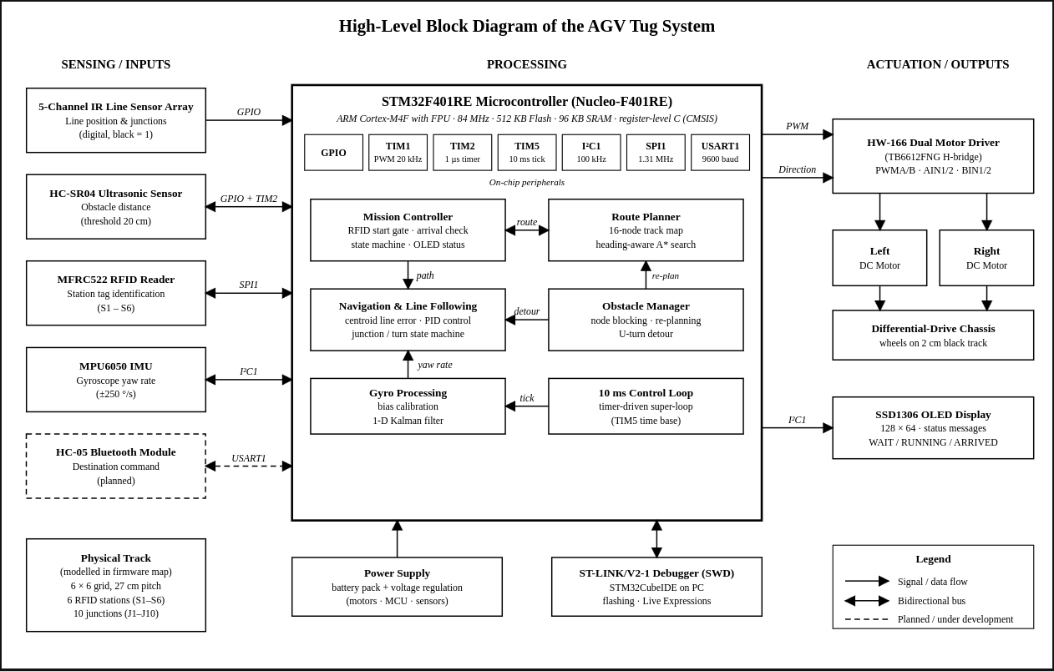
Fig 3.1: System block diagram of the AGV Tug System

The diagram above shows the main information and the control paths. Sensors provide inputs to the microcontroller. The firmware processes those inputs and sends movement commands to the motor driver. The display provides the current status of the system to a user.

3.3 Components of the System

Components | Role
STM32F401RE Microcontroller | Processes sensor inputs, runs the AGV application, FreeRTOS tasks and controls the system behavior.
IR sensor array | Detects the line and provides information used by the navigation logic to guide the tug.
RFID reader | Reads station tags to confirm destinations.
Ultrasonic sensor | Detects a blockage on the path and sends a signal to the system to respond.
MPU6050 motion sensor | Provides motion and orientation measurements to the application
HW-166 H-bridge motor driver | Receives motor control signals from the microcontroller and controls the motors.
Drive motors | Move the AGV according to the commands of the control system
HC-05 Bluetooth module. | Gives a wireless serial link. The firmware supports receiving a station destination on a phone and sending an appropriate message.
OLED Display | Shows current states or error to the user.
LM2596 buck converter | Steps down the battery supply to a lower voltage for the connected electronics.
Table 3.1: An overview of the components and their functions used throughout the project.

3.4 Operating Flow of the System

The flow at the startup begins with the system initialization where the hardware and software components are initialized and calibrates the motion sensor. The system then waits for the confirmation to begin from the departure station. Once the start station is confirmed, the navigation logic uses a mapped route and the line sensors input to guide the AGV safely. The ultrasonic sensor task checks for any blockages, while the RFID checks for destination/intermediate station tags. When the destination is reached, the system waits for confirmation and updates its displayed status. FreeRTOS is used to compartmentalize these tasks. The control task handles navigation and motor decisions. The other tasks provide obstacles, RFID, or display updates to support the control task.

3.5 System Requirements

S.No | Requirement | Related subsystem
1 | Follow a marked route and navigate between mapped stations. | IR array, navigation, motors
2 | Confirm start and destination stations using RFID. | RFID reader
3 | Detect obstacles and allow the system to respond. | Obstacle sensor, navigation
4 | Use motion-sensor data during operation. | MPU6050
5 | Display system status. | OLED
6 | Schedule control and monitoring tasks using FreeRTOS. | STM32F401RE
7 | Support Bluetooth communication with a phone. | HC-05
8 | Power the system from a battery through regulated power circuitry. | 3S battery, BMS, LM2596
9 | Operate without encoder-based motion feedback. | Control system

4. Tools and Systems

4.1 Hardware
The AGV tug uses an STM32F401RE microcontroller as its brain. It receives information from the sensor, runs the navigation and the control software, and sends commands to the motor driver. The system also includes a Bluetooth connection and a battery-based power supply.

4.1.1 Sensors
The IR sensor array detects the marked route and supplies line-position information to the controller. The RFID reader identifies station tags. An ultrasonic sensor is used to detect obstacles, while the MPU6050 provides motion measurements to the application.

4.1.2 Motor and Bluetooth Systems.
The HW-166 H-bridge driver receives control signals from the STM32F401RE and drives the tug’s motors. The HC-05 module provides a Bluetooth serial connection. The Serial Bluetooth Manager application was used to connect to the tug through this module.

4.1.3 Power System
The tug is powered by a 3S battery pack held in a 3S battery holder with a battery management system (BMS). An LM2596 buck converter steps down the battery supply for the system’s connected electronics. The final report should include the confirmed supply voltages and wiring details if they are available.

Component | Function
STM32F401RE | Runs the AGV software and coordinates system operation.
IR sensor array | Detects the line followed by the tug.
RFID reader | Reads station tags.
Ultrasonic sensor | Detects obstacles.
MPU6050 | Provides motion measurements.
HW-166 H-bridge driver | Drives the motors in response to controller signals.
Motors | Move the tug.
HC-05 | Provides a Bluetooth serial connection.
Serial Bluetooth Manager | Used to connect to the tug over Bluetooth.
3S battery holder and 3S BMS | Hold and manage the battery supply.
LM2596 buck converter | Step down the battery supply for connected electronics.
Table 4.1 A table of the components used and their functions in the project
4.2 Software Platform

4.2.1 STM32CubeIDE
STM32CubeIDE was used for the firmware project. It provides the development environment for working with the STM32 project and its build configurations.

4.2.2 CMSIS
The project uses the Cortex Microcontroller Software Interface Standard (CMSIS) to support software development for the ARM Cortex-M microcontroller. It provides the core definitions and interfaces used by the firmware.

4.2.3 FreeRTOS
FreeRTOS is used to schedule the AGV’s concurrent software tasks. The project separates functions such as control, obstacle monitoring, RFID checking, and display updates into tasks.

4.3 Hardware and Software Integration
The firmware connects the controller to the sensors, motor driver, display, and Bluetooth module through the microcontroller’s configured interfaces. Sensor information is processed by the application, and the controller sends the resulting movement commands to the HW-166 motor driver. The battery and power-conversion components supply power to the system.

Figure 4.1 Hardware connections between the controller, sensors, motor driver, Bluetooth module, and power system

4.4 Development and Bluetooth Connection Window
The firmware was developed within the STM32CubeIDE project using CMSIS and FreeRTOS. The Serial Bluetooth Manager application was used to establish a Bluetooth serial connection with the tug through the HC-05 module.
This chapter describes the tools and hardware platform used in the project. The detailed navigation logic, task behavior, and implementation are presented in the following chapters.

References:

[1] Amazon Web Services, “FreeRTOS Documentation,” FreeRTOS. [Online]. Available: FreeRTOS official documentation.

[2] R. Barry, Mastering the FreeRTOS Real Time Kernel: A Hands-On Tutorial Guide, Real Time Engineers Ltd.

[3] STMicroelectronics, STM32F401xB/C and STM32F401xD/E Advanced Arm-Based 32-bit MCUs Reference Manual, RM0368.

[4] STMicroelectronics, STM32F401xD STM32F401xE Arm Cortex-M4 32-bit MCU+FPU Datasheet, DS10086.

[5] Arm Ltd., “CMSIS-Core for Cortex-M,” Arm CMSIS Documentation.

[6] NXP Semiconductors, MFRC522 Standard Performance MIFARE and NTAG Frontend, Rev. 3.9, 2016.

[7] InvenSense Inc., MPU-6000/MPU-6050 Register Map and Descriptions, Rev. 4.2, 2013.

[8] InvenSense Inc., MPU-6000/MPU-6050 Product Specification, Rev. 3.4, 2013.

