AMAZON SALES DATA ANALYSIS
A Data Analytics Project Report

Project Overview
This project presents a comprehensive analysis of Amazon sales data to uncover insights related to sales performance, customer behavior, product trends, and operational efficiency. The objective is to apply data analytics techniques to transform raw data into meaningful business insights and actionable recommendations.

Technologies Used
Python | SQL | Power BI | Pandas | NumPy | Matplotlib | Seaborn

Date
[December, 2025]

Prepared by
ADHITHYA.R
Data Analyst
BE-CSE

1. Introduction
In today’s competitive e-commerce environment, data-driven decision-making plays a critical role in improving business performance. This project focuses on analyzing Amazon sales data to uncover insights related to sales trends, customer behavior, product performance, and operational efficiency.
The dataset contains approximately 25,000 transactions across multiple categories such as Electronics, Clothing, Home & Kitchen, and more. The objective is to transform raw data into meaningful insights that can support strategic decisions.

2. Project Objectives

The main objectives of this analysis are:
- Identify top-performing categories and products.
- Understand customer purchasing patterns.
- Evaluate order status (delivery, return, cancellation).
- Detect low-performing segments.
- Provide actionable business recommendations.

3. Project Summary

This project involves end-to-end data analysis, including data cleaning, exploration, visualization, and insight generation. The analysis highlights how a few categories dominate sales while others underperform.
It also identifies operational gaps such as returns and cancellations, which directly impact revenue and customer satisfaction.

4. Business Problem & Approach

  - Business Problem
The business aims to:
- Increase sales and revenue
- Improve customer satisfaction
- Reduce returns and cancellations
- Optimize product and category performance

4.2 Approach
Step 1: Data Cleaning (Jupiter notebook)
- Removed duplicate records
- Handled missing values using mean imputation
- Ensured consistency in categorical data

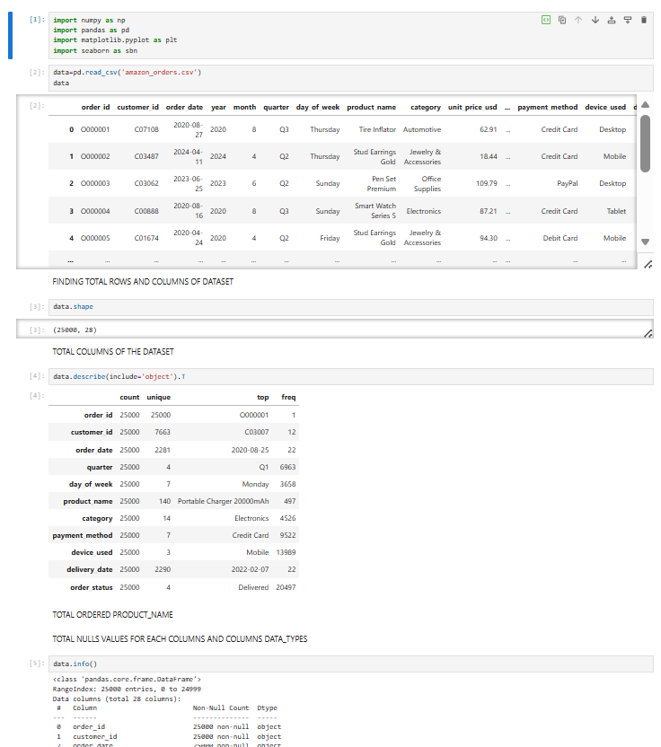
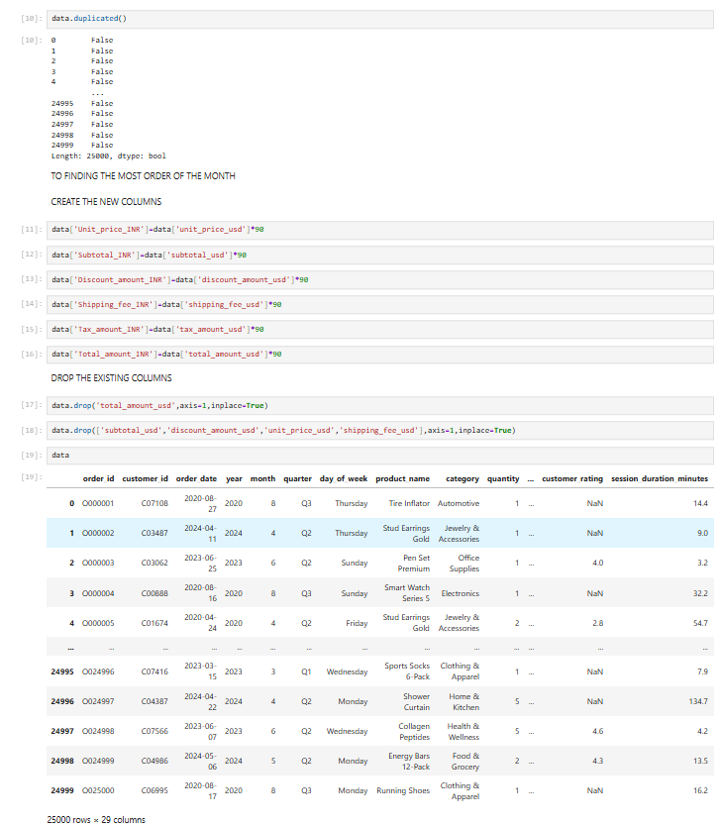
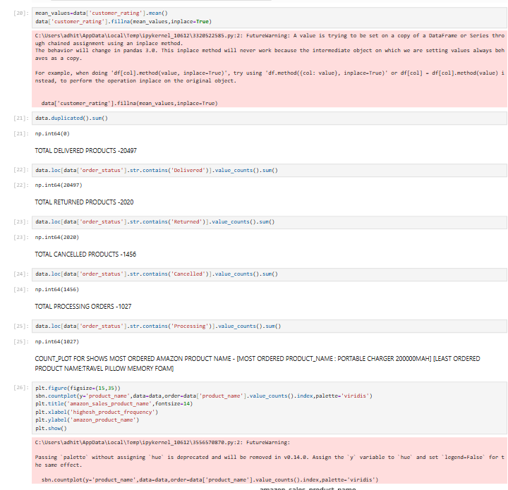
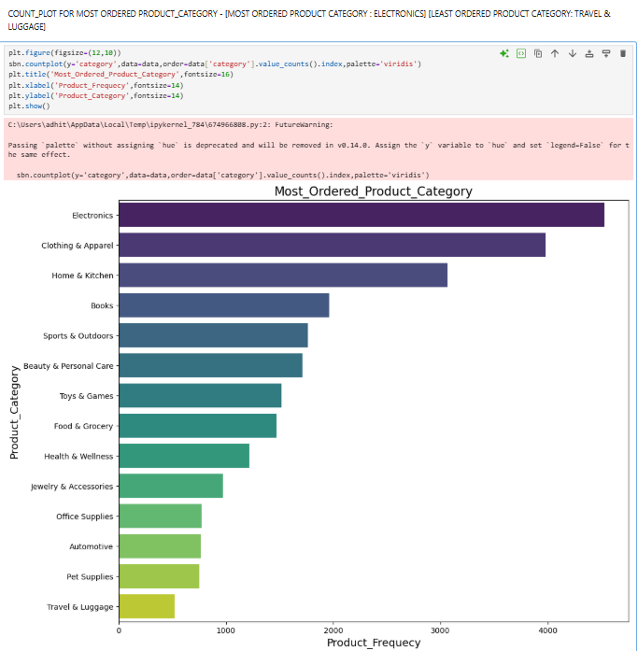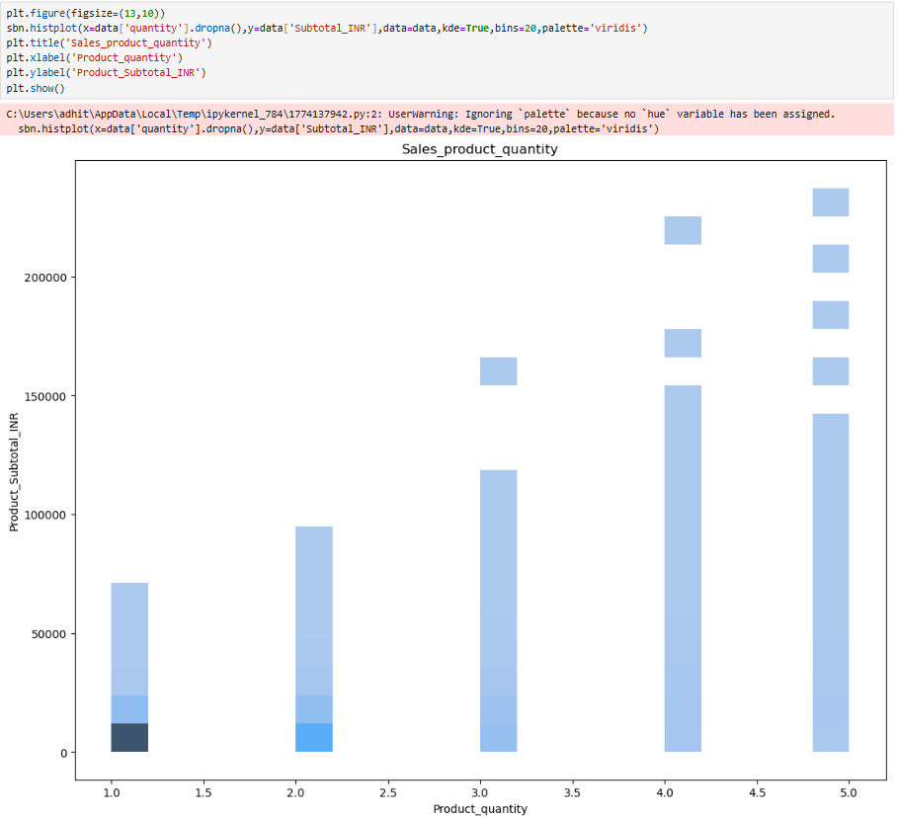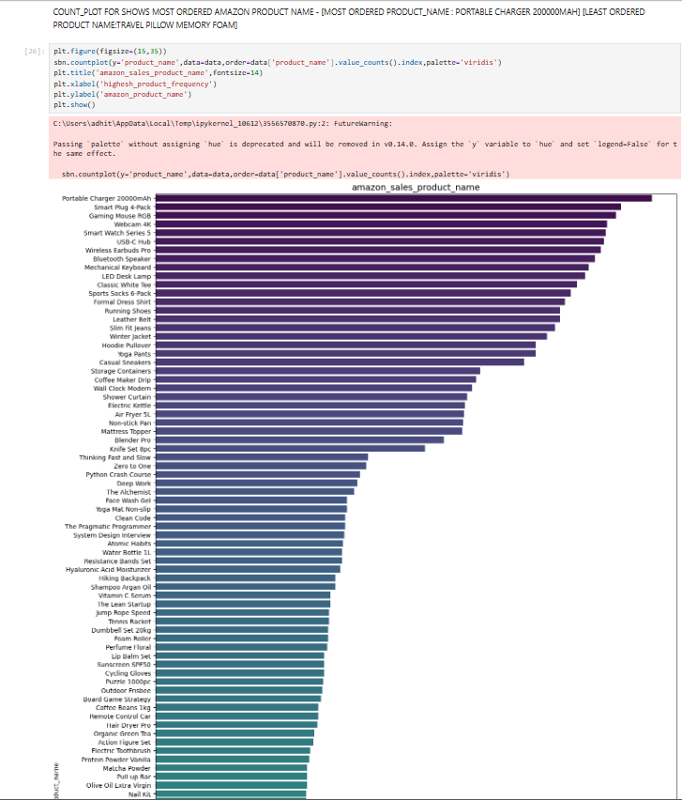

Step 2: Exploratory Data Analysis (EDA)
- Analyzed sales by category and product
- Evaluated customer ratings
- Studied order status distribution
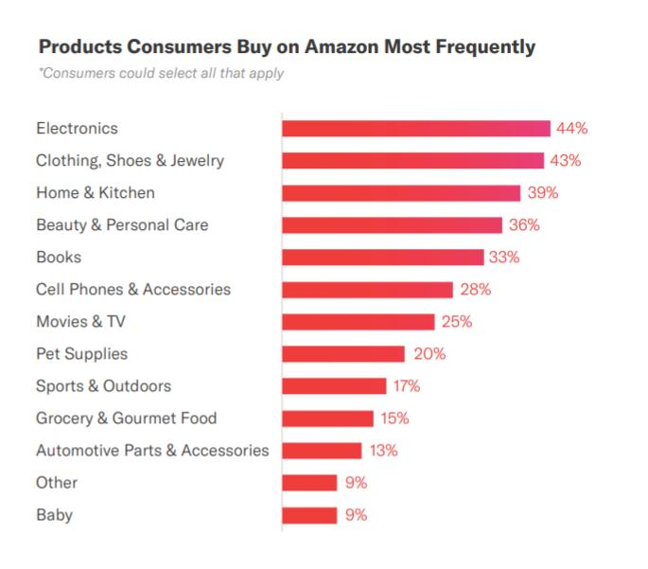
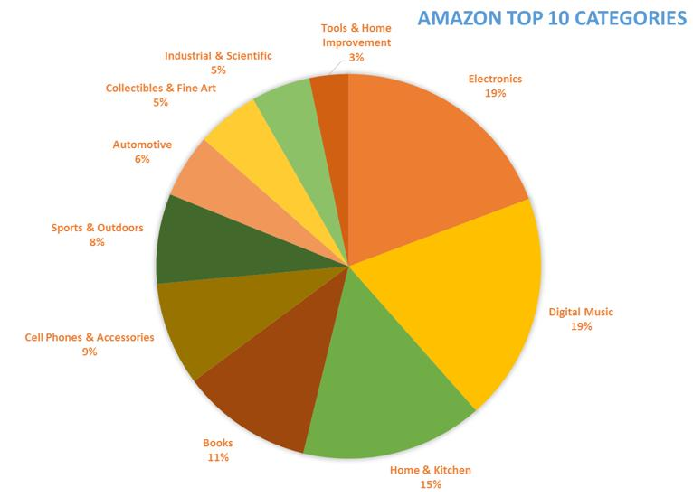
Step 3: Data Visualization
- Created bar charts and dashboards
- Compared category and product performance
- Identified patterns and trends
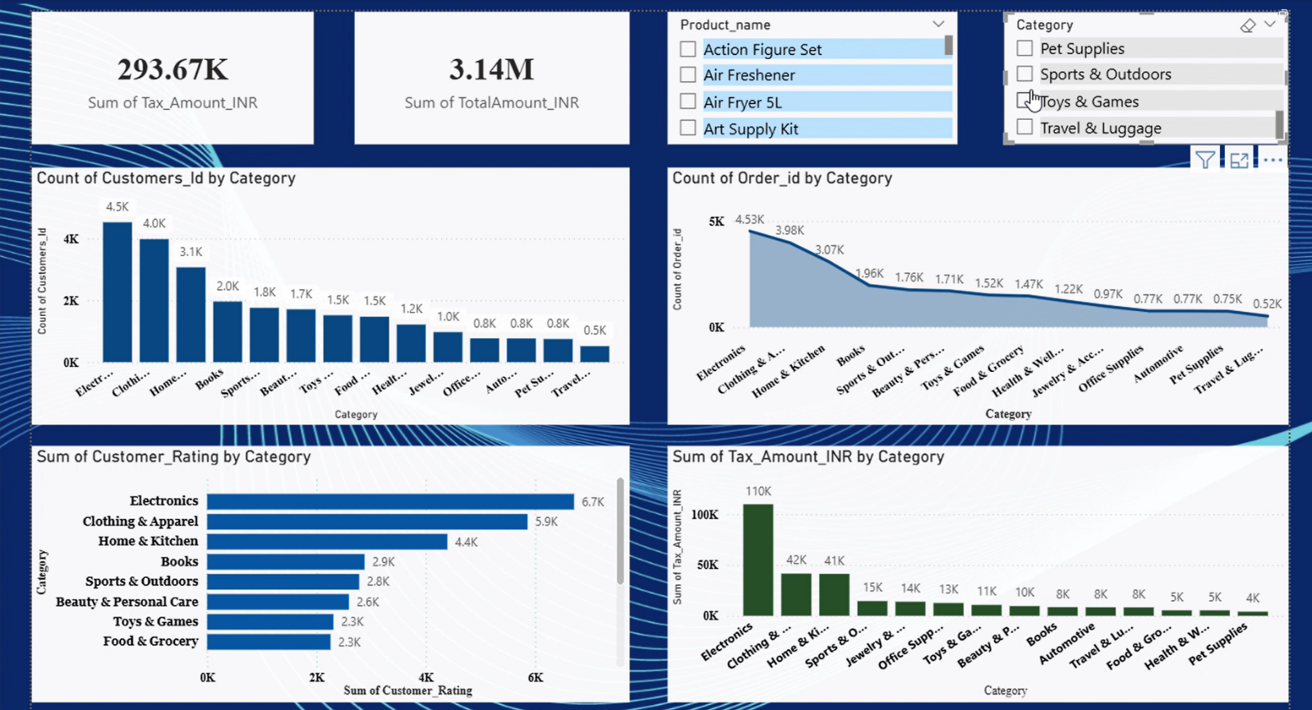

Step 4: Insight Generation
- Extracted meaningful business insights
- Identified strengths, weaknesses, and opportunities

5. Dataset Overview
- Total Records: ~25,000
- Columns: ~29
- Key Features:
  - Product Name
  - Category
  - Order Status
  - Customer Rating
  - Total Amount
  - Tax Amount

6. Data Preparation & Cleaning

- No duplicate records found
- Missing values in customer ratings were handled using mean imputation
- Data formatted for analysis and visualization

Outcome:
Clean and structured dataset ensured accurate and reliable insights

7. Sales Performance Analysis

  - Overall Sales Metrics

- Total Revenue: ₹3.14 Million
- Total Tax: ₹293.67K

Insight:
The business demonstrates strong revenue generation, supported by consistent transaction volume.

7.2 Category Performance
Top Categories:
- Electronics
- Clothing & Apparel
- Home & Kitchen
Insight:
Electronics is the primary revenue driver, while Clothing shows high purchase frequency.

Mid-Level Categories:
- Books
- Sports & Outdoors
- Beauty & Personal Care
Insight:
These categories show moderate demand and growth potential.

Low-Performing Categories:
- Travel & Luggage
- Pet Supplies
- Automotive
Insight:
Low contribution indicates limited demand or weak positioning.

8. Product Performance Analysis
Key Findings:
- Top products are dominated by electronics (chargers, smart devices)
- Clothing items also rank highly
Insight:
Sales follow a concentrated pattern, where a small number of products generate most revenue.

Business Implication:
- High dependency on best-selling products
- Opportunity to expand successful product lines

9. Order & Operational Analysis
  - Order Status Distribution

- Delivered: 82%
- Returned: 8%
- Cancelled: 6%
- Processing: 4%

9.2 Key Insights
Delivery:
Efficient logistics with a high success rate

Returns:
Moderate return rate indicates:
- Product quality issues
- Expectation mismatch

Cancellations:
Indicates:
- Delivery delays
- Pricing or checkout issues
Insight:
Approximately 14% of orders fail, impacting revenue and customer experience.

10. Customer Behavior Analysis
- Customers prefer Electronics and Clothing
- High ratings align with high-performing categories
- Repeat purchases are common in Clothing
Insight:
Customer satisfaction directly influences sales performance

11. Demand Pattern Analysis
The data follows a skewed distribution pattern:
- Few categories → high contribution
- Many categories → low contribution
Insight:
Business is highly dependent on top categories, especially Electronics.

12. Technologies Used
- SQL – Data querying
- Python – Data analysis
- Pandas, NumPy – Data processing
- Matplotlib, Seaborn – Visualization
- Power BI / Tableau – Dashboard creation
- Jupyter Notebook – Development

13. Key Insights Summary
- Electronics is the top-performing category
- Clothing shows high repeat purchase behavior
- Sales are concentrated in few products (Pareto effect)
- Delivery efficiency is strong (82% success rate)
- Returns and cancellations (~14%) impact performance
- Several categories show low engagement and require improvement

14. Recommendations
  - Improve Top Categories

- Expand Electronics product range
- Introduce premium offerings

  - Reduce Returns & Cancellations

- Improve product descriptions
- Enhance quality control
- Optimize delivery timelines

  - Boost Low-Performing Categories

- Run targeted marketing campaigns
- Offer discounts and bundles
- Improve product visibility

  - Diversify Revenue

  - Strengthen mid-level categories

  - Reduce dependency on Electronics

15. Conclusion
The Amazon sales data analysis highlights a strong business performance driven by key categories, supported by efficient operations and high customer engagement. However, challenges such as returns, cancellations, and uneven category performance need attention.
By focusing on customer experience, operational efficiency, and category diversification, the business can significantly improve profitability and sustain long-term growth.

