Netflix Customer Churn Analysis – Insight Report

Dataset Overview
The dataset contains 5,000 customer records with 14 variables related to customer demographics, subscription details, viewing behavior, payment methods, and churn status.
Key Variables
- Customer demographics: age, gender, region
- Subscription information: subscription type, monthly fee
- User engagement metrics: watch hours, average watch time per day, last login days
- Viewing preferences: favorite genre, device used
- Target variable: churned (0 = Active Customer, 1 = Churned Customer)

Customer Churn Distribution
Customer Status | Count | Percentage
Active Customers | 2485 | 49.7%
Churned Customers | 2515 | 50.3%

Insight
The churn rate is slightly higher than the active customer percentage, indicating a significant customer retention challenge. Nearly half of the customer base has discontinued the service, highlighting the importance of improving customer engagement and retention strategies.

Subscription Type vs Customer Churn
Subscription Type | Active | Churned
Basic | 634 | 1027
Standard | 898 | 748
Premium | 953 | 740
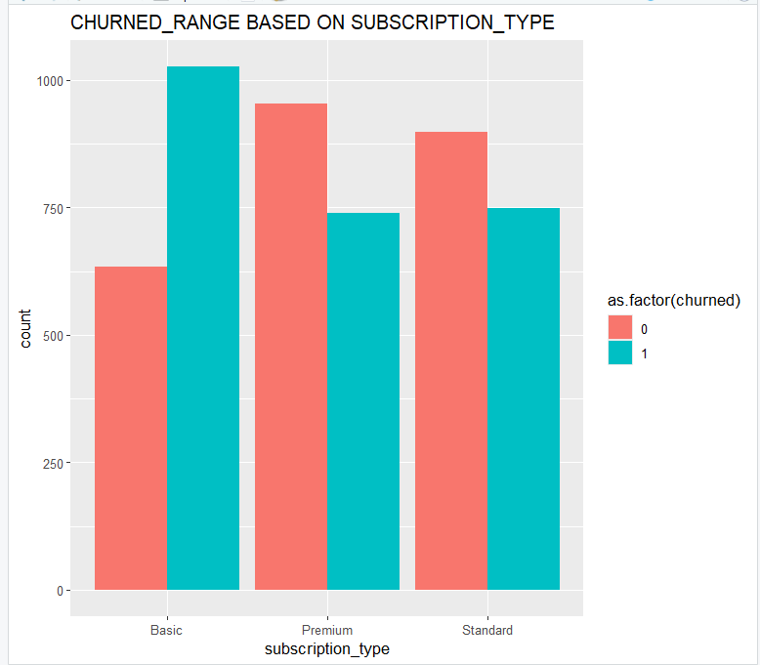

Insight
The Basic subscription plan recorded the highest churn rate among all subscription categories. Premium subscribers demonstrated stronger retention and lower churn behavior. Customers associated with higher-value subscription plans appear to remain more loyal to the platform.
Business Interpretation
Lower-tier subscription plans may provide fewer features or lower customer satisfaction, leading to higher customer loss. Premium plans appear to deliver greater perceived value and stronger user commitment.

Gender-wise Churn Analysis
Gender |  |  |  |  |  |  | Active |  |  |  | Churned
Female |  |  |  |  |  |  | 837 |  |  |  | 874
Male |  |  |  |  |  |  | 827 |  |  |  | 827
Other |  |  |  |  |  |  | 821 |  |  |  | 814
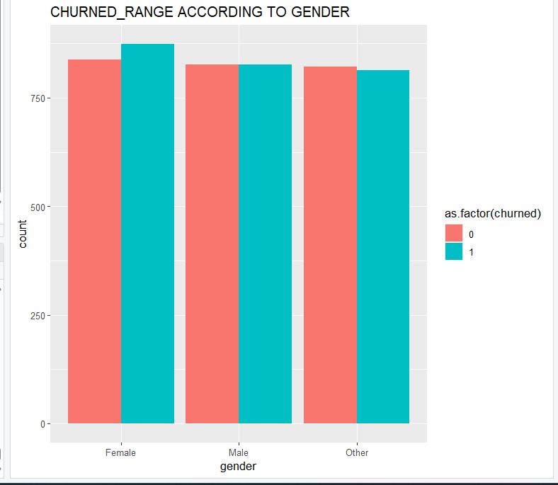

Insight
Customer churn is distributed almost equally across all gender categories. Gender does not appear to be a major factor influencing customer churn behavior.
Business Interpretation
Customer retention challenges are primarily influenced by behavioral and engagement-related factors rather than demographic characteristics.

Region-Based Customer Churn Analysis
Region |  |  |  |  |  |  |  |  |  |  |  |  |  |  |  |  |  |  | Active Customers |  |  |  |  |  |  |  |  |  |  | Churned Customers
Africa |  |  |  |  |  |  |  |  |  |  |  |  |  |  |  |  |  |  | 415 |  |  |  |  |  |  |  |  |  |  | 388
Asia |  |  |  |  |  |  |  |  |  |  |  |  |  |  |  |  |  |  | 415 |  |  |  |  |  |  |  |  |  |  | 426
Europe |  |  |  |  |  |  |  |  |  |  |  |  |  |  |  |  |  |  | 419 |  |  |  |  |  |  |  |  |  |  | 448
North America |  |  |  |  |  |  |  |  |  |  |  |  |  |  |  |  |  |  | 430 |  |  |  |  |  |  |  |  |  |  | 421
Oceania |  |  |  |  |  |  |  |  |  |  |  |  |  |  |  |  |  |  | 382 |  |  |  |  |  |  |  |  |  |  | 383
South America |  |  |  |  |  |  |  |  |  |  |  |  |  |  |  |  |  |  | 424 |  |  |  |  |  |  |  |  |  |  | 449

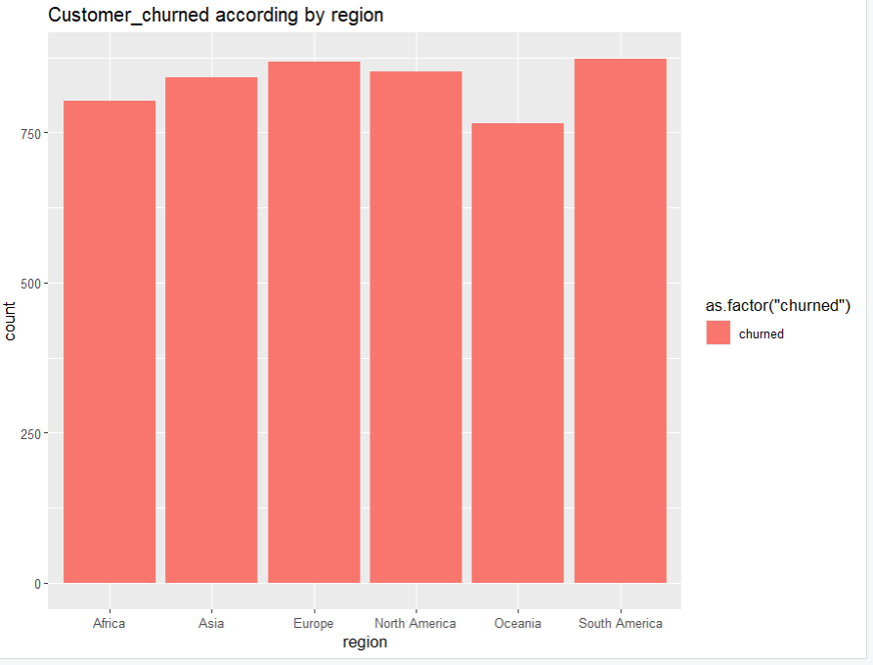

Comparative Regional Findings

Regions with Higher Customer Retention
- Africa
- North America
These regions demonstrate comparatively stable customer engagement and lower churn pressure.

Regions with Higher Churn Risk
- South America
- Europe
- Asia
These regions exhibit elevated churn behavior and require targeted retention interventions.

Last Login Days vs Churn
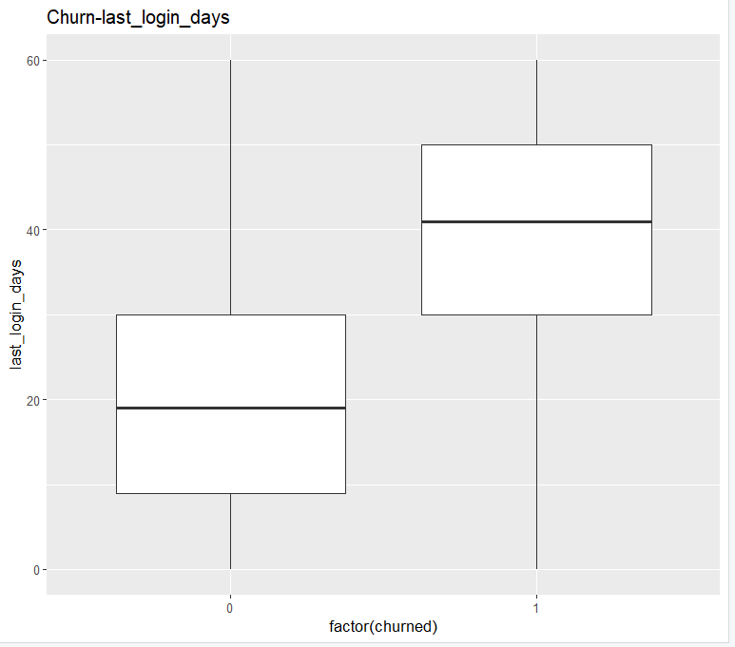

Insight
Customers with fewer inactive days were more likely to remain active, while customers with longer inactivity periods showed significantly higher churn rates. A noticeable increase in churn behavior is observed after approximately 30 inactive days.
Business Interpretation
Customer inactivity serves as one of the strongest indicators of potential churn. Reduced platform interaction strongly impacts long-term customer retention.

Monthly Fee vs Customer Churn

Monthly Fee | Active | Churned
8.99 | 634 | 1027
13.99 | 898 | 748
17.99 | 953 | 740

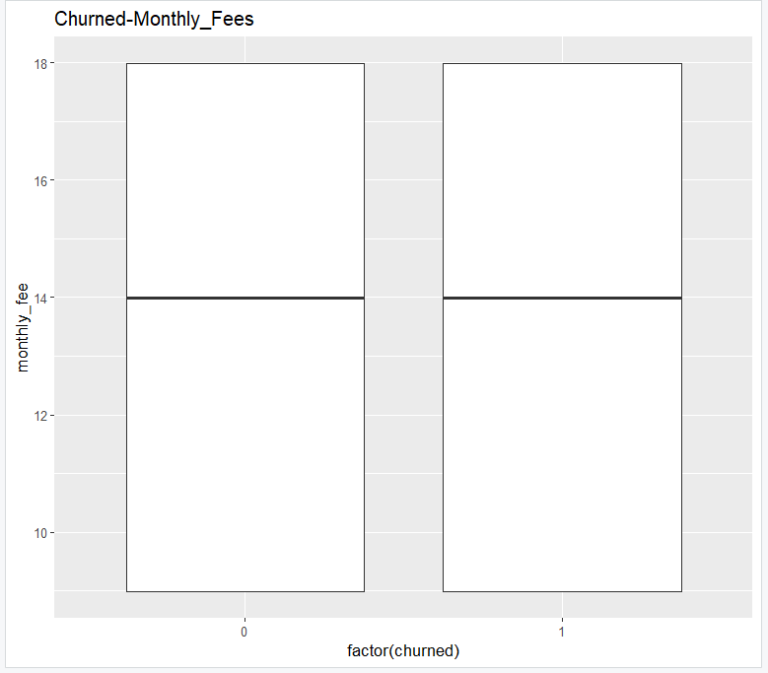

Insight
Customers subscribed to lower-priced plans experienced the highest churn levels, while customers paying higher subscription fees demonstrated stronger retention behavior.
Business Interpretation
Higher-paying customers appear to derive greater value from the platform and show stronger long-term engagement.

Favorite Genre vs Customer Churn
Genre |  |  |  |  |  |  |  | Active |  |  |  |  |  |  |  |  |  | Churned
Action |  |  |  |  |  |  |  | 332 |  |  |  |  |  |  |  |  |  | 365
Comedy |  |  |  |  |  |  |  | 343 |  |  |  |  |  |  |  |  |  | 342
Documentary |  |  |  |  |  |  |  | 359 |  |  |  |  |  |  |  |  |  | 370
Drama |  |  |  |  |  |  |  | 349 |  |  |  |  |  |  |  |  |  | 382
Horror |  |  |  |  |  |  |  | 346 |  |  |  |  |  |  |  |  |  | 367
Romance |  |  |  |  |  |  |  | 375 |  |  |  |  |  |  |  |  |  | 350
Sci-Fi |  |  |  |  |  |  |  | 381 |  |  |  |  |  |  |  |  |  | 339
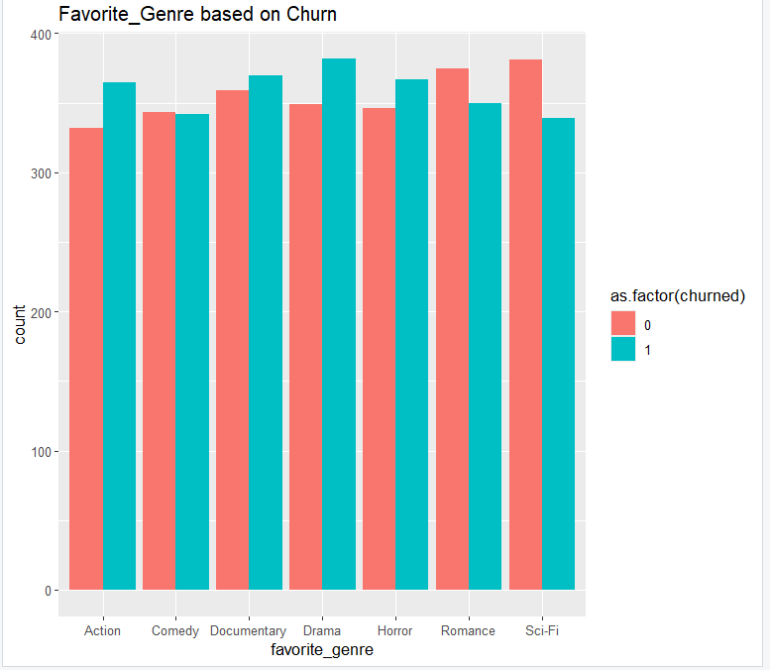

Insight
Romance and Sci-Fi viewers demonstrated comparatively lower churn rates and stronger customer retention. Drama, Horror, and Action genres experienced relatively higher churn behavior.

Business Interpretation
Viewer content preferences influence customer retention patterns. Certain genres appear more successful in maintaining long-term customer engagement.

Watch Hours Analysis
Metric |  |  |  |  |  |  |  |  | Value
Mean Watch Hours |  |  |  |  |  |  |  |  | 11.65
Median Watch Hours |  |  |  |  |  |  |  |  | 8.00
Maximum Watch Hours |  |  |  |  |  |  |  |  | 110.40
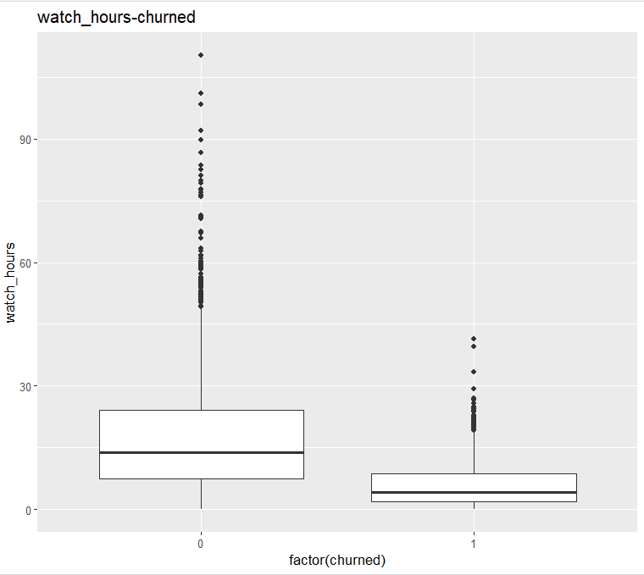
Insight
Customer engagement levels vary significantly across the dataset. Higher viewing activity is associated with stronger retention, while customers with lower watch hours are more likely to churn.
Business Interpretation
Viewing engagement plays a critical role in customer retention and platform loyalty.

Device Usage Analysis
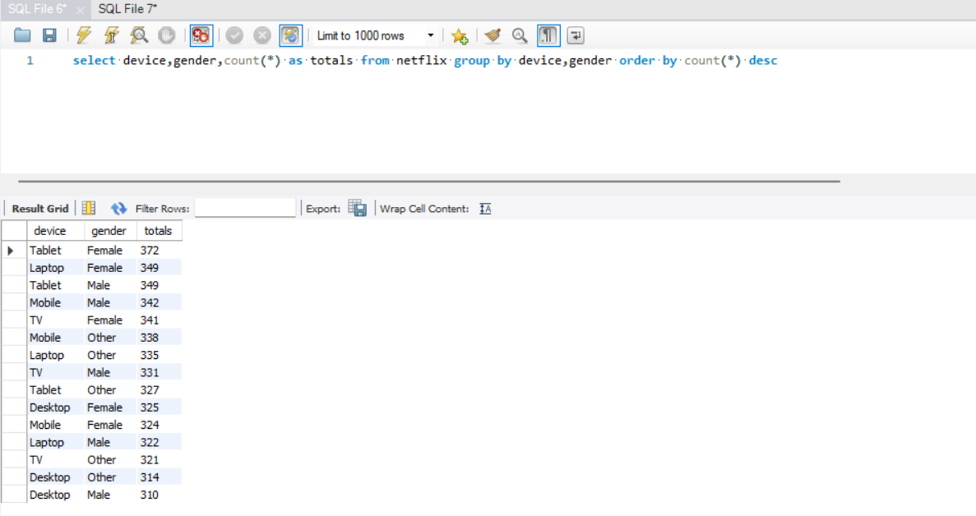
Insight
TV and Mobile devices appear to dominate customer viewing activity, while Desktop and Tablet usage remains comparatively lower.

Business Interpretation
Streaming optimization for TV and Mobile platforms is essential for improving customer experience and engagement.

Predictive Model Performance
Confusion Matrix Summary
Metric |  |  |  |  |  |  |  | Value
Accuracy |  |  |  |  |  |  |  | 87.5%
Sensitivity |  |  |  |  |  |  |  | 83.3%
Specificity |  |  |  |  |  |  |  | 91.65%
Balanced Accuracy |  |  |  |  |  |  |  | 87.47%

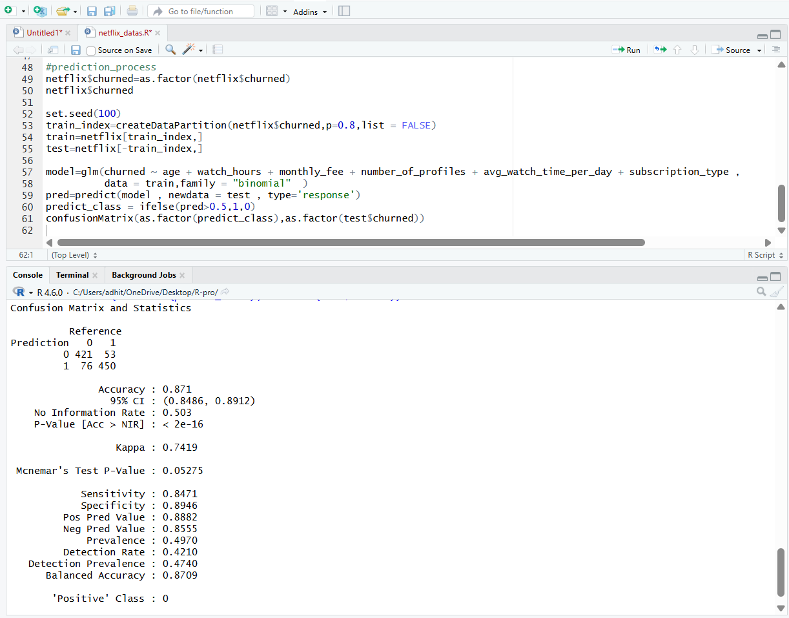
Insight
The churn prediction model achieved strong classification performance with high predictive accuracy. The model effectively identifies both active and churned customers.

Business Interpretation
The predictive model can support proactive customer retention strategies by identifying high-risk customers before churn occurs.

Major Factors Influencing Customer Churn

Key Churn Drivers
- Last Login Days
- Subscription Type
- Monthly Fee
- Watch Hours
- Favorite Genre

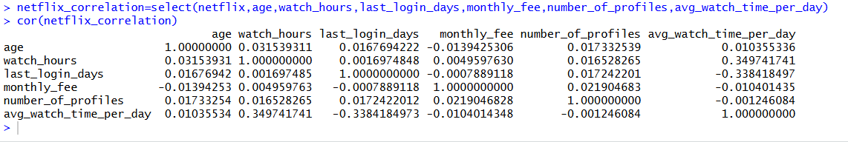

Final Business Insights

1. Customer inactivity represents the strongest predictor of churn behavior.

2. Basic subscription customers demonstrate significantly higher cancellation rates.

3. Premium subscribers exhibit stronger loyalty and long-term retention.

4. Lower engagement levels directly increase churn probability.

5. Higher-paying customers generate better retention performance.

6. Genre preference influences customer loyalty patterns.

7. Customer behavior metrics outperform demographic variables in churn prediction.

8. The predictive model provides highly reliable churn classification capability.

Final Conclusion
The analysis identified customer inactivity, lower subscription plans, reduced viewing engagement, and content preferences as major contributors to customer churn. Premium subscribers and highly engaged viewers demonstrated stronger retention behavior. The predictive model achieved high accuracy in identifying churn patterns, enabling data-driven customer retention strategies and improved business decision-making.

