NETFLIX CUSTOMER CHURN DATA ANALYSIS

A Data Analytics Project Report
Technologies Used
R Programming | ggplot2 | dplyr | caret | Logistic Regression | Data Visualization | Machine Learning

Prepared by
ADHITHYA.R
Data Analyst
BE-CSE

Date
[Febraury, 2026]

Project Domain
Customer Churn Prediction and Retention Analytics

1. Introduction
The online streaming industry has become highly competitive due to the rapid growth of digital entertainment platforms. Customer retention has become one of the most important factors influencing business success in subscription-based services such as Netflix. Customer churn occurs when subscribers discontinue their subscriptions, resulting in revenue loss and reduced long-term customer value.
This project focuses on analyzing customer behavior patterns and identifying the major factors contributing to customer churn using R Programming. The analysis helps understand why customers leave the platform and how customer retention can be improved using data-driven insights.

2. Project Objective
The primary objectives of this project are:
- To analyze customer churn behavior
- To identify major factors influencing churn
- To evaluate customer engagement patterns
- To understand subscription-based retention behavior
- To build a churn prediction model
- To generate practical business recommendations for improving customer retention

3. Dataset Description
The dataset contains 5,000 customer records and 14 variables related to customer demographics, streaming activity, subscription details, and engagement behavior.

Dataset Variables
Variable | Description
customer_id | Unique customer identification number
age | Customer age
gender | Gender category
subscription_type | Subscription plan
watch_hours | Total streaming watch hours
last_login_days | Number of inactive days
region | Customer location
device | Streaming device used
monthly_fee | Subscription price
churned | Customer status (0 = Active, 1 = Churned)
payment_method | Payment mode
number_of_profiles | Profiles linked to account
avg_watch_time_per_day | Average daily watch duration
favorite_genre | Most preferred genre

4. Tools and Technologies Used
Tool | Purpose
R Programming | Data analysis
ggplot2 | Data visualization
dplyr | Data manipulation
caret | Machine learning evaluation
Logistic Regression | Churn prediction model

5. Data Preprocessing
Before analysis, the dataset was cleaned and prepared for machine learning.
Preprocessing Steps
- Removed missing values
- Removed duplicate records
- Converted categorical variables
- Prepared training and testing datasets

6. Exploratory Data Analysis (EDA)
6.1 Overall Customer Churn Analysis
Customer Status | Count | Percentage
Active Customers | 2485 | 49.7%
Churned Customers | 2515 | 50.3%

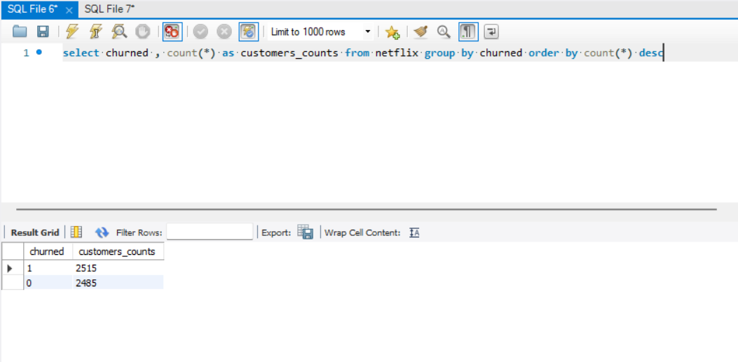

Insight
The churn percentage is slightly higher than the active customer percentage. Nearly half of the customer base has discontinued the subscription service.

Practical Explanation
This indicates that customer retention has become a major business challenge. A high churn rate directly affects company revenue because acquiring new customers is more expensive than retaining existing customers.
If this trend continues:
- subscription revenue decreases
- customer acquisition cost increases
- long-term business growth becomes unstable

Business Recommendation
Netflix should focus on:
- improving customer engagement
- increasing user satisfaction
- reducing inactivity
- enhancing personalized recommendations

6.2 Subscription Type vs Customer Churn
Subscription Type | Active | Churned
Basic | 634 | 1027
Standard | 898 | 748
Premium | 953 | 740

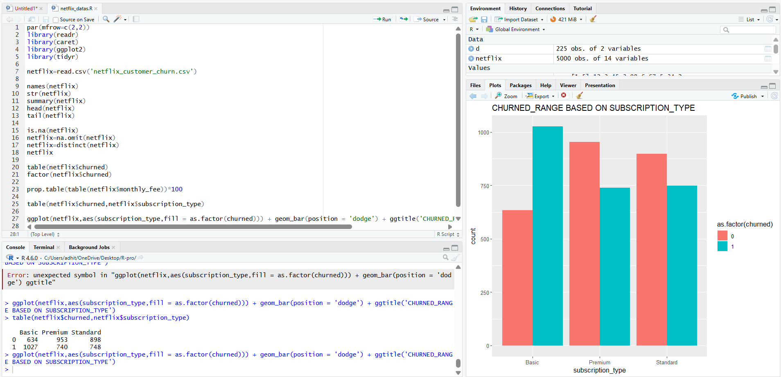

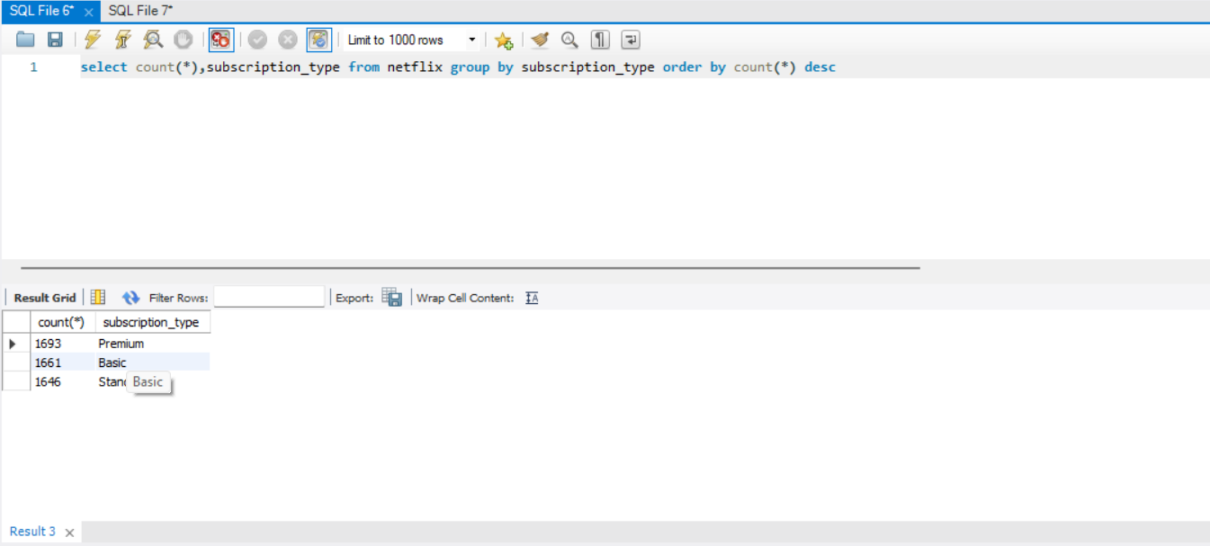

Insight
The Basic subscription plan has the highest churn count, while Premium users show stronger retention.

Practical Explanation
Customers using the Basic plan may feel limited due to:
- fewer features
- lower streaming quality
- limited user experience
- reduced value perception
Premium subscribers receive:
- better streaming quality
- multiple device support
- enhanced viewing experience
As a result, Premium users become more engaged and less likely to cancel subscriptions.
Business Recommendation
Possible strategies include:
- encouraging Basic users to upgrade
- offering temporary Premium access
- introducing personalized upgrade discounts
- improving feature awareness for Basic users

6.3 Gender-Based Churn Analysis
Gender | Active | Churned
Female | 837 | 874
Male | 827 | 827
Other | 821 | 814

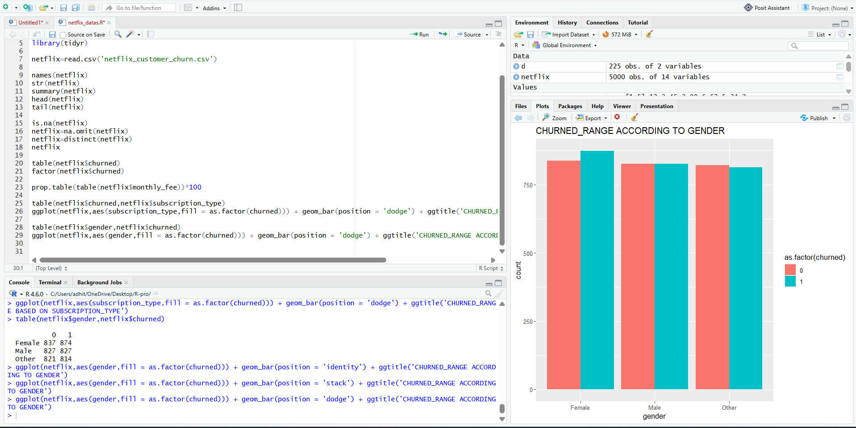
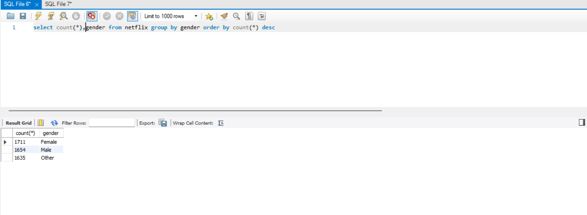

Insight
Customer churn distribution is almost equal across all gender categories.

Practical Explanation
Gender does not significantly affect customer churn behavior. The platform experience appears to influence all customers similarly regardless of demographic category.

This indicates that:
- engagement behavior matters more than gender
- streaming activity is a stronger churn indicator
- subscription value influences retention more than demographics

Business Recommendation
Retention strategies should focus on:
- customer behavior
- watch activity
- engagement patterns
- personalized content recommendations
- instead of demographic targeting

6.4 Region-Based Churn Analysis
Region | Active | Churned
Africa | 415 | 388
Asia | 415 | 426
Europe | 419 | 448
North America | 430 | 421
Oceania | 382 | 383
South America | 424 | 449

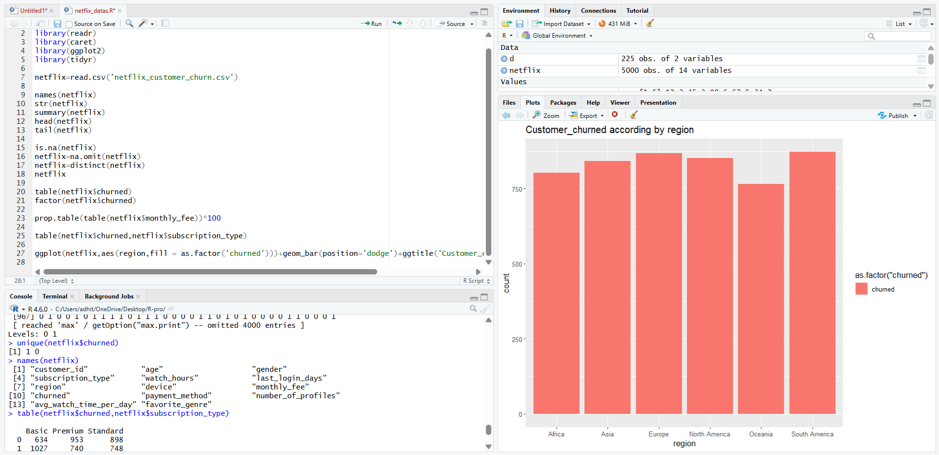
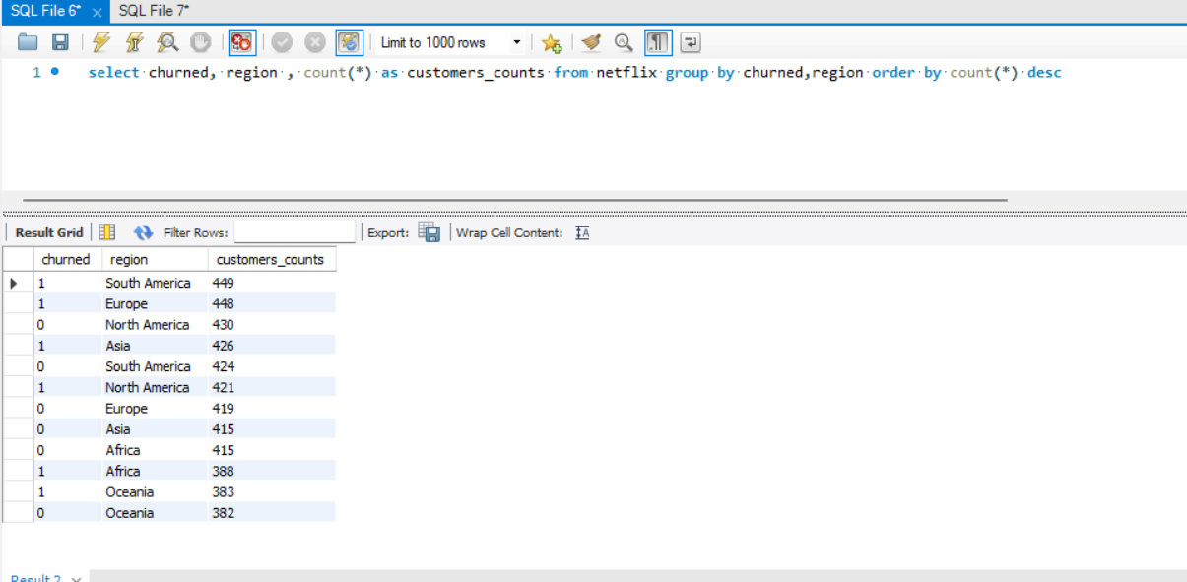
Insight
South America and Europe show higher churn counts compared to other regions.

Practical Explanation
Different regions may experience different customer retention behaviors because of:
- regional pricing differences
- content availability
- internet accessibility
- local competition
- viewer preferences
South America and Europe may face:
- stronger competition from other streaming platforms
- lower customer satisfaction
- pricing sensitivity
- lower engagement levels
North America and Africa show comparatively stable customer retention behavior.

Business Recommendation
Region-specific retention strategies should include:
- localized content
- regional recommendation systems
- pricing optimization
- language-based personalization
- region-specific promotions

6.5 Last Login Days Analysis
Observation
Customers with longer inactivity periods demonstrate significantly higher churn probability.
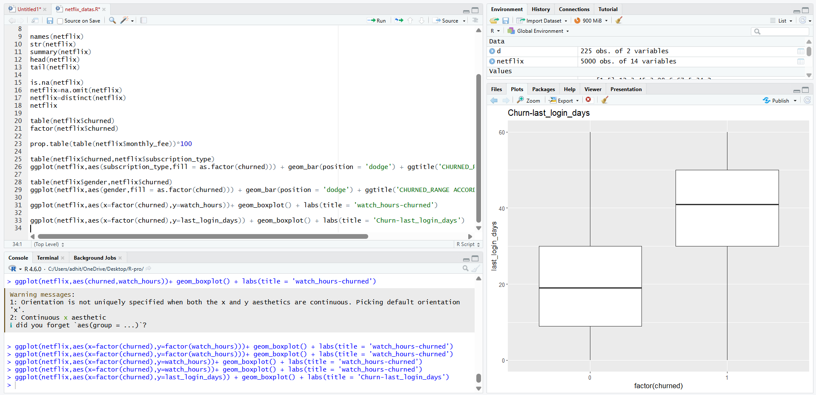

Insight
Customer inactivity is one of the strongest predictors of churn.
Practical Explanation
When customers stop using the platform regularly:
- engagement decreases
- content interaction reduces
- emotional connection with the platform weakens
Customers inactive for long periods are more likely to:
- forget platform value
- lose subscription interest
- move to competitor platforms
A noticeable increase in churn occurs after approximately 30 inactive days.
Business Recommendation
Automated engagement systems should include:
- inactivity reminders
- personalized recommendations
- trending content notifications
- email campaigns
- re-engagement promotions

6.6 Monthly Subscription Fee Analysis
Monthly Fee | Active | Churned
8.99 | 634 | 1027
13.99 | 898 | 748
17.99 | 953 | 740
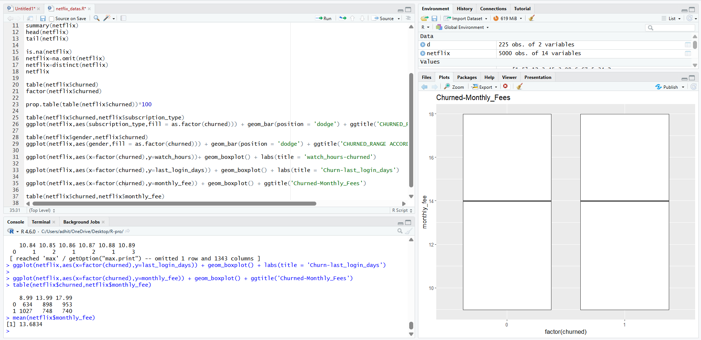
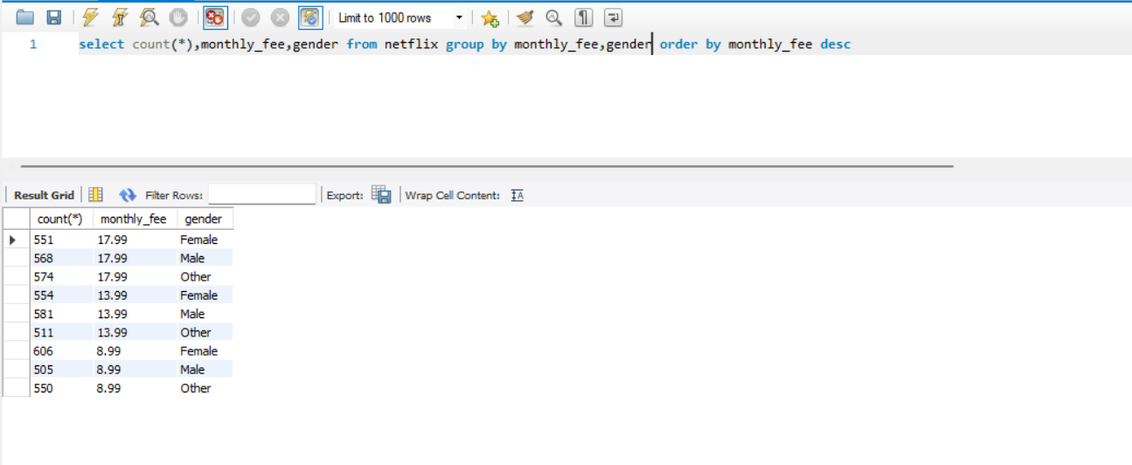
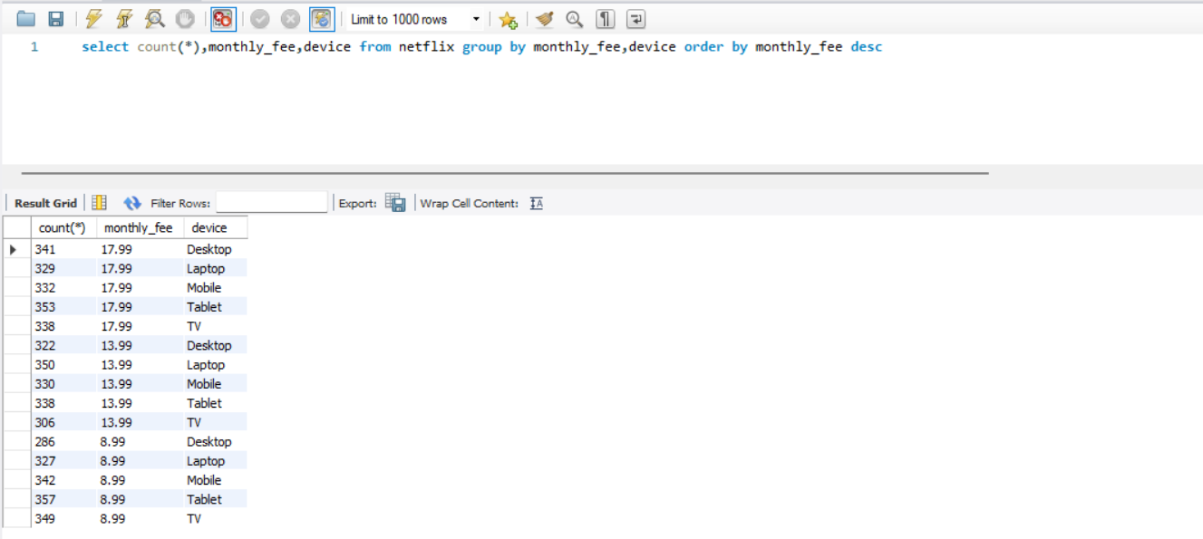

Insight
Customers using lower-priced plans exhibit higher churn behavior.
Practical Explanation
Lower-priced users may:
- use the platform less frequently
- perceive lower service value
- maintain weaker subscription commitment
Higher-paying users generally:
- consume more content
- spend more time on the platform
- develop stronger dependency on streaming services
This increases customer loyalty among Premium users.
Business Recommendation
Retention improvement strategies may include:
- increasing value perception for Basic plans
- offering bundled content benefits
- introducing loyalty rewards
- enhancing user engagement for low-tier subscribers

6.7 Favorite Genre Analysis
Genre | Active | Churned
Action | 332 | 365
Comedy | 343 | 342
Documentary | 359 | 370
Drama | 349 | 382
Horror | 346 | 367
Romance | 375 | 350
Sci-Fi | 381 | 339
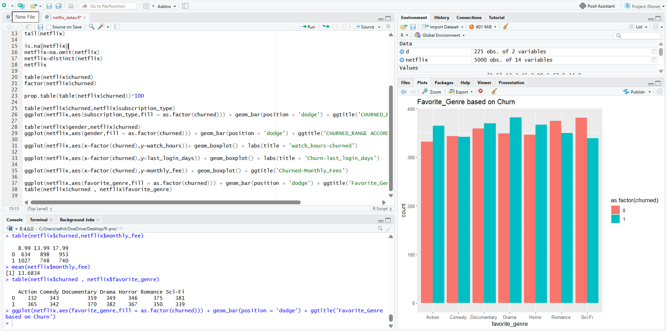
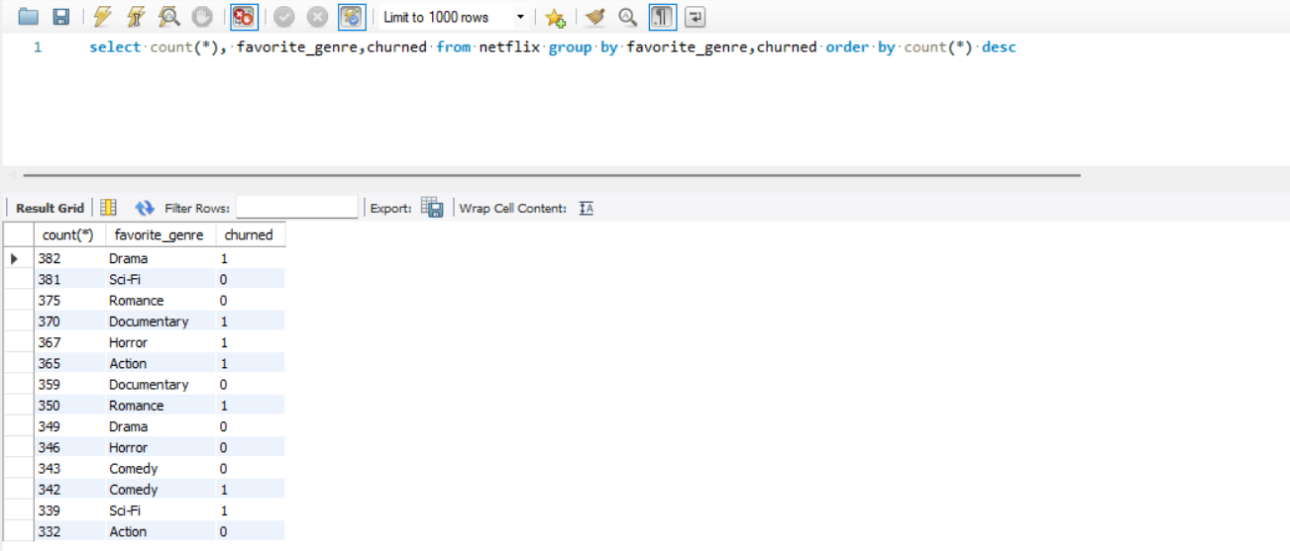
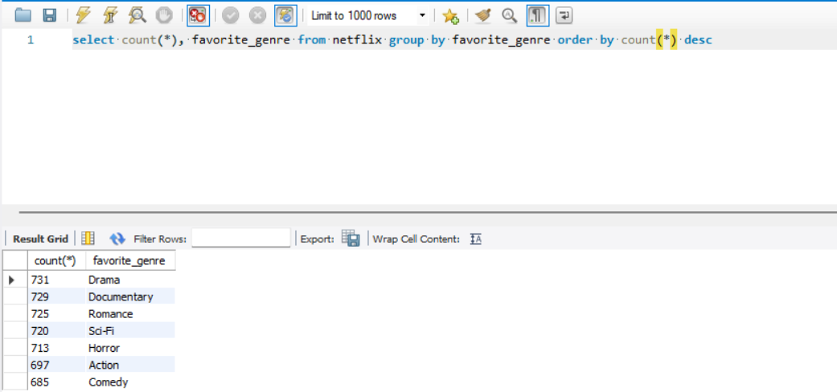

Insight
Romance and Sci-Fi viewers demonstrate stronger retention compared to Drama and Horror viewers.

Practical Explanation
Certain genres naturally encourage:
- binge-watching behavior
- long viewing sessions
- emotional engagement
- repeated platform usage
Romance and Sci-Fi viewers may remain subscribed longer because of stronger content attachment and continuous content consumption.

Higher churn genres may indicate:
- lower content satisfaction
- weaker recommendation accuracy
- reduced content availability

Business Recommendation
Netflix can improve retention through:
- genre-based recommendations
- personalized watchlists
- investment in high-retention genres
- targeted promotions for high-risk viewers

6.8 Watch Hours Analysis
Metric | Value
Mean Watch Hours | 11.65
Median Watch Hours | 8.00
Maximum Watch Hours | 110.40
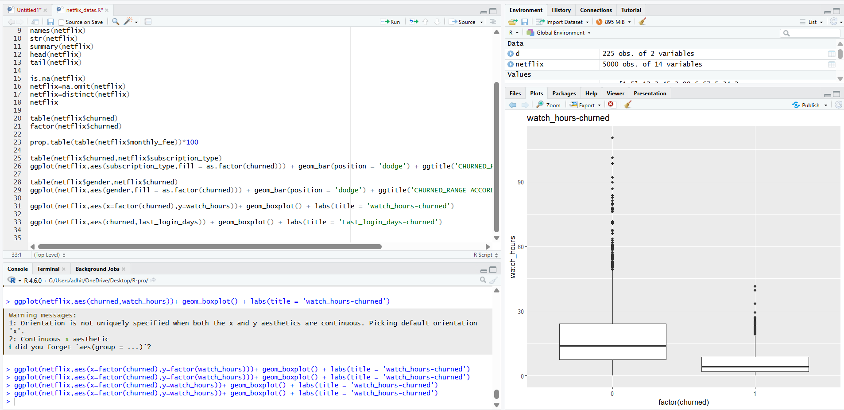

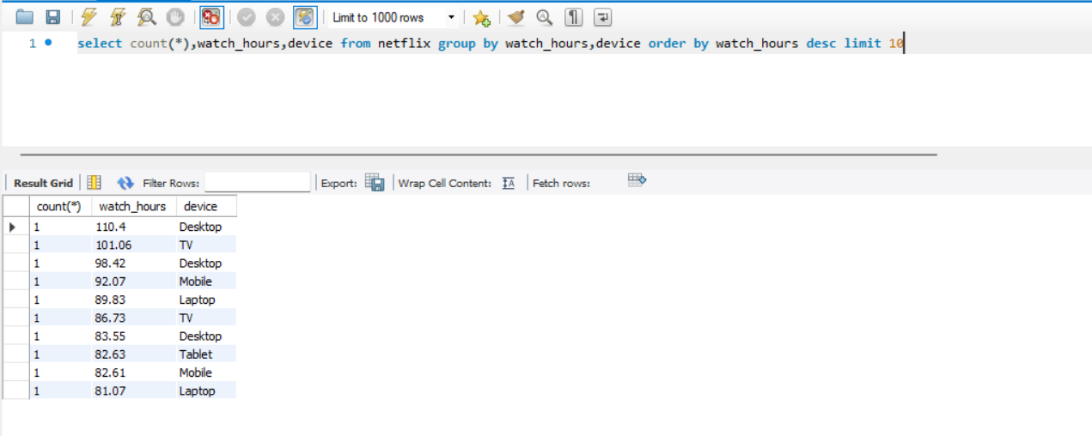
Insight
Lower watch-hour customers demonstrate higher churn probability.
Practical Explanation
Watch hours directly represent customer engagement.
Customers with:
- high watch hours are highly engaged
- low watch hours show reduced platform interest
Highly engaged users:
- receive more entertainment value
- interact more with recommendations
- depend more on platform content
This reduces the likelihood of churn.
Business Recommendation
Engagement improvement strategies include:
- personalized recommendations
- autoplay functionality
- binge-content suggestions
- trending series promotion
- viewing history analysis

6.9 Device Usage Analysis
Observation
TV and Mobile devices appear to dominate streaming activity.
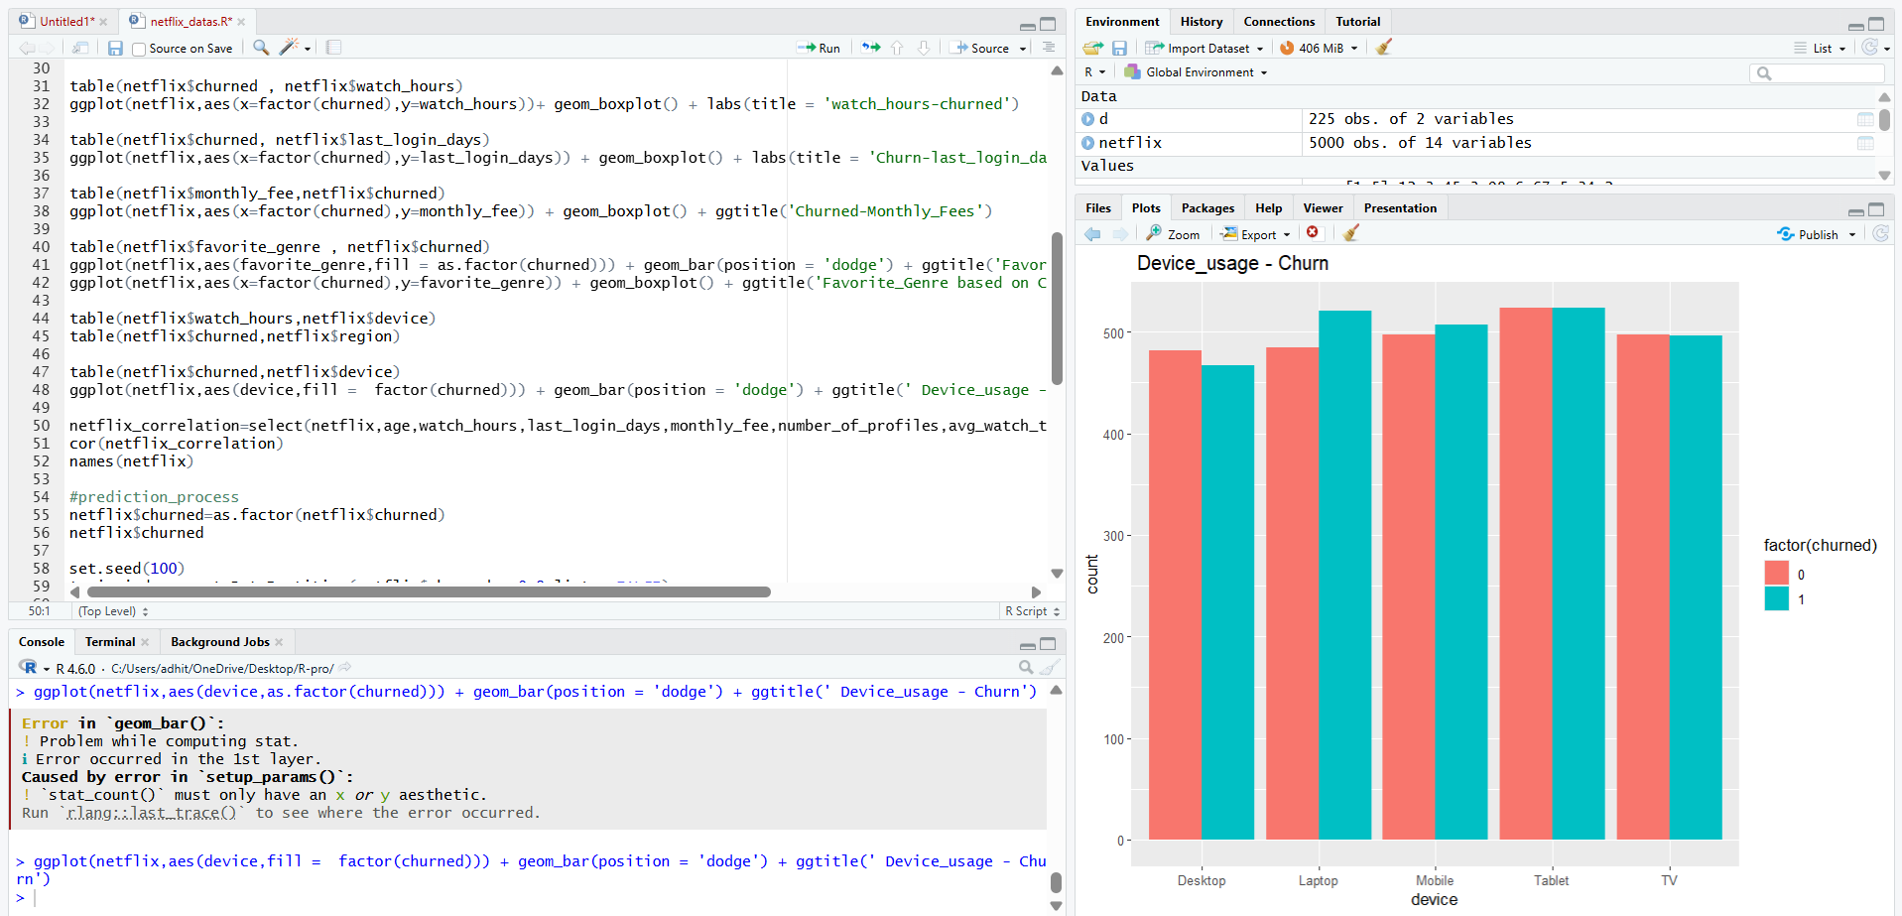


Practical Explanation
Customers prefer:
- TV devices for long-duration entertainment
- Mobile devices for convenience and accessibility
Smooth device performance improves overall customer satisfaction and viewing experience.

Business Recommendation
Platform optimization should focus on:
- Smart TV applications
- mobile streaming quality
- cross-device synchronization
- user interface improvement
- faster application performance

7. Machine Learning Model
Model Used
Logistic Regression
Purpose
To predict whether a customer is likely to churn based on behavioral and subscription-related variables.

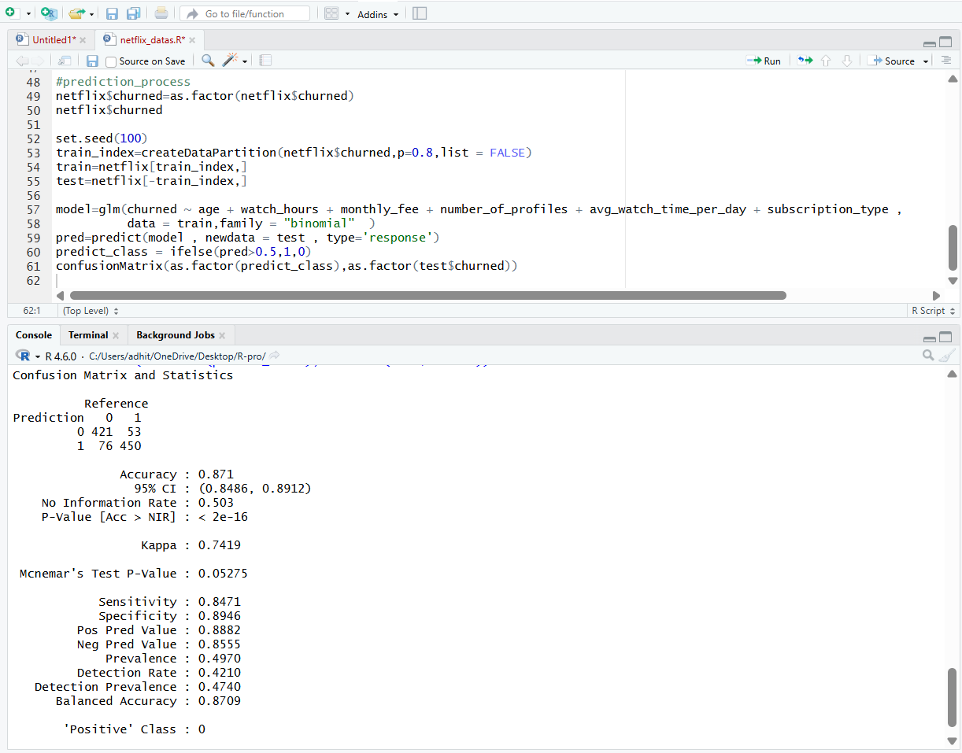

8. Model Performance Evaluation
Metric | Value
Accuracy | 87.5%
Sensitivity | 83.3%
Specificity | 91.65%
Balanced Accuracy | 87.47%

Insight
The model achieved high prediction accuracy and effectively identifies churned customers.

Practical Explanation
The model can help businesses:
- identify customers likely to cancel subscriptions
- target high-risk users early
- reduce revenue loss
- improve retention planning
High specificity indicates strong performance in identifying actual churned customers.

10. Major Factors Influencing Churn
Most Important Churn Drivers
- Customer inactivity
- Subscription type
- Monthly subscription fee
- Watch hours
- Favorite genre
- Regional engagement patterns

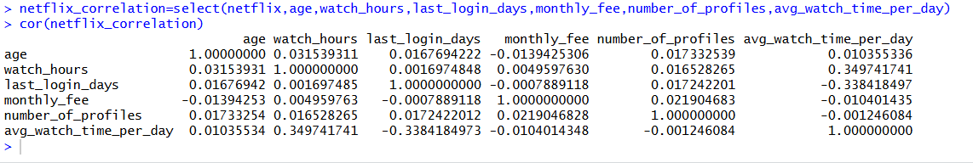

11. Final Business Insights

1. Customer inactivity is the strongest indicator of subscription cancellation.

2. Basic subscription plans experience the highest customer churn.

3. Premium subscribers demonstrate stronger loyalty and engagement.

4. Streaming engagement directly affects customer retention.

5. Regional market behavior influences churn probability.

6. Genre preferences impact long-term customer engagement.

7. Behavioral variables are more important than demographic variables in churn prediction.

8. The machine learning model successfully predicts customer churn with high accuracy.

12. Conclusion
The Netflix Customer Churn Analysis identified the major behavioral and subscription-related factors responsible for customer cancellations. The analysis revealed that inactivity, reduced watch engagement, lower subscription plans, and regional variations significantly influence churn probability.
Premium subscribers and highly engaged viewers demonstrated stronger customer loyalty and lower cancellation behavior. Genre preferences and streaming habits also played important roles in customer retention patterns.
The Logistic Regression model achieved 87.5% prediction accuracy, demonstrating strong capability in identifying high-risk customers. The findings provide valuable business insights for improving customer retention, increasing engagement, and reducing revenue loss through data-driven decision-making.

