**Building a Recipe Recommendation System**



***Name : Afshan Zeba Niyas***

***Batch Name : Data science***

***Project Name: Building a Recipe Recommendation System***

***Date : 31/10/2023***

**INTRODUCTION:**

The modern world is replete with an abundance of culinary choices, making dining decisions a complex and often overwhelming task. Food Recommendation Systems have emerged as a solution to this challenge, leveraging the power of artificial intelligence and data-driven algorithms to assist users in making informed and personalized dining choices.

In a fast-paced and technology-driven society, people seek convenience and personalization in various aspects of their lives, including their food preferences. A Food Recommendation System is designed to cater to these needs, providing users with a personalized and tailored dining experience. This system can operate in various contexts, ranging from mobile applications and websites to in-restaurant kiosks.

The primary objective of a Food Recommendation System is to simplify the decision-making process and enhance the overall dining experience. By considering individual user preferences, dietary restrictions, location, and historical data, the system generates recommendations for restaurants, dishes, and even cuisines that align with the user's unique tastes.

**Project Objective:**

The objectives of building a Recipe Recommendation System are as follows:

1. **Personalized Recipe Suggestions**: The primary objective is to provide users with personalized recipe recommendations based on their individual preferences, dietary restrictions, and historical cooking behaviour. This personalization aims to enhance the user's cooking experience and encourage them to try new and exciting dishes.
2. **Improved User Engagement**: The system should engage users by offering a variety of recipes that cater to their specific tastes and dietary needs. This can lead to increased user satisfaction, longer app or website usage, and repeat visits.
3. **Increased Culinary Exploration**: Encourage users to explore a wider range of cuisines, ingredients, and cooking techniques. The system should not only suggest familiar recipes but also introduce users to new and diverse culinary experiences.
4. **Efficient Search and Discovery**: Simplify the recipe search and discovery process by providing relevant and timely recipe suggestions. This should save users time in deciding what to cook and make the overall cooking experience more efficient.
5. **Dietary Compatibility**: Accommodate users with various dietary restrictions and preferences, such as vegetarian, vegan, gluten-free, low-calorie, or keto diets. Ensure that recipe recommendations align with these dietary requirements.
6. **Real-time Feedback Integration**: Gather and utilize user feedback to continuously improve the recommendation algorithms. This includes tracking which recipes users try, what they like or dislike about them, and adjusting future recommendations accordingly.
7. **Balanced Recommendations**: Offer a balance between well-loved, frequently cooked recipes and novel, adventurous suggestions. Strive to cater to both comfort food desires and culinary exploration.
8. **Algorithm Performance Evaluation**: Regularly assess the system's performance through metrics like click-through rates, user engagement, and user satisfaction surveys to gauge the effectiveness of the recommendation algorithms.
9. **Scalability and Responsiveness**: Ensure that the system can scale to accommodate a growing user base while remaining responsive in delivering real-time recommendations.
10. **Integration of Natural Language Processing (NLP)**: Implement NLP techniques to extract meaningful information from recipes and user reviews, allowing for more context-aware and informative recipe recommendations.

These objectives collectively contribute to the success of the Food Recommendation System project by creating a platform that simplifies dining decisions, enhances user experiences, and benefits both users and restaurants in the food industry.

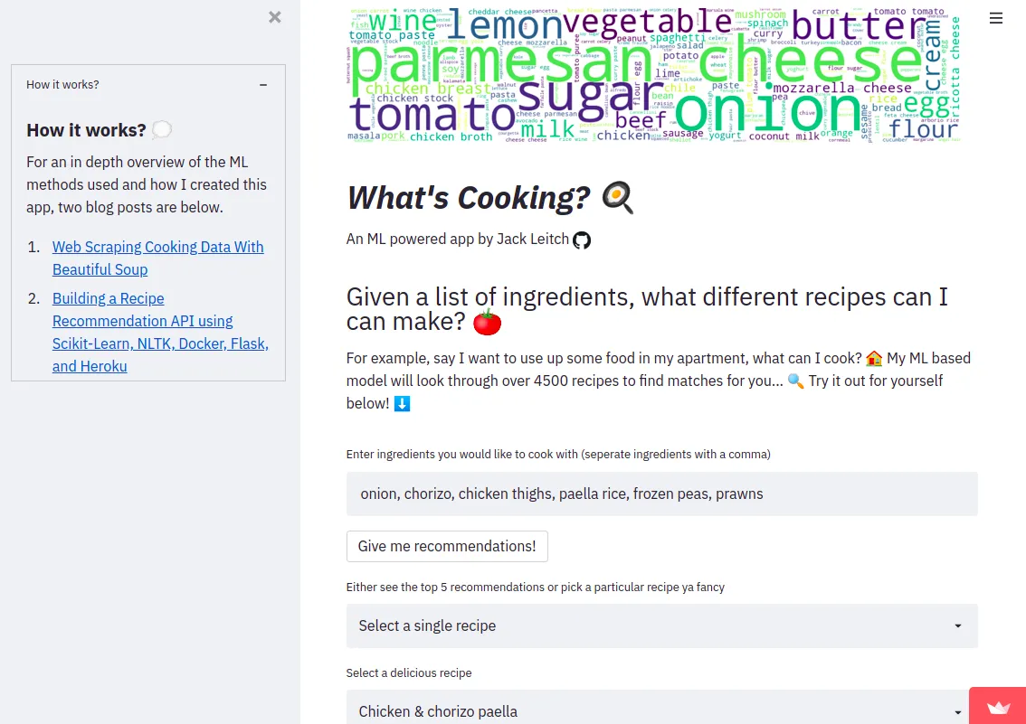

**CONTENTS:**

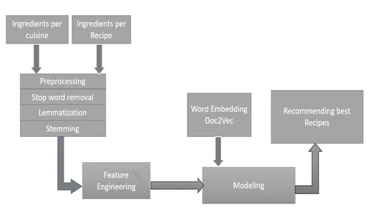

The contents of a comprehensive document on "Building a Recipe Recommendation System" can include the following sections:

1. **Introduction**

1.1 Purpose

1.2 Scope

1.3 Definitions, Acronyms, and Abbreviations

1.4 References

* 1. Overview

1. **Overall Description**

2.1 Product Perspective

2.2 Product Functions

2.3 User Classes and Characteristics

2.4 Operating Environment

2.5 Design and Implementation Constraints

2.6 Assumptions and Dependencies

1. **Specific Requirements**

3.1 External Interfaces

3.2 User Interfaces

3.3 User Registration and Profiles

3.4 Recommendation Algorithms

3.5 User Interactions

3.6 Performance Requirements

3.7 Design Constraints

3.8 Reliability

3.9 Scalability

1. **System Models**

4.1 Use Case Diagrams

4.2 Activity Diagrams

4.3 Sequence Diagrams

4.4 Data Flow Diagrams

4.5 State Transition Diagrams

1. **External Interface Requirements**

5.1 User Interfaces

5.1.1 User Registration Interface

5.1.2 Recommendation Display Interface

5.1.3 User Profile Interface

5.1.4 Admin Dashboard

1. **Non-Functional Requirements**

6.1 Performance Requirements

6.2 Security Requirements

6.3 Usability Requirements

6.4 Scalability Requirements

6.5 Reliability Requirements

6.6 Data Privacy Requirements

6.7 Legal and Compliance Requirements

This table of contents provides a structured framework for an SRS document specific to a Food Recommendation System, ensuring that it covers all the necessary aspects, from the project's introduction to detailed requirements, system models, and non-functional requirements.

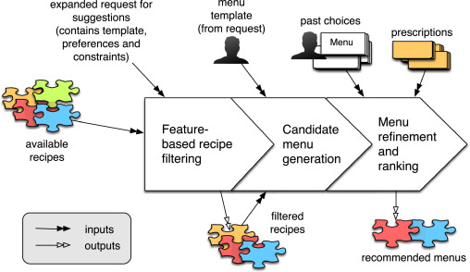

Top of Form

Bottom of Form

Each of these sections provides a critical component of the document, offering insights into the planning, design, implementation, and evaluation of a Recipe Recommendation System. It should serve as a comprehensive guide for those interested in building such systems and conducting research in this field.

**Conclusions:**

In this Software Requirements Specification (SRS) document, we have outlined the comprehensive requirements and specifications for our Food Recommendation System. The completion of this document marks a crucial milestone in the development of our system, providing a clear and detailed roadmap for the project.

The primary objective of this system is to create a personalized and convenient dining experience for our users. By leveraging advanced recommendation algorithms, considering non-functional requirements such as security, usability, and scalability, and adhering to legal and compliance standards, we aim to deliver a product that simplifies the process of choosing where and what to eat while enhancing the overall dining experience.

Throughout this SRS document, we have defined the system's purpose, scope, and specific requirements, ranging from user registration to recommendation algorithms, user interactions, and administration. We have addressed performance, design constraints, quality attributes, and a variety of other requirements essential to the success of the system.

Furthermore, we have provided a set of system models, including use case diagrams, activity diagrams, sequence diagrams, data flow diagrams, and state transition diagrams, to help visualize the system's functionality and user interactions. These models serve as a valuable resource for both developers and stakeholders.

The external interface requirements have been clearly detailed, encompassing user interfaces, software interfaces, and communication interfaces. These interfaces are vital components in ensuring a seamless user experience and system functionality.

We look forward to embarking on this exciting journey, leveraging technology to simplify dining decisions and enhance the culinary experiences of our users. With the guidance of this SRS document, we are well-prepared to proceed with the development, testing, and eventual launch of our innovative Food Recommendation System.

This conclusion section summarizes the importance of the SRS document, acknowledges the key objectives, and sets the stage for the development phase of the project. It emphasizes the user-centric approach and the goal of creating an exceptional food recommendation system.

STEP1:

STEP 2:

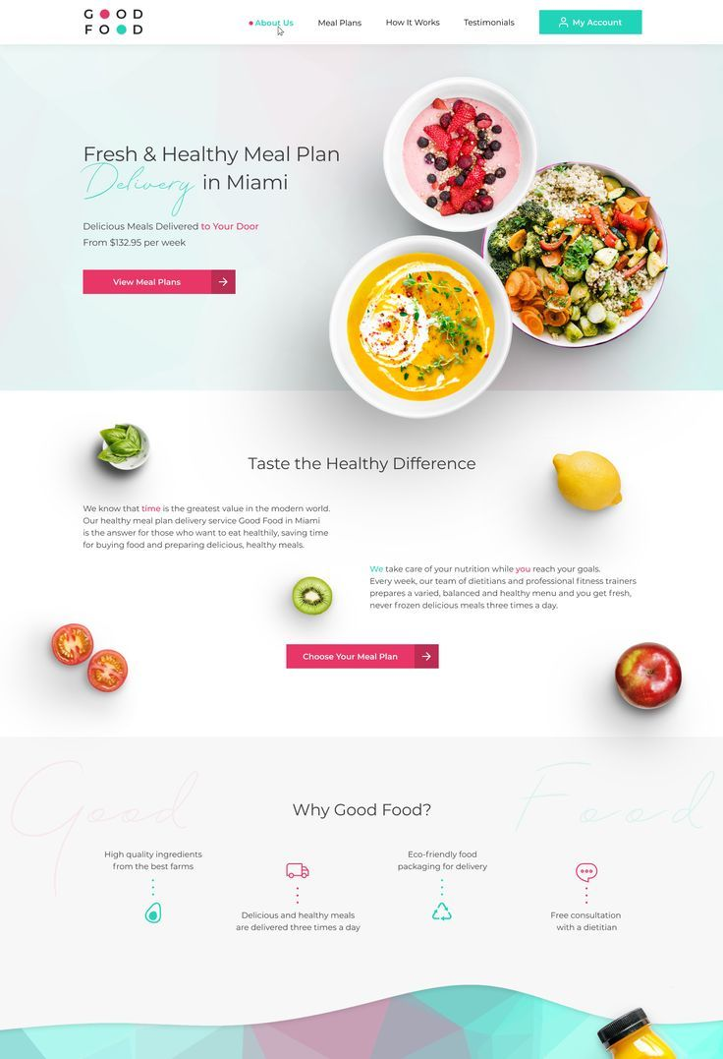

STEP 3:

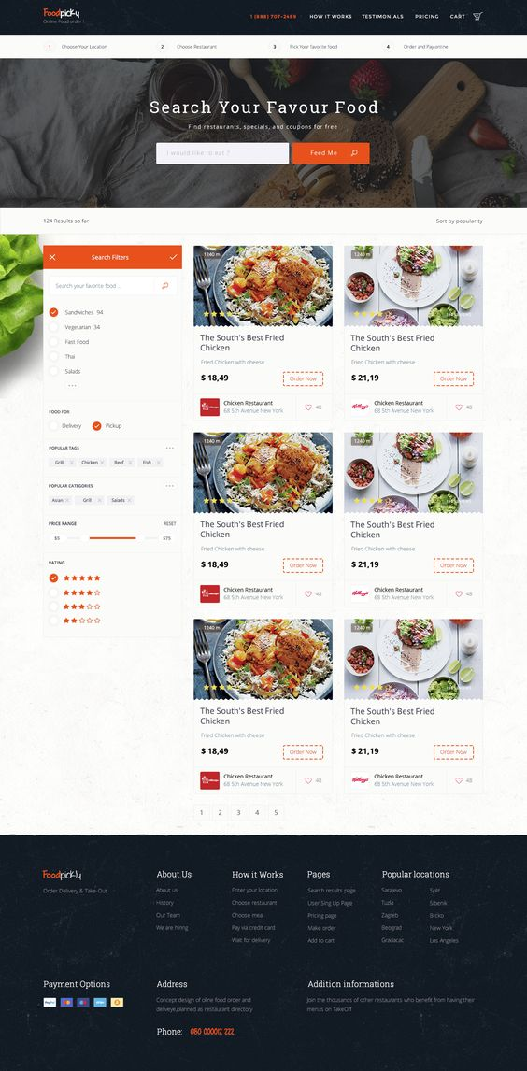

STEP 4:

