

**Name: Adhithyan K S**

**Batch Name: Data science**

**Project Name: Tour recommendation system Date: 15-07-2024**

**Introduction**

The burgeoning tourism industry has witnessed a paradigm shift with the advent of digital platforms. While these platforms offer an abundance of information, travelers often find themselves overwhelmed by the sheer volume of choices. This project aims to revolutionize the travel planning experience by developing an intelligent tour recommendation system.

By leveraging advanced data science techniques and machine learning algorithms, we seek to create a platform that understands individual preferences, explores diverse interests, and delivers highly personalized tour recommendations. Our system will analyze a vast dataset encompassing tourist attractions, user profiles, and booking history to identify patterns and trends that inform tailored suggestions. By going beyond traditional recommendation systems, we aspire to create a truly immersive and unforgettable travel experience for users.

This project envisions a future where travelers can effortlessly discover hidden gems, optimize their itineraries, and maximize their enjoyment of their journeys

**Project Objective:**

The objective of building the Tour Recommendation System are follows:

1. **Personalized Tour suggestion:** The primary objective of this project is to develop a data-driven tour recommendation system that provides personalized and relevant travel suggestions to users. By leveraging advanced machine learning techniques, we aim to enhance the travel planning experience by offering tailored recommendations based on individual preferences and interests.
2. **User engagement:** This involves personalizing recommendations, incorporating interactive elements, and providing additional value beyond basic suggestions. By focusing on user experience and satisfaction, the goal is to keep users returning to the platform for their travel planning needs.
3. **Efficient Search and Discovery:** This involves building a comprehensive database, providing advanced search options, and utilizing user data to suggest relevant destinations. By combining technology like GIS with user feedback, the goal is to enhance the location discovery process.
4. **Real-time Feedback Integration:** By quickly gathering and analyzing user input, the system can adapt to changing preferences and provide more accurate recommendations. This leads to a better user experience and increased satisfaction.
5. **Balanced Recommendation:** The system should not only suggest tours based on user preferences but also introduce diverse choices to encourage exploration. This is achieved by combining user data with algorithms that prioritize variety and novelty, while also allowing users to control their preference for familiar or unfamiliar recommendations.
6. **Algorithm Performance Evaluation:** This includes tracking user behavior like clicks, bookings, and spending, as well as gathering user feedback on recommendation relevance. By analyzing these metrics, we can understand how well the system is meeting user needs and identify areas for improvement.
7. **Scalability and Responsiveness:** This involves using technology to handle large amounts of data and users efficiently, while also making sure the system reacts promptly to user requests.
8. **Integration of Natural Language Processing (NLP):** NLP is essential for understanding and extracting information from text data within the tourism domain. By analyzing user reviews, tour descriptions, and other textual content, NLP helps improve recommendation accuracy, enhance search capabilities, and provide a more personalized user experience.
9. **Data privacy and security:** This involves protecting user information like personal details, preferences, and travel history from unauthorized access, misuse, or disclosure. It also includes ensuring data accuracy and integrity. By implementing robust security measures and adhering to privacy regulations, user trust can be established, fostering a safe and secure platform.
10. **Cost-effectiveness:** This involves efficient use of resources such as data, technology, and personnel. By optimizing processes, reducing operational costs, and generating revenue through the platform, the project can achieve financial sustainability and maximize its return on investment.

These objectives work together like a well-oiled machine. The core features deliver a great user experience. Supporting objectives like user engagement and real-time feedback keep users keep happy and coming back.

Finally, cost-effectiveness and data privacy ensure the project runs smoothly and users trust the platform. This combination creates a successful tour recommendation system that benefits everyone

**Contents**

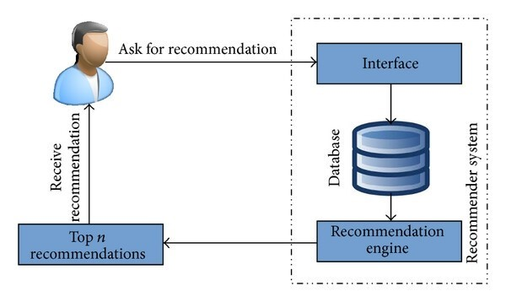

# Introduction

* Project overview and objectives
* Target audience and user profiles
* System scopes and boundaries
* Definitions, acronyms, and abbreviations

# Overall description

* Product perspective
* Product functions
* User characteristics
* General constrains
* Assumptions and Dependencies
* Product variations

# Specific Requirements

* Functional requirements (e.g., user registration, search, recommendation, booking)
* Non-functional requirements (e.g., performance, security, usability, maintainability)
* External interface requirements (e.g., APIs, databases)
* User interface requirements (e.g., screen layouts, navigation)

# Functional Requirements

* Users should be able to create and manage user profiles.
* The system should provide personalized tour recommendations based on user preferences.
* Users should be able to search for tours based on various criteria (location, interests, budget, etc.).
* The system should allow users to book tours and make payments.

# Non-functional Requirements

* The system should be responsive and load quickly.
* The system should be secure and protect user data.
* The system should be scalable to accommodate increasing user numbers.
* The system should be accessible to users with disabilities.

This table of contents provides a structured framework for an SRS document specific to a Tour Recommendation System, ensuring that it covers all the necessary aspects, from the project's introduction to detailed requirements, system models, and non-functional requirements

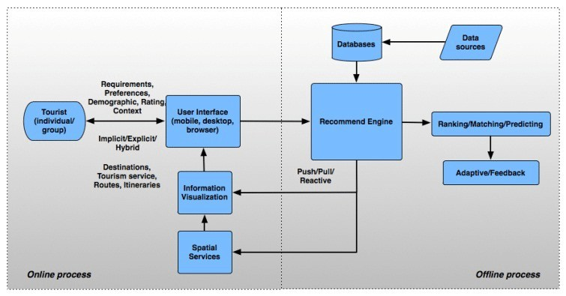

Each of these sections provides a critical component of the document, offering insights into the planning, design, implementation, and evaluation of a Tour Recommendation System. It should serve as a comprehensive guide for those interested in building such systems and conducting research in this field.