₹ RECOUP
Bounded, ML-First Revenue Recovery for Razorpay
Recover the revenue you already earned. Recoup detects failed payments and abandoned checkouts, uses calibrated machine-learning models to decide the safest recovery move and how likely it is to work, executes it under hard policy limits, and proves — with a signed webhook round-trip — exactly how much money it brought back.
Razorpay AI Buildathon 2026
Track: AI Revenue Recovery · Technical Documentation
github.com/adhithyyaa/Buildathon-2026

Contents
Contents 2
1. Executive Summary 3
Who it is for 3
What the demo proves in 60 seconds 3
2. The Core Idea — ML Proposes, Deterministic Code Disposes 4
3. System Architecture 5
The three tiers 5
4. The Recovery Pipeline — End to End 6
Stage by stage 6
5. The Case Lifecycle (State Machine) 7
6. The Machine-Learning Tier 8
The six model-service outputs (validated, honestly labelled) 8
How good are the models — stated honestly 8
Recovered ₹ versus what? — the counterfactual holdout 9
Cross-world transfer — does it generalize? 9
7. The Decision & Policy Engine 11
8. The Action Executor 12
9. The Webhook Money Path & Exactly-Once Recovery 13
10. The Recovery Lab — Incremental ₹, Not Gross (the standout) 14
11. The Data Model 15
12. The Dashboard 16
13. India Compliance (Policy-as-Code) 17
14. Evidence & Testing 18
A real Razorpay round-trip (not just a self-test) 18
Automated tests & CI 18
15. Modules Used — Libraries & Source Files 19
External libraries & frameworks 19
Internal source modules 19
16. How to Run 21
17. Glossary 22

In Word: right-click the table above → Update Field → Update entire table to fill page numbers.

1. Executive Summary
Recoup is a bounded, ML-first operations system that recovers failed Razorpay payments and abandoned checkouts. In India a failed payment is rarely a change of heart — it is usually mechanical and recoverable: a UPI collect request timed out, an issuing bank had a downtime window, a card was momentarily declined, an OTP/3DS step was abandoned, or an e-mandate auto-charge failed. Each has a different correct recovery move and a different correct timing.
The job is therefore decisioning under constraints — the right action, on the right channel, at the right time — which is a tabular ranking / classification problem, not a language problem. Recoup is built around one design invariant:
“ML proposes, deterministic code disposes.”
The machine-learning models decide (what to do and how likely it is to work); a deterministic policy engine disposes (it can override or block any decision); a deterministic executor moves the money through an allow-listed set of actions; and an LLM is used only to explain decisions in words — never to make them. A signed Razorpay webhook proves how much money actually came back.

Who it is for
Mid-market Indian D2C / subscription merchants processing ~₹50L–₹5Cr/month on Razorpay — large enough that 1–2 recovery points is real money (₹1–10L/month), too small to staff a data-science team. Recoup does not compete with Razorpay's first-party recovery products (Agent Studio, the Intelligent Retry Engine, Optimizer). It is the measurement-and-governance layer that plugs under them: holdout-measured incremental recovery, calibrated per-case probabilities, deterministic error-reason triage, India policy-as-code, and an append-only audit trail — the things none of those products publish.

What the demo proves in 60 seconds
- What is at risk? A ranked queue of at-risk cases with a live at-risk-₹ total.
- What did the model decide, and how sure is it? Five model predictions plus the normalized reason, shown next to the policy checks.
- What did it actually do? A real Razorpay test-mode payment link, a scheduled retry, or a human escalation.
- How much did it recover? Pay the link with a test card → a signed webhook flips the case to recovered and the recovered-₹ counter ticks up.

2. The Core Idea — ML Proposes, Deterministic Code Disposes
This is the first question a reviewer asks: “what is the AI actually doing here?” The answer is deliberate and auditable. Every at-risk case is scored by a tier of tabular models, which propose a decision. A deterministic policy engine then approves, modifies, or blocks that proposal, and a deterministic executor carries out only a fixed, allow-listed set of actions. No model — tabular or language — touches money or has the final say.
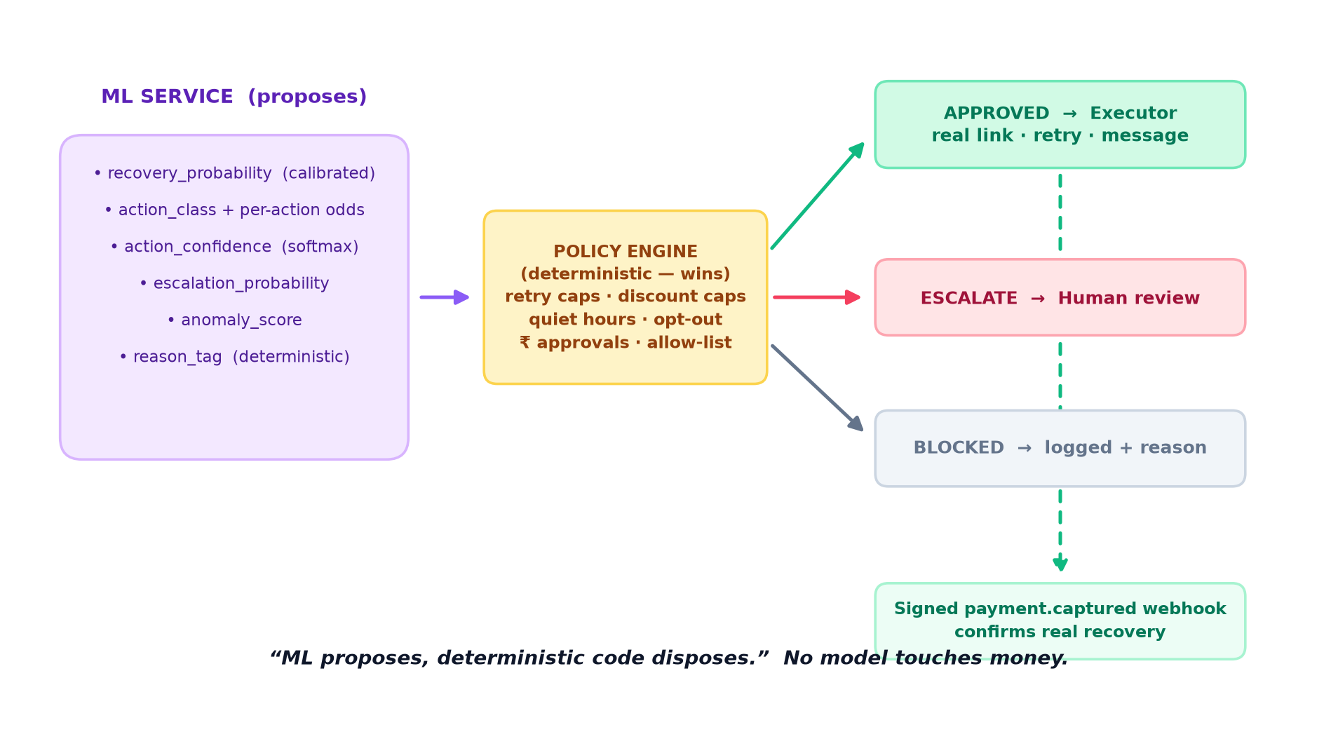
Figure 2.1 — The models only ever propose; deterministic code decides what is allowed to happen.
Why ML and not “a cron job with if-statements”: the mapping from (failure reason × amount × customer history × timing × channel) to the recovery move with the highest expected return is contextual and merchant-specific. A static rule table encodes one person's guess once; a calibrated model learns it from outcomes, quantifies its own uncertainty, and improves as real recovery data replaces the synthetic bootstrap.
Where the LLM is kept out. The LLM is called only, and only on demand, to explain a decision in plain English, draft the customer-facing message, and summarize an escalation. If it is down or returns junk, these fall back to templates and nothing about the money path changes — because the money path never depended on it.

3. System Architecture
Recoup is a three-tier system. The money path is written in typed TypeScript (so the code that moves money is type-checked end to end); the models live in a separate Python service (so they are trained and served with the right tools); and a React dashboard makes every decision, metric, and audit row visible.
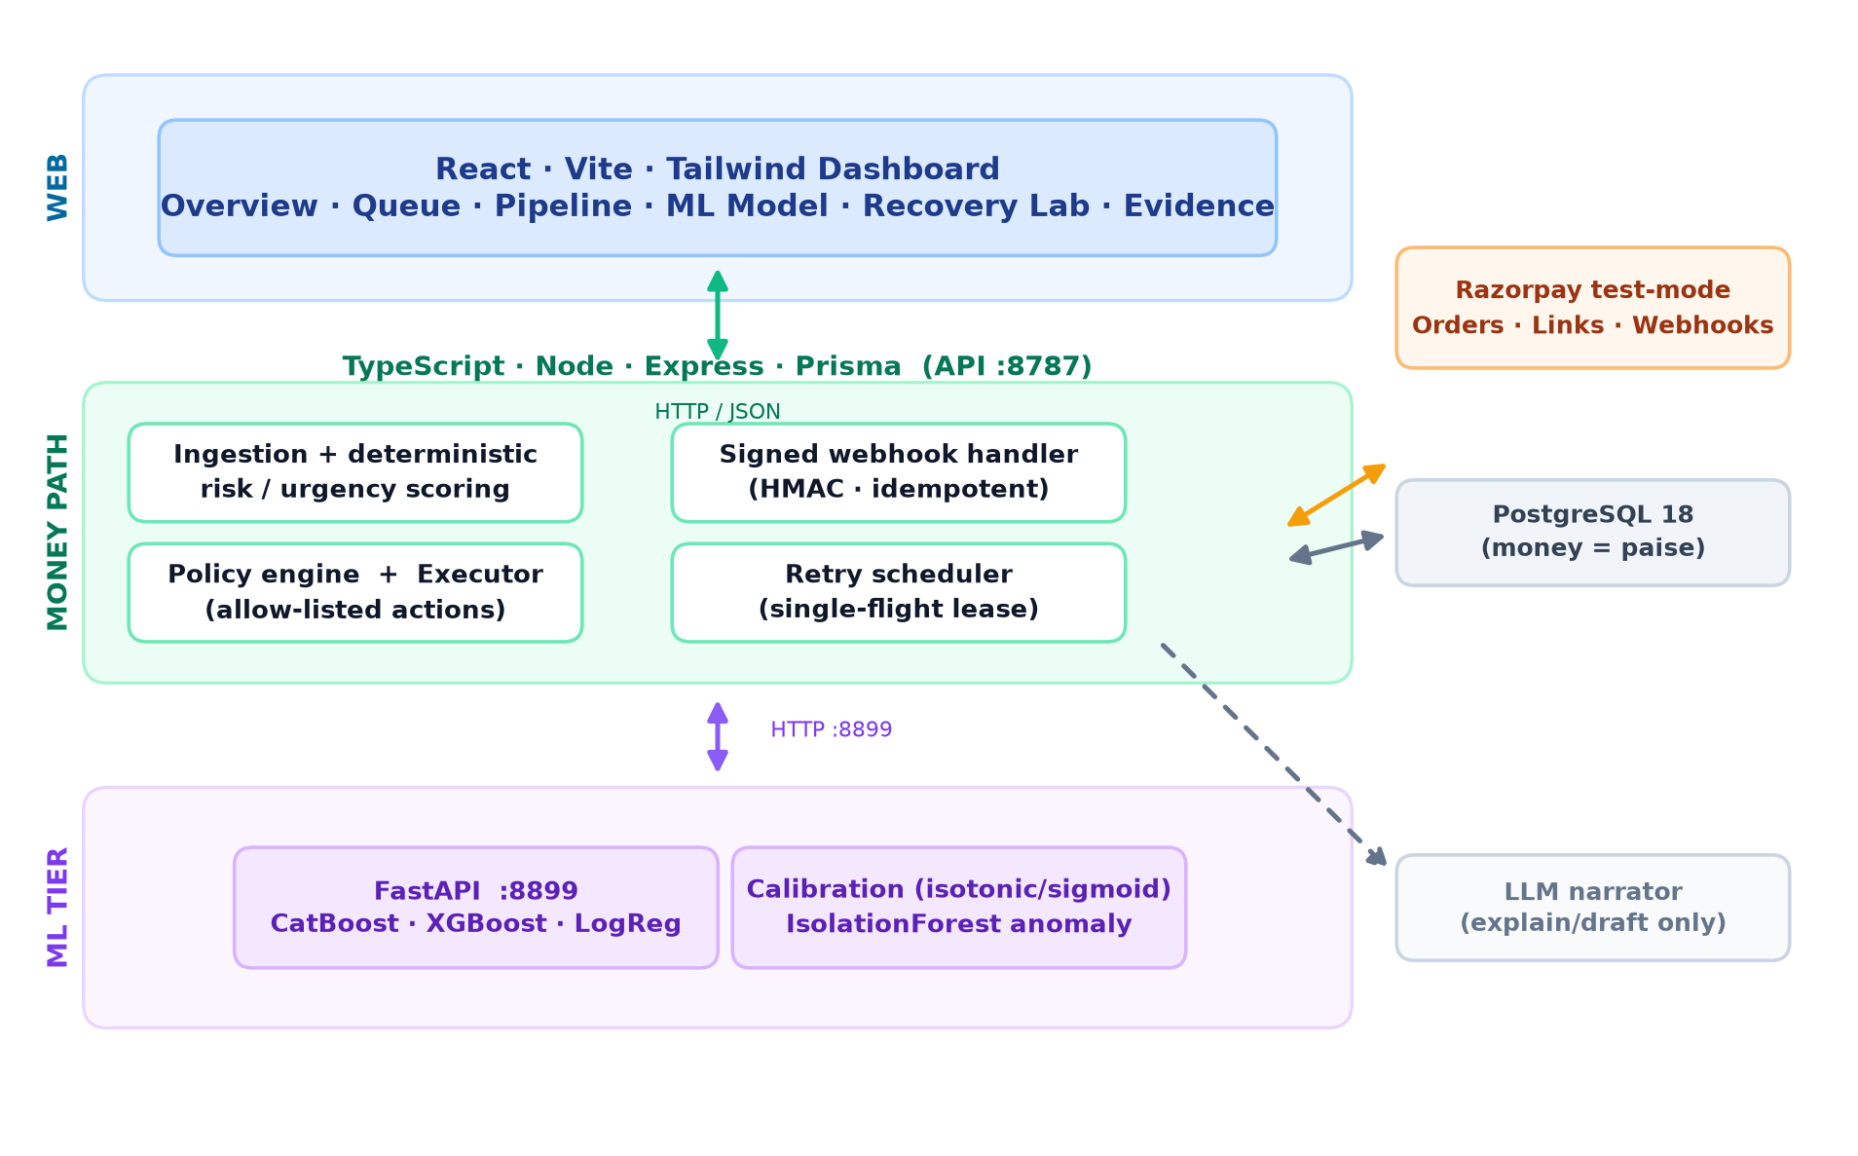
Figure 3.1 — Three tiers: React dashboard, the TypeScript money path, and the Python ML tier, over PostgreSQL and Razorpay.

The three tiers
- Web (React · Vite · Tailwind). Six views — Overview, Recovery Queue, Pipeline, ML Model, Recovery Lab, Evidence — plus a per-case detail page. Same-origin fetches proxied to the API.
- Money path (Node · Express · Prisma, API :8787). Ingestion + deterministic risk scoring, the policy engine and allow-listed executor, the signed-webhook handler, and a single-flight retry scheduler. Money is stored as integer paise, never floats.
- ML tier (FastAPI :8899). CatBoost (primary) benchmarked against XGBoost and a Logistic-Regression baseline, isotonic/sigmoid calibration, and an IsolationForest anomaly detector.
- Data & integrations. Real PostgreSQL 18 embedded locally (no Docker); Razorpay test-mode Orders, Payment Links and Webhooks; a provider-agnostic LLM (Anthropic or any OpenAI-compatible provider) used only for narration.
Resilience: if the ML service is unreachable the pipeline falls back to a deterministic rule-based plan (flagged source: 'fallback'), so it never stalls; if Razorpay's link API fails the executor degrades to a simulated link and logs why.

4. The Recovery Pipeline — End to End
A case flows through ten deterministic stages. Every arrow that changes a case writes an audit-log row (before_state → after_state, actor, details), so the whole run is replayable and explainable.
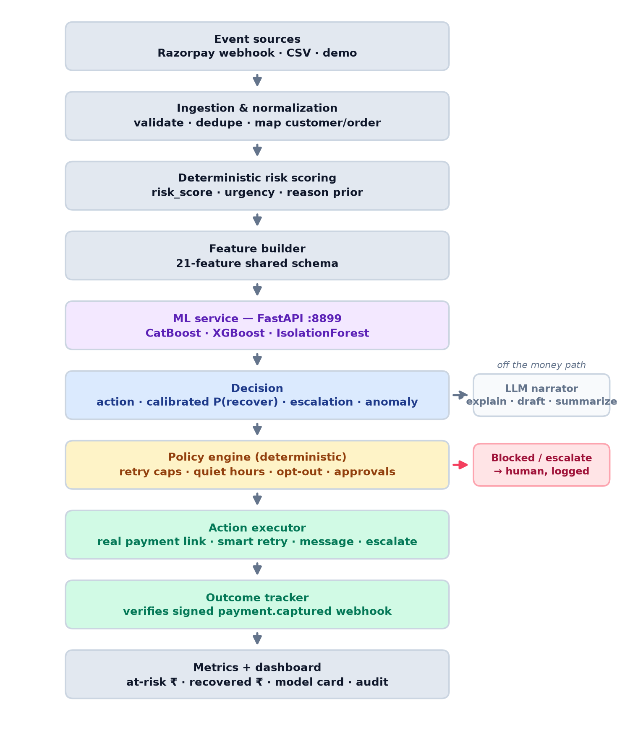
Figure 4.1 — From event ingestion to recovered-₹, with the policy branch and the off-money-path LLM narrator.

Stage by stage
- Event sources → Ingestion. Razorpay webhooks, CSV replay, or the demo panel are validated, de-duplicated, and mapped to a customer/order.
- Risk scoring (deterministic). A risk_score, urgency_score, and a reason prior are computed in code before any model runs.
- Feature builder. The 21-feature shared schema (features.py) — the single source of truth used by both training and serving, so train/serve skew cannot creep in.
- ML service → Decision. The models return the chosen action, a calibrated recovery probability, escalation risk and an anomaly score.
- Policy engine → Executor. Deterministic guardrails approve, modify, block or escalate; approved actions are dispatched by the allow-listed executor.
- Outcome tracker → Metrics. A signed payment.captured webhook confirms real recovery; the dashboard shows at-risk ₹, recovered ₹, the model card and the audit trail.

5. The Case Lifecycle (State Machine)
A case is one recovery-workflow instance for one at-risk event. It moves through an explicit, allow-listed state machine — never an open-ended agent loop. Every transition is logged; invalid transitions fail loudly rather than silently corrupting state.
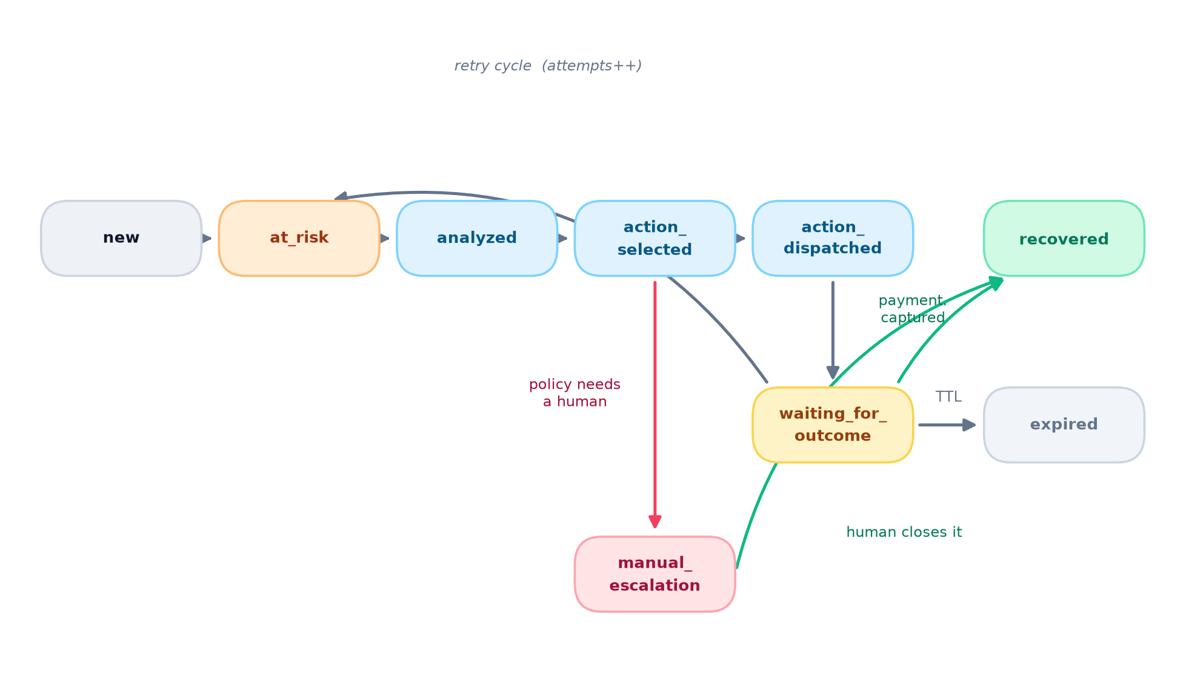
Figure 5.1 — The bounded case lifecycle. Recovery is only ever booked on a real captured payment.
State | Meaning / how it is entered
new → at_risk | Event normalized and scored.
analyzed | Deterministic risk scoring done.
action_selected | ML decision produced and policy-checked.
action_dispatched → waiting_for_outcome | Executor ran an approved action (link sent / retry scheduled).
recovered | A signed payment.captured webhook confirmed the money came back.
expired | The recovery window (TTL) passed with no capture.
at_risk (retry) | Retry cycle — attempts++ — back into the queue.
manual_escalation | Policy required a human (e.g. high value); a human approves & dispatches or rejects.

6. The Machine-Learning Tier
A separate Python service (FastAPI, port 8899) so the models are trained and served with the right tools while the money path stays in typed TypeScript. Three models are trained and reported side by side so the model choice is defended with numbers, not asserted.
Model / component | Role
CatBoost (primary) | Native categorical handling (reason, method, channel, merchant type) with no leakage-prone one-hot; strong calibration out of the box.
XGBoost (benchmark) | Gradient-boosted benchmark, trained and reported alongside.
LogisticRegression (baseline) | Simple, interpretable baseline — the bar CatBoost must clear.
CalibratedClassifierCV (isotonic / sigmoid) | Turns raw scores into probabilities whose predicted rate matches the observed rate.
IsolationForest | Per-case anomaly and a windowed, per-reason z-scored failure-spike detector.

The six model-service outputs (validated, honestly labelled)
The pipeline persists exactly these outputs per case. Five are model predictions; reason_tag is a deterministic normalization (labelled honestly so nobody mistakes it for a trained head).
Output | Source | Meaning
recovery_probability | CatBoost → isotonic-calibrated | Calibrated P(recovered) — safe to threshold and feed EV math.
action_class + per_action_recovery | CatBoost multiclass | Next-best action and the modelled odds of each allowed action.
action_confidence | CatBoost softmax (uncalibrated) | How peaked the action distribution is — a relative confidence, not a probability.
escalation_probability | CatBoost → sigmoid-calibrated | P(this case needs a human).
anomaly_score | IsolationForest | How unusual this case is vs. the learned normal.
reason_tag | deterministic taxonomy | Normalized failure reason (not a trained head).

How good are the models — stated honestly
All metrics are on a time-ordered held-out split (train on earlier days, test on the latest ~20% by day_index), so nothing is inflated by temporal leakage.
Metric | Result | The honest caveat
Recovery ROC-AUC (CatBoost, calibrated) | ≈ 0.75 · 95% CI [0.739, 0.765] | Edge over LogReg is real but small (+0.013); CatBoost is primary for calibration + native categoricals, not a headline gap.
Action head accuracy | ≈ 70% (≈ 84% agreement with EV-optimal) | Labels are deliberately noisy — a genuine learning problem, not a tautology.
Escalation (calibrated) | Brier ≈ 0.07 | Well-calibrated hand-off signal.
Failure-spike detection | ≈ 87.5% | On injected incident windows.

Recovered ₹ versus what? — the counterfactual holdout
A gross “money recovered” number on a simulator you wrote proves nothing. So the eval rolls four arms over the time-ordered holdout and scores each with the world's independent ground-truth (never the model's own prediction — the anti-circularity guard). It is run against two independently-authored worlds to show when the ML earns its keep:
Arm (net recovery rate) | World A — reason-dominated | World B — context-driven
do-nothing | 6.4% | 9.1%
rules-only (reason triage) | 38.2% | 26.8%
ML + policy (deployed) | 38.2% | 37.3%
oracle (best action) | 38.6% | 43.1%
ML lift over rules-only | −₹10k · a tie | +₹5.49M · CI [5.1M, 5.8M] · significant
Read honestly: in World A the best action is almost entirely a function of the failure reason, so a rules baseline is already near-optimal and the ML ties it — we show the tie rather than hide it. World B is authored independently: the best action is driven by a latent customer archetype that leaks into features, so a reason lookup predicts it only ~24% while the model predicts it ~85%. There the ML beats the rules baseline by +₹5.49M (significant). The takeaway: the ML's edge over rules scales with how much the optimal action depends on context beyond the failure reason — and real merchant recovery is context-driven.

Cross-world transfer — does it generalize?
To answer the loudest critique (“every number is on a synthetic world you wrote”), a recovery model trained on one world is frozen and evaluated on the independently designed other world it never saw.
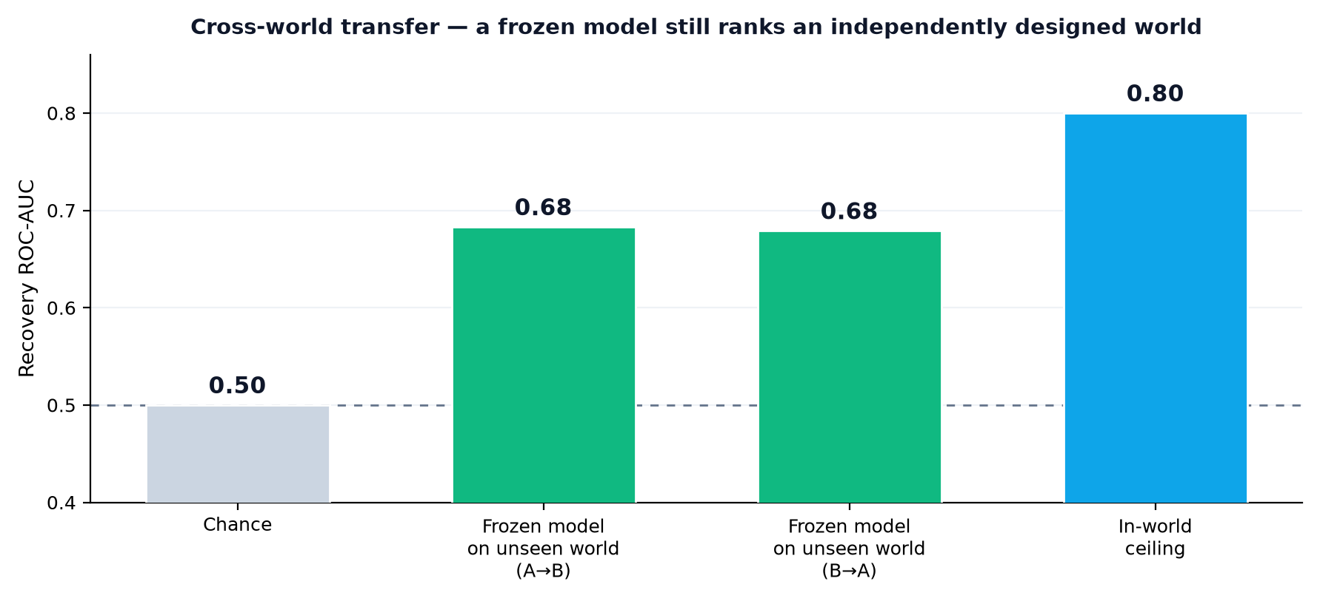
Figure 6.1 — A frozen model still ranks an unseen world at ROC-AUC ≈ 0.68 (chance 0.50, in-world ceiling ≈ 0.80).
Roughly 70% of the in-world edge over chance survives transfer in both directions — the shared payment-recovery structure (retry fatigue, staleness decay, opt-out suppression, amount effects) generalizes. The action policy, by contrast, does not transfer, and that unflattering result ships unfiltered (python ml/src/transfer.py).

7. The Decision & Policy Engine
Policies are configuration, evaluated in deterministic code, and they win over the model. Each evaluation records which rules passed or failed and a human-readable “why” string shown in the UI. The engine returns one of three outcomes: approved (dispatch now or at a scheduled time), escalate (a human must approve first), or blocked (not permitted at all).
Guardrail | Rule | Why (India context)
Retry cap | at most 3 retries | NPCI e-mandate rule: 1 original + limited retries.
Discount cap | ≤ 10%, only if amount ≥ floor and EV-positive | Never give away margin below break-even.
Quiet hours | 21:00–08:00 IST → no outreach (retries still allowed) | Do not message customers overnight.
Opt-out | no outreach at all | Respect customer consent.
Human approval | amount ≥ ₹25,000 or an incentive is proposed | High-value / discount actions need a person.
AFA ceiling | high-value auto-debit retry needs an additional-factor / human step | NPCI/RBI e-mandate framework.
RBI TAT hold | failed-but-debited → no action until T+1 auto-reversal | Avoids a double-debit complaint.
Allow-list | block any action not in the fixed set | Defense in depth — the model can never invent an action.
Failure-spike defer | if a reason is spiking now, defer the retry | Don't add to a live bank/UPI outage.
Lab auto-suppress | a reason with no proven lift → take no action | Stop spending where it can't beat doing nothing.

8. The Action Executor
The executor carries out exactly one policy-approved action per case, from a fixed allow-list. There is no path for the AI to make it do anything else. Every action writes an Action row and moves the case along the state machine; recovery is only booked later, on a real capture.
Action | What it does
smart_retry | Schedules a re-attempt of the original payment (retries ignore quiet hours; they don't message the customer).
send_payment_link | Creates a real Razorpay Payment Link and sends it on the chosen channel.
offer_incentive | A payment link with a policy-capped discount applied (requires human approval).
send_reminder | A message-only nudge (no new link), deferred out of quiet hours.
escalate_to_human | Hands the case to a person with an LLM-drafted summary.
no_action | Deliberately does nothing this cycle (e.g. suppressed reason / active incident) and revisits later.
Kill switch: a global operator pause stops all automated dispatch and retries; the intended action is still recorded, but nothing is sent, and the case is held for human review.

9. The Webhook Money Path & Exactly-Once Recovery
Recovery is booked only when a real, signed payment.captured webhook arrives — the round-trip that is expensive to fake. The handler is deliberately ordered for safety.
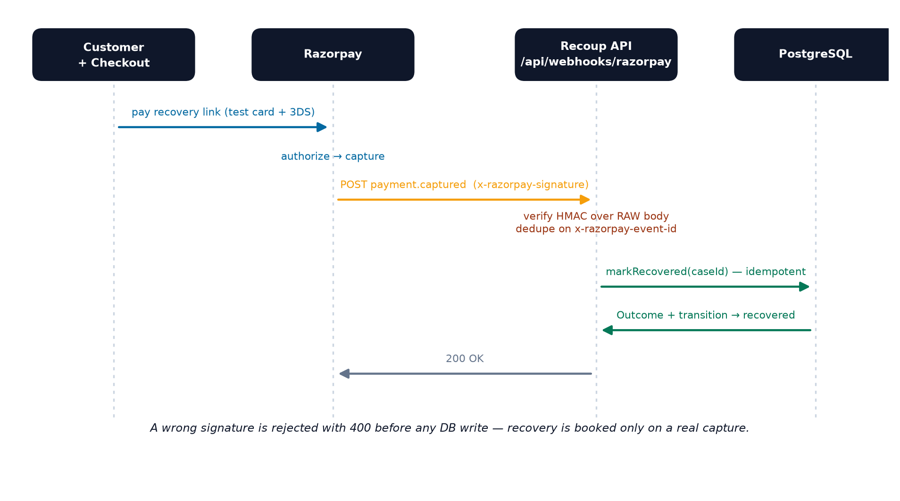
Figure 9.1 — The signed round-trip. A wrong signature is rejected with 400 before any database write.
- Verify first. The HMAC-SHA256 signature is checked over the raw request body (the webhook route is mounted before the JSON parser); a wrong or missing signature is rejected with 400 before any DB write.
- Idempotent by design. Deliveries are de-duplicated on the x-razorpay-event-id header, but processed first and recorded after success — so a crash mid-processing safely retries, and the underlying operations (ingest dedupes, markRecovered is a no-op once recovered) are themselves idempotent.
- Exactly-once under concurrency. Concurrent redeliveries are serialized per case; the money is booked once — one Outcome row, one audit row — verified by a dedicated integration test suite (a duplicate webhook, a concurrent-redelivery storm, and a crash-mid-processing case).

10. The Recovery Lab — Incremental ₹, Not Gross (the standout)
Every recovery product reports gross recovered ₹. That number proves nothing — some of those customers would have paid anyway. The number that matters, and that neither Razorpay's agents nor the vendors publish, is the incremental recovery: how much we recovered over what would have happened with no action.
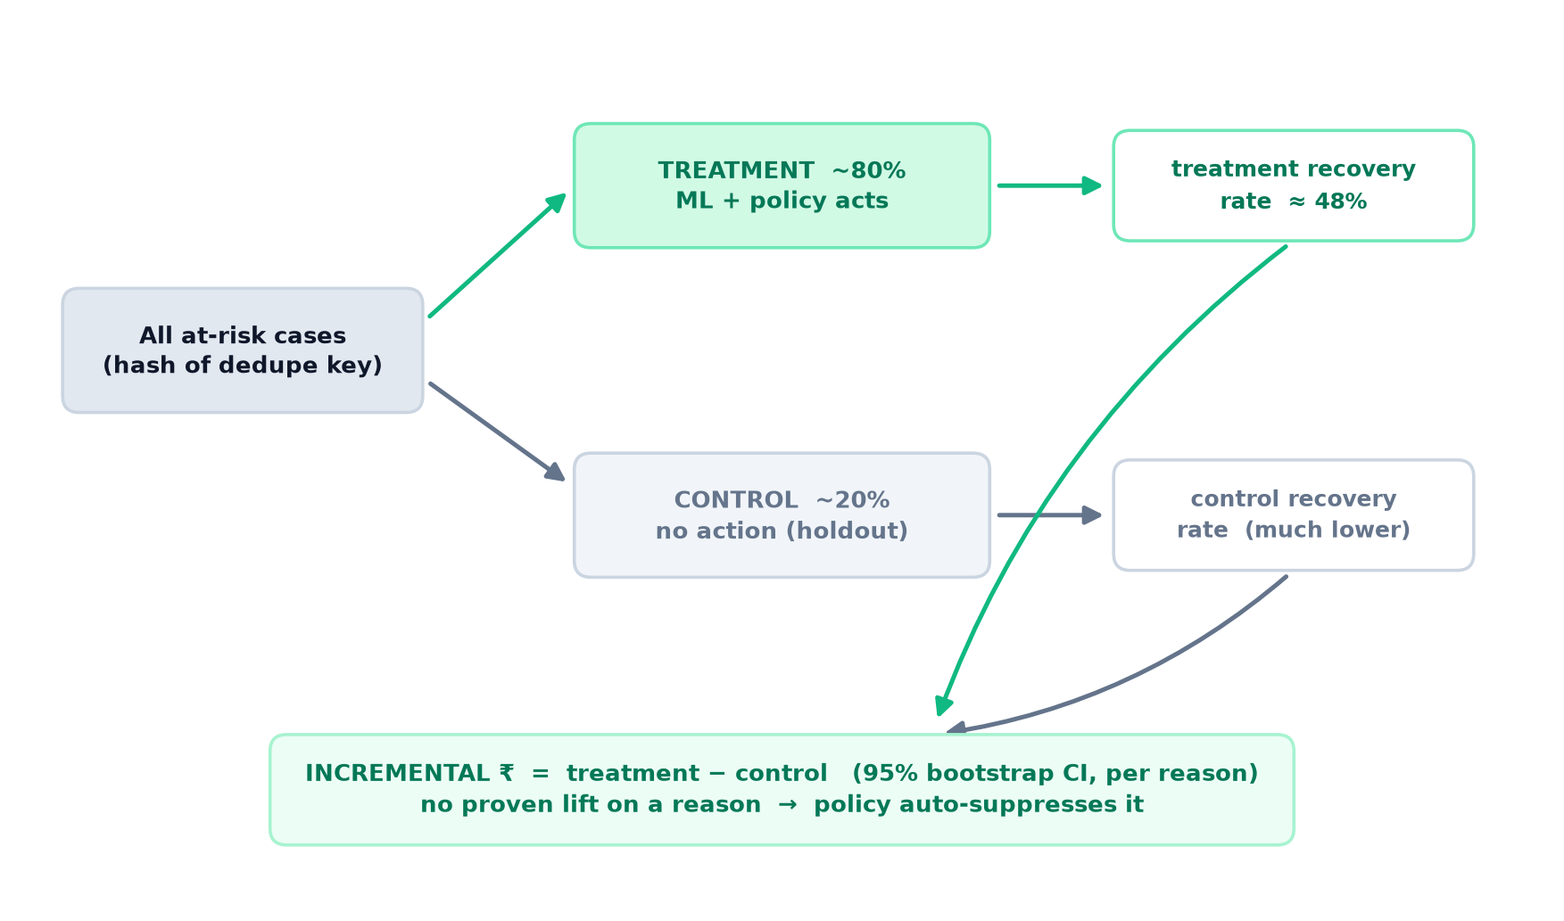
Figure 10.1 — A live control holdout turns “trust us” into a CI-bounded, provable incremental number.
- Holdout. At ingest each case is deterministically assigned an arm — treatment (the ML+policy pipeline acts) or a ~20% control (no action). The assignment is a hash of the dedupe key, so a replay reproduces the same split.
- Measurement. Over all resolved cases the Lab computes treatment-rate − control-rate (₹-weighted) with a 95% bootstrap CI, overall and per failure reason. In the demo the treatment arm recovers ≈ 48% vs a much lower control — a large, significant lift.
- The efficiency loop. Any reason where treatment does not beat control (with enough evidence) is wasted effort — the policy auto-suppresses it until it re-proves itself. This is what makes the layer make Razorpay more efficient: it continuously proves which actions add incremental value and prunes the ones that don't.
- Doubles as a live A/B / drift signal on the model, filling the “no live shadow eval” production-ML gap. Surfaced on the dashboard as the Recovery Lab panel (GET /api/lab).

11. The Data Model
The schema (server/prisma/schema.prisma) centres on the Case — one recovery workflow. Money is stored as integer paise everywhere (₹1,499.00 → 149900), never floats; Prediction and AuditLog are append-only.
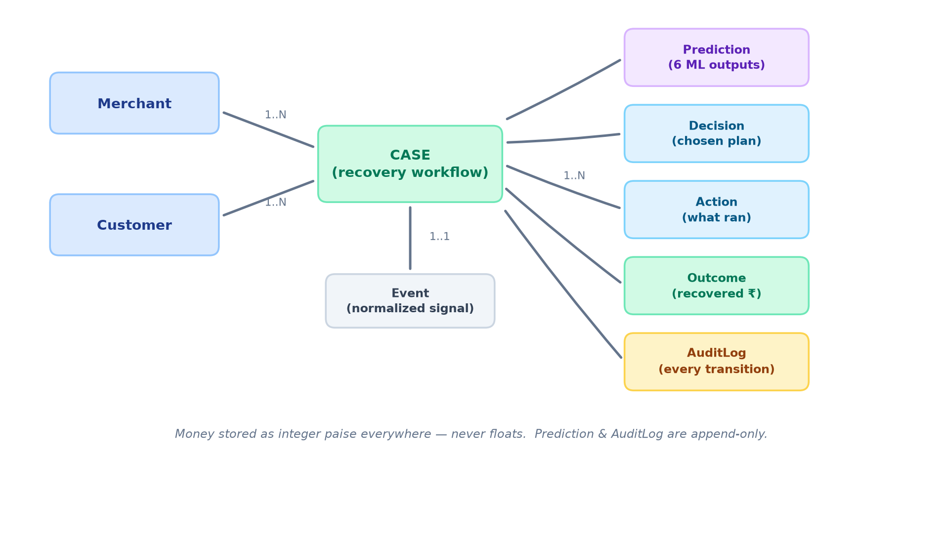
Figure 11.1 — Entities and relationships. Every model-service run appends a Prediction; every transition appends an AuditLog.
Entity | What it holds
Merchant / Customer | The tenant and the payer; Cases are scoped to a merchant.
Event | The raw, normalized at-risk signal (the failure).
Case | The recovery workflow instance and its current state.
Prediction | Append-only record of the six model-service outputs per run.
Decision / Action | What was chosen and what actually ran (channel, link, status).
Outcome | The result — recovered amount, minutes-to-recovery, notes (with the pay_ id).
AuditLog | Every state transition: before → after, actor, details.

12. The Dashboard
A React (Vite + Tailwind) console with a sidebar and six views, plus a per-case detail page. It makes every decision, metric and audit row visible, and includes a discreet operator “Demo” menu (seed → run pipeline → advance retries → resolve outcomes) and a kill switch.
View | What it shows
Overview | Essential KPIs (recovered ₹, recovery rate, at-risk exposure, incremental ₹), a recovery-impact bar, and a Platform-Modules showcase.
Recovery Queue | Every at-risk case ranked by risk/urgency — Risk, Merchant/Customer, Amount, Reason, Action, State, Recovered — with search and filters.
Pipeline | The live operational flow (case counts per stage) and the bounded-agent “how a case is handled” walkthrough.
ML Model | The model card: ROC-AUC comparison, the calibration reliability curve, and feature importances.
Recovery Lab | Incremental ₹ + CI, treatment vs control rates, per-reason lift, and suppression candidates.
Evidence | The real Razorpay test-mode captures, cross-referenced to the case each recovered, with a keys-free replay.
Case detail | The full decision story: journey tracker, ML prediction panel, policy check, action taken, outcome, and audit trail.

13. India Compliance (Policy-as-Code)
Compliance is not a document — it is enforced in the money path (§7). The rules encode real Indian payments constraints so the engine is safe to point at production traffic:
- RBI harmonised TAT. A failed-but-debited payment auto-reverses by T+1; Recoup holds (no retry, no outreach) until it settles, avoiding a double-debit complaint.
- NPCI e-mandate retry cap. 1 original attempt + a limited number of retries; beyond that the case escalates rather than hammering the rail.
- Additional-Factor-Authentication (AFA) ceiling. High-value auto-debit retries require a human / additional-factor step, not a silent retry.
- Quiet hours (IST) & opt-out. No outreach 21:00–08:00; opted-out customers get no outreach at all.
- Economic floor. Below a minimum pursuit amount, recovery is not economical and is blocked.

14. Evidence & Testing

A real Razorpay round-trip (not just a self-test)
Two real Razorpay test-mode payments were captured through Razorpay's hosted Checkout + 3DS and recovered real cases via the production signed-webhook path — the same code that runs in the demo. The captured payments (fetched back from the Razorpay API) are committed at server/fixtures/razorpay/live-captures.json with the real ids pay_TTxufNdQ8rLAvB and pay_TTyBx4OQoIQFkj.
Anyone can replay that exact round-trip against a local server — no keys, no tunnel:
# terminal A
cd server && RAZORPAY_WEBHOOK_SECRET=whsec_local_selftest npm run dev
# terminal B
cd server && RAZORPAY_WEBHOOK_SECRET=whsec_local_selftest npm run replay:roundtrip # → "✅ REPLAYED …"

Automated tests & CI
- Money-path integration suite. DB-backed tests that prove exactly-once recovery: a signed-vs-tampered signature, ingest idempotency, the recovery moment, duplicate event-id dedupe, a crash-mid-processing retry, and a six-way concurrent-redelivery storm.
- Policy property tests + typecheck + ML train/eval. Wired into CI (server typecheck + tests, web typecheck, and the ML train → counterfactual eval → cross-world transfer on both worlds).

15. Modules Used — Libraries & Source Files

External libraries & frameworks
Module / library | Tier | Role in Recoup
CatBoost | ML (Python) | Primary decision model — recovery, action, escalation heads.
XGBoost | ML (Python) | Gradient-boosted benchmark reported alongside CatBoost.
scikit-learn | ML (Python) | LogisticRegression baseline, CalibratedClassifierCV, IsolationForest, metrics.
pandas / numpy | ML (Python) | Feature frames, the synthetic world model, and the eval harness.
FastAPI + Uvicorn | ML (Python) | Serves the models over HTTP :8899.
Node.js + Express | Money path (TS) | The API, pipeline orchestration, and webhook handler.
Prisma | Money path (TS) | Type-safe ORM and migrations over PostgreSQL.
embedded-postgres | Money path (TS) | Runs a real PostgreSQL 18 locally with no Docker.
Razorpay SDK | Money path (TS) | Test-mode Orders, Payment Links, and webhook verification.
zod / dayjs | Money path (TS) | Input validation and time handling (IST quiet hours).
Vitest | Money path (TS) | Policy property tests + the money-path integration suite.
React + Vite + Tailwind | Web | The dashboard UI and build tooling.
react-router | Web | The sidebar app shell and per-view routing.
LLM SDK (Anthropic / OpenAI-compatible) | Narration | Explain / draft / summarize only — off the money path.

Internal source modules
Source file | Responsibility
ml/src/features.py | The 21-feature shared schema — single source of truth for train & serve.
ml/src/worldmodel.py · worldmodel2.py | Two independently-authored synthetic worlds (reason-dominated & context-driven).
ml/src/train.py · eval.py · transfer.py | Training + calibration, the counterfactual holdout eval, and the frozen cross-world transfer.
ml/src/serve.py | The FastAPI inference service.
server/src/pipeline/* | runCase orchestration, scoring, the ML client, and the decision step.
server/src/domain/policy.ts | The deterministic policy engine (§7).
server/src/domain/executor.ts | The allow-listed action executor (§8).
server/src/domain/state.ts | The case state machine and logged transitions (§5).
server/src/domain/recovery.ts | markRecovered — idempotent, exactly-once recovery booking.
server/src/domain/lab.ts · world.ts | The Recovery Lab lift measurement and the demo outcome world (§10).
server/src/routes/webhooks.ts | The signed-webhook handler (§9).
web/src/pages · components | The six dashboard views, case detail, and the shared UI kit.

16. How to Run
No Docker and no cloud account are needed for the database. Four processes run in separate terminals.
# 0. Install
cd server && npm install && cd ../web && npm install && cd ..
cd ml && python -m venv .venv && .venv/Scripts/pip install -r requirements.txt && cd ..

# 1. Train the models (writes ml/artifacts + ml/metrics.json)
ml/.venv/Scripts/python ml/src/worldmodel.py
ml/.venv/Scripts/python ml/src/train.py

# 2. Run everything (separate terminals)
cd server && npm run db:local # DB :5432
ml/.venv/Scripts/python -m uvicorn serve:app --app-dir ml/src --port 8899 # ML :8899
cd server && cp .env.example .env && npm run prisma:migrate && npm run dev # API :8787
cd web && npm run dev # web :5173

Open http://localhost:5173 → Seed cases → Run pipeline → Advance retries, and watch the ML model card and the recovered-₹ move.

17. Glossary
Term | Meaning
Case | One recovery-workflow instance for one at-risk event.
Calibrated probability | A score whose predicted rate matches the observed rate (safe to threshold / feed EV math).
Incremental ₹ (lift) | Recovered ₹ over a no-action control — treatment-rate minus control-rate, with a CI.
Counterfactual holdout | Scoring arms with the world's independent ground truth so the eval never grades itself.
Cross-world transfer | Freezing a model trained on one world and scoring the independently designed other world.
Idempotent | Safe to run more than once with the same effect — the basis of exactly-once recovery.
Policy-as-code | Compliance rules enforced in the money path, not written in a document.
AFA | Additional-Factor-Authentication — the human/extra step high-value auto-debits require.

