CEMP - Cloud Employee Management Platform (AKS)
Lab: Helm Chart Rollout, Rollback & Kustomize vs Helm Comparison
.NET 9 API | Azure Kubernetes Service | Helm 3 | NGINX Ingress | Kind

1. LIVE ENDPOINTS - FINAL RESULT
Production AKS:
http://74.235.37.70/api/employees # LoadBalancer IP - Direct
http://cemp.local/api/employees # Ingress IP - 172.171.152.23

Local Development (Kind) - NEW - No Port-Forward Needed!
http://cemp.local:8080/api/employees # Ingress via NGINX
http://cemp.local:8080/swagger # Swagger UI
http://cemp.local:8080/ # Welcome Message

Test Commands:
curl -H "Host: cemp.local" http://172.171.152.23/api/employees
curl http://cemp.local:8080/api/employees -UseBasicParsing

Result: StatusCode: 200 OK
Content: [{"id":1,"name":"Adhi","department":"DevOps","email":"adhi@mpc.com","salary":90000.00}]
Screen short : Ingress with IP
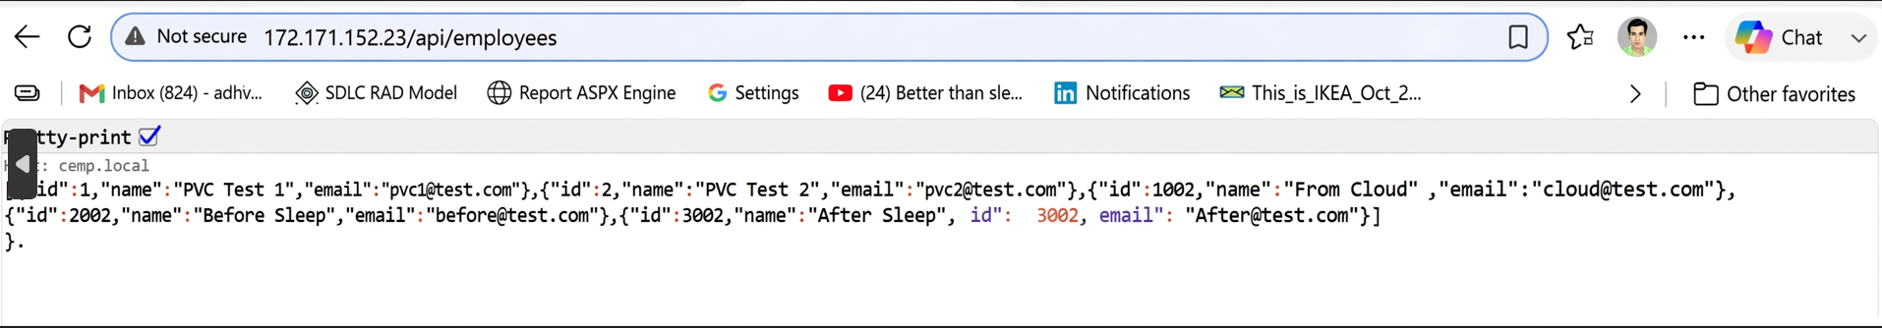

Screenshot 2: local-kind-ingress cemp.local:8080 working
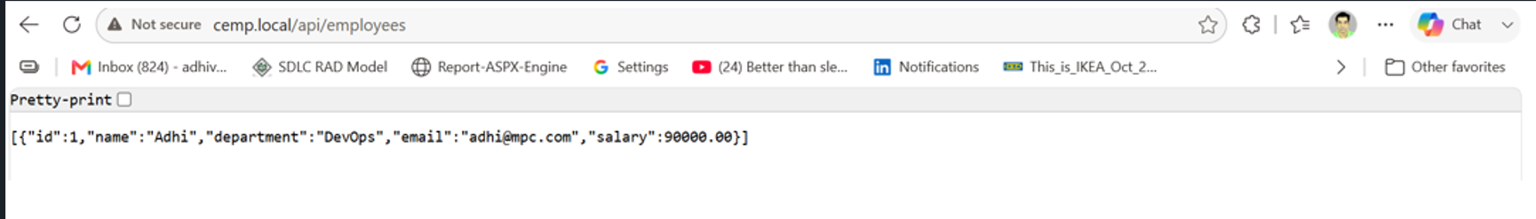

2. PROJECT STRUCTURE
This repo contains 2 deployment approaches: Manual Kustomize & Helm Templated
Without Helm - Manual Kustomize (k8s/aks-new/ & k8s/overlays/)
k8s/
├── base/ # Common base manifests
├── overlays/
│ ├── local/ # Kind local - 1 replica, hostPort 8080
│ │ ├── kustomization.yaml # - ../../base + ingress.yaml
│ │ ├── ingress.yaml # cemp.local -> cemp-api-service:80
│ │ └── patches/
│ ├── dev/ # DEV: 1 replica, dev image, debug
│ └── prod/ # PROD: 3 replicas, v16, high resources
└── aks-new/ # AKS direct manifests
├── 00-namespace.yaml # ROOT - creates 'cemp' namespace
├── 01-configmap.yaml # App config (env variables)
├── 02-secret.yaml # DB credentials
├── 03-deployment.yaml # cemp-api (uses 01 + 02, DB_SERVER=mssql-service)
├── 04-service.yaml # Exposes 03-deployment
├── 05-ingress-aks.yaml # Routes to 04-service (host: cemp.local)
├── 06-pvc.yaml # Persistent Volume for SQL - 10Gi
├── 07-sql-deployment.yaml # MSSQL (needs 06-pvc)
└── 08-sql-service.yaml # mssql-service:1433

With Helm - Templated Approach (cemp-chart/)
cemp-chart/
├── Chart.yaml # Chart metadata v0.1.0
├── values.yaml # ACTIVE - Single source of truth
├── .helmignore # Excludes docker/, charts/
└── templates/
├── deployment.yaml # Uses {{ .Values.image.repository }}:{{ .Values.image.tag }}
├── service.yaml # Uses {{ .Values.service.type }}
└── ingress.yaml # Uses {{ .Values.ingress.host }}

helm/acs-old/ # Archived - Old-values.yaml backup for rollback reference
[INSERT IMAGE HERE - Screenshot 3: 03-project-structure-comparison.png]
3. YAML ROOT & RELATIONS - DEPENDENCY FLOW
00-namespace → 01-configmap + 02-secret + 06-pvc → 03-deployment & 07-sql-deployment → 04-service & 08-sql-service → 05-ingress
Detailed Relations:
1. 03-deployment.yaml uses 01-configmap + 02-secret (envFrom)
2. 03-deployment.yaml depends on 08-sql-service.yaml (DB_SERVER=mssql-service:1433)
3. 04-service.yaml exposes 03-deployment.yaml (selector: app=cemp-api)
4. 05-ingress.yaml routes to 04-service.yaml (backend service)
5. 06-pvc.yaml provides storage for 07-sql-deployment.yaml (volume mount)
6. 07-sql-deployment.yaml is exposed by 08-sql-service.yaml

Screenshot 4: 04-yaml-root-dependency-flow.png
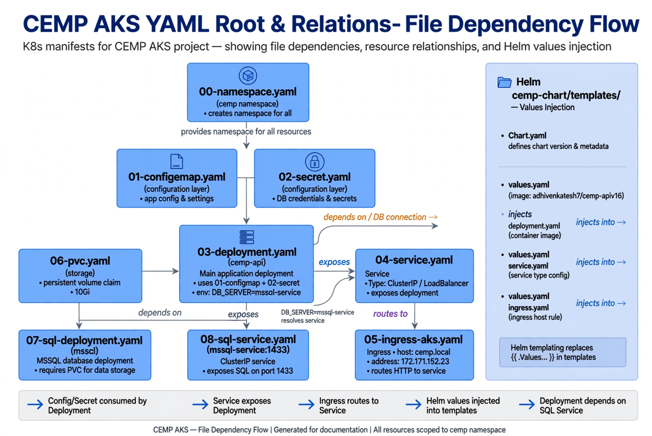
4. WITHOUT HELM VS WITH HELM - COMPARISON

Feature | Without Helm (Kustomize) | With Helm (Templated)
Config | Multiple YAML files | Single values.yaml
Templating | Manual patches, overlays | Go templating {{ .Values }}
Rollout | kubectl apply -k overlays/prod | helm upgrade --set image.tag=v17
Rollback | Manual kubectl apply previous | helm rollback 1
History | No history tracking | helm history
Scalability | Copy-paste YAML | Change values.yaml only
Best For | Learning, small projects | Production, large teams

Recommendation: Use Helm for production due to rollback & history.

5. HELM FLOW - values.yaml to TEMPLATES
Step 1 - Edit values.yaml:
image:
repository: adhivenkatesh7/cemp-api
tag: v16
service:
type: ClusterIP
ingress:
host: cemp.local

Step 2 - Go templating in templates/deployment.yaml:
image: {{ .Values.image.repository }}:{{ .Values.image.tag }}
→ Renders to: adhivenkatesh7/cemp-api:v16
Step 3 - Helm Engine renders final K8s manifests
Step 4 - Deploys to AKS
Screenshot 5: 01-helm-chart-flow.png
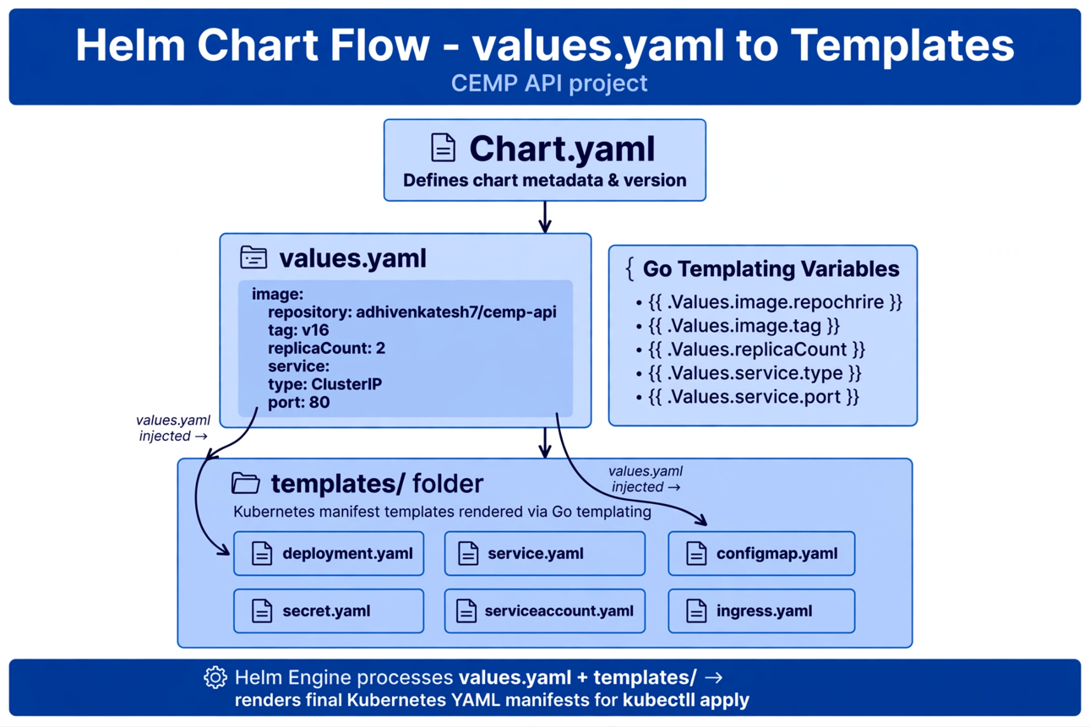

6. KUSTOMIZE OVERLAYS & HELM VALUES - 2 USE CASES
Dev Overlay (k8s/overlays/dev/kustomization.yaml):
- 1 replica
- dev image tag
- debug logs, lower resources
- dev DB
Command: kubectl apply -k k8s/overlays/dev

Prod Overlay (k8s/overlays/prod/kustomization.yaml):
- 3 replicas
- v16 image
- high resources, TLS, PVC
Command: kubectl apply -k k8s/overlays/prod

Local Overlay (k8s/overlays/local/kustomization.yaml) - NEW:
- Kind with ingress
- hostPort 8080/8443
- cemp.local host
Command: kubectl apply -k k8s/overlays/local

Helm Values:
- helm/acs-old/Old-values.yaml: Legacy backup, rollback reference. Not actively deployed.
- cemp-chart/values.yaml (ACTIVE): Single source of truth, templated via {{ .Values }}.
- .helmignore: Like .gitignore - excludes docker/, charts/, legacy when helm package.

Screenshot 6: 05-kustomize-overlays-use-cases.png
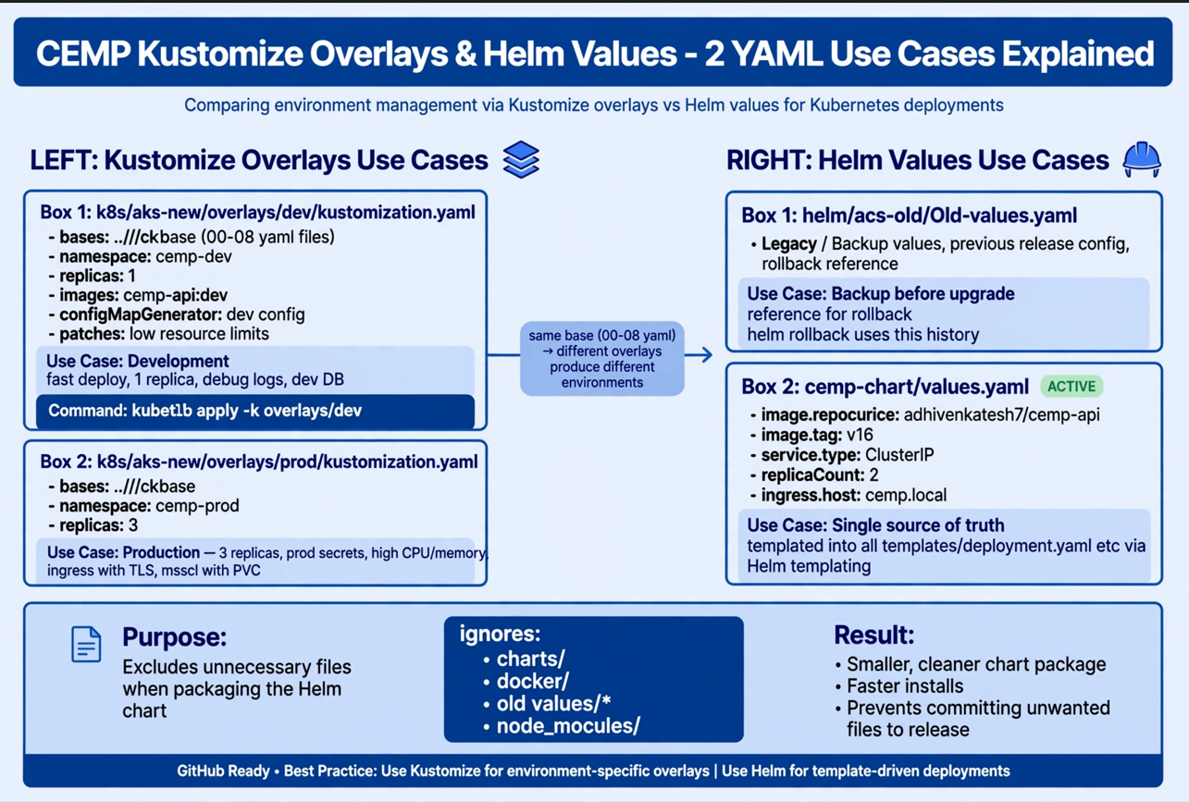

7. KIND-CONFIG.YAML - LOCAL CLUSTER WITH INGRESS PORTS
kind: Cluster
apiVersion: kind.x-k8s.io/v1alpha4
nodes:
- role: control-plane
extraPortMappings:
- containerPort: 80
hostPort: 8080
protocol: TCP
- containerPort: 443
hostPort: 8443
protocol: TCP

Key Fix: extraPortMappings allows direct http://cemp.local:8080 access without kubectl port-forward.
Previous error was due to TAB character and wrong indent - fixed by using 2 spaces indent.

8. LOCAL DEVELOPMENT STEPS (KIND) - FINAL WORKING
# 1. Create cluster
kind delete cluster --name cemp
kind create cluster --name cemp --config kind-config.yaml
# 2. Install NGINX Ingress for Kind
kubectl apply -f https://raw.githubusercontent.com/kubernetes/ingress-nginx/main/deploy/static/provider/kind/deploy.yaml
kubectl wait --namespace ingress-nginx --for=condition=ready pod --selector=app.kubernetes.io/component=controller --timeout=120s
# 3. Add host entry (Run as Admin)
notepad C:\Windows\System32\drivers\etc\hosts
Add: 127.0.0.1 cemp.local
# 4. Deploy
kubectl apply -k k8s/overlays/local
kubectl get pods -n cemp-local -w

# 5. Access - NO port-forward needed!
curl http://cemp.local:8080/api/employees -UseBasicParsing
Start http://cemp.local:8080/swagger in browser

9. ROLLOUT, ROLLBACK & HISTORY
# Current Release
helm list -n cemp
# NAME REVISION STATUS CHART
# cemp-release 3 deployed cemp-chart-0.1.0

# Upgrade to new version (Rollout)
helm upgrade cemp-release ./cemp-chart -n cemp --set image.tag=v17 --set service.type=ClusterIP

# Watch rollout
kubectl rollout status deployment/cemp-release-cemp-chart -n cemp
kubectl get pods -n cemp -w

# Check history (Previous & New)
helm history cemp-release -n cemp
# REVISION 1 superseded (v16) - Previous
# REVISION 2 deployed (v17) - New
# REVISION 3 deployed (rollback to v16)

# Rollback to previous
helm rollback cemp-release 1 -n cemp

# Verify
kubectl get pods -n cemp
curl http://74.235.37.70/api/employees

Note: v17 image doesn't exist on DockerHub (only v16), so pod shows ImagePullBackOff - expected for demo. Use v16 for final.

# Completion Details
$ helm list -n cemp
NAME NAMESPACE REVISION STATUS CHART APP VERSION
cemp-release cemp 3 deployed cemp-chart-0.1.0 1.16.0

$ kubectl get ingress -n cemp
NAME CLASS HOSTS ADDRESS PORTS AGE
cemp-ingress nginx cemp.local 172.171.152.23 80 16m

10. DEPLOY AKS
# Manual
kubectl apply -f k8s/aks-new/00-namespace.yaml
kubectl apply -f k8s/aks-new/

# Or with Kustomize
kubectl apply -k k8s/aks-new/overlays/prod

# Or with Helm (Recommended)
helm install cemp-release ./cemp-chart -n cemp --create-namespace

# Verify
kubectl get pods -n cemp
kubectl get svc -n cemp
kubectl get ingress -n cemp

© CEMP AKS • Built with .NET 9, AKS, Helm 3, NGINX Ingress, Kind
Author: Adhi | Final - v16-final-dual-db | Date: Sep 2026
Recommendation: Use Helm for scalability & rollback, Kustomize for overlays

