pip install fastapi uvicorn

[ Web Browser User Interface ]
│
▼ (Served from Local AWS S3 via Floci on Port 4566)
[ http://localhost:4566/employee-dashboard/index.html ]
│
▼ (Secure REST AJAX calls via Native JS)
[ FastAPI Backend API Engine on Port 8000 ]
│
▼ (Server-Side Schema & Regex Input Sanitization)
[ Pydantic v2 Model Verification Layer ]
│
▼ (pyodbc Driver Communication Layer)
[ Relational Engine: MS SQL Server LocalDB Instance ]

SERVICE SIDE PYTHON FILE app.py
CLIENT-SIDE FILE app.html

FLOCI SETUP
- Locally run the docker
- floci start
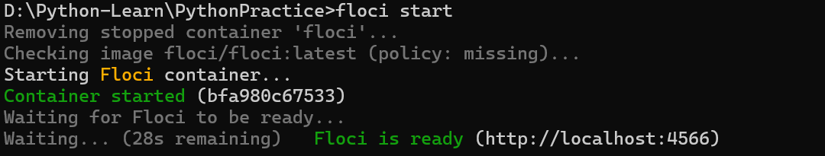

Step 2:
Provision S3 Storage Buckets via AWS CLI
aws s3 mb s3://employee-dashboard --endpoint-url=http://localhost:4566 --region us-east-1
Copy the app.html file right into Floci's emulated storage block:
aws s3 cp app.html s3://employee-dashboard/index.html --endpoint-url=http://localhost:4566
Check in the browser
http://localhost:4566/employee-dashboard/index.html
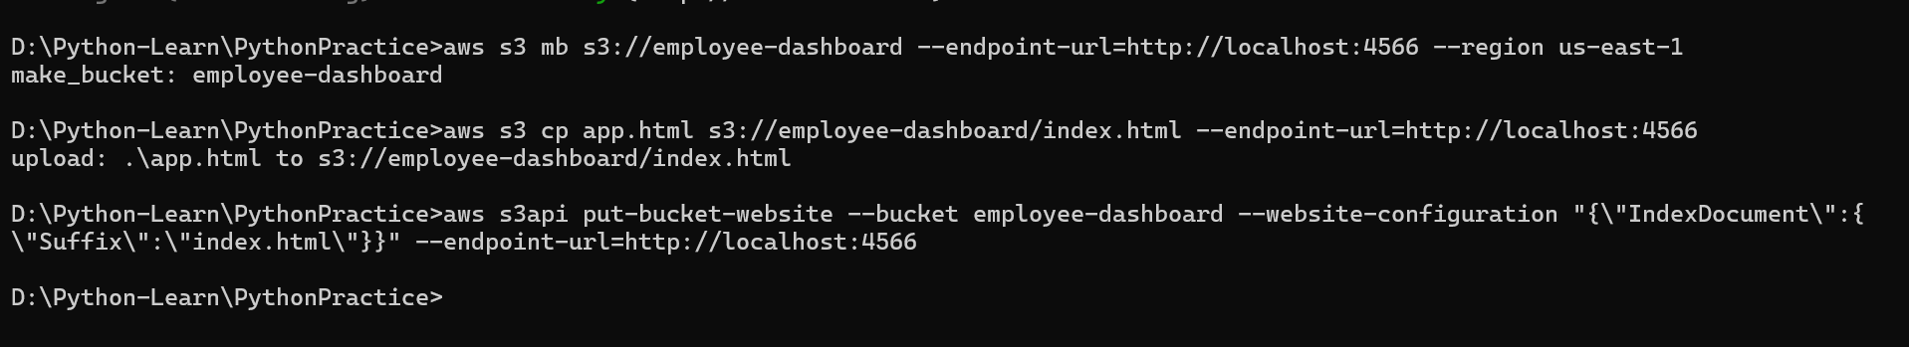
Security & Maintenance Checklists
Primary Key Locks: Ensure that during edit transitions, the UI script invokes .disabled = true on the empcode field to preserve relational consistency.
XSS Neutralization: The @field_validator regex function safely catches and strips structural symbols (<...?>), stripping malicious javascript vectors before they can be saved to SQL.
CORS Realignment: When executing public production builds on real cloud instances, restrict the allow_origins=["*"] to your exact hosting domain layout to harden endpoints.

To deploy floci-azure
pip install sqlalchemy

floci az start

Introuducing yaml file docker-compose.yml

AWS CLOUD DEPLOYMENT
aws ecr get-login-password --region us-east-1 | docker login --username AWS --password-stdin 355033546958.dkr.ecr.us-east-1.amazonaws.com
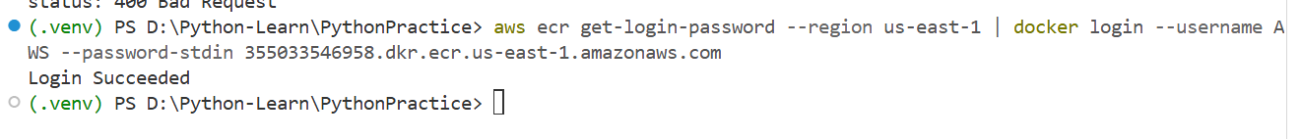
Step 1 docker build -t python-cloud-api:latest .
Step 2 docker tag api:latest ://amazonaws.com

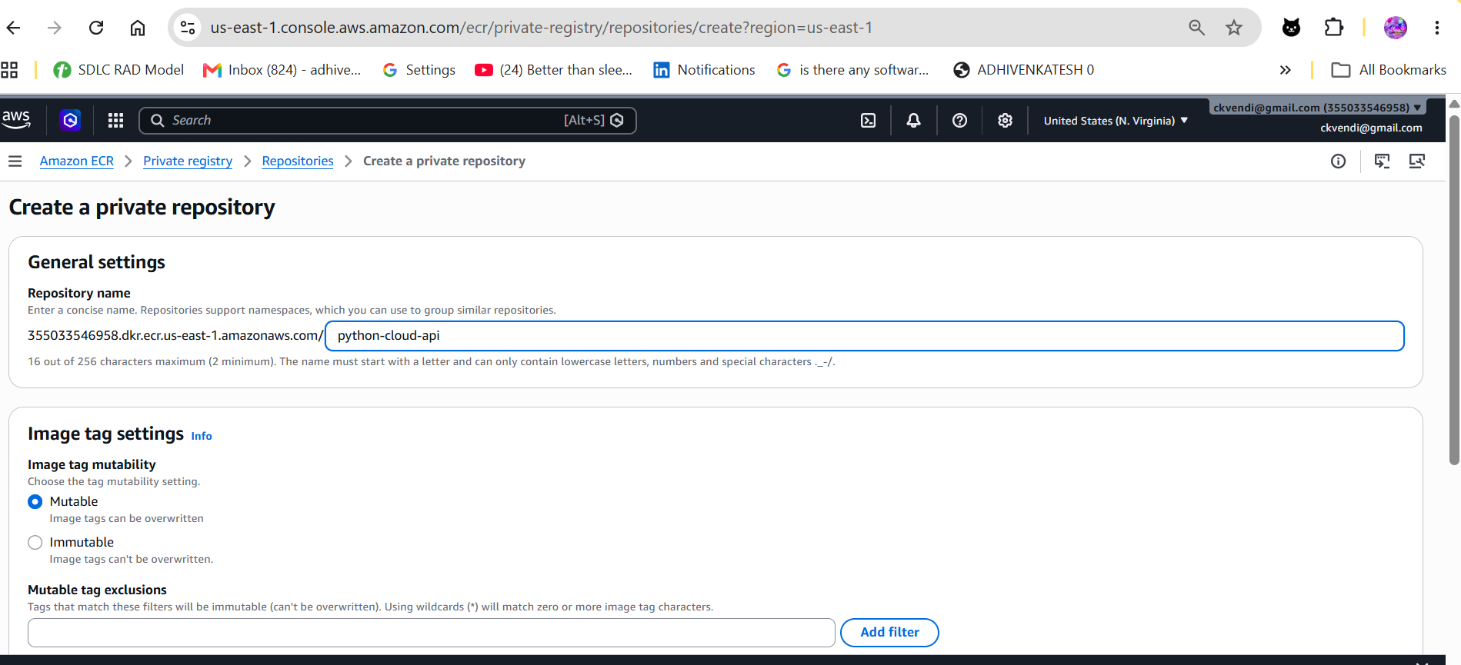
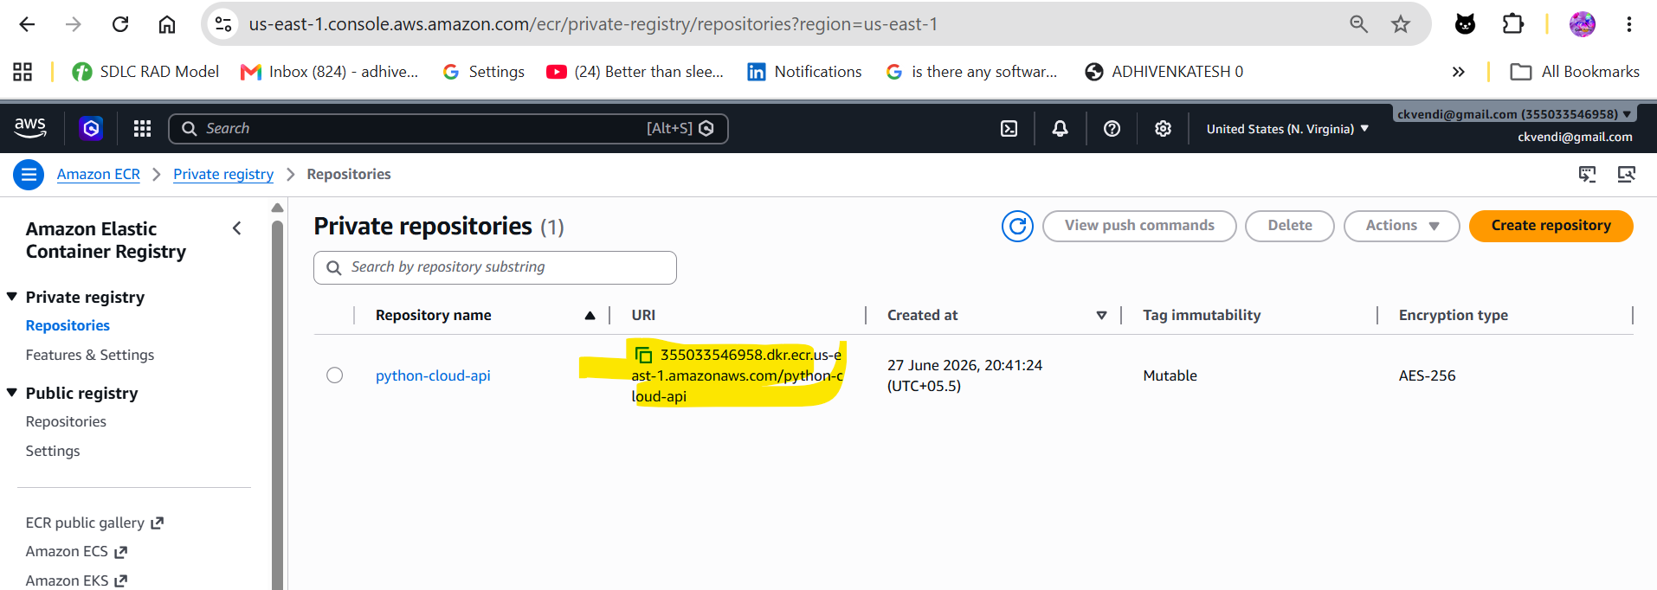

Hre .. docker URI has been copied
Next step 1
docker tag python-cloud-api:latest 355033546958.dkr.ecr.us-east-1.amazonaws.com/python-cloud-api
sTep 2
docker push 355033546958.dkr.ecr.us-east-1.amazonaws.com/python-cloud-api

