
Healthcare Management System Database Design and Implementation

Student Name:
Student ID:

Submission Date:

Table of Contents
1. Introduction 4
2. Objectives 4
3. System Description 5
4. Database Design (EERD Explanation) 5
5. Table Structure (Schema Description) 7
6. Sample Data Insertion 9
7. Important Queries and Outputs 10
8. Advanced Features 17
9. Results and Analysis 19
10. Conclusion 21
11. Future Scope 21
References 22
Appendix 24

List of Figures
Figure 1: EERD Diagram 6
Figure 2: Table Structure (Schema Description) 8
Figure 3: Sample Data Insertion 9
Figure 4: Display All Patients 10
Figure 5: Display All Doctors with Department 11
Figure 6: Appointment Details (Patient + Doctor) 12
Figure 7: Total Appointments per Doctor 12
Figure 8: Total Billing per Patient 13
Figure 9: Find Pending Payments 14
Figure 10: Medical Records with Doctor Details 14
Figure 11: Prescription Details for Patients 15
Figure 12: Total Revenue Generated 16
Figure 13: Update Payment Status 16
Figure 14: Search Patients by Name 17
Figure 15: Delete an Appointment 17
Figure 16: Patient Appointment View 18
Figure 17: Billing Summary View 19
Figure 18: STORED PROCEDURE (Reusable Logic) 20
Figure 19: STORED PROCEDURE (Reusable Logic) 20

1. Introduction
Healthcare Management System refers to a database structure that is aimed at handling hospital records in a systematic and effective manner. It contains data on patients, physicians, employees, appointment, medical history, prescriptions, billing, and payments. The system allows having all data in one and hence easy to access and handle. Healthcare systems deal with large amounts of data every day. Patient information, history of treatment, schedules, and financial information must be stored correctly and retrieved fast. A database can also manage this information effectively, lessen duplication, and offer consistency within various departments.
There are numerous issues with manual systems. Paper documents may be lost, damaged or misplaced. Locating information is time consuming and updating records is slow. There are frequent mistakes and interdepartmental communication becomes hard. The more the number of patients, the less reliable is the management of data manually. This system addresses these problems through automation of data management. It enables users to create patients, delegate doctors, appointments, store health record, prescriptions, and billing and payments. Data is also all interconnected, enhancing accuracy and facilitating a flow of work. The database management system was MySQL, which was used to develop the system. Tables, relationship definitions, data insertion, and queries were created using SQL. These solutions are a reliable and effective platform to handle healthcare data (Amna et al., 2023).

2. Objectives
The primary goal of the project is to create and develop and introduce a structured Healthcare Management System on the basis of relational database. The idea is to create a system that is capable of storing and handling hospital information in an effective and organized way. The system is concerned with the management of real-life healthcare operations and its integration between various parties, including patients, physicians, appointments, medical records, and billing. Among the objectives is to have accurate patient data by storing their personal and contact information in a centralized database. Scheduling and tracking of appointments between patients and doctors is another goal to achieve proper coordination of healthcare services. The system is also meant to keep a close medical history, diagnosis and treatment, which assists in keeping track of patient history.
Moreover, the system manages prescription information of drugs and aids in billing and payment processing. The database is a complete solution to both clinical and administrative operations in a healthcare setting by incorporating these functions (Chanda, 2024).

3. System Description
The Healthcare Management System functions through condensing and connecting information among various tables to aid existing operations in hospitals. Every operation within the system has a structured flow and this makes sure that the data is stored properly and can be extracted easily when required. The system links patients, physicians, appointments, medical records, prescriptions and financial transactions in a logical order.
It begins with the registration of a patient in the system. The patient is able to make an appointment with a doctor once he has been registered. This creates a link between the patient and the doctor through the Appointment table. Every appointment will keep the information about the date, time, and status that can be used to organize the schedules.
Following the appointment, the doctor will enter the diagnosis and treatment of the patient into the table Medical_Record. On the basis of this data, prescriptions are created and saved in the Prescription table containing medicine information, dosage, and time period. Financial data are also handled in the system. Once a patient has been consulted or treated, he or she is issued with a bill. This billing data is contained in the Billing table. The details of payment are entered in the Payment table when the patient makes a payment. Such an entire flow is used to ensure that medical and financial processes are appropriately tracked and linked to the system (Farooq, 2026).

4. Database Design (EERD Explanation)
The healthcare management system database design is determined by a structured EER database, which establishes all the entities and relationships. The design will avoid duplication of data and all components of the system are well connected. All of them are important constituents of the hospital activity.
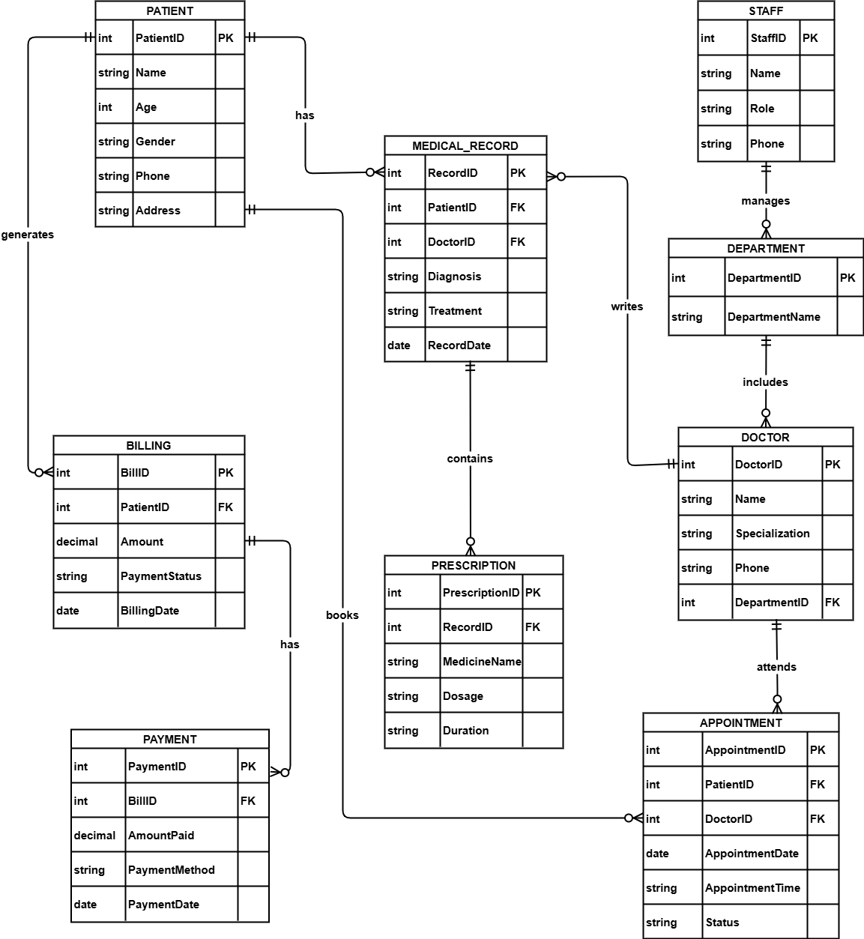
Figure 1: EERD Diagram
Personal information like name, age, gender, contact and address is kept in the Patient entity. The Doctor entity contains the details of the doctors, whether they are specialized or not and the department they are in. The Department entity represents various divisions of the hospital like cardiology or neurology. The Staff entity contains the information about non-doctor staff who facilitate the operations of the hospital and are associated with departments.
The Appointment entity is the mediator between the patients and the doctors. It records details of how a patient encounters a doctor and monitors the doctor visit status. The Medical_Record entity records the details of the diagnosis and treatment that occur following an appointment. This will make sure that the medical history of the individual patients is well documented. The Prescription entity is connected with the medical record and contains medicine information, dosage and timeframe (Gaikwad et al., 2024).
Billing entity captures the financial services offered to the patients. Payment details of payments made against those bills are stored at the Payment entity. The linkages among objects are well defined. A patient is able to make several appointments, and a doctor is able to make several appointments. The medical records are written by a doctor on behalf of a patient and each medical record may contain one or more prescriptions. A patient creates a billing record once the services are received, and every bill could be associated with payment information. This design provides rational flow of data and the strong ties between the entire components of the system.

5. Table Structure (Schema Description)
The database is composed of several tables which are meant to accommodate particular information and have clear relationships among various aspects of the healthcare system. Every table has its purpose and structure.
Patient table contains personal information of name, age, gender, phone number, and address. It is the principal agent because all medical and financial processes are connected with patients. The Doctor table contains the details of the doctors, such as their name, specialization, contact details and department that they are in. The Department table is a table which represents various hospital units, including cardiology, neurology, and orthopedics and assists in organizing physicians and personnel.
The Staff table contains the data about staff members of the hospital that are not physicians, including nurses, technicians, and administrative staff. Every employee is attached to a department and this assists in the management of roles and duties.
The Appointment table relates the patients and doctors. It contains the date of appointment, time of appointment and appointment status which aids in the organization and monitoring of visits. The Medical_Record table is a table that records the diagnosis and treatment information that doctors enter at the conclusion of an appointment. This is to guarantee that the medical history of every patient is taken care of (K.Nishanthan et al., 2022).
The Prescription table includes details of medicine including medicine name, dosage, and duration. It is connected to the medical record, which means that prescriptions are formulated on the basis of real diagnoses.
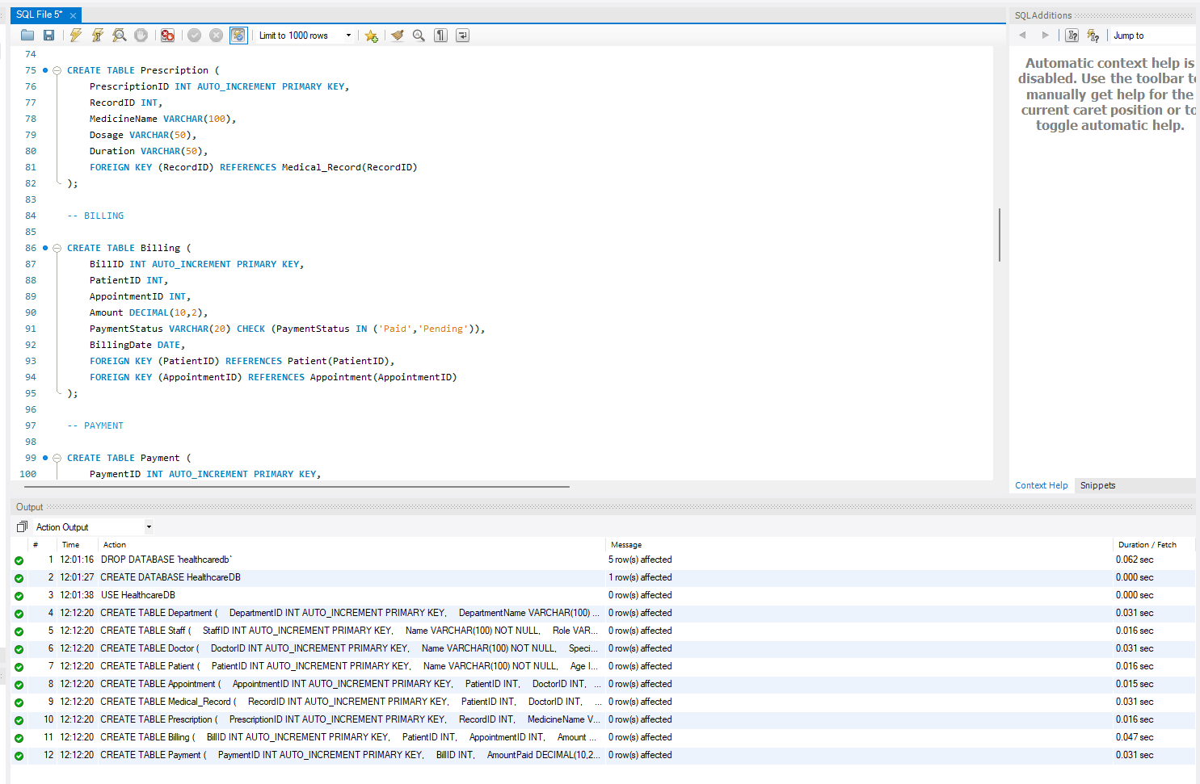
Figure 2: Table Structure (Schema Description)
The Billing table captures the cost of services offered to patients like consultation and treatment cost. Payment table contains information on payments made by patients such as date and method of payment. Collectively, the tables facilitate clinical and financial management in the system (Kumar Singu, 2024).

6. Sample Data Insertion
The database was populated with sample data to verify the functionality and all the tables and relationships were functioning properly. In the absence of sample data, one cannot check whether queries give meaningful results or whether the system is operating as expected. The data that is inserted assists in simulation of real hospital operations and enables appropriate testing of various scenarios.
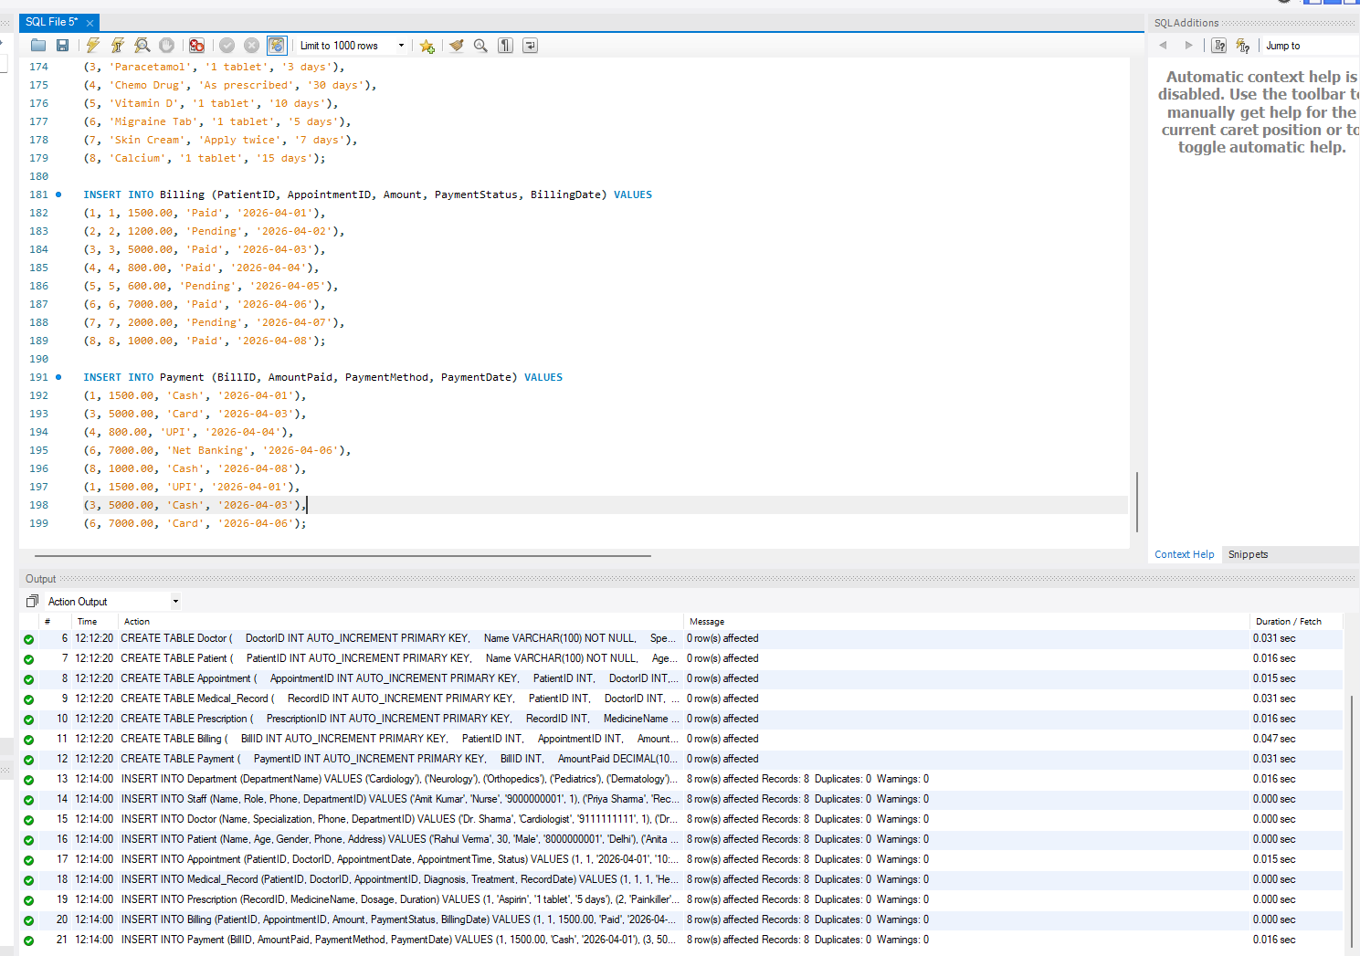
Figure 3: Sample Data Insertion
Tables within the system have approximately eight records, which is sufficient to do queries like joins, aggregation, and even filtering. The data values are realistic and represent reality of healthcare situations. Indicatively, the Patient table is filled with people having various names, ages, genders, and places. The Hospital doctor table contains various doctors of various specializations in various departments.
Cases are also diverse in the dataset. Appointments will be made in various dates with various statuses like completed and pending. In medical records, various diagnoses and treatments are provided, including simple cases, to more severe. Prescription information entails various medicines, dosage and periods (Lee et al., 2023).
Billing records indicate amount of charges depending on the type of treatment and payment records indicate the various methods of payment. This diversity will provide the system with the ability to address various real-life situations and facilitate the right testing of all database operations.

7. Important Queries and Outputs
Healthcare Management System was tested with a large number of SQL queries that illustrate the fundamental features of the database. These queries involve data retrieval queries, joins queries, aggregation queries, filtering queries, updating queries and deletion queries. The outputs assure that the system is functioning properly and the tables are all related to each other. All queries represent a real situation in a hospital and demonstrate how the system facilitates clinical and administrative activities.
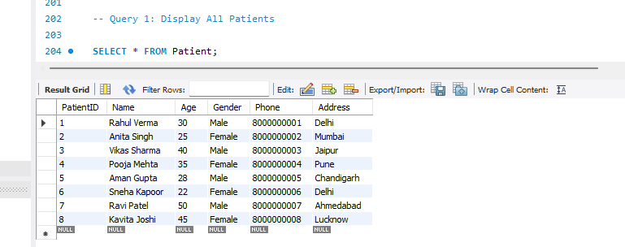
Figure 4: Display All Patients
Query 1 gets all the records of Patient table. The output contains eight patients with complete personal data including name, age, gender, phone number and address. The fact that there are various age groups and locations means that the system has the capacity to store a variety of patient data. This query verifies that the Patient table is well formatted and that all records that have been inserted can be accessed without errors. It is also the basis of other operations, as the whole activity in the system is dependent on patient data (Lee et al., 2024).
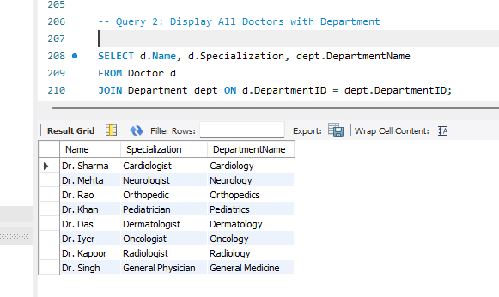
Figure 5: Display All Doctors with Department
Query 2 shows the details of doctors including the department of the doctor. This is through the joining of the Doctor and Department tables with the use of a foreign key. The output will indicate the name of each doctor, his or her specialization, and the name of the department. The outcome validates the fact that every physician is properly placed in a department, like cardiology, neurology, or orthopedics. The query can be used to gain insight into the organization of hospitals and to direct patients to the appropriate specialist. It also proves that normalization has been used, as the data in the department table has not been duplicated in the Doctor table.
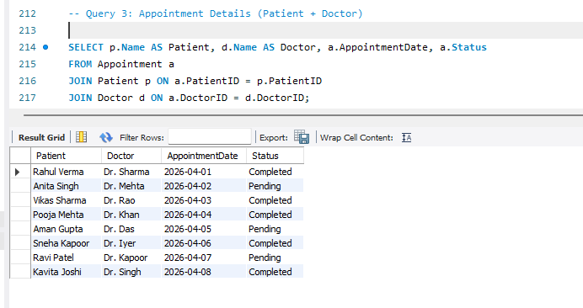
Figure 6: Appointment Details (Patient + Doctor)
Query 3 shows individual appointment information which is a combination of Patient, Doctor and Appointment tables. The output contains the names of the patients, the names of the doctors, the date of appointments, and the status of the appointments which can be completed or pending. This question is the essence of how the system works wherein patients communicate with doctors in pre-scheduled appointments. The findings demonstrate that every appointment is correctly documented and associated with patients and physicians. This substantiates that the relationships of foreign keys are working properly and that information integrity is held among tables (Li et al., 2023).
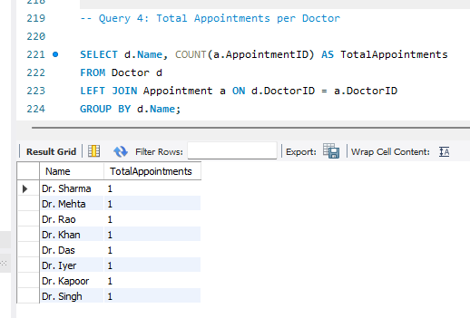
Figure 7: Total Appointments per Doctor
In Query 4, the number of appointments per doctor is computed with the help of the COUNT function and GROUP BY. The output indicates that every doctor has a single appointment, and this has a reflection of the well-balanced sample data. The query is significant as it shows how to use aggregation functions that are necessary to analyze data. This query would assist in the scheduling decision and also assist in the measurement of doctor workload in a real hospital. Left join is used to make sure that doctors who have no appointments would still be present in the result making the query more complete (Ruf, Greten and Korangy, 2023).
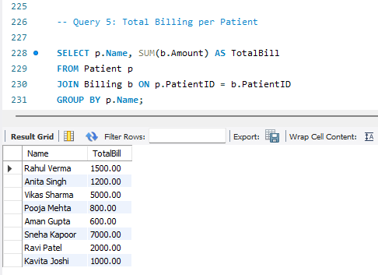
Figure 8: Total Billing per Patient
Question 5 sums up the total billing of every patient and the results are calculated using the SUM function. The billing amount is different in the output, and this depends upon the kind of treatment obtained. As an example, patients with complicated treatments have larger bills, whereas patients with simple consultations have lower bills. Such inconsistency makes the data set real and it proves that the system can process financial data successfully. The query will ensure that billing table is properly connected with the Patient table and financial calculations are correct.
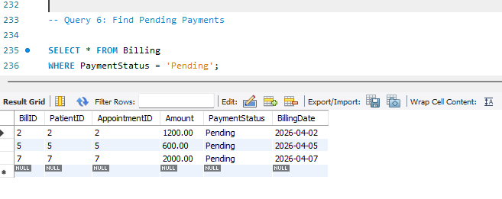
Figure 9: Find Pending Payments
The Query 6 involves the identification of pending payments by filtering the billing records with a payment status of pending. The output indicates three bills that are unpaid and this could facilitate the monitoring of payments that have not been made. This query is applicable to the hospital administration since the staff can know the patients who failed to pay. It further demonstrates that the system enables the process of filtering operations which are necessary in retrieving particular information in huge datasets.
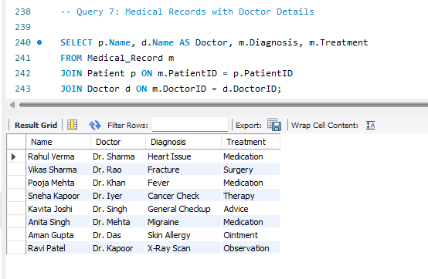
Figure 10: Medical Records with Doctor Details
Query 7 displays medical records along with doctor details. It displays patient names, doctor name, and diagnosis and treatment details. The product is a variety of medical cases including heart problems, fractures, fever, and general checkups. This confirms that the Medical_Record table is functioning well and that it contains significant clinical data. The query also shows that medical records are well connected with patients as well as doctors and this is vital in ensuring that patient history remains accurate.
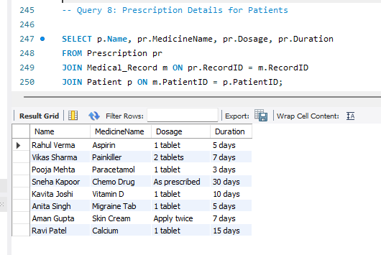
Figure 11: Prescription Details for Patients
The eighth query will be used to retrieve the prescription information of patients by combining the Prescription and Medical_Record tables. The output will include medicines, dosage, and time of each patient. The data contains various prescriptions, both short-term and long-term medications. This query will ensure that the prescription information is properly saved and connected with the medical records. It also brings to light the fact that the system is capable of handling specific treatment details.
The 9th query is the total revenue generated by the hospital calculated by the use of SUM in the billing table. The output presents the total revenue of 19100 which is equivalent to the total sum of all billing records. This proves the financial information to be consistent and accurate. This query is significant to the management since it gives a brief summary of the hospital income and assists in decision-making.
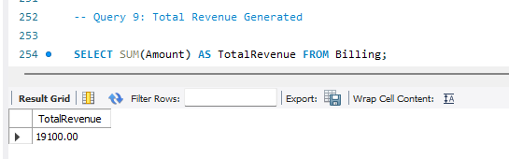
Figure 12: Total Revenue Generated
Query 10 changes the payment status of a bill. This output indicates that a single row was updated, and this proves that the update operation was successful. This is to show that the system allows modification of data and is capable of dealing with real-time. In actual situation, this would be a sign of a patient paying.
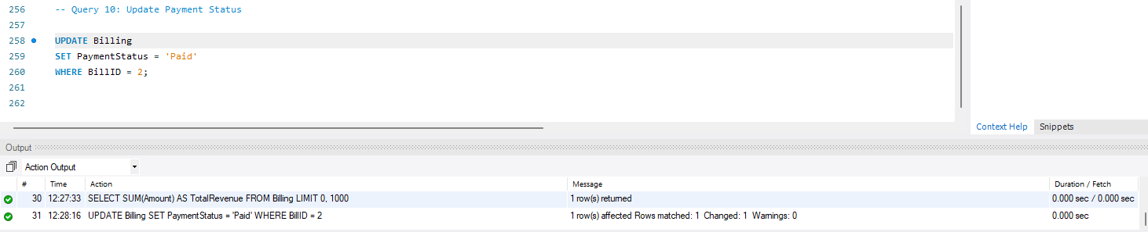
Figure 13: Update Payment Status
The query 11 is a search of patients based on pattern matching and uses the LIKE operator. The output presents the patients with names beginning with a particular letter. This query also exhibits flexible data retrieval and can be utilized when full details are not known and can be used in a quick search.
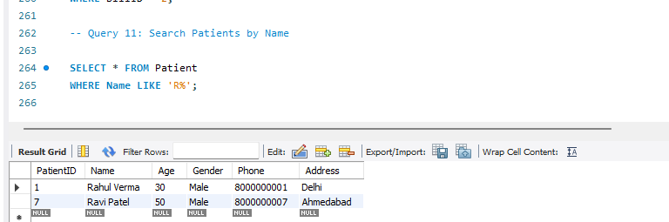
Figure 14: Search Patients by Name
Query 12 attempts to delete an appointment record. As indicated in the output, nothing was changed in terms of output, as there was no record with the specified record. This ascertains that the system is safe when it comes to doing delete operations to remove invalid data.
On the whole, these queries show that the database is operational, resilient, and can be used to facilitate actual healthcare activities.
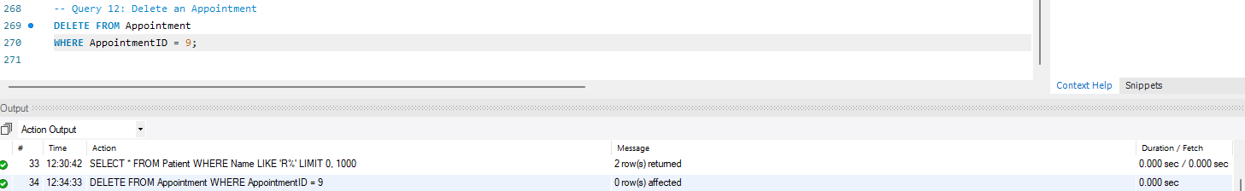
Figure 15: Delete an Appointment

8. Advanced Features
The database has a number of superior features that enhance performance, reduce querying, and automation.
Search speed and query performance are enhanced with the help of indexes. Fields like patient name and date of appointment were indexed. When filtering or searching data, these indexes assist in deleting records in lesser time, particularly when the data set is large.
Views are applied to complex queries to simplify them by caching commonly-used joins in virtual tables. The Patient-Appointment-View integrates the details of the patient, doctor and appointment into one view where all the details of the appointments can be viewed easily. The
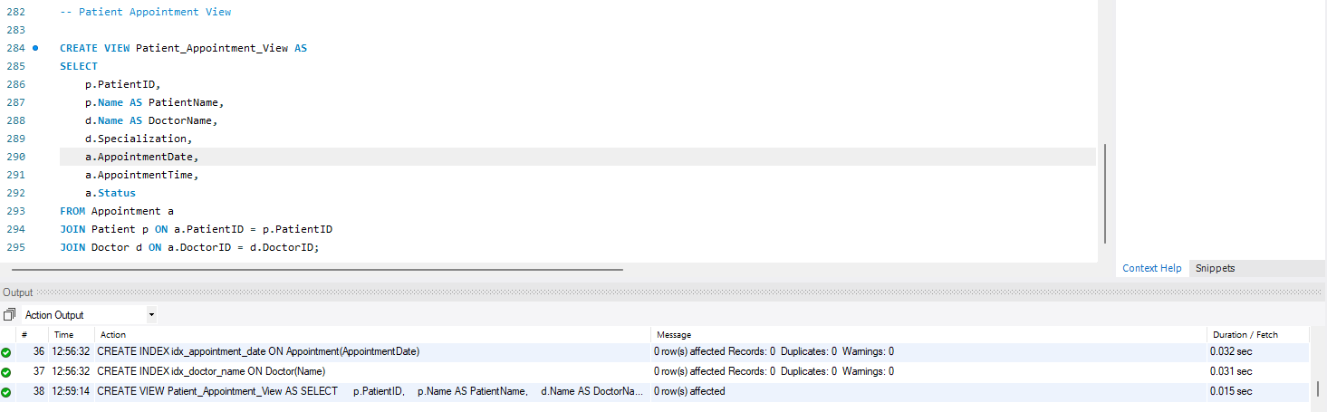
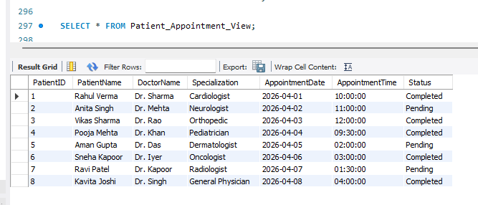
Figure 16: Patient Appointment View
Billing Summary View is used to give a simplified perspective of the billing data of patients, thus, aiding in the financial reporting without the need to write repeated join queries.
A stored procedure called GetPatientBills had been developed to give query logic that would be reused. It enables users to call all the billing records of a given patient by inputting the patient ID as an input parameter. This will save the process of having to rewrite the same query several times (Tarbell et al., 2023).
Automatic updates in the system were also introduced through a trigger. Upon the insertion of a new payment in the Payment table, the trigger will automatically change the billing status of the same to that of Paid. This would be used to guarantee data consistency and the lessening of manual effort in record maintenance.
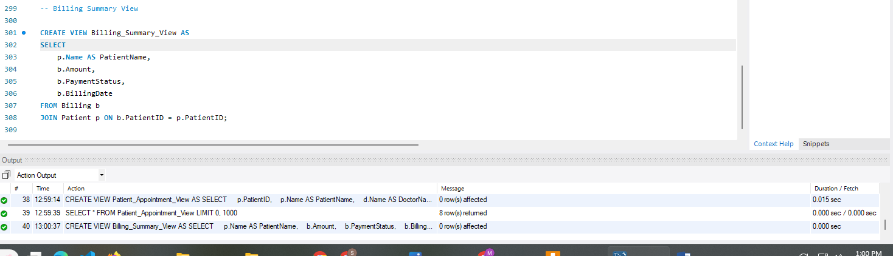
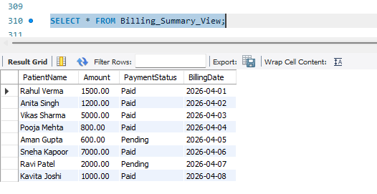
Figure 17: Billing Summary View

9. Results and Analysis
The findings indicate that the Healthcare Management System is functionally correct and facilitates all the major operations. The tables are linked using appropriate relationships and the resultant confirms that the data flow in and out of the patients, doctors, appointments, medical records, prescriptions, billing, and payments are correct. Foreign keys are used to verify the validity of every record and the consistency of related information within the system. The queries generate significant output that is based on real hospital events. The query of appointment reveals that there is the correct tracking of patient visits with doctor appointments and status updates. The query of medical records and prescriptions makes sure that the information on diagnosis and treatment remains in place. There are also clear insights in financial queries. The accumulated revenue that is given by the system is 19100 which is an equivalent of all the billing records and proves consistency of data.
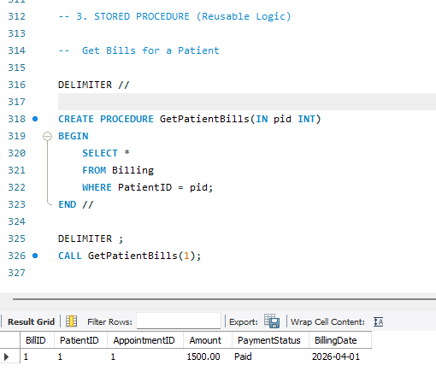
Figure 18: STORED PROCEDURE (Reusable Logic)
The system will also be used to identify the unpaid bills and the staff will be able to monitor the bills and act accordingly. This helps in financial management and enhances efficiency in the administration. On the whole, the outputs show that the database is trustworthy, well-organized, and can be used to facilitate the real healthcare processes in a real setting.
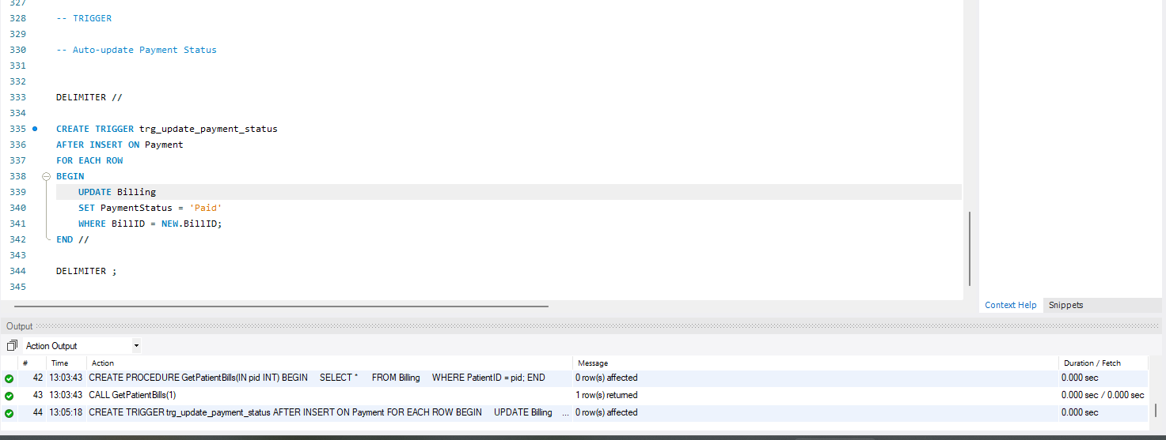
Figure 19: STORED PROCEDURE (Reusable Logic)

10. Conclusion
The database of the Healthcare Management System was designed and implemented successfully to handle the hospital data in a systematic and effective manner. The system helps to combine the essential elements of patients, doctors, appointments, medical records, prescriptions, billing and payments into one relational database. All the components are interrelated by clear relationships, therefore, ensuring the data flow and consistency.
The database enhances efficiency since it enables rapid entry, retrieval and updating of data. It minimizes mistakes through implementation of constraints and proper correctness of connections among tables. Such activities as tracking of appointments, recording of treatment, and billing management can be managed in a systematic way without repetition and misunderstanding (Tishan, 2021).
Decision making is also supported by the system as it gives meaningful outputs in terms of queries. The data on the total revenue, the pending payments and the details of the appointments can be used in the planning and administration. Comprehensively, the database is a credible option in the management of healthcare operations at an effective level.

11. Future Scope
The system may be expanded by including a user login option to control the access and manage the roles of an administrator, a doctor, and a staff. A reporting and dashboard application can be created, which will offer graphical data such as the trend of revenue, number of appointments, and patient figures. A web or mobile application can also be linked to the database, and this facilitates real-time access by the users and enhances usability. Sensitive patient information can be secured with security features like data encryption, authentication and access control. These are some of the improvements that will ensure that the system becomes more scalable, secure and more appropriate to real-world healthcare settings.

References
Amna, D., Memon, F.A., Memon, F., Halepoto, I.A. and Bhangwar, A.R. (2023). Database System for Medical Record Keeping and Retrieval. Journal of Applied Engineering & Technology (JAET), [online] 7(1), pp.93–104. doi:https://doi.org/10.55447/jaet.07.01.101.
Chanda, N.D. (2024). Improving Healthcare Efficiency with Data Analytics : A Case Study on SQL-Based Patient Information Systems. International Journal of Scientific Research in Computer Science Engineering and Information Technology, [online] 10(4), pp.346–348. doi:https://doi.org/10.32628/cseit2436477.
Farooq, A. (2026). Use of Database Systems in Pharmacy and Healthcare Management. [online] doi:https://doi.org/10.20944/preprints202604.0012.v1.
Gaikwad, G., Mahamuni, C.V., Kadam, R. and Pandita, S. (2024). Smart Hospital Management System: Streamlining Healthcare Operations with SQL Integration. Journal of Trends in Computer Science and Smart Technology, [online] 6(2), pp.112–124. doi:https://doi.org/10.36548/jtcsst.2024.2.002.
K.Nishanthan, S.Mathyvathana, R.Priyanthi, A.Thusara, D.I. De Silva and Dulanji Cooray (2022). The Hospital Management System. International Journal of Engineering and Management Research, [online] 12(5), pp.135–149. doi:https://doi.org/10.31033/ijemr.12.5.17.
Kumar Singu, S. (2024). Transforming Healthcare Data Management with NoSQL: A New Era of Scalability and Efficiency. International Journal of Science and Research (IJSR), [online] 13(10), pp.216–220. doi:https://doi.org/10.21275/es241003091413.
Lee, G., Hwang, H., Bae, S., Kwon, Y., Shin, W., Yang, S., Seo, M., Kim, J.-Y. and Choi, E. (2023). EHRSQL: A Practical Text-to-SQL Benchmark for Electronic Health Records. [online] arXiv.org. Available at: https://arxiv.org/abs/2301.07695 [Accessed 6 Apr. 2026].
Lee, G., Kweon, S., Bae, S. and Choi, E. (2024). Overview of the EHRSQL 2024 Shared Task on Reliable Text-to-SQL Modeling on Electronic Health Records. arXiv (Cornell University). [online] doi:https://doi.org/10.48550/arxiv.2405.06673.
Li, L., Zhou, Y., Tu, W., Luo, Y. and Lin, Z. (2023). Foreign Direct Investment Decision Making: Perceived Environment Uncertainty and Digital Capability. Academy of Management Proceedings, [online] 2023(1). doi:https://doi.org/10.5465/amproc.2023.17475abstract.
Ruf, B., Greten, T.F. and Korangy, F. (2023). Innate lymphoid cells and innate-like T cells in cancer — at the crossroads of innate and adaptive immunity. Nature Reviews Cancer. [online] doi:https://doi.org/10.1038/s41568-023-00562-w.
Tarbell, R., Choo, K.-K.R., Dietrich, G. and Rios, A. (2023). Towards Understanding the Generalization of Medical Text-to-SQL Models and Datasets. [online] arXiv.org. Available at: https://arxiv.org/abs/2303.12898 [Accessed 6 Apr. 2026].
Tishan, Y. (2021). Hospital Database Management. [online] doi:https://doi.org/10.13140/RG.2.2.26744.52484.

Appendix
GitHub Link:
https://github.com/adhixit09/Healthcare-Management-System-Database-Design-and-Implementation

