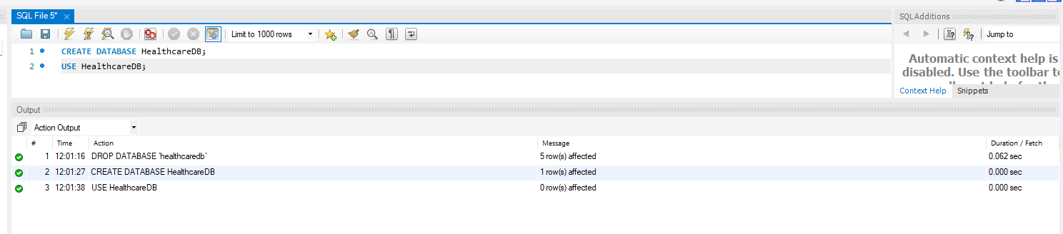
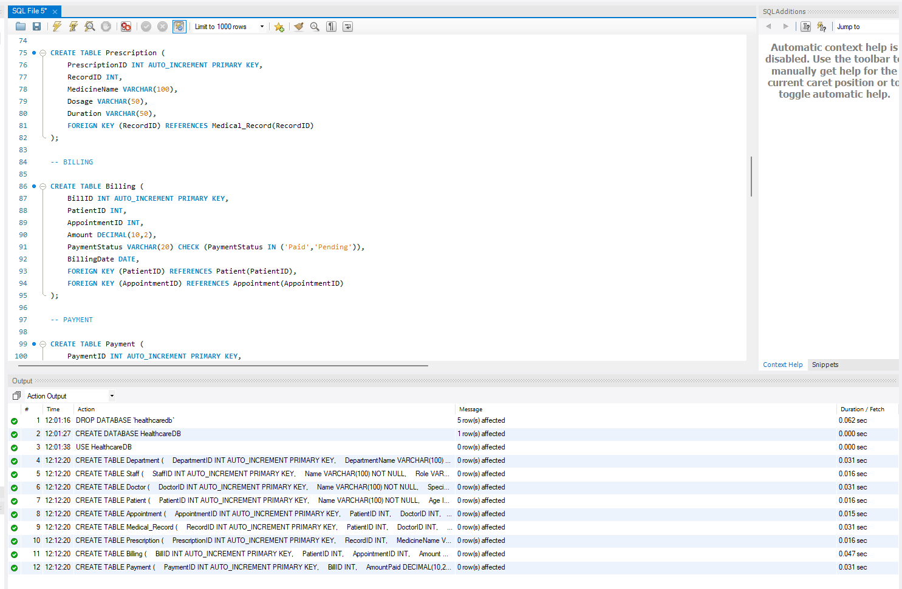
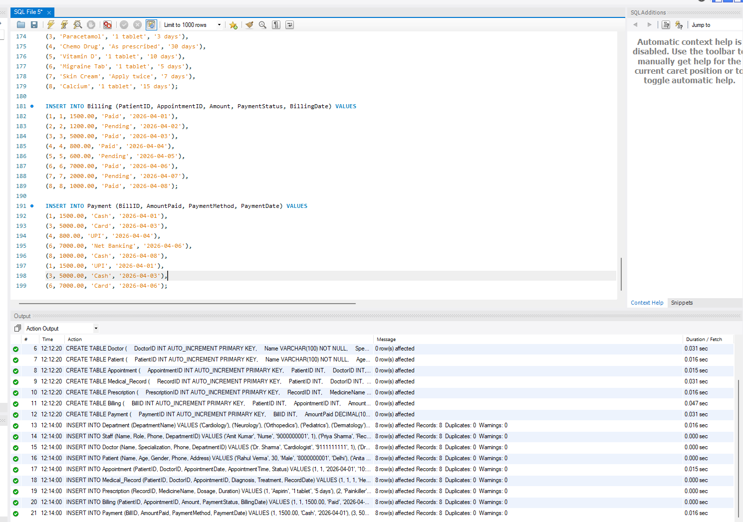

IMPORTANT QUERIES
Query 1: Display All Patients
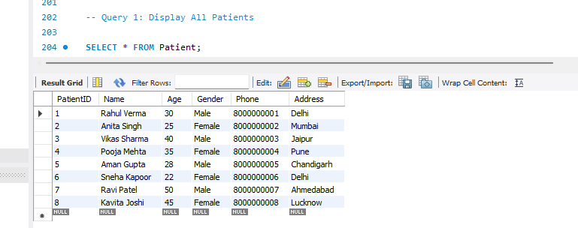
Query 2: Display All Doctors with Department
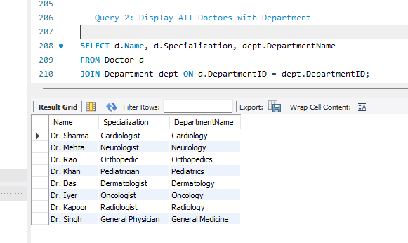
Query 3: Appointment Details (Patient + Doctor)
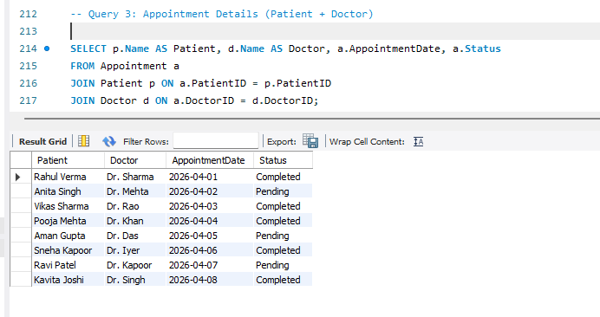
Query 4: Total Appointments per Doctor
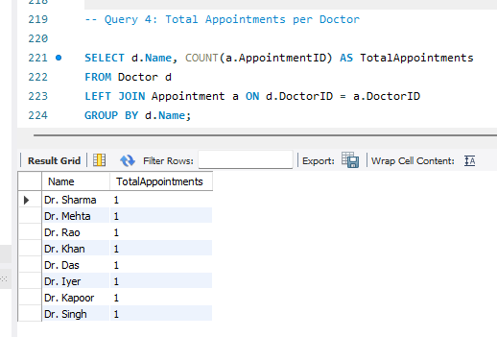
Query 5: Total Billing per Patient
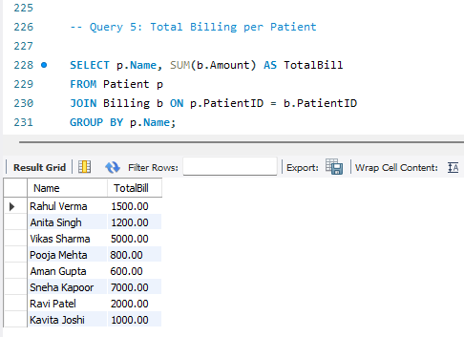
Query 6: Find Pending Payments

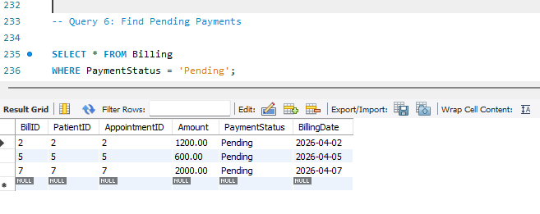
Query 7: Medical Records with Doctor Details
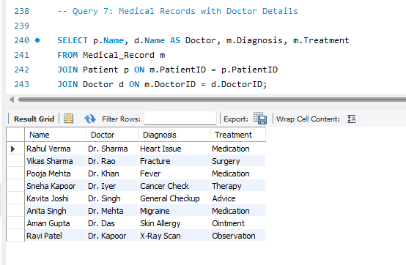
Query 8: Prescription Details for Patients
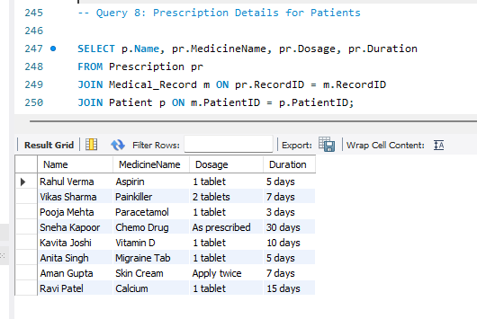
Query 9: Total Revenue Generated
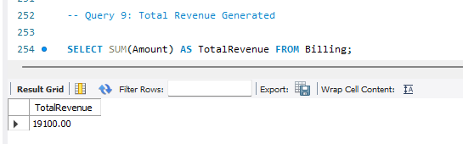
Query 10: Update Payment Status
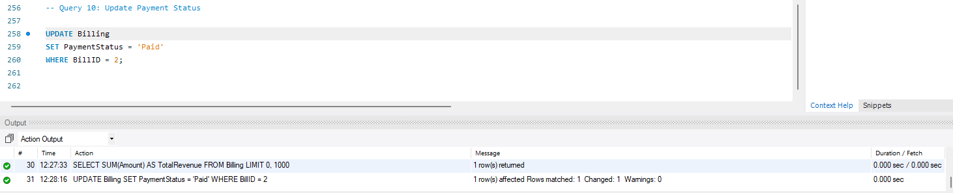
Query 11: Search Patients by Name
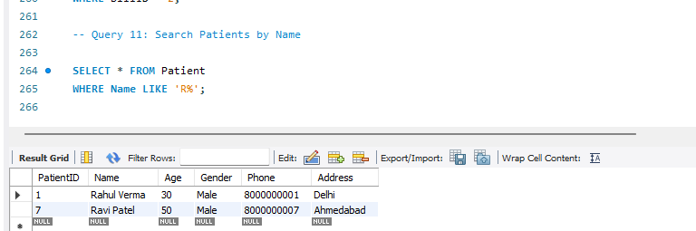
Query 12: Delete an Appointment
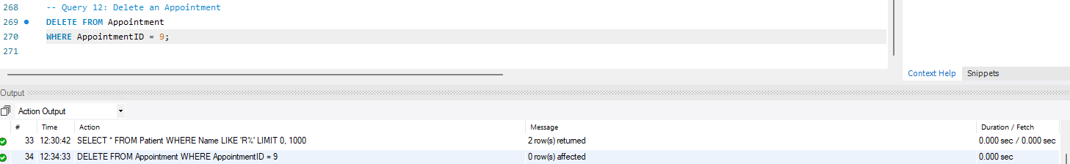
INDEX

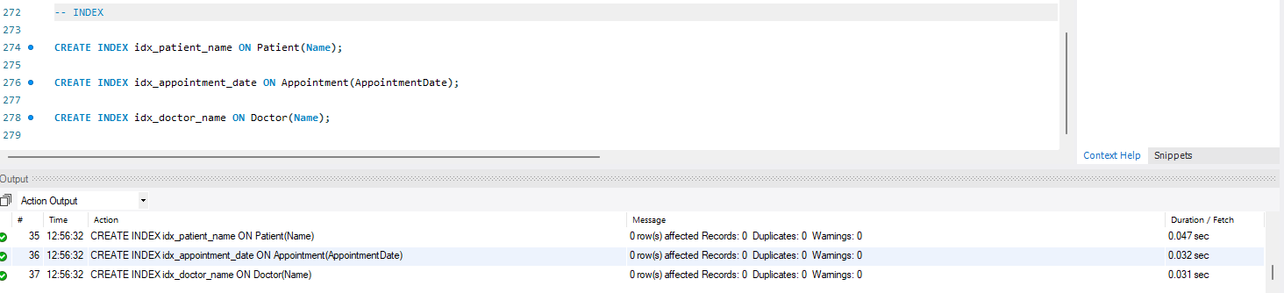

VIEW

Patient Appointment View
SELECT * FROM Patient_Appointment_View;
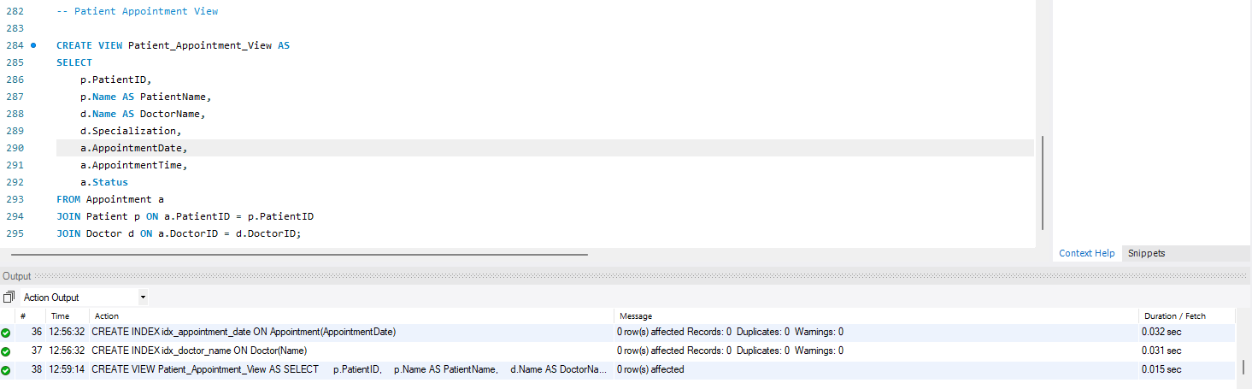
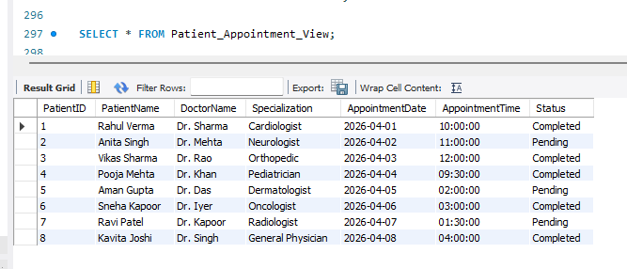
-- Billing Summary View

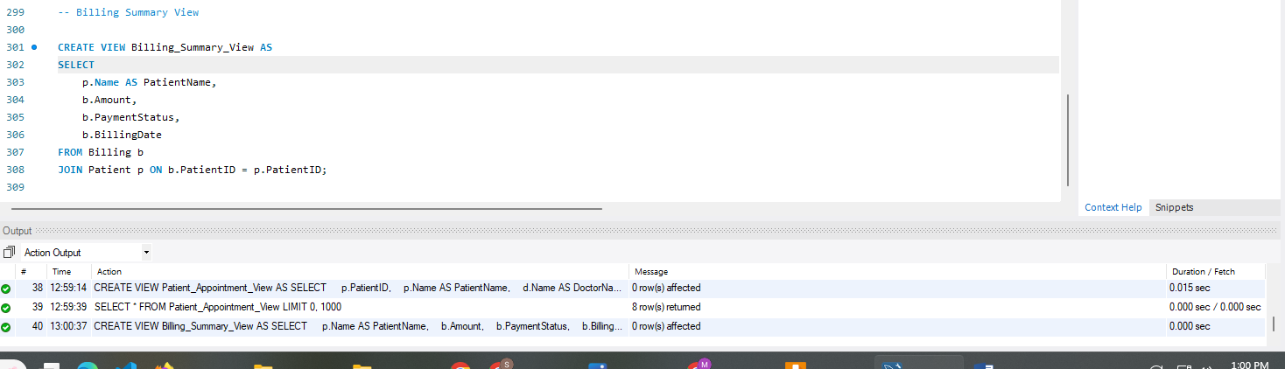
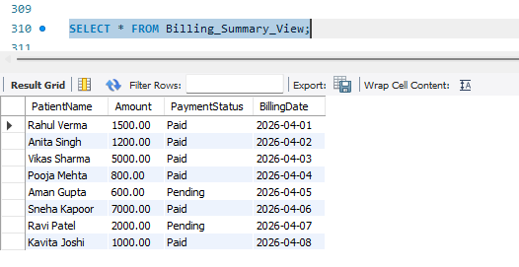

STORED PROCEDURE (Reusable Logic)

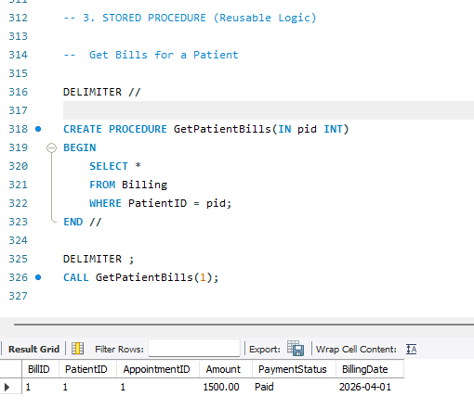

TRIGGER
