BUSINESS REQUIREMENTS DOCUMENT
Dublin Port Freight & Logistics Cost Optimization
Prepared by Adham AlHers · Business Analyst Portfolio Project · August 2026

1. Purpose
This document defines the business requirements for a cost-efficiency review of the company's inbound freight operations across Dublin Port and Rosslare Europort. The review is triggered by rising freight costs since the shift to direct EU routes post-Brexit, and the absence of a data-driven basis for carrier selection.

2. Stakeholders
Role | Interest / Requirement
Logistics Manager | Wants lower cost per shipment without missing delivery SLAs to customers.
Finance | Wants freight cost as a predictable, falling % of landed goods cost.
Warehouse Operations | Wants transit-time consistency — late shipments disrupt inbound scheduling.
Procurement / Ops Coordinator | Currently selects carriers manually; wants clear criteria to defend carrier choices.

3. Current-State Pain Points
- Carrier selection is manual and habit-based — there is no routine comparison of cost-per-kg or on-time performance across carriers before booking.
- Freight cost has risen since the shift toward direct EU routes (avoiding UK customs friction), but no one has quantified whether that cost is buying better reliability.
- Invoices are reconciled against quotes after the fact, not used proactively to inform the next booking decision.

4. Defining "Cost Efficiency" (the core requirements-gathering question)
Before analysis could begin, the single biggest ambiguity to resolve with stakeholders was: what does "reduce freight cost" actually mean? Two different answers lead to two different projects:
- Option A — Minimize cost per kg, full stop, accepting some reliability trade-off.
- Option B — Minimize cost per kg subject to a hard floor on on-time delivery %, since late shipments have a downstream cost (warehouse disruption, customer SLA breaches) that doesn't show up on a freight invoice.
Agreed definition with stakeholders: Option B. Any recommended carrier change must not reduce on-time performance versus the current baseline. This constraint directly shaped the analysis in Section 6 — the recommendation was selected specifically because it improves cost AND reliability simultaneously, removing the trade-off question entirely.

5. Scope
In scope:
- The 3 highest-volume inbound freight routes: UK Landbridge (Dublin-Holyhead), EU Direct (Dublin-Cherbourg), EU Direct (Rosslare-Dunkirk).
- All carriers currently used on those routes.
- Cost-per-kg and on-time % as the two core metrics.
Out of scope:
- Outbound/export freight.
- Customs brokerage fees and warehousing costs (freight cost only).
- Contract renegotiation terms — this document supports a recommendation, not a signed carrier contract.

6. Current Process Map & Bottleneck
The process below reflects the current manual booking workflow. The bottleneck — carrier selection happening by default/habit rather than by current cost or reliability data — is the root cause this analysis addresses.
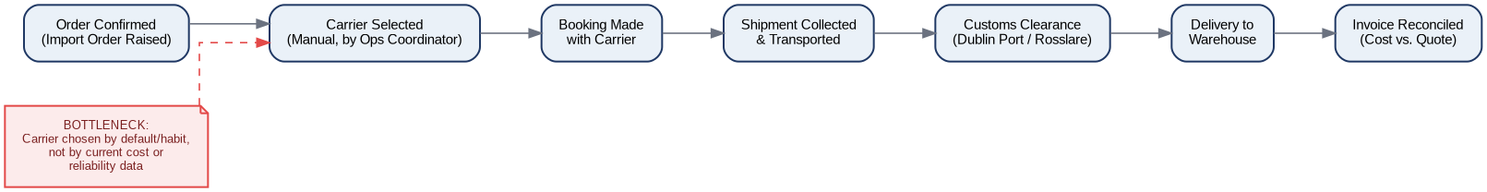

7. Success Metrics
Metric | Target
Freight cost per kg (Dublin-Cherbourg route) | Reduce by 10%+ within 2 quarters of reallocation
On-time delivery % | No decrease vs. current baseline (90.5% overall)
Carrier selection process | Move from ad hoc to a quarterly data review against this dashboard

8. Assumptions & Risks
- Assumes carrier rate cards remain stable during the reallocation period — a formal rate renegotiation would need re-validation.
- Assumes Celtic Sealink has spare capacity to absorb reallocated volume from Atlantic Cargo Ferries on the Dublin-Cherbourg route (to be confirmed directly with the carrier before implementation).
- Risk: reliability differences between carriers may narrow or reverse over time — recommend the quarterly review cadence in Section 7 rather than a one-off switch.

