Lab 1 Report
Name: Rushat Rai
Student ID: 313591061

1. Training Results
Both variants use the same network (4 × 6-tuples with 8 isomorphisms each), α = 0.1 (0.1/32 per feature) and P(2) = 0.7, P(4) = 0.3, and were trained for 100,000 episodes with the submitted td_state.cpp and td_afterstate.cpp. Each point in Figure 1 is the mean score of 1,000 consecutive training episodes.
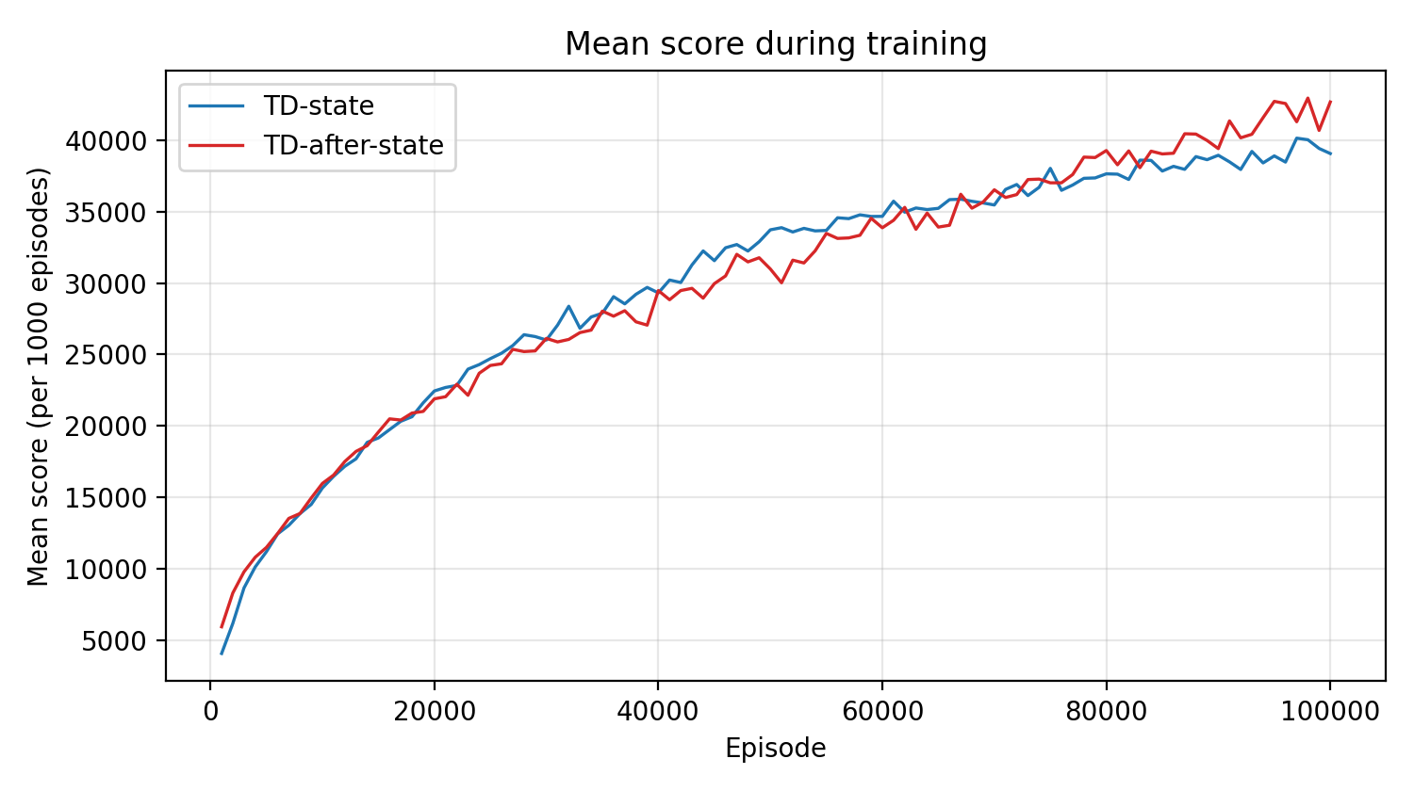
Figure 1. Mean score per 1,000 training episodes.
Table 1. Final results.
 | TD-state | TD-after-state
Mean score, last 1,000 training episodes | 39,063 | 42,672
2048 rate, last 1,000 training episodes | 79.0% | 79.9%
2048 rate, 1,000 games after loading the weights | 81.2% | 77.5%
Training time (single thread) | 1 h 03 min | 31 min

The two curves are almost identical for the first 40k episodes. TD-state is ahead between roughly 45k and 75k episodes, which fits its action selection averaging over every possible popup tile. It levels off near 39k towards the end, while TD-after-state keeps improving and finishes higher (mean 42.7k), mainly because it reaches 4096 more often. Both reach 2048 in about 80% of games. TD-state took about twice as long to train because it evaluates every possible next state for each move.

2. n-Tuple Network
There are far too many 2048 boards for a table of values, so V is approximated with an n-tuple network. The board is stored as 16 cells of 4 bits, each holding the tile exponent (0 = empty, 1 = 2, 2 = 4, …). An n-tuple is a fixed set of n cells; the exponents in those cells, read as an n-digit base-16 number, index a lookup table of weights. Each 6-tuple therefore has a table of 16⁶ ≈ 16.8M weights, one per local tile configuration.
I use the four 6-tuples from the sample code: {0,1,2,3,4,5}, {4,5,6,7,8,9}, {0,1,2,4,5,6} and {4,5,6,8,9,10}. Because the value of a position does not change under rotation or reflection, each tuple is also applied to the 8 isomorphic placements (4 rotations × mirror), all sharing the same table. The value of a board is the sum of the m = 4 × 8 = 32 looked-up weights:
V(b) = Σᵢ₌₁³² θ[ indexᵢ(b) ]
This is linear in the weights, so a TD update with error δ adds αδ/m = 0.1·δ/32 to each of the 32 weights used by the board (learning::update divides by the 4 tuples, pattern::update by the 8 isomorphisms). TD-state evaluates before-states (s and s''); TD-after-state evaluates after-states (s').

3. TD(0), TD-state and TD-after-state
TD(0) learns a value function from experience by bootstrapping: after each step, the estimate is moved towards the reward plus the current estimate of the next state, without waiting for the end of the episode:
V(Sₜ) ← V(Sₜ) + α [ Rₜ₊₁ + V(Sₜ₊₁) − V(Sₜ) ]
Rₜ₊₁ + V(Sₜ₊₁) is the TD-target and Rₜ₊₁ + V(Sₜ₊₁) − V(Sₜ) is the TD-error. No discounting is used since the objective is the final score, and a terminal state has value 0. As in the assignment pseudocode, a whole episode is played first and the updates are then applied from the terminal step back to the first, so each target uses the successor's freshly updated value.
A move in 2048 splits into a deterministic part and a random part: s → (a, r) → s' → (random tile) → s''. The two variants learn values on different sides of the random tile:
TD-state learns V(s) of before-states. V(s) alone does not rank actions, so action selection must take the expectation over the random tile, which requires the popup model: r + Σ P(s'')V(s''). The TD-target is r + V(s'') for the s'' that actually occurred.
TD-after-state learns V(s') of after-states. Since s' is a deterministic result of the move, action selection is just r + V(s') with no expectation or model. The expectation over tiles is learned into V(s') from samples. The TD-target is r_next + V(s'_next), where a_next is the greedy action in s''.

4. Implementation
Both programs use the sample's game loop: each chosen move is stored in path as (s, s', a, r), and s'' of a record is the before-state of the next record. After the episode, update_episode walks path from the terminal record back to the first.

4.1 TD-state
Action selection. For each legal action, select_best_move scores the move as r + expected_value(s'), which places a 2 (probability 0.7/k) and a 4 (probability 0.3/k) in each of the k empty cells of s' and sums the weighted V(s''). A terminal s'' counts as 0; this can only happen when the popup fills the last empty cell.
EVALUATE(s, a) = r + Σₛ'' P(s, a, s'') V(s'')
float expected_value(const board& after) const {
int empty[16], k = 0;
for (int i = 0; i < 16; i++) {
if (after.at(i) == 0) empty[k++] = i;
}
float expect = 0;
for (int i = 0; i < k; i++) {
board next = after;
next.set(empty[i], 1);
expect += 0.7f * value_of(next, k);
next.set(empty[i], 2);
expect += 0.3f * value_of(next, k);
}
return expect / k;
}

Learning. TD-target = r + V(s''), TD-error = TD-target − V(s). v_next holds V(s''): it starts at 0 for the terminal state and is then set to the updated V(s) of each step.
TD backup. The backup runs from the sampled next before-state s'' to s; the after-state s' is only passed through and has no stored value.
s —(a, r)→ s' —(random tile)→ s''
V(s) ← V(s) + α [ r + V(s'') − V(s) ]
void update_episode(std::vector<state>& path, float alpha = 0.1) const {
// V(s) <- V(s) + alpha * (r + V(s'') - V(s)), where V(terminal) = 0
float v_next = 0;
for (path.pop_back(); path.size(); path.pop_back()) {
state& move = path.back();
float td_target = move.reward() + v_next;
float td_error = td_target - estimate(move.before_state());
v_next = update(move.before_state(), alpha * td_error);
}
}

4.2 TD-after-state
Action selection. Each legal action is scored as r + V(s') using estimate on the after-state; no expectation over popup tiles.
EVALUATE(s, a) = r + V(s')
Learning. For each record, the greedy move in s'' is found again with the current weights, giving a_next, r_next and s'_next. TD-target = r_next + V(s'_next) (0 if s'' is terminal), TD-error = TD-target − V(s').
TD backup. The backup runs from the next after-state s'_next to s': the tile sampled after s' gives s'', and the greedy action in s'' gives r_next and s'_next.
s' —(random tile)→ s'' —(a_next, r_next)→ s'_next
V(s') ← V(s') + α [ r_next + V(s'_next) − V(s') ]
void update_episode(std::vector<state>& path, float alpha = 0.1) const {
// V(s') <- V(s') + alpha * (r_next + V(s'_next) - V(s')), where a_next = argmax over A(s'')
board next = path.back().before_state();
for (path.pop_back(); path.size(); path.pop_back()) {
state& move = path.back();
state best = select_best_move(next);
float td_target = best.is_valid() ? best.value() : 0;
float td_error = td_target - estimate(move.after_state());
update(move.after_state(), alpha * td_error);
next = move.before_state();
}
}

