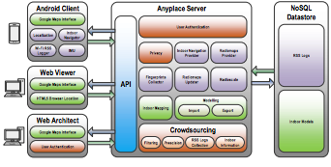

In this project we will use almost the same structure (a new chart needed to be drawn). For database either we are going to use MongoDB or Mysql database. For the front end part we will use web pages to view and manage the architect module. In addition, we are going to use REST API to upload the log and communicate with the server.