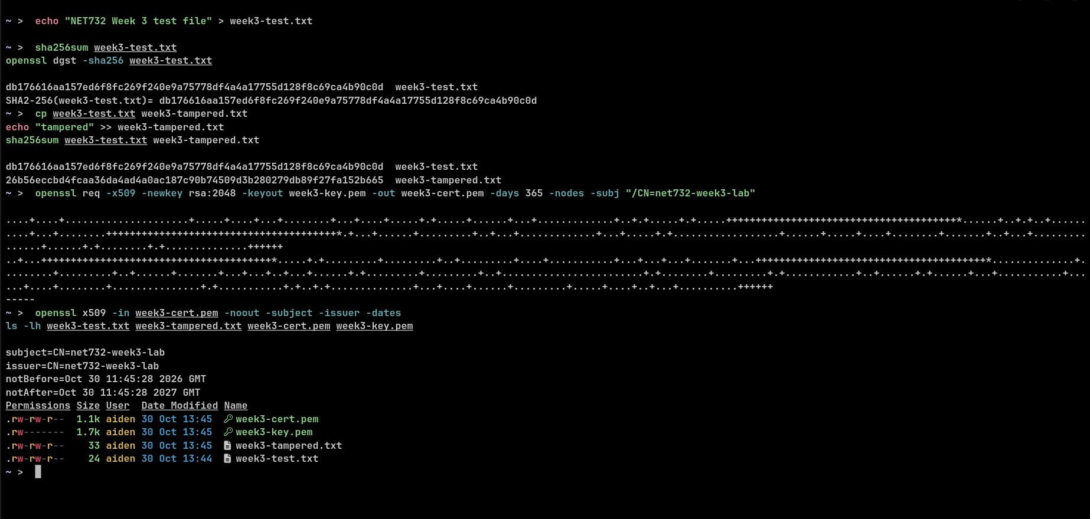

Week 3: Cryptography

For Week 3 I created a test file called week3-test.txt. It was 24 bytes, and it just contained the words "NET732 Week 3 test file". I hashed it with two independent tools, sha256sum and openssl dgst -sha256, and both gave me the same hash, db176616aa157ed6f8fc269f240e9a75778df4a4a17755d128f8c69ca4b90c0d. That agreement told me the file was intact, and that the tools agreed with each other.

The tamper test was simple. I copied the file to week3-tampered.txt and added one word, tampered, which took it to 33 bytes. Its hash then came out as 26b56eccbd4fcaa36da4ad4a0ac187c90b74509d3b280279db89f27fa152b665, which was entirely different from the original. So a single word change broke the match completely.

For the certificate part I generated a self-signed X.509 certificate with OpenSSL, RSA 2048-bit, valid for 365 days, with CN=net732-week3-lab. When I inspected it, the subject and the issuer were the same, both CN=net732-week3-lab, and it was valid from 30 Oct 2026 to 30 Oct 2027. That is correct for a self-signed lab certificate. In production the issuer would be a certificate authority instead. I kept the private key, week3-key.pem, private, and it is not included in this submission.

Reflection

Hashing gave me a fast integrity check for a SOC. A file, a download, or a suspected malware sample can be compared against a known-good hash in seconds, and any mismatch, however small the change, shows up straight away. Certificates take that same trust idea and apply it to identity. The certificate binds a name to a key, and the issuer tells you who vouches for it.

Conclusion

File integrity verification worked as expected, and I could create and inspect a basic certificate with OpenSSL. The fact that both tools gave the same hash proves the original file was intact, the tamper test proves that even a 9-byte change is detectable, and the self-signed certificate shows the identity side of cryptography in a lab setting. My next actions are to apply the same hash-comparison method to the Week 11 malware sample, and in a production setting to replace self-signed certificates with CA-issued ones and automate hash checking, so tampering is caught without manual comparisson.

