Week 6: Host Intrusion Analysis

For Week 6 I reviewed running processes with ps aux, listening ports and connections with ss -tulnp and ss -tnp, running services with systemctl, and current logins and load with who -a and uptime, all on the Ubuntu guest.

Nothing suspicious turned up in the processes. The highest real CPU user was gnome-shell at 0.4%, with tailscaled, containerd/dockerd, qemu-guest-agent, and spice-vdagentd all expected in this VM. The only public TCP listener was SSH on port 22, which matched the Week 5 Nmap result. All the other listeners were loopback-only, for DNS and NTP, or Tailscale-only. There were three established connections, all outbound to port 443, to 102.67.165.185, 192.200.0.113, and 199.165.136.100, which was consistent with the normal TLS traffic seen in earlier captures. Twenty-six services were running, all standard, and the host showed 1 logged-in user with a load average of 0.12.

A host compromise would typically show up as an unknown process, an unexpected listener, or an outbound connection to an unfamiliar port or host. None of those indicators were present. The one evidence gap was process mapping for the Tailscale-bound high ports, due to the fact that ss was run without sudo and left the process column blank. Those ports are bound to the Tailscale interface only, not publicly, so the risk is low, but a follow-up with sudo ss -tulnp would close it.

Reflection

Host analysis is a cross-check, not a standalone verdict. Week 6's clean process and listener list is what lets Week 4's SSH events be read as lab-generated rather than as signs of a compromised host.

Conclusion

No indicators of host compromise were found. Processes, services, listeners, and connections all map to expected system, desktop, and lab services, the only public service is the already-accounted-for SSH port, and host load and login state are normal. My next actions are to close the one evidence gap with sudo ss -tulnp to map the Tailscale-bound ports to processes, and in production to baseline the expected process and listener list, so any new entry triggers an alert instead of relying on manual review.
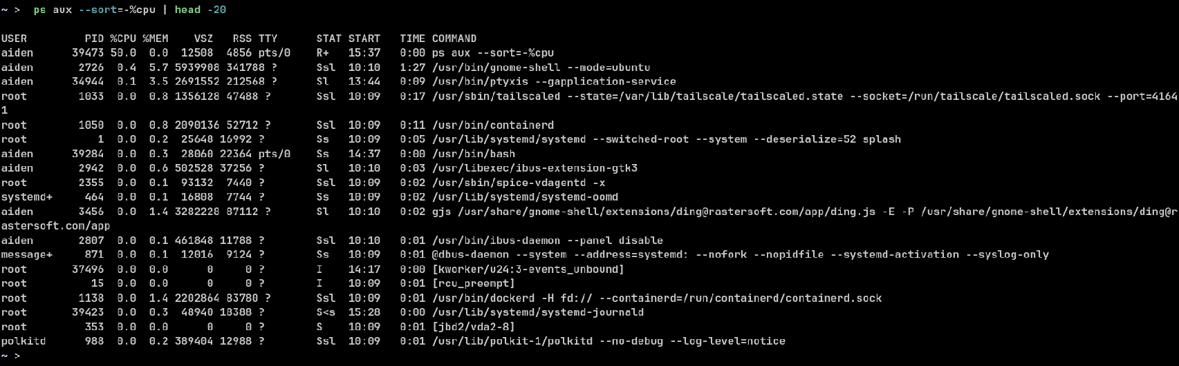
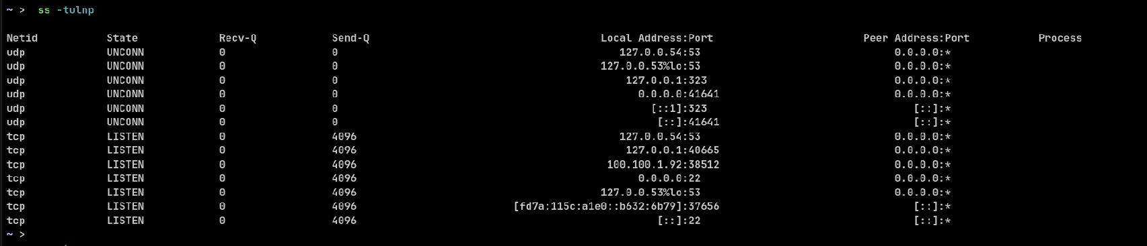
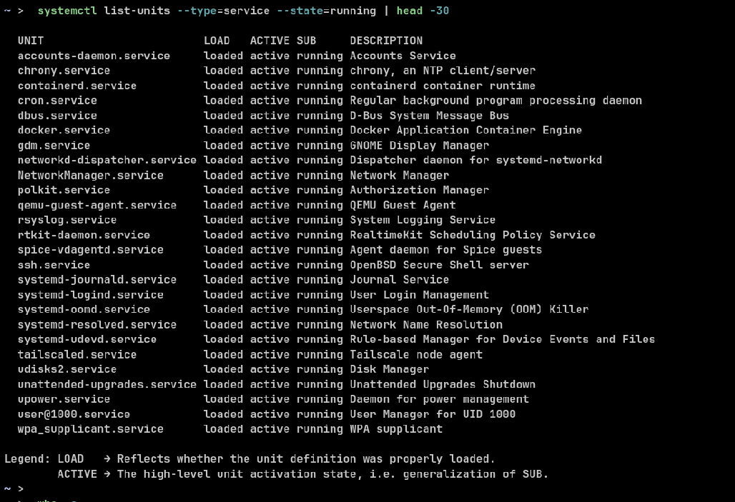
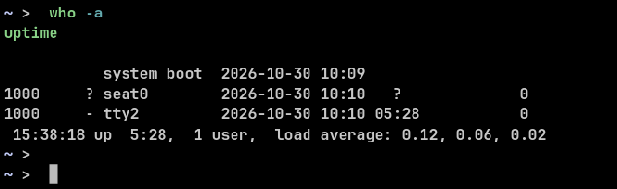
What was done: Reviewed running processes (ps aux), listening ports and connections (ss -tulnp, ss -tnp), running services (systemctl), and current logins/load (who -a, uptime) on the Ubuntu guest.

Findings: No suspicious process was found — the highest real CPU user was gnome-shell (0.4%), with tailscaled, containerd/dockerd, qemu-guest-agent, and spice-vdagentd all expected in this VM. The only public TCP listener was SSH on port 22, matching the Week 5 Nmap result; all other listeners were loopback-only (DNS, NTP) or Tailscale-only. Three established connections were present, all outbound to port 443 (102.67.165.185, 192.200.0.113, 199.165.136.100), consistent with normal TLS traffic seen in earlier captures. Twenty-six services were running, all standard, and the host showed 1 logged-in user with a load average of 0.12.

Analysis: A host compromise would typically show as an unknown process, an unexpected listener, or an outbound connection to an unfamiliar port or host. None of those indicators were present. The one evidence gap is process mapping for the Tailscale-bound high ports, because ss was run without sudo and left the process column blank — those ports are bound to the Tailscale interface only, not publicly, so the risk is low, but a follow-up with sudo ss -tulnp would close it.

Reflection: Host analysis is a cross-check, not a standalone verdict — Week 6's clean process and listener list is what lets Week 4's SSH events be read as lab-generated rather than as signs of a compromised host.

Conclusion: No indicators of host compromise were found. Next action: use Weeks 4–6 together as the evidence base for the Week 7 midterm incident investigation.

