Week 8: Secure Network Design

For Week 8 I set up two segments on enp1s0 in the guest, as 802.1Q VLAN subinterfaces. The manual names Packet Tracer for this week, and I did it on the lab guest instead, which still let me test the same segmentation and access-control ideas on real interfaces.

I made VLAN 10 the trusted side, on 192.168.10.0/24 with 192.168.10.10, and VLAN 20 the untrusted guest side, on 192.168.20.0/24 with 192.168.20.10, and I brought both of them UP. I checked them with ip -d link show, which gave me vlan protocol 802.1Q and ids 10 and 20, and I checked the addresses again with ip addr show.

First I pinged 192.168.20.10 from the trusted side, with nothing blocking it yet. Both packets came back, no loss, averaging 0.079 ms, so at that point the trusted side could just reach the untrusted side. I then added an iptables OUTPUT rule to drop all traffic to 192.168.20.0/24, made sure it was actually showing in the chain listing, and ran that exact ping again. Nothing came back this time, 2 sent and 0 received, so 100% loss. Once I had that result I took the rule out again, so the guest networking went back to normal.

That was the part that stuck with me. Just splitting the network into VLANs did not, on its own, keep anything apart, because without a rule the two sides talked to each other fine. It was the firewall rule that actually drew the line, and I could see it working because the ping flipped from working to not working when that was the only thing I changed. The source had not changed, the destination had not changed, just the rule.

If I was doing this for real, I would not leave that rule on the host. I would put it on the router or firewall sitting between the VLANs, and I would only open up the specific services that need to cross, not everything.

Reflection

For a SOC, that separation matters, because a host that gets compromised in the untrusted segment should not just be able to walk into the trusted systems. It also helps with spotting trouble, because traffic crossing between segments when it should not be there stands out a lot more in logs and captures.

Conclusion

I built a segmented network and tested the access control on it, and I proved the control by measuring it, not just by setting it up. The VLANs were up and verified at the interface level, and the firewall boundary showed up clearly in the before-and-after ping test. My next actions are to take that same least-privilege idea into Week 9, for users and files, and in production to move the inter-VLAN rule onto the network firewall, scope it per service, and log any denied attempts to cross segments, so a SOC can actually see them.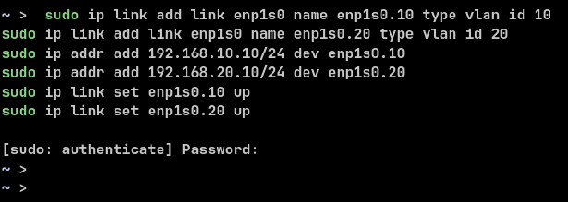
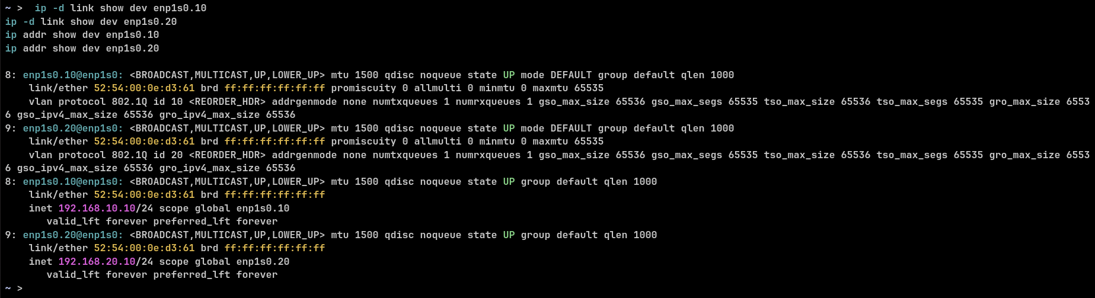
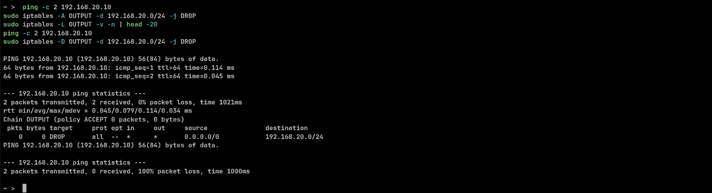
s

