Project Plan
Taniya Dutta Adhikari

Table of Contents
1 Planning Basis 2
1.1 Scope 2
1.2 Milestones 2
1.3 Phases 2
1.4 Activities 3
1.5 Tasks 3
2 Project Plan 4
2.1 Schedule 4
2.2 Assumptions 4
2.3 Constraints 5
3 Appendix 5

Planning Basis

Scope
The purpose of this project is to apply predictive analytics and select appropriate models to make data-driven decisions for identified business problem. In this project I will be identifying a business problem, finding the correct data from the appropriate data sources, identify appropriate modelling techniques to analyse data and use results to make better decisions.

Milestones

Milestone | Description | Delivery Date
Team Information/ Communication Plan | Submit Team Information and Project plan with detail schedule, activities, and phases. | 03/21/21
Data Selection and Proposal Due | Identify problem statement and select appropriate dataset for the problem. Create and submit a project proposal and project requirements. | 03/28/21
Preliminary Analysis | Finish preliminary analysis on the data and submit initial results with the draft of the final paper. | 04/18/21
Project Presentation & Status | Submit the detailed presentation slides with the critical results of the projects. Include all the challenges and future scope of the project. | 05/16/21
Final Project & Presentation | Submit final project paper which includes background, abstract, business problem and well as summary of the final results and conclusion. | 06/05/21

Phases

Phase | Description© | Sequence
Initiation | This will be the combination of milestone 1 and 2 activities. Identification of team will be done in this phase. Collaboration with potential reviewers for peer review. | Phase # 1
Planning | Development of a project plan and schedule, Formulating the business problem and selection of quality dataset for the project will be done. I will be identifying the potential use of predictive analytics and create a project proposal. | Phase # 2
Execution | Kick-Off draft final project submission. Clean and perform EDA on the dataset. Select appropriate model so we can make data-driven decision. Perform evaluation and testing of the model. Deployment of the model. | Phase # 3
Closure | Summarize the results and draw conclusions. Submit the final paper and presentation | Phase # 4

Activities

Phase | Activity | Description© | Sequence
Initiation | Team Identification | Project will be done independently. Collaboration with classmates | Activity 1
Initiation | Initial Set-up for Project | Creating Folder and threads in MS Teams. | Activity 2
Planning | Project Plan | Development and submission of Project plan and schedule. | Activity 3
Planning | Requirements | Creating initial requirements for project, identify business problem and select data | Activity 4
Execution | Preliminary Data Preparation | Conduct initial data cleaning and exploratory data analysis | Activity 5
Execution | Preliminary Modelling | Select modelling and conduct initial evaluation. Submit Analysis | Activity 6
Execution | Intermediate Analysis | Make updates to data preparation step and EDA. Make updates to modelling. | Activity 7
Execution | Test and Evaluation | Conduct final EDA, model selection and evaluation. | Activity 8
Execution | Release | Deploy model and summarize and draw final conclusions. Develop Technical report. | Activity 9
Closure | Final Submission | Make any necessary updates to project report and do final submission | Activity 10

Tasks
A ‘task’ is simply an item of work to be completed within the project. List all tasks required to undertake each activity, within the following table:

Phase | Activity | Task | Sequence
Initiation | Team Identification | Identify Team member/s  Collaborate with classmates for Peer Review | Task 1  Task 2
Initiation | Initial Set-up for Project | Create discussion thread  Create folder in Teams | Task 3  Task 4
Planning | Project Plan | Create Project Plan  Create a Project Schedule | Task 5  Task 6
Planning | Requirements | Identify a business problem and scope  Conduct initial research  Identify data sources  Select dataset  Develop preliminary requirements  Develop Proposal Plan | Task 7  Task 8  Task 9  Task 10  Task 11  Task 12
Execution | Preliminary Data Preparation | Initiate and Conduct Peer Review 1  Preliminary Data Preparation  Preliminary Exploratory Data Analysis  Initiate and Conduct Peer Review 2 | Task 13  Task 14  Task 15  Task 16
Execution | Preliminary Modelling | Preliminary Model Selection  Preliminary Test, and Evaluation  Summarize preliminary results and conclusions  Develop preliminary Project Draft | Task 17  Task 18  Task 19  Task 20
Execution  Execution | Intermediate Analysis  Intermediate Analysis | Initiate and Conduct Peer Review 3  Intermediate Data Preparation and EDA  Intermediate Model Selection  Intermediate Test, and Evaluation  Draw intermediate results and conclusions  Develop Presentation Slides | Task 21  Task 22  Task 23  Task 24  Task 25  Task 26
Execution | Test and Evaluation | Initiate and Conduct peer review 4  Final data preparation and EDA  Final Model Selection  Final Test and Evaluation | Task 27  Task 28  Task 29  Task 30
Execution | Release | Initiate and Conduct peer review 5  Deployment of the Model  Develop preliminary project presentation  Develop preliminary executive summary  Develop preliminary technical report | Task 31  Task 32  Task 33  Task 34  Task 35
Closure | Final Submission | Update project presentation  Update executive summary  Update technical report  Submit Final Presentation and Paper  Initiate and Conduct peer review 6 | Task 36  Task 37  Task 38  Task 39  Task 40

Project Plan

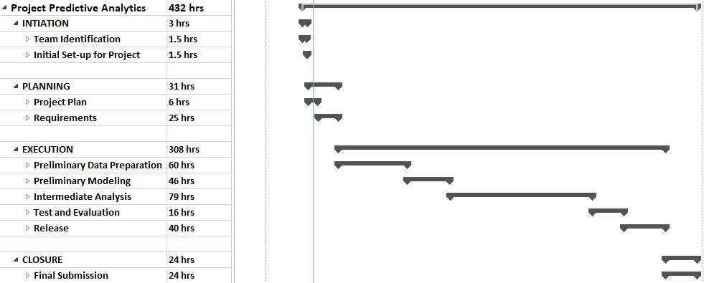
Schedule

Note: Refer to the Appendix for a detailed project schedule.

Assumptions
It is assumed that:
- The project will not change in scope.
- The work hours are estimated based on 2-3 hours daily contributions.
- The project business problem will not change.
- The days are estimated without including any holidays

Constraints
- The project must operate within the milestone’s deadlines.
- Must complete the project within normal working hours.
- The project team must deliver the audio presentation

Appendix
- Detailed Project Schedule
- Summarized Project Schedule
- Ms Project Schedule File (if needed)

